**Equation**

#### Open Statement

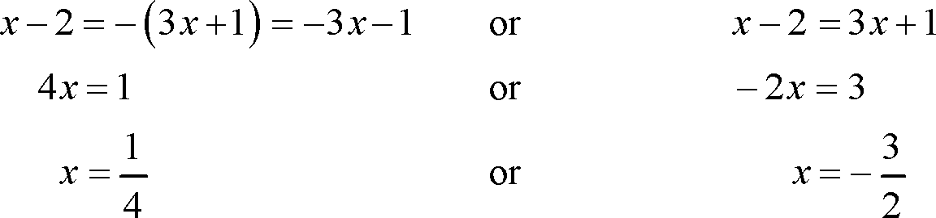source: tutorial.math.lamar.edu  
Fig: Open statement

The mathematical statement, which cannot be predicted as true or false statements (until the variable is replaced by any number) are known as an open statement.

x>5, x+3<4, 2y-1≥9 etc. are the example of an open statement.

**Linear equations in one variable**

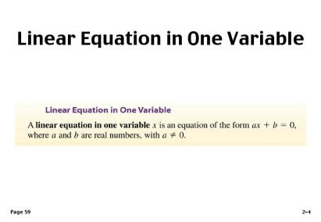source: www.tes.com  
Fig: Linear Equation in One Variation

The open statement containing 'equal to' (=) sign and can be true only for a fixed value of variable is called equation.

Further more in x+2 = 5, the equation has only one variable which is x. So, it is the equation of one variable. Also the variable x has power 1.So it is called a linear equation. Thus, x+2 = 5 is a linear equation in one variable.

**Solution to equations**

Suppose x+2 = 7

This equation can be true only for a fixed value of x which is 5. So, 5 is called the solution (or root) of the equation.The process of getting a solution to an equation. The process of getting a solution to an equation is called solving equation.

**Applications of equations**

Generally, we use equations to find the unknown value of any quantity. For this, we should consider the unknown value of the given verbal problems as the variable like x, y, a, b etc. Then the verbal problems should be translated into mathematical sentences in the form of equations. And by solving the equations we obtain the required values.

Things to remember

* The process of getting a solution to an equation.
* The process of getting a solution to an equation is called solving equation.
* The verbal problems should be translated into mathematical sentences in the form of equations.

### Questions and Answers

#### Click on the questions below to reveal the answers

**4(3 - x) = 2x - 15**

Solution:

or, 4(3 - x) = 2x - 15  
or, 12 - 4x = 2x - 15  
or, -4x - 2x = -15 - 12  
or, -6x = -27  
or, x = 276

∴ x = 92

**[Solve   
x + 20% of x = Rs 180](file:///D:\\Project%20materail\\test.html" \l "collapse31762)**

Solution:

or, x + 20% of x = Rs 180  
or, x + 20100

 × x = Rs 180  
or, x + *x*5  = Rs 180  
or, 5*x*+*x*5 = Rs 180  
or, 6*x*5 = rs Rs 180  
or, 6x = 5 × Rs 180  
or, x = Rs 9006   
or, x = Rs 150  
∴ x = Rs 150

**The sum of two numbers is 35. if one of the numbers is 21, find the other number.**

Solution:

Let the other number be x.  
Now,  
or, x + 21 = 35  
or, x = 35 - 21  
or, x = 14  
So, the required number is 14.

**A sum of Rs 50 is dived into two parts. If the greater part exceeds the smaller by Rs 10, find the parts of the sum.**

Solution:

Let the smaller part of the sum be Rs x.  
Then,  
the greater part of the sum = Rs (x + 10)   
Now,  
or, x + (x + 10) = Rs 50  
or, 2x = Rs (50 - 10)  
or, x = Rs 402

or, x = Rs 20  
∴ The smaller part of the sum = x = Rs 20  
The greater part of the sum = Rs (x + 10) = Rs (20 + 10) = Rs 30

**If x + 4 =  9, then what will be the value of x?**

13  
6  
5  
3

**If 2x + 1 = x + 3, what will be the value of x?**

1  
4  
2  
3

**If 3,6x - 6.1 = 5.9 - 2.4x, find the value of x.**

6  
2  
4  
8

**The sum of two numbers is 28. If one the numbers is 16, find the other number.**

5  
7  
2  
3

**If x + 20% of x = Rs 180, find the value of x.**

Rs 130  
Rs 140  
Rs 150  
Rs 120

**Solve:   
4(3 - x) = 2x - 15**

(frac{9}{2})  
(frac{2}{3})  
(frac{2}{9})  
(frac{3}{2})

**Solve:  
-(frac{x}{4}) = 5**

-10  
-5  
-20  
-15

**Solve:**

**3(3 - 2x) = -5 (x- 1)**

4  
6  
10  
8

**The difference of two numbers is 24. If the smaller number is 18, what will be the greater one.**

48  
44  
46  
42

**Solve:  
x = 220  - 10% of x**

Rs 200   
Rs 220  
Rs 210  
Rs 230

## Trichotomy and Inequalities

#### Trichotomy

The property of real numbers which guarantees that for any two real numbers a and b, exactly one of the following must be true.

Either a<b, a=b or a>b.

Such property of whole numbers is known as Trichotomy property. The sign (=) 'equal to' (<) 'lesser than' and (>) 'greater than are the trichotomy sign.

**Negation of trichotomy**

Suppose any two numbers 3 and 5.

Here, 3<5 or 5>3 are a true comparison. But 3≮

5 (3 is not less than 5) or 5≯

3 (5 is not greater than) are the false comparison.

Here, 3≮

5 is the negation of 3<5 and 5≯

3 is the negation of 5>3.

Thus '≮

' (is not less than) is the negation of '<' (is less than) '≯

' (is not greater than) and '≠' (is not equal to) is the negation of '=' (equal to).

**Trichotomy Rules**

1. When an equal positive number is added to or subtracted from or multiplied or divided by both sides of trichotomy sign the sign remain the same. For example,  
   7>5, then 7+2>5+2  
   9>6, then 9-4>6-4
2. When both sides of trichotomy sign are multiplied or divided by an equal negative number, the sign '<' is changed to '>' and the sign '>' is changed to '<'. For example,  
   6>5, then 6×(-2)<5×(-2) (a>b then a(-c))<b×(-c)

**Inequalities**

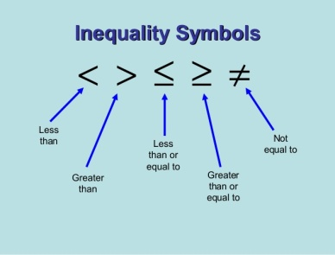source: www.slideshare.net  
Fig: Inequality

When an open statement contains the signs of less than '<', greater than '>', less than equal to (≤) or greater than equal to (≥) it is known as an inequation. An inequation is also called inequality.

x>10, y<4, p≥-5 etc are the examples of inequalities.

**Replacement set and solution set**

The set of values of x that makes the inequality true is {1,2,3} then it is known as the solution set. However, the set of natural numbers, N = {1,2,3,4,5} from which numbers are used to replace x in the inequality is known as the replacement set. For examples,

N = {1,2,3,4,5}

When x = 1, 1<4 (It is true)

When x = 2, 2<4 (It is true)

When x = 3, 3<4 (It is true)

When x = 4, 4<4 (It is false)

When x = 5, 5<4, (It is false)

**Graphical representation of solution set**

For the graphical representation of solution sets, we use number lines to show the solution sets of the given inequalities.

Things to remember

* The property of real numbers which guarantees that for any two real numbers a and b, exactly one of the following must be true.
* Trichotomy Rules
  1. When an equal positive number is added to or subtracted from or multiplied or divided by both sides of trichotomy sign the sign remain the same.
  2. When both sides of trichotomy sign are multiplied or divided by an equal negative number, the sign '<' is changed to '>' and the sign '>' is changed to '<'.
* For the graphical representation of solution sets, we use number lines to show the solution sets of the given inequalities.

### Questions and Answers

#### Click on the questions below to reveal the answers

**If R = {1, 2, 3, 4, 5} be the replacement set of the inequality 2x + 3 < 11, find its solution set.**

Solution:

Here, the replacement set, R = {1, 2, 3, 4, 5}  
The given inequality is,   
or, 2x + 3 < 11   
or, 2x + 3 - 3 < 11 - 3  
or, 2x < 8   
or, 2*x*2

 < 82

or, x < 4

Now,   
when x = 1, 1 < 4 which is true  
when x = 2, 2 < 4 which is true  
when x = 3, 3 < 4 which is true  
when x = 4, 4 < 4 which is true  
∴ Solution set = {1, 2, 3}

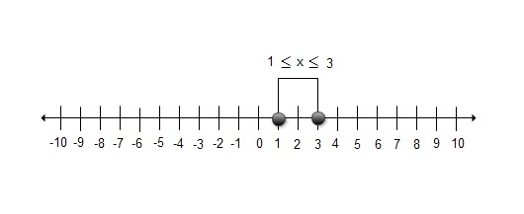

**Find the solution sets of the 3x - 2 > x + 10 inequalities.**

Solution:

or, 3x - 2 > x + 10   
or, 3x -  2 - x > 10   
or, 2x - 2 > 10  
or, 2x - 2 + 2 > 10 + 2  
or, 2x > 12  
or, 2*x*2

 > 122

or, x > 6  
∴ Solution set = {7, 8, 9, . . . .. . . }

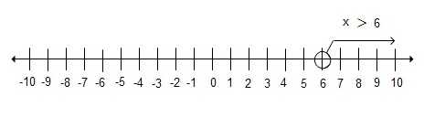

**The difference of three times a number and 7 is less than and equal to -10, solve the inequality.**

Solution:

Let the number be x   
According to the given statement,   
3x - 7 ≤ -10   
or, 3x - 7 + 7 ≤ -10 + 7 (7 is added to both sides.)  
or, 3x ≤ -3   
or, 3*x*3

 ≤  −33

 (Both sides are divided by 3)  
or, x ≤  -1  
∴ Solution set = {-1, -2, -3, . . . . . }

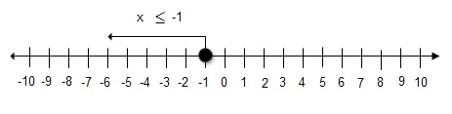

**When one-fourth of a number os subtracted from 3, the difference is greater than equal to 2, solve the inequality.**

Solution:

Let the number be x.   
According to the given statement.  
3 - *x*4

 ≥ 2   
or, 3 - 3 - *x*4 ≥ 2 - 3  (3 is subtracted from both sides)  
or, -*x*4 ≥ - 1  
or, -4 × -(*x*4

) ≤ -1 × (-4)  (Both sides are multiplied by -4. So, the sign ≥ is change into ≤ .)  
or, x ≤ 4   
∴ Solution set = {4, 3, 2, 1, 0, -1, . . . . .. . .    }

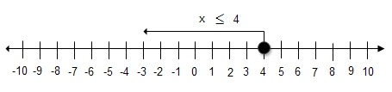

**The property of whole numbers is known as ______ property.**

Trichotomy  
Inequality   
Negation  
Graphical

**An inequation is also called ______ .**

graphic  
trichotomy   
inequality  
division axiom

**______ is an open statement containing 'equal to' (=) sign.**

Trichotomy   
Inequality  
Equation  
Graph

**If the open statement contains the sign of 'less than' (<), 'greater than' (>), 'less than and equal to' (≤), or 'greater than and equal to' (≥), it is known as ______ .**

trichotomy   
inequation   
graph  
negation