**Factors and Factorisation**

#### Factorisation of expressions which have a common factor in each of its terms

source: saylordotorg.github.io  
Fig: Factorization of Expression

The factor which is present in each term is taken as common and each term of the expression divided by the common factor and the quotient represents the factorization of the expression. For example,

ax+ay

= a(x+y)

= axy2 + ax2y

= 2xy(y + 2x)

**Factorisation of expressions having a common factor in the group of terms**

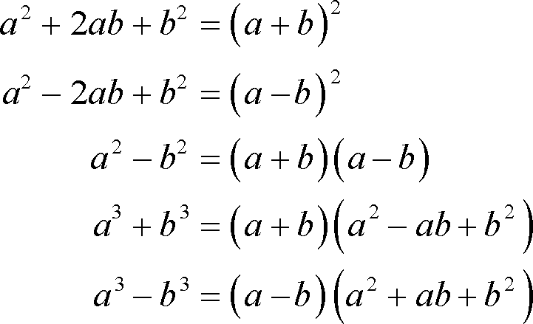source: tutorial.math.lamar.eduFig: Factorization of expression having common factor

In this case, the terms of the given expression are arranged in groups in such a way that each group has a common factor. For example,

a2 + ab + ca + bc

a(a+b) + c(a+b)

(a+b)(a+c)

**Factorisation of expressions having the difference of two squared terms**

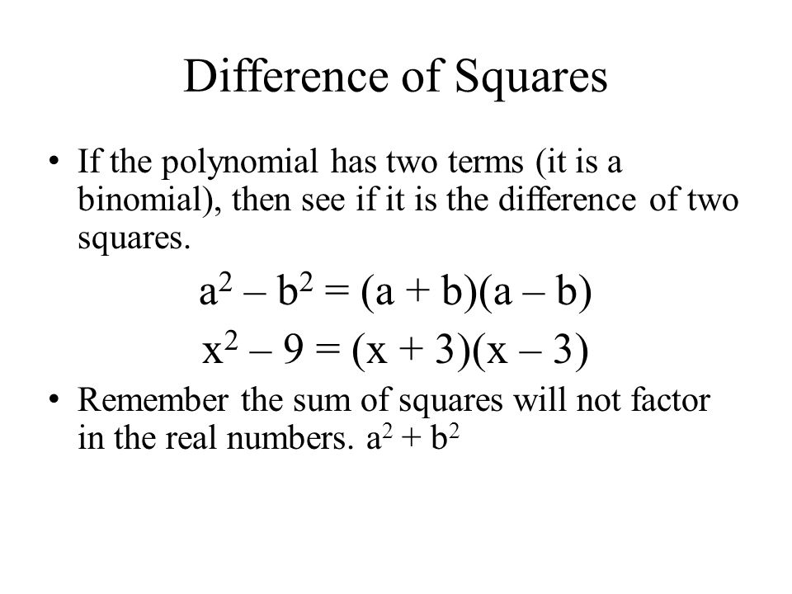source: slideplayer.comFig: Factorization of having the difference of two square

The algebraic expressiona2 - b2 is the difference of two squared terms. Here a2 and b2 are the squared terms and a and b are their square roots respectively. We have learnt that a2 - b2 is the product of (a+b) and(a-b)

∴

a2 - b2 = (a+b) (a-b)

So, (a+b) and (a-b) are the factors of a2 - b2

To factorise such expression, we should re-write given terms in the form of a2 - b2.

Then, a2 - b2 = (a+b) (a-b) represents the factorise. For example,

a) 4x2 + 9y2

= (2x)2 - (3y)2

= (2x+3y)(2x-3y)

b) 9x2 + 25y2

= (3x)2 + (5y)2

= (3x+5y)(3x-5y)

**Factorisation of expressions of the form x2 + px + q**

While factorising a trimonial expression of the formx2 + px + q, we should search any two number a and b such that a+b = p and ab = q. Clearly a and b must be the factors of q. Then px is expanded in the form ax + bx and factorization is performed by grouping.

Things to remember

* The terms of the given expression are arranged in groups in such a way that each group has a common factor.
* The algebraic expression a2 - b2 is the difference of two squared terms.

### Questions and Answers

#### Click on the questions below to reveal the answers

**a2 + ab + ca + bc**

Solution:

a2 + ab + ca + bc

 = a(a+b) + c(a+b)

 = (a+b) (a+c)

**Factorise: x2 - 3a + 3x - ax**

Solution:

x2 - 3a + 3x - ax

 = x2+ 3x - ax - 3a

 = x(x+3) -a (x+3)

 = (x+3) (x-a)

**Factorise: 81x4 - 16y4**

Solution:

 = (9x2)2 - (4y2)2

 = (9x2 + 4y2) (9x2 - 4y2)

 = (9x2 + 4y2) [(3x2)2 - (2y)2]

 = (9x2 + 4y2) (3x + 2y) (3x - 2y)

**If (a+b) = 2, find the value of a3 + b3 + 6ab.**

Solution:

Here, (a+b) = 2

∴

(a+b)3 = 23

or, a3 + 3a2b + 3ab2 + b3 = 8

or, a3 + b3 + 3ab(a+b) = 8

or, a3 + b3 + 3ab×2 = 8

or, a3 + b3 + 6ab = 8

So, the reqiured value of a3 + b3 + 6ab is 8.

**Simplify: 24×40 - 20×24**

Solution:

 = 24(40 - 20)

 = 24×20

 = 480

**Simplify by factorization process: 652 - 552**

Solution:

 = (65+55) (65-55)

 = 120×10

 = 1200

**What will be factors of 2 and 3?**

3  
2  
5  
6

**What will be results of 24 × 40 - 20 × 24 by simplifying?**

460  
480  
430  
410

**What will be answered when simplifying 652 - 552**

600  
1000  
500  
1200

**Factorise x2 + 5x + 6**

(x + 3) (x + 2)  
(x + 2) (x + 3)  
(x - 2) (x + 3)  
(x - 2) (x - 3)

**Factorise x2 - 4.**

(x + 2) (x - 1)  
(x + 1) (x - 4)  
(x - 2) (x + 2)   
(x + 2) (x - 2)

**Factorise x2 - 3a + 3x - ax**

(x - 2) (x + a)  
(x + 3) ( x - a)  
(x + 1) (x + a)  
(x - a) ( x + a)

**Resolve into factors 3a(x + y) - 4b(x + y)**

(x - y) (2a + 2b)  
(x + y) (a + b)  
(x + y) (3a - 4b)  
(x + y) (a - b)

**Simplify 79 × 81 - 5**

6391  
6399  
6394  
6395

**Factorise:  max - may**

am(x + y)  
mx - xy  
ma(x - y)   
m(x - y + a)

**Factorise 36 × 24 + 26 × 36**

1800  
1500  
1600  
1700

## Factorisation, HCF and LCM

#### Highest Common Factor(HCF)

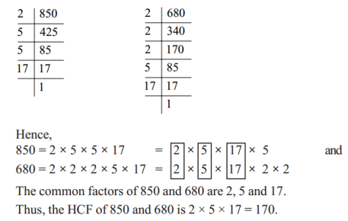source: www.cbsetuts.com  
Fig: Highest Common Factor

HCF is the highest number that is the greatest thing for simplifying fractions. For example, the factors common to 12 and 3 are 2,3.

∴

HCF of 12 and 8 is 3.

1. **HCF of monomial expressions**  
   We can find the HCF of the given monomial expressions just by taking the common variable with the least power. The HCF of the numerical coefficient is obtained as like in the case of arithmetic. For example,  
   Find the HCF of x4y2 and x2y4  
   1st expression = x4y2  
   2nd expression = x2y4  
   ∴

• HCF = x2y2

• **HCF of polynomial Expression**  
We can find the HCF of polynomials by factorizing them. For example,  
Find HCF of ax - bx and a2 - b2  
1st expression = ax - bx= x(a-b)  
2nd expression = a2 - b2 = (a-b)(a+b)  
∴

1. = (a-b)

**Lowest Common Multiple (LCM)**

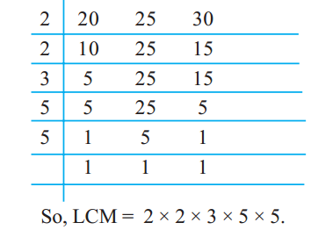source: www.cbsetuts.com  
Fig: Lowest Common Multiple

The smallest positive number that the multiple of two or more numbers is LCM. For example, the LCM of a2 and a3 is a3.

1. **Lowest common factor of monomial expressions**  
   We can find the LCM of the given monomial expressions just by taking the common variable with the highest power. For examples,  
   1sr expression = ax2  
   2nd expression = a2x2  
   ∴

• a2x2

• **LCM of polynomial expressions**  
To find LCM of polynomial expressions . We should factorize them. Then the product of a common factors and remaining factors is the LCM of the given expressions. For examples,  
Find the L.C.M of ax2 + ax and a2x2 + a2x  
1st expression = ax2 + ax = ax(x+1)  
2nd expression = a2x2 + a2x = a2x(x+1)  
∴ LCM = a2x(x+1)

Things to remember

* We can find the HCF of the given monomial expressions just by taking the common variable with the least power.
* We can find the HCF of polynomials by factorizing them.
* We can find the LCM of the given monomial expressions just by taking the common variable with the highest power.
* To find LCM of polynomial expressions . We should factorize them. Then the product of a common factors and remaining factors is the LCM of the given expressions.

### Questions and Answers

#### Click on the questions below to reveal the answers

**Find the HCF of x4y2 and x2y4.**

Solution:

1st expression = x4y2

2nd expression = x2y4

∴

HCF = x2y2

**Find the HCF of 4ab2 and 6a2b3.**

Solution:

1st expression = 4ab2

 = 2×2ab2

2nd expression = 6a2b3

 = 2×3a2b3

∴

HCF = 2ab2

**Find the HCF of ax - bx.**

Solution:

1st expression = ax - bx = x(a-b)

2nd expression = a2 -b2 = (a+b)(a-b)

∴

HCF = (a-b)

**Find the HCF of x2 + xy + zx + yz and x2 - y2.**

Solution:

1st expression = x2 + xy + zx + yz = x(x+y) + z(x+y) = (x+y) (x+z)

2nd expression = x2 - y2 = (x+y) (x-y)

∴

HCF = (x+y)

**Find the LCM of 4x3y3 and 6xy.**

Solution:

1st expression = 4x3y3

 = 2×2x3y3

2nd expression = 6xy

 = 2×3xy

∴

LCM = 2×2×3 x3y3

 = 12x3y3

**Find the LCM of ax2 + ax and a2x2 + a2x.**

Solution:

1st expression = ax2 + ax = ax(x+1)

2nd expression = a2x2 + a2x = a2x(x+1)

∴

LCM = a2x(x+1)

**What is the H.C.F. of x4y2and x2y4**

x4y4  
x2y2  
xy4  
x4y

**What is the H.C.F. of 4ab2 and 6a2b3**

2ab  
2a2b2  
2a3b  
2ab2

**Find the L.C.M. of ax2and a2x2**

ax  
ax2  
a2x2  
a2x

**Find the L.C.M. of 4x3y3 and 6xy**

x3y3  
24x3y3  
12x3y3  
6xy3

**Find the L.C.M. of a2 + a and a2 - 1**

a + 1  
a(a2 - 1)  
a2+ 1  
a - 1

**Find the H.C.F of ax - bx and a2 - b2**

 a - b  
x(a - b)2  
a2+ b2 + x  
x(a + b)

**Find the H.C.F. of p4q3 and p3q4**

p2q2  
p4q4  
p3q3  
pq

**Find the L.C.M. of a2 and a3**

a5  
a6  
a3  
a2

**Find the L.C.M. of 2x + 4 and x2 + 2x**

2x(x + 2)  
2(x - 2)  
(x + 2)2  
(x - 2)2

**Find the H.C.F. of x3 - x2y and x2 - y2**

 x + y   
x3 + y3  
x - y   
x2 - y2

**Find the L.C.M. of a2 - 5a + 3ab - 15ab and ax - 5x**

5x - a + 3b  
x(a - 5) (a + 3b)  
2x + 3x - y  
3x(a - b)

## Simplification of Rational Expressions

#### Simplification of Rational Expression

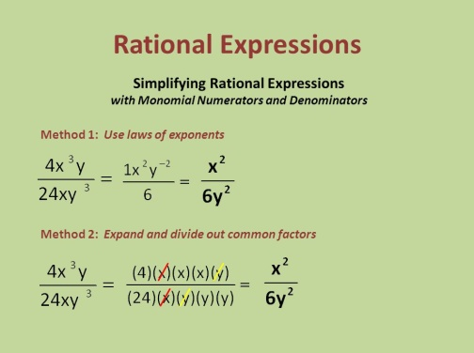source; slideplayer.comFig: Simplification of Rational Expression

As we know that 1, 2, 12

,−45, etc are the rational numbers. Similarly,*x*2,*x*2*y*2,*x*+3*x*−8

, etc. are called rational expressions. Here we shall discuss about addition, subtraction,multiplication and division of rational expressions.

**Multiplication of Rational Expressions**

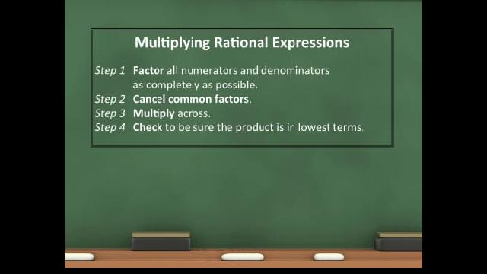source: ctle.hccs.edu  
Fig: Multiplication of Rational Expression

In multiplication, we simplify the numerical coefficients as in a case of multiplication of fraction. In the case of variables, we apply the product and quotient rules of indices. In a division, we should multiply the dividend by the reciprocal of a division. For example,

4*a*3*b*25*a*3*y*3

×10*x*4*y*312*a*4*b*

2*x*4−3×*y*3−23*a*4−3×*b*3−2

2*xy*3*ab*

ans.

**Addition and Subtraction of Rational Expression with the different denominators**

In this case, we should find the LCM of the denominators. Then the LCM is divided by each denominator and the quotient is multiplied by the corresponding numerator as in a case of simplification of unlike fraction. For example,

*x*2

+*x*6

3*x*+*x*6

=4*x*6 =2*x*3 ans.

Things to remember

* In a division, we should multiply the dividend by the reciprocal of a division.
* LCM is divided by each denominator and the quotient is multiplied by the corresponding numerator as in a case of simplification of unlike fraction.

### Questions and Answers

#### Click on the questions below to reveal the answers

**Multiply: 4*a*3*b*25*x*3*y*2**

#### × 10x4y312a4b3

Solution:

4*a*3*b*25*x*3*y*2

 × 10*x*4*y*312*a*4*b*3

 = 4*a*3*b*2×10*x*4*y*35*x*3*y*2×12*a*4*b*3

 = 2*x*4−3×*y*3−23*a*4−3*b*3−2

 = 2*xy*3*ab*

#### Divide: 5x28ax3

#### ÷ 15a3y316a2x2

Solution:

 = 5*x*28*ax*3

 ÷ 15*a*3*y*316*a*2*x*2

 = 5*x*28*ax*3

× 15*a*3*y*316*a*2*x*2

 = 2*a*2*x*4*y*3*a*4*x*3*y*3

 = 2*x*4−33*a*4−2*y*3−1

 = 2*x*3*a*2*y*2

#### Simplify: 6y24x2

#### × 2x33y3

#### ÷ 5xy6ab

Solution:

6*y*24*x*2

 × 2*x*33*y*3 ÷ 5*xy*6*ab*

6*y*24*x*2

 × 2*x*33*y*3 × 6*ab*5*xy*

6*abx*3*y*25*x*3*y*4

6*ab*5*y*4−2

6*ab*5*y*2

**Simplify   
(frac{3x + y}{4a}) + (frac{3x - y}{4a})**

(frac{2a}{3x})  
(frac{3x}{2a})  
(frac{4x}{a})  
(frac{x}{a})

**Simplify  
(frac{x}{2}) + (frac{x }{6})**

(frac{2x}{3})  
(frac{3x}{2})  
(frac{x}{2})  
(frac{3x}{3})

**Divide:  
(frac{5x^2y}{8ax^3}) ÷ (frac{15a^3y^3}{16a^2x^2})**

(frac{4x^2}{4a^2y})  
(frac{3x}{4ay^3})  
(frac{2x}{3a^2y^2})  
(frac{3x}{2ay})

**Simplify:  
(frac{a^2}{a + b}) - (frac{b^2}{a + b})**

b - a  
a + b  
b + a  
a - b

**Simplify:  
(frac{a^3}{x^3y^2}) × (frac{c^3x}{ab^2}) ÷ (frac{a^2c^2}{b^2xyz})**

xy (x - y)2  
2x2y (x2- y2)  
4xy (9x2 - 4y2)  
3xy(x + y)