**Integers**

#### Review on Integers

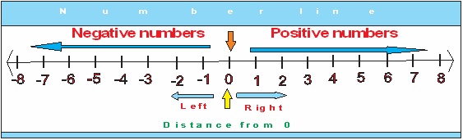source: www.ipracticemath.com  
Fig: Integers

An integer is a whole number (not a fractional number) that can be positive, negative, or zero.  
The set of integers is denoted by the letter 'Z'.  
Z = {. . . . . . . . . . -3, -2, -1, 0, 1 , 2, 3 . . . . . . . . .} is the set of integers. i.e. both +ve and -ve.  
Z+ = {+1, +2, +3, +4, +5, +6 . . . . . . . . .} is the set of +ve integers.  
Z-= {-1, -2, -3, -4, -5, -6 . . . . . . . . . } is the set of -ve integers.

In the above number line, the negative integers left to the zero are increasing.  
i.e. -3< -2< -1< 0< 1< 2< 3< 4 and so on.

#### Absolute Value of Integers

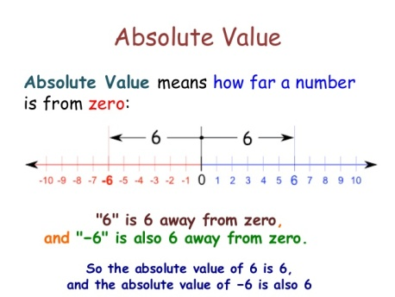source: www.slideshare.net  
Fig: Absolute Value of Integers

The absolute value of an integer is the numerical value without power to whether the sign is negative or positive. For example:  
let A and B be two places in which A is -5 km left from zero and B is +5 km right from zero. Then, what can be the distance between A and B.  
In simple sense,  
Distance of A + Distance of B,  
= -3 + 3  
= 0, which is impossible.  
But by using absolute value, we can write as:  
Distance of (A + B) = |-3| + |3|  
= 3 + 3  
= 6 km.  
In such case, the numerical value of either 3 or -3 will be same i.e. 3.

#### Operation on Integers

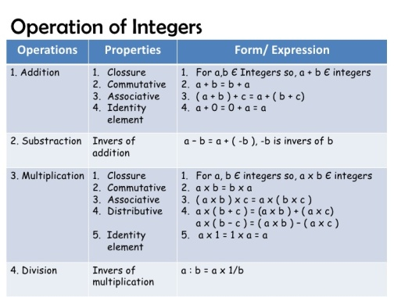source: www.slideshare.net  
Fig: Operation on Integers

The fundamental operations of integers on number lines are:addition

* addition
* subtraction
* multiplication
* division

Things to remember

* An integer is a whole number (not a fractional number) that can be positive, negative, or zero.
* The absolute value of an integer is the numerical value without power to whether the sign is negative or positive.
* The set of integers is denoted by the letter 'Z'.

### . Questions and Answers

#### Click on the questions below to reveal the answers

**Add and Subtract: (+4) + (+5) and (+9) - (+4)**

Solution:

In addition, Here, (+4) + (+5)

 = +(4+5) = +9 ans.

Again, In subtraction, Here, (+9) - (+4)

 = + (5-4) = +5 ans.

**Define Integers. Add: (+5) + (-2).**

Answer: The set of all the numbers both positive and negative including zero is called the set of integers.

Solution:

Here, (+5) + (-2)

 = +(5-2) = +3

**Add and Subtract: (+3) + (-7) and (+5) - (-3) respectively.**

Solution:

In Addition, Here, (+3) + (-7)

 = (-7) + (+3)

 = -(7-3) = -4 ans.

Again, Here, (+5) - (-3)

 = (+5) + (+3)

 = +(5+3) = +8 ans.

**Mention the rules of multiplication of integers. Multiply: (+3) × (+2)**

The rules of multiplication of integers are:

* The product of a positive integer and a negative integer is a negative integer.
* The product of two negative integers or two positive integers is a positive integer.

Solution:

Here, (+3) × (+2)

 = +6 ans.

**Mention the rules of dividing the integers. Divide: (+8) ÷ (+2)**

The rules of dividing the integers are:

* When you divide two integers with the same sign, the result is always positive.
* When you divide two integers with different signs, the result is always negative.

Solution:

Here,  (+8) ÷ (+2)

 = (+4)

Quiz

**Write the integers that lie 3 units right and 3 units left to -2.**

1, -5  
4, -5  
3, -5  
2, -5

**write the integers that lie 5 units right and 5 unit left to -5.**

1, -10  
3, -10  
0, -10  
2 -10

**Write the integers that lie 8 units right and 8 units left to +2.**

9, -6  
12, -6  
11, -6  
10, -6

**Write the integers that lie 10 units right and 10 units left to +5.**

15, -5  
15, -2  
15, -3  
15, --4

**What are the opposite integers of -2.**

+5  
+4  
+3  
+2

**What are the opposite integers of +5.**

-4  
-3  
-5  
-2

**What is the sum of (-8) and  its additive inverse of (+3)?**

-14  
-12  
-11  
-13

**What is the sum of (+6) and its additive inverse?**

1  
3  
2

**Subtract (-7) from the additive inverse of (-2).**

+6  
+9  
+3  
+1

**Find the sum of (+5) and the additive inverse of (-12).**

+17  
+12  
+9  
+15

## Sign Rules and Properties of Integers

#### Rules of Addition and Subtraction of Integers

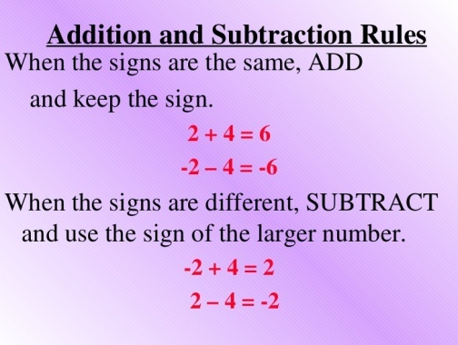source: www.slideshare.net  
Fig: Addition and Subtraction of Integers

1. The positive integers are always added holding the positive (+) sign in resulting value. For example,  
   (+5) + (+6) = 11 or (+11)
2. The negative integers are always added holding the negative (-) sign in the resulting value. For example,  
   (-5) + (-6) = -11
3. The positive and negative integers are always added holding the negative (-) sign in the resulting value. For example,  
   (+6) + (-5) = 1 or (+1)  
   (-6) + (+5) = -1

#### Properties of addition of Integers

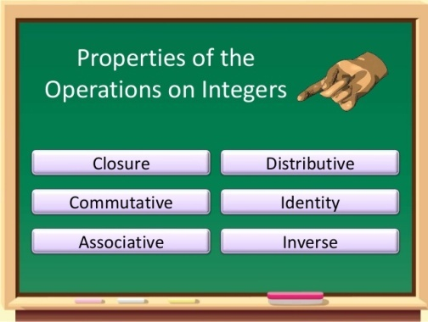source: www.slideshare.net  
Fig: Properties of Additional of Integers

1. **Closure property**  
   Closure property states that the sum of any two integers is also integers. For example,  
   (+2) + (+3) = +5, which is an integer  
   (+3) + (-2) = +1, which is an integer  
   (-3) + (+2) = -1, which is an integer  
   Thus, if x and y be any two integers and z is the set of integers then x + y∈ z.
2. **Commutative property**  
   Commutative property states that thesum of any two integers remains unchanged if their places are interchanged. If x and y are two integers, then x + y = y + z  
   For example,  
   (+2) + (+3) = (+3) + (+2) = +5  
   (-3) + (+2) = (+2) + (-3) = -1
3. **Associative property**  
   Associative property states that the sum of any three integers remains unchanged if the order in which they are grouped is altered. If x, y and z are three integers, then (x + y) + z = x + (y + z)  
   For example,  
   (+3) + (+4) + (+5) = (+3) + [(+4) + (+5)] = (+3) + (+9) = +12  
   (+3) + (-4) + (+5) = (+3) + [(-4) + (+5)] = (+3) + (+1) = +4
4. **Additive property of zero (0)**  
   If zero (0) is added +0 any integers, the sum is equal to the integer itself. So, zero (0) is known as the identity element of addition. If a is any integer, then a + 0 = a  
   For example,  
   (+2) + 0 = (+2) or 2  
   (-3) + 0 = (-3)
5. **Additive inverse**  
   Each integer is said to the additive inverse of the other if the sum of any two integer is zero (0). If a is any integer, then (+a) + (-a) = 0, where (+a) is the additive inverse of (-a) and (-a) is te additive inverse of (+a).

Things to remember

* The positive integers are always added holding the positive (+) sign in resulting value.
* Commutative property states that the sum of any two integers remains unchanged if their places are interchanged.

### Questions and Answers

#### Click on the questions below to reveal the answers

**What are the signs rules for the addition and subtraction of integer? Mention.**

The sign rules for the addition and subtraction of integers are:

* The positive integers are always added.
* The negative integers are always added.
* The positive and negative integers are always subtracted.

**Add: (+2) + (+5)**

Solution:

Here, (+2) + (+5)

 = +7 or 7 ans.

**Add: (+4) + (-1) and (+4) + (-7)**

Solution

Here, (+4) + (-1)

 = +3 or 3

Similarly, (+4) + (-7)

 = -7 (The difference holds the sign of the bigger integer.)

**Simplify :  
2 × 5 -7 + 12**

14  
12  
15  
13

**What will be the answer of 5 times the sum of 6 and 2.**

46  
44  
42  
40

**What will be the answer of 10 is subtracted from 3 times the sum of 8 and 12.**

22  
24  
20  
26

**If (+2) × x = (-6), find the value of x.**

-3  
-2  
-6  
-4

**What will be the answer of 6 times the difference of 12 and 4 is divided by the product of 8 and 3.**

4  
2  
6  
8

**The total cost 5 pens at Rs 12 each and 3 boxes at Rs 18 each, find the correct answer.**

Rs 110  
Rs 112  
Rs 114  
Rs 108

**What will be the answer of 3 times the sum of 7 and 8 is divided by 9.**

4  
5  
7  
6

**Simplify:  
20 ÷ 2 (18 - 32 ÷ 4)**

1  
7  
5  
3

**Make the mathematical expression and simplify, 4 times the difference of 9 and 3 is divided by 8.**

4  
5  
6  
3

**Simplify:**

**18 - {23 - 3 (3 - 5)}**

-13  
-11  
-14  
-12