**Hindu Arabic Numeration System**

### Hindu-Arabic Number

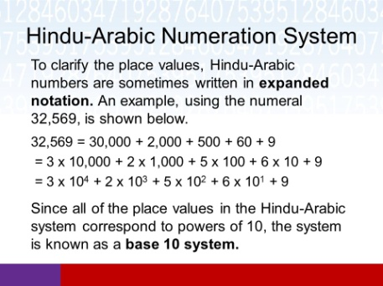source: slideplayer.com  
Fig: Hindu-Arabic Number

It is the number system in which ten digits (i.e. 0, 1, 2, 3, 4, 5, 6, 7, 8 ,9 ) are used. Any whole number can be written using a combination of these ten digits. As it is based on the grouping of tens, it is also known as Decimal Number System or the Base Ten System. The value of each digit in a number depends on its place in the number. For example:  
6 9 8 2

Thus, we can obtain the place value of any digit in a number by multiplying the digit by its place. So,the above number can also be expressed in expanded form as:  
6982 = 6× 1000 + 9× 100 + 8× 10 + 2× 1  
= 6× 103 + 9× 102 + 8× 101 + 2× 100 [∵

100 = 1]

#### Periods and places in Nepali and in International System

**Nepali System**The table below shows the periods and places of number in Nepali system:

|  |  |  |  |  |  |  |  |  |  |  |  |  |  |
| --- | --- | --- | --- | --- | --- | --- | --- | --- | --- | --- | --- | --- | --- |
| Periods | Kharabs | | Arabs | | Crores | | Lakhs | | Thousands | | Units | | |
| Places | Ten Kharabs | Kharabs | Ten Arabs | Arabs | Ten Crores | Crores | Ten Lakhs | Lakhs | Ten Thousand | Thousand | Hundred | Tens | Once |
| Power of 10 | 1012 | 1011 | 1010 | 109 | 108 | 107 | 106 | 105 | 104 | 103 | 102 | 101 | 100 |
| Number |  | 6 | 9 | 2 | 4 | 3 | 1 | 7 | 2 | 8 | 0 | 1 | 6 |

From the above table, the number name of 692431728016 is:  
Six kharab ninety-two arab forty-three crores seventeen lakh twenty-eight thousand sixteen.

**International System**

|  |  |  |  |  |  |  |  |  |  |  |  |  |
| --- | --- | --- | --- | --- | --- | --- | --- | --- | --- | --- | --- | --- |
| Periods | Bllions | | | Millions | | | Thousands | | | Units | | |
| Places | Hundred Billions | Ten Billions | Billions | Hundred Millions | Ten Millions | Millions | Hundred Thousands | Ten Thousand | Thousands | Hundreds | Tens | Once |
| Power  of 10 | 1011 | 1010 | 109 | 108 | 107 | 106 | 105 | 104 | 103 | 102 | 101 | 100 |
| Number | 6 | 9 | 2 | 4 | 3 | 1 | 7 | 2 | 8 | 0 | 1 | 6 |

In International system, the number name of 692431728016:  
Six hundred ninety-two billion four hundred thirty-one million seven hundred twenty-eight thousand sixteen.

#### Use of Commas

1. **Use of commas in Nepali system**  
   At first, units period is separated, then the numbers of places of thousand, lakhs, crores etc are separated. For examples, 692431728016 is written as Six kharab ninety-two arab forty-three crores seventeen lakh twenty-eight thousand sixteen.
2. **Use of commas International system**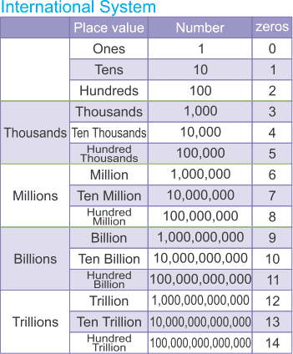source: www.flexiprep.com  
   Fig: International Commas System At first, units period is separated, then the numbers of places of thousands, millions and billions are separated. For example,692431728016 is written as Six hundred ninety-two billion four hundred thirty-one million seven hundred twenty-eight thousand sixteen.

Things to remember

It is the number system in which ten digits (i.e. 0, 1, 2, 3, 4, 5, 6, 7, 8 ,9 ) are used. Any whole number can be written using a combination of these ten digits. As it is based on the grouping of tens, it is also known as Decimal Number System or the Base Ten System.

### Questions and Answers

#### Click on the questions below to reveal the answers

**[Re-write the numerals using commas according to Nepali as well as an International system. Then write the number name in the both systems.  
485913082](file:///D:\\Project%20materail\\test.html" \l "collapse31132)**

Solution:

In Nepali System,  
48,59,13,082 = Forty-eight crores fifty-nine lakhs thirteen thousands and eighty-two.

In International System,  
485,913,082 = Four hundred eighty-five million nine hundred thirteen thousand and eighty-two.

**The distance between the sun and the earth is about fifteen crore twenty lakh kilometer. Write this distance in numeral using commas according to Nepali and International systems. Re-write the number name in International system.**

Solution:

In Nepali system,  
fifteen crores twenty lakh kilometer = 15,20,00,000

In International system,  
fifteen crore twenty lakh kilometer = 152, 000, 000  
One hundred fifty two million.

**Re-write 7236095841numerals using commas according to Nepali as well as an International system. Then write the num,ber name in the both system.**

Solution:

In Nepali system,  
7,23,60,95,841 = Seven arab twenty-three crore sixty lakh ninety-five thousand eight hundred and forty-one.

In International system,  
7,236,095,841 = Seven billion two hundred thirty-six million ninety-five thousand eight hundred and forty-one.

**Re-write 905730218645 numerals using commas according to Nepali as well as an International system. Then write the num,ber name in the both system.**

Solution:

In Nepali system,  
9,05,73,02,18,645 = Nine kharab five arab seventy-three crore two lakh eighteen thousand six hundred and forty five.

In International system,  
905,730,218,645 = Nine hundred five billion seven hundred thirty million two hundred eighteen thousand six hundred and forty-five.

**The value of each digit in a number depends on its ______.**

number  
digit  
size  
place

**21,37,44,574 in which place does the number 3 lies in Nepali system of commas.**

crore  
lakhs  
Ten lakhs  
ten crore

**3,468,172,532 which commas system is this?**

Asian  
European  
International   
Nepali

**87,53,49,783 which commas system is this?**

Asian  
Erupean  
International  
Nepali

## Binary Number System

#### Binary number system

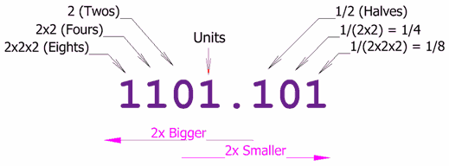source: www.mathsisfun.com  
Fig: Binary Number System

Binary number system consists of two digits 0 and 1 and its base is 2. Each digit or bit in binary number system can be 0 or 1. Digital computer represents all kinds of data and information in the binary system.

#### Conversion of binary numbers to decimal number

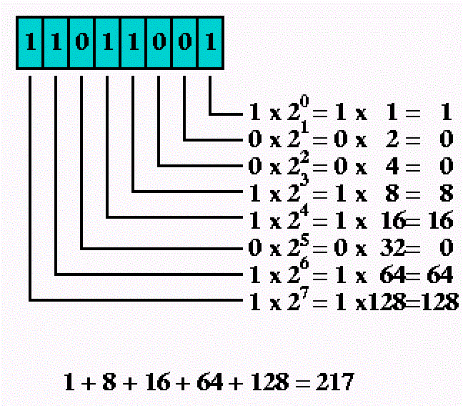source: javarevisited.blogspot.com Fig: Binary Number into Decimal Number

1100112 = 1× 25 + 1× 24 + 0× 23 + 0× 22 + 1× 21 + 1× 20In order to convert a binary number into a decimal, it is expanded in the power of 2. Then by simplifyingthe expanded form of the binary number, we obtain a decimal number. For example,  
10112 = 1× 23 + 0× 22 + 1× 21 + 1× 20  
= 8 + 0 + 2 + 1  
∴ 10112 = 11

= 32 + 16 + 0 + 0 + 2 + 1  
∴ 1100112 = 51

#### Conversion of decimal number to binary number

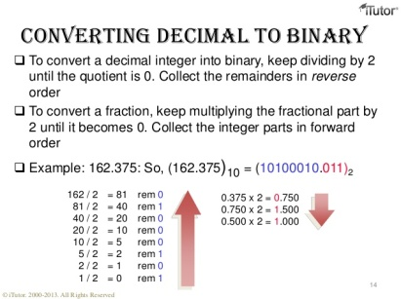source: www.slideshare.net  
Fig: Decimal Number into Binary Number

We can convert decimal number into a binary number by using the place value table of the binary system. For example:  
Convert 30 into binary system

|  |  |  |  |  |  |
| --- | --- | --- | --- | --- | --- |
| 25 | 24 | 23 | 22 | 21 | 20 |
| 32 | 16 | 8 | 4 | 2 | 1 |
|  | 1 | 1 | 1 | 1 | 0 |

From the table:  
or, 30 = 1× 16 + 1× 8 + 1× 4 + 1× 2 + 1× 1  
or, 30 = 1× 24 + 1× 23 + 1× 22 + 1× 21 + 1× 20  
∴ 30 = 111102

**Alternative method**We must divide the given number successively by 2 in order to convert decimal number into binary number. The remainder obtained in each successive division is listed in a separate column. For example:

Things to remember

1. Binary number system consists of two digits 0 and 1 and its base is2.
2. Each digit or bit in binary number system can be 0 or 1.
3. Digital computer represents all kinds of data and information in the binary system.

### Questions and Answers

#### Click on the questions below to reveal the answers

**[Convert binary numbers into decimal numbers.  
1110](file:///D:\\Project%20materail\\test.html" \l "collapse31145)2**

Solution:

11102= 1 × 23+ 1 × 22 + 1 × 21 + 0 × 20  
= 1 × 8 + 1 × 4 + 1 × 2 + 0  
= 8 + 4 + 2   
= 14   
∴ 11102= 14

**[Convert binary numbers into decimal numbers.  
101101](file:///D:\\Project%20materail\\test.html" \l "collapse31146)2**

Solution:

1011012= 1 × 25 + 0 × 24 + 1 × 23 + 1 × 22 + 0 × 21 + 1 × 22   
= 1 × 32 + 0 + 1 × 8 + 1 × 4 + 0 + 1 × 1   
= 32 + 8 + 4 + 1  
= 45  
∴ 1011012= 45

**[Convert decimal numbers into binary numbers.  
25](file:///D:\\Project%20materail\\test.html" \l "collapse31147)**

Solution:

|  |  |  |  |  |  |
| --- | --- | --- | --- | --- | --- |
| 25 | 24 | 23 | 22 | 21 | 20 |
| 32 | 16 | 8 | 4 | 2 | 1 |
|  | 1 | 1 | 0 | 0 | 1 |

25 = 1 × 16 + 1 × 8 + 0 × 4 + 0 × 2 + 1 × 1  
= 1 × 24 + 1 × 23 + 0 × 22 + 0 × 21 + 1 × 20  
= 11001  
∴ 25 = 110012

**______ system consists of two digits 0 and 1 and its base is 2.**

Octal number  
Quinary number  
Decimal number  
Binary number

**We must divide the given number successively by ______  in order to convert decimal number into binary number.**

4  
6  
2  
8

**In order to convert a binary number into a decimal, it is expanded in the power of ______.**

2  
3  
4  
5

**Each digit or bit in binary number system can be _____.**

1 or 2  
0 or 1  
1 only  
0 only

## Quinary Number System

#### Quinary Number System

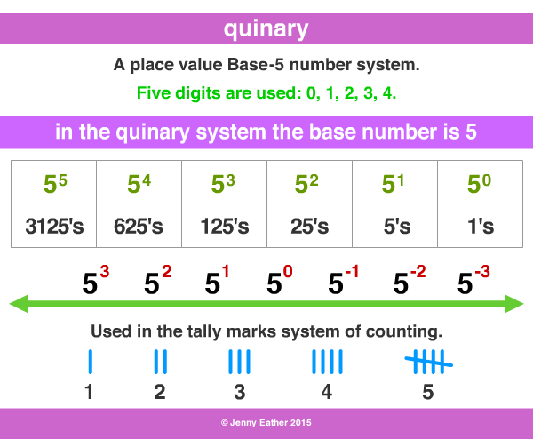source: www.amathsdictionaryforkids.comFig: Quinary Number System

Quinary number system consists of five digits 0 to 4 and its base is 5. It is also known as the base five system. The number of quinary number system can be expressed in the power of 5.

#### Conversion of quinary number into decimal number

The number is expressed in the power of 5 in order to convert a quinary into decimal number. Then, by simplifying the expanded form of the quinary number, we get a decimal number. For example:  
16 = 1× 51 + 6× 50  
= 1× 5 + 6× 1  
= 5 + 6  
= 11

#### Conversion of decimal number into quinary number

We can convert a decimal number into quinary number by using the place value table of the quinary system. For example:  
Convert 15 into quinary system

|  |  |  |  |  |
| --- | --- | --- | --- | --- |
| 54 | 53 | 52 | 51 | 50 |
| 625 | 125 | 25 | 5 | 1 |
|  | 1× 53 | 1× 52 | 0 × 51 | 3× 50 |
|  | 1 | 1 | 0 | 3 |

Here,  
153 = 1× 125 + 1× 25 + 0× 5 + 3× 1  
= 1× 53 + 1× 52 + 0× 51 + 3× 50  
∴ = 11035

**Alternative method**We should dividethe given number successively by 5 until the quotient is zero in order to convert decimal number int quinary number. The remainders of each successive division are then arranged in reverse order to get required quinary number. For example:

|  |  |  |
| --- | --- | --- |
| Divisor | Dividend | Remainders |
| 5 | 134 | 4 |
| 5 | 26 | 1 |
| 5 | 5 | 0 |
| 5 | 1 | 1 |
| 5 | 0 |  |
|  |  |  |

Now, arranging the remainders in reverse order: 10145

∴

135 = 10145

Things to remember

* Quinary system is also known as the base five system.
* The number of quinary number system can be expressed in the power of 5.
* By simplifying the expanded form of the quinary number, we get a decimal number.

### Questions and Answers

#### Click on the questions below to reveal the answers

**[Convert the quinary numbers into decimal numbers.  
32](file:///D:\\Project%20materail\\test.html" \l "collapse31142)5**

Solution:

325 = 3 × 51 + 2 × 50   
325= 3 × 5 + 2 × 1  
325= 15 + 2   
325= 17

**[Convert quinary numbers into decimal numbers.  
1324](file:///D:\\Project%20materail\\test.html" \l "collapse31143)5**

Solution:

13245= 1 × 53 + 3 × 52 + 2 × 51 + 4 × 50  
13245= 1 × 125 + 3 × 25 + 2 × 5 + 4 × 1  
13245= 125 + 75 + 10 + 4  
13245= 214

**[Convert decimal numbers into quinary numbers.  
134](file:///D:\\Project%20materail\\test.html" \l "collapse31144)**

Solution:

|  |  |  |  |  |
| --- | --- | --- | --- | --- |
| 54 | 53 | 52 | 51 | 50 |
| 625 | 125 | 25 | 5 | 1 |
|  | 1 × 53 | 0 × 52 | 0 × 51 | 0 × 50 |
|  | 1 | 0 | 1 | 4 |

Here,  
134 = 1 × 125 + 0 × 25 + 1 × 5 + 4 × 1  
134 = 1 × 53 + 0 × 52+ 1 × 51 + 4 × 50  
134 = 1014  
∴ 134 = 10145

Quiz

**Convert 12, decimal number into binary number.**

11012  
10012  
11002  
10102

**Quinary number system consists of five digits 0 to 4 and its base is ______.**

5  
3  
2  
4

**The quinary number system is also known as _______.**

the base of six system  
the best of seven system   
the base of five system  
the base of two sytem

**Convert 18 decimal number into quinary number.**

224  
446  
113  
335

**Convert 7 decimal number into the quinary system.**

145  
135  
155  
125

**The quinary number is express in power ______, when converted into decimal number system.**

7  
3  
9  
5

## HCF and LCM

#### Highest Common Factor ( H.C.F)

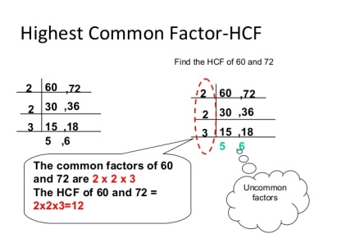source: www.slideshare.net  
Fig: Highest Common Factor (H.C.F)

The largest positive integer which divides two or more integers without any remainder is called Highest Common Factor (HCF). It is the possible factor of respective numbers.

**To find H.C.F by Factorization method**At first, we should find the prime factors of the given number, then the product of the common prime factors is the H.C.F of the given numbers. For example:  
Find the H.C.F of 30 and 42  
Solution,

Here,  
30 = 2× 3× 5× 1  
42 = 2× 3× 7× 1  
∴ H.C.F = 2× 3× 1  
= 6

**To the H.C.F by division method**  
In this method, we divide the larger number by the smaller one and again the first remainder. So obtained divides the first divisor. The process is continued till the remainder becomes zero. The last divisor for which the remainder becomes zero and it is the H.C.F of the given numbers. For example:  
Find the H.C.F of 30 and 42

#### Lower Common Multiple (L.C.M)

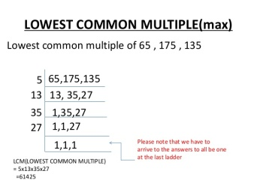source: www.slideshare.net  
Fig: Lowe Common Multiple

The lower common multiple is the lowest factor of respective numbers.

**To find L.C.M by Factorisation method**  
At first, the prime factor of the given number are to be found out, then the product of the common prime factors and the remaining prime factors(which are not common) is the L.C.M of the given numbers. For example:  
Find the L.C.M of 30 and 42

Here,  
30 = 2× 3× 5  
42 = 2× 3× 7  
L.C.M = 2× 3× 5× 7  
= 210

**Division method**  
In this method, the given numbers are arranged in a row and they are successively divided by the least common factors till the quotient are 1 or prime numbers. Then, the product of these prime factors is the L.C.M of the given number. For example:

∴ L.C.M = 2× 3× 5× 5× 7  
= 1050

Things to remember

1. The largest positive integer which divides two or more integers without any remainder is called Highest Common Factor (HCF).  It is the possible factor of respective numbers.
2. The lower common multiple is the lowest factor of respective numbers.

### Questions and Answers

#### Click on the questions below to reveal the answers

**Write the sets of all possible factors of 16, 24 and 32. Then make a set of their common factors and find their H.C.F.**

Solution:

Here,  
F(16) = {1, 2, 4, 8, 16}  
F(24) = {1, 2, 3, 4, 6, 8, 12, 24}  
F(32)= {1, 2, 4, 8, 16, 32}  
Now,  
F(16) ∩ F(24) ∩  F(32) = {1, 2, 4, 8}  
∴ H.C.F. of 16, 24 and 32 is 8.

**Find the H.C.F. of 28, 42 and 70 by prime factorization method.**

Solution:

Here,  
28 ÷ 2 = 14 (remainder is 0)  
14 ÷ 2 = 7 (remainder is 0)  
Now,  
28 = 2 × 2 × 7  
42 = 2 × 3 × 7  
70 = 2 × 5 × 7  
∴ H.C.F = 2 ×  7 = 14

**Find the H.C.F. of 28, 42 and 70 by prime factorization method.**

Solution:

Here,  
28 ÷ 2 = 14 (remainder is 0)  
14 ÷ 2 = 7 (remainder is 0)

42 ÷  2 = 21 (remainder is 0)  
21 ÷  3 = 7 (remainder is 0)

70 ÷  2 = 35 (remainder is 0)  
35 ÷  5 = 7 (remaindder is 0)  
Now,  
28 = 2 × 2 × 7  
42 = 2 × 3 × 7  
70 = 2 × 5 × 7  
∴ H.C.F = 2 ×  7 = 14

**Find the L.C.M. of 24 and 36.**

Solution:

Here,  
24 ÷ 2 = 12 (remainder is 0)   
12 ÷ 2 = 6 (remainder is 0)  
6 ÷ 2 = 3 (remainder is 0)

36 ÷ 2 = 18 (remiander is 0)  
18 ÷ 2 = 9 (remainder is 0)  
9 ÷ 3 = 3 (remainder is 0)

Now,  
24 = 2 × 2 × 2 × 3  
36 = 2 × 2 × 3 × 3  
∴ L.C.M. = 2 × 2 × 3 × 2 × 3 = 72

**Write the sets of a few multiples of 4, 6 and 8. Make a set of their common multiples and find their L.C.M.**

Solution:

Here,  
M(4)= {4, 8, 12, 16, 20, 24, 28, 32, 36, 20, 44, 48, . . . . . . . }  
M(6) = {6, 12, 18, 24, 30, 36, 42, 48, 54, 60, . . . . . . . . }  
M(8)= {8, 16, 24, 32, 40, 48, 56, 64, 72, 880, . . . . . . }  
Now,  
M(4)∩ M(6) ∩ M(8)= (24, 48, . . . . . . . }  
∴ L.C.M. of 4, 6, 8 is 24.

**Find the L.C.M of 24, 36 and 48 by prime factorisation method.**

Solution:

24 ÷ 2 = 12 (remainder is 0)   
12 ÷ 2 = 6 (remainder is 0)   
6 ÷ 2 = 3 (remainder is 0)

36 ÷ 2 = 18 (remainder is 0)  
18 ÷ 2 = 9 (remainder is 0)  
9 ÷ 3 = 3 (renmainder is 0)

48 ÷ 2 = 24 (remiander is 0)   
24 ÷ 2 = 12 (remainder is 0)   
12 ÷ 2 = 6 (remainder is 0)  
6 ÷ 2 = 3 (remiander is 0)

Now,  
24 = 2 × 2 × 2 × 3  
36 = 2 × 2 × 3 × 3  
48 = 2 × 2 × 2 ×  2 × 3  
∴ L.C.M. = 2 × 2 × 2 × 3 × 3 × 2 = 144

**The largest positive integer which divides two or more integers without any remainder is called ______.**

lowest common factor  
integers  
whole number  
highest common factor

**The lowest factors of a respective number is known as ______.**

highest common factor  
lowest common multiple  
lowest common factor  
integers

**The H.C.F. of  20 and 100 is ______.**

5  
100  
10  
20

**The H.C.F. of 12 and 60 is ______.**

60  
3  
12  
4

**Find the least number which is exactly divisible by 32, 48 and 64.**

134  
143  
153  
192

**Find the L.C.M. of 18, 27.**

54  
28  
34  
12

**Find the H.C.F. of 60, 90 and 120.**

30  
60   
90  
120

**Find the greatest number that divides 60 and 84 without leaving a remainder.**

12  
6  
24  
18

**Find the L.C.M. of 5, 50, 75 and 100.**

100  
300  
50  
75

**Find the 30, 40, 60, and 80.**

260  
220  
280  
240

## Root and Sequence Number

#### Square and Square Root

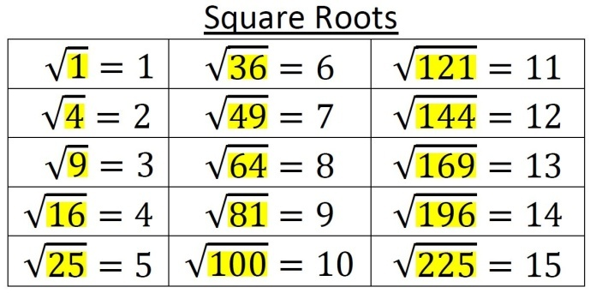source: aharri5on.com  
Fig: Square and Square root

**Perfect Square Number**  
A perfect square number is the product of two integers among the whole number. It is the perfect root of a particular number. For example:  
1× 1 = 12(1 squared) = 1 (1 is a perfect square number)  
2× 2 = 22(2 squared) = 4 (4 is a perfect square number)  
3× 3 = 32 (3 squared) = 9 (9 is a perfect square number)  
Thus, a perfect square number is the product of two identical number 1, 4, 9, 16, 25, 36, 49, 64, 81, 100 . . . . . . . . . . . and so on.

**Square Root**

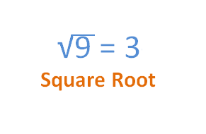source: calculator.swiftutors.com  
Fig: Square Root

A number that creates a specified number when it is multiplied by itself is said to be a square root. It is the product of two equal number. The radical symbol (√

) is used to denote square root of a number. For example:  
1–√ = 1  
4–√ = 2  
9–√ = 3  
64−−√

= 8

**Note:**1 is the square number of 1, so 1 is called the square root of 1.  
9 is the square number of 3, so 3 is called the square root of 9.  
49 is the square number of 7, so 7 is called the square root of 49.

**Factorization Method**

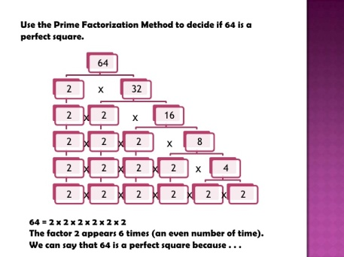source: www.slideshare.net  
Fig: Factorization Method

In order to find out the square roots of a perfect square number, factorization method is used. For example:  
Find the square root of 64 using factorization method.

So,  
64 = 2× 2× 2× 2× 2× 2  
= 22×22×22  
∴ 64−−√

= 2× 2× 2 = 8

**Division Method**

In order to find out the square roots of decimals and larger numbers, division method is used. For example:  
Find the square root of 2704 using division method.

1. Starting from the unit place, pair up the numbers and use a bar mark for ease.
2. Take the first pair (i.e. 27) and think of the largest perfect square which is less or equal to 27 which is 25.
3. The square root of 25 is 5.
4. So, write 5 as both divisor and quotient. Multiply 5×5 and write just below 27, then subtract 25 from 27. You will get the remainder 2.
5. In divisor side add 5 + 5 = 10, which is the trial divisor.
6. Then, bring down the other pair i.e. 04. And the new dividend is 204.
7. 20 is two times divisible by 10, so write 2 in both quotient and divisor.
8. Here, the product of 102× 2 is 204. Write the result just below the dividend and subtract the result from the dividend. We get the remainder 0. Thus, 52 is the square root of 2704.

#### Cube and Cube Root

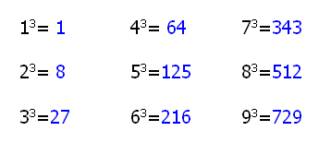source: www.futilitycloset.com  
Fig: Cube and Cube Root

There is one unit cube so 1 is a cubic number.

There are 8 unit cubes. So, 8 is a cubic number.

There are 27 unit cubes, so 27 is a cubic number.

13 = 1× 1× 1 = 1 (1 is the cube of 1 & 1 is the cube root of 1)  
23 = 2× 2× 2 = 8 (8 is the cube of 2 & 2 is the cube root of 8)  
53 = 5× 5× 5 = 125(125 is the cube of 5 & 5 is the cube root of 125)  
73 = 7 × 7 × 7 = 343 (343 is the cube of 7& 7is the cube root of 343)

**Cube Number:**Cubic number is the product of three iderntical number.  
**Cube root of a cubic number:**Cube root of a cubic number is one of the identical numbers.It is denoted by the symbol √3

. For example:  
or, 1–√3 = 1  
or,27−−√3 = 3  
or,729−−−√3

= 9 etc.

#### Sequence of Number

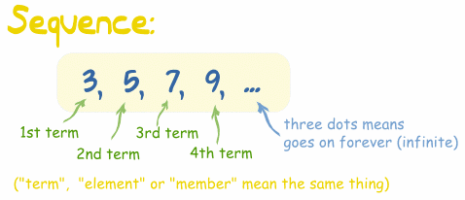source: www.mathsisfun.comFig: Sequence of Number

The list of number or object in a specific order is said to be a sequence. For example:

1. 1, 2, 3, 4, 5, 6, . . . . . . . . .  
   In this group of numbers, the common difference between each consecutive pair is 1. So, the numbers are in a fixed pattern.
2. 4, 8, 12, 16, 20, 24, . . . . . . . .  
   In this group of numbers, the second number of each consecutive pair is double to first one. Here, the number one in fixed pattern.

#### Rules for Sequence

**Rule 1:**Lets supopose a sequence 2, 4, 6, 8, 10, 12, . . . . . .  
Here, the common difference between each consecutive pair is 2. Consider 'n' as the number of terms of the sequence.  
Then, the common difference is 2 and & the first term of the rule be 2n+ . . . . . . . . . . or 2n- . . . . . . . . . .  
To get the first term 2,  
n = 1  
2n± . . . . . . .  
= 2× 2 + 0 = 4  
Similarly,  
To get the second term 4,  
n = 1  
2n± . . . . . . .  
= 2× 2 + 0 = 2  
Here,  
To get the nth term o0f the sequence, the rule must be 2n. In this way, we can find out the nth term of any sequence.

**Rule 2:**  
Lets suppose the sequence 2, 5, 8, 11, 14, . . . . . . .  
Consider that a denotes the first term and d denotes the common difference of the sequence.

|  |  |  |  |
| --- | --- | --- | --- |
| d = 5 - 2 = 3 | d = 8 - 5 = 3 | d = 11 - 8 = 3 | d = 14 - 11 = 3 |
| 2 + 3 = 5 | 5 + 3 = 8 | 8 + 3 = 11 | 3 + 11 = 14 |

From the above illustration,  
The 1st term (t1) = a = 2  
The 2nd term (t2) = a + (2 - 1)d = a + d = a  
The 3rd term (t3) = a + (3 - 1)d = a + 2d  
The 4th term (t4) = a + (4 -1)d = a + 3d  
∴ nth term (tn) = a + (n - 1)d  
by using the nth term, we can find the 12th term of the sequence as :  
8th term (t8) = a + (8 - 1)d  
= a + 7d  
= 2 + 7× 3  
= 23

Things to remember

* A perfect square number is the product of two integers among the whole number.
* A number that creates a specified number when it is multiplied by itself is said to be a square root. It is the product of two equal number.
* The list of number or object in a specific order is said to be a sequence.

### Questions and Answers

#### Click on the questions below to reveal the answers

**Find the square root of 144 by prime factorization method.**

Solution:

144 ÷ 2 = 72 (remainder is 0)  
72 ÷ 2 = 36 (remainder is 0)   
36 ÷ 2 = 18 (remainder is 0)   
18 ÷ 2 = 9 (renainder is 0)   
9 ÷ 3 = 3 (remainder is 0)

Now,   
144 = 2 × 2 × 2 × 2 × 3 × 3  
144 = 22 × 22 × 32  
∴ 144−−−√

= 2 × 2 × 3   
= 12

**Find the square root of 576 by prime factorization method.**

Solution:

576 ÷ 2 = 288 (remainder is 0)  
288 ÷ 2 = 144 (remainder is 0)  
144 ÷ 2 = 72 (remainder is 0)   
72 ÷ 2 = 36 (remainder is 0)   
36 ÷ 2 = 18 (remainder is 0)  
18 ÷ 2 = 9 (remainder is 0)  
9 ÷ 3 = 3 (remainder is 0)

Now,  
576 = 2 × 2 × 2 × 2 × 2 × 2 × 3 × 3  
576 = 22 × 22 × 22 × 32  
∴ 576−−−√

= 2 × 2 × 2 × 3   
= 24

#### Simplify: 8–√

#### × 318−−√

#### × 248−−√

Solution:

= 8–√

 × 318−−√ × 248−−√  
= 4×2−−−−√ × 39×2−−−−√ × 216×3−−−−−√  
= 22–√ × 3 × 32–√ × 2 × 43–√  
= 1444–√   
= 1444×3−−−−√  
= 144 × 23–√  
= 2883–√

**Find the square root of 1.96.**

Solution:

1.96 = 196100

∴ 1.96−−−−√ = 196100−−−√  
= 2×2×7×7√2×2×5×5√  
= 22×72√22×52√  
= 2×72×5   
= 1410   
= 1.4

#### Simplify: 256625−−−√

Solution:

= 256625−−−√

= 2×2×2×2×2×2×2×25×5×5×5−−−−−−−−−−−−−√  
= 22×22×22×2252×52−−−−−−−−−√  
= 2×2×2×25×5  
= 1625

Quiz

### A number that creates a specified number when it is multiplied by itself is said to be ______.

cube root  
square root  
multiply number  
sequences number

### The radical symbol (") is used to denote ______.

multiply number  
cube root  
sequences number  
square root of a number

### (sqrt {64}) = ______

12  
6  
8  
4

**______ is the product of three identical number.**

square number  
Cubic number  
multiply number  
sequences number

### ______ is one of the identical numbers.

square root of a cubic number  
Cube root of a cubic number  
multiple number  
cube rroot of square number

### Cube root is denoted by the symbol ______.

(sqrt[6]{})  
(sqrt[2]{})  
(sqrt[3]{})  
(sqrt[9]{})

**Square root is denoted by the symbol ______.**

√  
(sqrt[3]{})  
W  
l

### The list of number or object in a specific order is said to be a ______.

multiple number  
square  
cube  
sequence