**Perimeter**

#### Perimeter of Plane Figure

All the Triangle , Circle , Square, and Rectangle are plan figure . The total length of the boundary lines of plan figure is called its perimeter.Perimeter of Triangles :

#### Perimeter of Triangles :

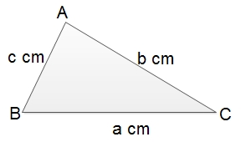

The sum of the length of its three sides is known as a perimeter of triangles . Therefore,

∴

Perimeter of △*DEF*

=DE + EF+ FD = a+b+c

The half of its perimeter is known as semi -perimeter of triangle . It is denoted by the letter '**s**'.

∴

Semi -perimeter of △DEF= *a*+*b*+*c*2

#### Perimeter of Rectangles :

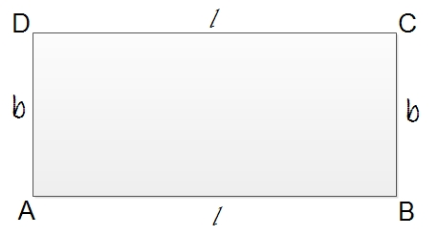

The opposite sides of rectangle are always equal . So , the lengths = EF=GH=l

the breadths =FH=EG=b

The perimeter of the rectangles EFGH =EF+FG+GH+HG

=l+b+l+b=2l+2b

=2(l+b)

∴

Perimeter of rectangle = 2(l+b)

In the case of Square , its perimeter =2(l+l)

=2x2l=4l

#### Perimeter of circles :

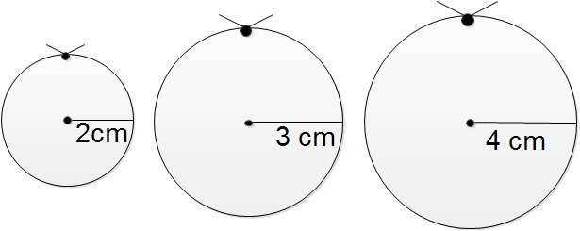

At first draw three circles with radii 2cm , 3cm, and 4cm, and place the pieces of strings along the circumference of each separately .

Then start measuring the length of each string separately with the help of scale . Then, find the ratios of the length of the circumference of each circle to its diameter . Now , you all will find the ratio *circumferencediameter*

is almost the same for every circle. The constant ratio is represented by Greek letter 'π' (pie). So , the circumference of circle is**c**and its diameter be**d,**

Now , \(\frac{circumfernce }{diameter})=π

or, \(\frac{c}{d})=π

or, c=πd

Diameter of circle (d) =2xradius (r).

So, circumference or the perimeter of circle (c) =2πr

The perimeter of circle =πd or2πr

Things to remember

* All the Triangle , Circle , Square, and Rectangle are plan figure . The total length of the boundary lines of plan figure is called its perimeter.
* The sum of the length of its three sides is known as a perimeter of triangles .
* The opposite sides of a rectangle are always equal .

### Questions and Answers

#### Click on the questions below to reveal the answers

**If the perimeter of a rectangular field of length 25m is 86m, find its breadth.**

Solution:

Here,  
the length of the field (l) = 25 m  
the perimeter of the field = 86 m  
Now,   
the perimeter of the rectangular field = 86 m  
or, 2(l + b) = 86 m  
or, 25 + b = 862

m  
or, 25 + b = 43 m  
or, b = (43 - 25) m  
or, b = 18 m  
∴ the required breadth of the field is 18 m

**The radius of a circular ground is 35m, find the length of wire required to fence it with 4 rounds. Also find the cost of fencing at Rs 10 per meter.**

Solution:

Here,  
the radius of the circular ground (r) = 35m  
its perimeter = 2πr  
= 2 × 227

 × 35 m  
= 2 × 22 × 5  
= 220 m  
∴ The required length of wire = 4 × 220m  
= 880 m  
Again,  
the required cost of fencing = 880 × Rs 10  
= Rs 8800

Quiz

**What is the formula of  perimeter of rectangle?**

l + b  
2(l + b)  
2 l + b  
4 l

**What is the formula of perimeter of a circle?**

(πr)2  
πr  
2πr  
πr2

**What is the formula of a semi-perimeter of a triangle?**

(frac{a + b + c}{2})  
(frac{a + b - c}{2})  
a + b + c  
(frac{a + b + c}{3})

**If the perimeter of a rectangular field of length 25m is 86m, what will be its breadth.**

15m  
18m  
21m  
13m

**If the perimeter of a circular ground is 352m, what will be its radius?**

24m  
43m  
73m  
56m

**If the circumference of a circular field is 132m then what will be its diameter.**

38m  
42m  
19m  
12m

**In the equilateral triangle whose one of the side is 4.5 cm them what will be its perimeter?**

11.2 cm  
18.3 CM  
12.4 cm  
16.2 cm

**Find the semi-perimeter of a triangular park whose lengths are 15m, 20.5m and 17.5m.**

21.3 m  
23.6 m  
25.4 m  
26.5 m

**The Semi-perimeter of a triangle is denoted by ______.**

s  
s-p  
t  
p

**The value of "π" is ______ .**

(frac{2.2}{7})  
(frac{7}{22})  
22  
(frac{22}{7})

## Area of Plane Figures

The plane surface enclosed by the boundary line of a plane closed figure is known as its area . The area is always measured in a square unit. For example,cm2 , mm2,m2etc.

**Area of rectangles :**

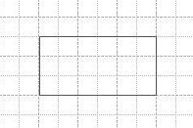

In the adjoining graph , the area of each square room is 1 cm2. So , the surface enclosed by the rectangle is 10 cm2.

∴

Area of rectangle = 10 cm2

i.e . 5 rooms along length x 2 rooms breadth = 10cm2

∴

Area of rectangle = length x breadth = l x b

**Area of triangles**

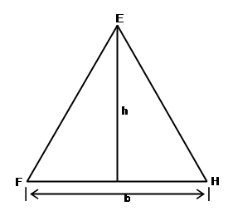

Here , area of the triangle EFG= length x breadth

=FG xGH

=base x height

=b x12

h

12

bh

So the area of triangle =12

base x height = 12

b xh

**Area of trianglesgle**

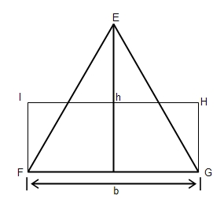

Here , area of triangle = area of rectangle FGHI

= length x breadth

=FG XGH

=base x hieight

=b x12

=12

bh

So , the area of tringle =12

base x height = 12

b xh

**Area of Parallelogrms**

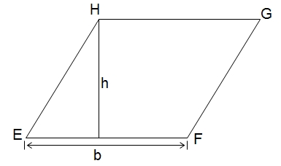

Here , area of the parallelogram EFGH =Area of the rectangle of EFGH

= length x breadth

=EF x FI

= base x height

= b x h

So, the area of parallelogram = base x height

= b x h

**Area of circles :**

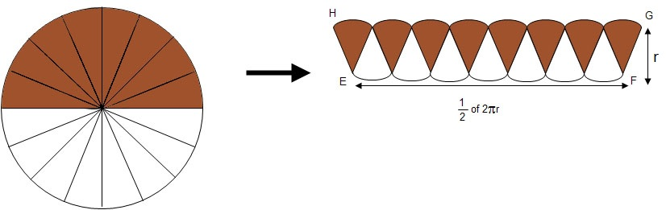

The length of rectangle EFGH (l) =12

x circumference = 12

x2 πr

The breadth of rectangle EFGH (b) = r

area of the circle = Area of rectangle EFGH

= length x breadth

=πr x r

=πr2

So , the area of circle =**πr2**

Things to remember

* Area of rectangle = length x breadth = l x b.
* The area of parallelogram = base x height.
* The area of circle =**πr2**

### Questions and Answers

#### Click on the questions below to reveal the answers

**Find the area of the given figure.**

#### 

Solution:

Here,  
area of two rectangles = l × b   
= 20 cm × 15 cm  
= 300 cm2  
Also,  
area of two triangles = 2 (12

 ×b × h)   
= 2 × 12 × 15 × 10 cm2= 150 cm2  
Again,  
∴ Area of the figure = 300 cm2 + 150 cm2  
= 450 cm2

**Find the area of the given figure.**

#### 

Solution:

Area of the rectangle = l × b   
= 20 cm × 15 cm   
= 300 cm2  
Radius of each semi-circle = 142

= 7 cm  
Area of two semi-circles = 2(12πr2)  
= 227 × 7 × 7 cm2   
   
= 154 cm2  
∴ Area of the figure = 350 cm2 + 154 cm2= 504 cm2

**Find the area of the shaded region in the given figure.**

#### 

Solution:

Here,  
Area of parallelogram = b × h   
= 16 cm × 10cm   
= 160 cm2  
Area of triangle = 12

b × h   
= 12 × 16 cm × 10 cm  
= 80 cm2  
∴ Area of the shaded region = Area of parallelogram -Area of triangle  
= 160 cm2 - 80 cm2  
= 80 cm2

#### 

**Find the area of the shaded regions in the given figures.**

Solution:

Area of rectangle = l × b   
= 12 cm × 9 cm  
= 108 cm2  
Area of parallelogram = b × h   
= 6 cm × 4 cm  
= 24 cm2   
∴ Area of the shaded region = Area of rectangle - Area of parallelogram  
= 108 cm2 - 24 cm2       
= 84 cm2

#### 

**Find the area of shaded regions in the given figure.**

Solution:

Here,  
Area of bigger rectangle = l × b   
= 20 cm × 16 cm   
= 320 cm2  
Area of smaller rectangle = l × b   
= 14 cm × 10 cm   
= 140cm2   
∴ Area of the shaded region = Area of bigger recatngle - Area of smaller rectangle   
= 320 cm2 - 140 cm2   
= 180 cm2

**If the perimeter of a circular ground is 220 m, find its radius and area.**

Solution:

Here,  
The perimeter of circular ground = 220 m  
or, 2πr = 220 m  
or, 2 × 227

 × r = 220 m  
or, r = 220×72×22 m  
or, r = 35 m  
Now,  
Area of the circular ground = πr2  
= 227 × 35 m × 35 m  
= 3850 m2

Quiz

**The formula of area of rectangle is ______ .**

l × b  
l ÷ b  
l - b  
l + b

**The formula of area of triangle is ______ .**

l × b  
b × h × l  
(frac{1}{2}) b × h  
b × h

**he formula of area of parallelograms is ______.**

b × h  
l × b  
l × h  
l × b × h

**If the perimeter of a circular ground is 220 m, then find its radius.**

35 m   
34 m  
36 m  
37 m

**Find the area of triangle in which base = 8 cm, height = 5.5 cm.**

24 cm2  
22 cm2  
23 cm2  
21 cm2

**The perimeter of a square ground is 128 m, find its area.**

1042 m2  
1036 m2  
1012 m2  
1024 m2

**Find the area of a square field is 625 m2,  find its perimeter.**

70m  
90m  
80m  
100m

**If the perimeter of a circle is 44cm, find its area.**

147 cm2  
154 cm2  
123 cm2  
138 cm2

**A square room is 15 m long, what will be its area of carpet required to cover its floor.**

240 m2  
225 m2  
210 m2  
235 m2

**A rectangular field is 40 m long and its area is 1120 m2, find its breadth.**

20 m  
22 m   
28 m  
24 m

## Nets and Skeleton Models of Regular Solids

**Octahedron**

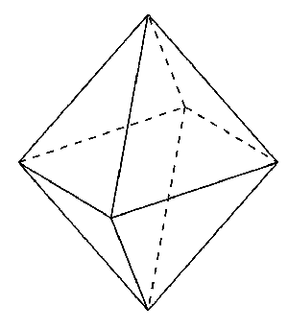Source:math.stackexchange.com  
Fig:octahedron

* Each surface is an equilateral triangle .
* It's a regular solid .
* It has eight surfaces .

**Tetrahedron**

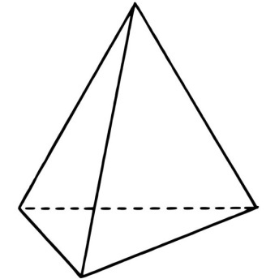Source:www.kidsmathgamesonline.com  
Fig:Tetrahedron

* Each surface is an equilateral triangle .
* It's a regular solid .
* It has four surfaces .

**Cube**

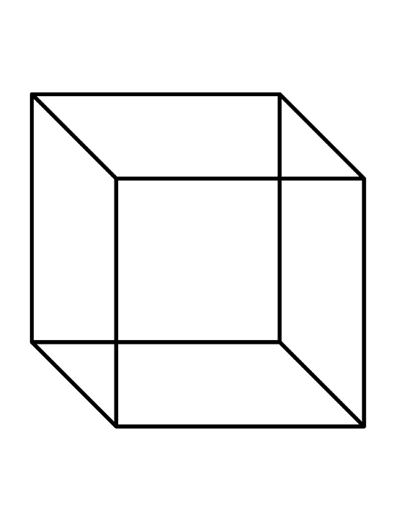Source:www.clipartpanda.com  
Fig: Cube

* It's a regular solid and it's also called a regular hexahedron.
* It has six surfaces .
* Each surface is square.

Following are the table to know about the number of vertices , edges and faces of some regular polyhedrons :

|  |  |  |  |  |
| --- | --- | --- | --- | --- |
| Regular polyhedron | No. of vertices(V) | No.of edges (E) | No. of face (F) | F + V-E |
| Tetrahedron | 4 | 6 | 4 | 4+4-6=2 |
| Hexahedron | 8 | 12 | 6 | 6+8-12=2 |
| Octahedron | 6 | 12 | 8 | 8+6-12=2 |

In any regular polyhedron , F+V-E =2 is true. This rule was developed by Swiss Mathematician Euler. It is called Euler's rule.

**Cone :**

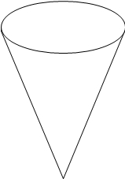fig: cone

* It's curved surface meet at a point called it's vertex.
* It has curved surface with the circular base.
* It is a solid object.

**Cylinder**

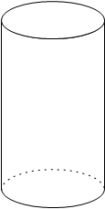fig:cylinder

* It has a curved surface with two circular bases .
* It is a solid object.

Things to remember

* The cylinder has a curved surface with two circular bases .
* Cone  has curved surface with the circular base.
* Cube has six surfaces .
* In any regular polyhedron , F+V-E =2 is true. This rule was developed by Swiss Mathematician Eular. It is called Eulr's rule.

.

### Questions and Answers

#### Click on the questions below to reveal the answers

**The volume of a rectangular box is 1600 cm3 and its height is 5 cm. If it is placed on a table, find the area covered by it on the table.**

#### 

Solution:

Here,  
Volume of the box (V) = 1600 cm3   
height of the box = 5 cm  
Now,  
Volume of the box = Area of its base × height   
∴ Area of its base × 5 = 1600  
or, Area of its base × height = 1600   
or, Area of its base = 16005

or, Area of its base = 320 cm2  
So, its base covers an area of 320 cm2 on the table.

**If the surface area of a cubic block is 96 cm2, find the length of its each edge.**

Solution:

Here,  
the surface area of the cubic block = 96 cm2  
or, 6 l2 = 96 cm2  
or, l2 = 966

#### cm2 or, l2= 16 cm2 or, l = 16cm2−−−−−√ or, l = 4 cm ∴ The length of its each edge is 4 cm.

**A rectangular metallic block is 16 cm long, 8 cm broad and 4 cm thick. If it is melted and converted into a cube , find the surface area of the cube.**

Solution:

length of the block (l) = 6 cm   
breadth of the block (b) = 8 cm  
 thickness of the block (h) = 4 cm  
Now,  
Volume of the block = l × b × h   
= 16 cm × 8 cm × 4 cm   
= 512 cm3   
volume of the cube = volume of the block   
or,  l3 = 512 cm3   
or, l = 512*cm*3−−−−−−√3

or, l = 8 cm  
Again,   
the surface area of the cube = 6 l2   
= 6 × (8 cm)2   
= 384 cm2

**The area of the base of a rectangular water tank is 30,000 cm2. Find the height of the water level when there is 3000 litres of water in the tank. (1 l = 1000 cm3)**

#### 

Solution:

Here,  
the volume of water = 3000 l  
= 3000 × 1000 cm3  
Now,  
the volume of the part of the tank containing water = volume of water   
or, Area of its base × height = 3000 × 1000 cm3   
or, 30,000 cm2 × h = 3000 × 1000 cm3  
or, h = 3000×1000*cm*330,000*cm*2

or, h = 100 cm  
So, the required height of water level in the tank is 100 cm (or 1 m).

Quiz

**The regular solid is also known as ______ .**

regular skeleton  
regular surface  
regular polyhedron  
regular hexahedron

**Octahedron has _______ surfaces.**

eight  
six  
nine  
seven

**Cube has ______ surfaces.**

four  
two  
six  
eight

**The meeting point of a curved surface is known as ______ .**

segment  
vertex  
base  
edges

**The line segments that joins any two faces of a regular polyhedron is called its ______ .**

vertex  
edges  
faces  
base

**Tetrahedron is a ______ solid.**

regular  
irregular  
same  
curved

**Tetrahedron has ______  number of vertices.**

6  
3  
4  
5

**Hexahedron has ______  number of edges.**

6  
4  
12  
8

**Octahedron has ______ number of faces.**

10  
7  
8  
6

**Tetrahedron has ______ surfaces.**

three  
four  
six  
five

## Area of solids

Some example of solids is like , Cube , cuboid , sphere , cone , pyramid , etc. Length , breadth, and height are three dimensions of solid objects .

**Area of cube**

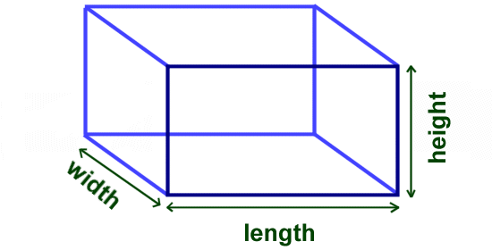Source : [www.ducksters.com](http://www.ducksters.com)  
Fig :Area of cude

A cube has 6 square faces . Each square face has an area of l2.

∴

Surface area of cube =6l2.

* A lidless rectangular box does not have its top face .

So , it has only 5 rectangular faces .

∴

Area of a lidless rectangular box = 2(lb+bh+lh)-lb

* A hollow rectangular box does not have top and bottom faces .

So , it has only 4 rectangular faces.

∴

Area of hollow rectangular box = 2(lb+bh+lh)-2lb=2(bh +lh)

* Area of lidless cubical box =5l2.
* Area of hollow cubical box =4l2

**Area of cuboid**

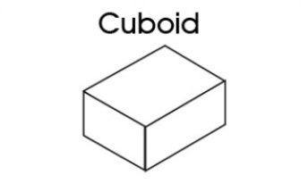Source :www.kidspot.comFig : Cuboid

Area of top and bottom faces = lb+lb=2lb

Area of side faces = bh +bh =2bh

Area of front and back faces = lh + lh=2lh

∴

**Surface area of cuboid = 2lb+2bh+2lh =2(lb+bh+lh)**

**Volume of solids**

The total space occupied by a solid is called its volume . Volume is measured in cu.mm(mm2) , cu.m (m3) , cu.cm(cm3) etc.

* **Volume of cube**

∴

Volume of cube = l x bx h

* **Volumne of cuboid**

∴

Volumn of cuboid = Area of base x height

Things to remember

* A cube has 6 square faces .
* Area of a lidless rectangular box = 2(lb+bh+lh)-lb
* Area of hollow cubical box =4l2
* Volume of cube = l x bx h
* Volume of cube = l x bx h

### . Questions and Answers

#### Click on the questions below to reveal the answers

**A rectangular block is 18 cm long, 12 cm broad and 8 cm thick. Find its surface area.**

#### 

Solution:

Here, length of the block (l) = 18 cm

breadth of the block (b) = 12 cm

thickness of the block (h) = 8 cm

Now, the surface area of the block = 2 (l×b + b×h + l×h)

 = 2 (18×12 + 12×8 + 18×8) cm2

 = 2 (216 + 96 + 144) cm2 = 912 cm2.

**The volume of a rectangular box is 1600 cm3 and its height is 5 cm. If it is placed on a table, find the area covered by it on the table.**

#### 

Solution:

Here, volume of the box (V) = 1600 cm3

height of the box = 5 cm

Now, volume of the box = Area of its base × height

∴

Area of the base × height = 1600

or, Area of its base × 5 = 1600

or, Area of its base = 16005

= 320 cm2

So, its base (b) covers an area of 320 cm2 on the table.

**If the surface area of a cubical block is 96 cm3, find the length of its each edge.**

#### 

Solution:

Here, the surface area of the cubical block = 96 cm3

 or, 6l2 = 96 cm2

l2= 966

cm2 = 16 cm2

l = 16*cm*2−−−−−√

4 cm

**A cuboid is twice as long as its breadth and it is 6 cm high. If its volume is 768 cm2.**

#### Find the length and breadth.

#### Find its surface area.

Solution:

Here, Let the breadth of the cuboid be x cm.

∴

The length of the cuboid will be 2x cm.

Now, the volume of the cuboid = 768 cm3

or, l×b×h = 768 cm3

or, 2x × x × 6 cm = 768 cm3

or, 2x2 = 7686

cm2 = 128 cm2

or, x2 = 1282

cm2 = 64 cm2

or, x = 64*cm*2−−−−−√

= 8 cm

So, the breadth (b) = x = 8 cm and the length (l) = 2x = 2 × 8 cm = 16 cm

Again, surface area of the cuboid = 2 (l×b +b×h + l×h)

 = 2 (16×8 + 8×6 + 16×6) cm2

 = 2 (128 + 48 + 96) cm2 = 544 cm2 ans.

**What is the formula of surface area of cuboid?**

2lb + bh + 2lh  
(lb + bh + lh)2  
lb + 2bh + lh  
2(lb + bh + lh)

**What is the formula of Area of a cube?**

l3  
4l  
2l  
l2

**What is the formula of a volume of cuboid ?**

2(l × b × h)  
l + b + h  
l × b × h  
2l × b × h

**What is the formula of a volume of cube?**

l6  
l4  
l2  
l3

**If the area of base = 104 cm2 and h = 5.5 cm, then what will be the volume of a cuboid.**

537 cm3  
563 cm3  
572 cm3  
582 cm3

**What is the formula of surface area of a cube?**

6l  
6l2  
6l + b  
l2

**If l = 5cm then what will be volume of cube.**

165 cm2  
145 cm2  
75 cm2  
125 cm2

**Find the surface area of a cube. where h = 4.5 cm.**

143.5 cm2  
134.5 cm2  
123.5 cm3  
121.5 cm2

**If the surface area of a cubical block is 96 cm2 , what will be its volume?**

64 cm2  
63 cm2  
65 cm2  
66 cm2

**A rectangular block is 18 cm long, 12 cm broad and 8 cm thick. What ill be its surface area.**

927 cm2  
934 cm2  
912 cm2  
9432