**Percentage**

#### Percent

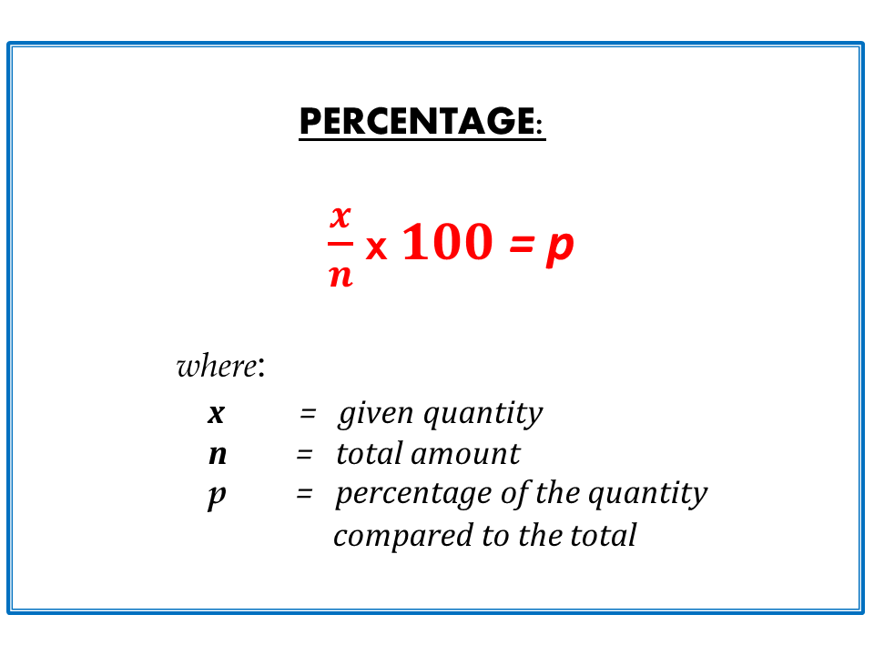source: igcseatmathematicsrealm.blogspot.com Fig: Percentage

Percent means parts per hundred or out of hundred. The symbol of a percent is %.

For example, 25% means 25 per 100 or, 25100

Percentage is a fraction written with a denominator 100.

**Conversion of fraction or decimal into percent**

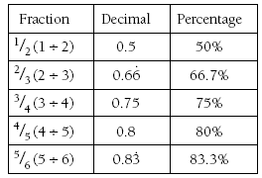source: nzmaths.co.nzFig: Fraction or Decimal into Percent

For the conversion of a fraction or decimal into percent multiply it by 100 and put the symbol % to the product. For example,

25

=25

× 100 % = 40 %

0.3 = 0.3× 100 % = 30 %

**Conversion of percent into fraction or decimal**

For the conversion of percent into fraction or decimal, divide it by 100 and remove the % symbol. For example,

20% =20100

=15

32% =32100

= 0.32

**To express a given quantity as the percent of whole quantity**

For the expression of the given quantity as the fraction of the whole quantity, then multiply the fraction by 100%. For examples,

20 as the percent of 80 =2080

× 100 = 25%

**To find the value of given percent of a quantity**

If this case is given, then multiply the quantity by the given percent. Then, convert the percent into a fraction and simplify. For example,

25% of Rs.250 = 25%× 250 =25100

× 250 = Rs. 62.5 ans.

**To find a quantity whose value of certain percent is given**

If this case is given, we can suppose the whole quantity by a variable such as x. Then we can form an equation and by solving the equation we can find the value of x. For example,

If 20% of a sum is Rs. 80. Find the sum

Here, Let the sum be Rs.x

Now, 20% of x = Rs.80

or, 20100

× x = Rs. 80

or, *x*5

= Rs.80

or, x =Rs. 80 × 5 = Rs.400

Things to remember

* Percentage is a fraction written with a denominator 100.
* For the conversion of a fraction or decimal into percent multiply it by 100 and put the symbol % to the product.
* For the conversion of percent into fraction or decimal, divide it by 100 and remove the % symbol.

### Questions and Answers

**The rate of a price of petrol is increased from Rs 50 per liter to Rs 55 per liter. Find the percentage increase in the price.**

Solution:

Here,   
the initial rate of a price = Rs 50 per liter  
The new rate of a price = rs 55 per liter  
∴ Increment in the rate price = Rs 55 - Rs  50 = rs 5  
Now,  
the increment percentage = *IncrementpriceInitialprice*

 × 100%  
= *Rs*5*Rs*50 × 100%   
= 10%  
So, the rate of a price of petrol is increased by 10%

**There are 225 boys in a school which is 75% of the total number of students. Find the number of girls in the school.**

Solution:

Let, the total number of students in the school be x.  
Here,  
or, 75% of x = 225  
or, 75100

 × x = 225  
or, 3*x*4 = 225  
or, x = 4×2253   
or, x = 300  
So, the total number of students in the school is 300,  
Again,   
Number of girls = 300 - 225   
So, there are 75 girls in the school.

Quiz

**Sameer obtained 60 marks out of 80 full marks in Maths. Express his marks in percentage.**

75%  
65%  
70%  
80%

**Express (frac{7}{20}) in percentage.**

37%  
33%  
39%  
35%

**Express 0.48 in percentage.**

8.4%  
84%  
48%  
4.8%

**Express 56% in decimal.**

05.6  
5.6  
5.06  
 0.56

**Express the Rs 36 as a percentage of Rs 720.**

20%  
10%  
5%  
15%

**Find the value of 75% of 60 full marks.**

45  
60  
50  
55

**Find the quantity whose 10% is Rs 160.**

Rs 6000  
Rs 1600  
Rs 16.00  
Rs 16,000

**(frac{3}{4}) of the total number of students in a school are boys. Find the percentage of boys.**

70%  
75%  
80%  
60%

**There are 48 students in a class. If 36 of them are boys, find the percentage of boys.**

60%  
80%  
90%  
75%

**52% of the total students in a school are girls. If there are 130 girls, find the total number of students in a school.**

290  
230  
250  
270