**Profit, Loss and Simple Interest**

#### Profit and Loss

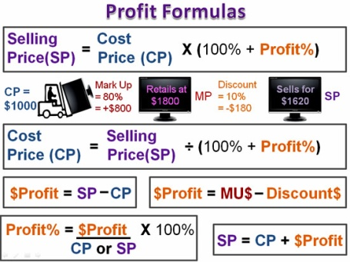source: passyworldofmathematics.com  
Fig: Profit and Loss

When the selling price of a good is higher than its cost then, it is called profit. In this case, profit is calculated as the difference between the selling price and the cost price.

|  |  |
| --- | --- |
| Profit | S.P - C.P |
| S.P | C.P + profit |
| C.P | S.P - profit |

Similarly, when the selling price of goods is lower than its cost price then it is called loss. The loss is calculated as the difference between the cost price and the selling price.

|  |  |
| --- | --- |
| Loss | C.P - S.P |
| C.P | S.P + loss |
| S.P | C.P- loss |

**Profit and Loss percent**

When there is an investment on Rs. 1000 and the C.P are considered as Rs. 100 and profit or loss is calculated on it, then it is called profit or loss percent. For example,

The cost price of an article is Rs. 250 and it is sold at a profit of Rs. 100.

Here, On C.P of Rs. 250, Profit is of Rs. 100.

On CP Rs.1, Profit is Rs. 100250

On CP of Rs. 100, profitis Rs.100250

× 100 = Rs.40

∴ On CP of RS. 100, Profit is Rs. 40. So it is called 40% on profit.

The formulaes for Profit and the loss percent are

1. Profit percent =*profitC*.*P*

× 100% or*S*.*P*−*C*.*PC*.*P*

• × 100%

• Loss percent =*LossC*.*P* × 100% or*C*.*P*−*S*.*PC*.*P*

1. × 100%

**Calculation of S.P when C.P and profit or loss percent are given**

For this case, firstafall it needs to find actual profit and actual loss from C.P

1. Actual profit = Profit percent× C.P
2. Actual Loss = Loss percent× C.P

So, we can calculate S.P as

1. S.P = C.P + Actual profit
2. S.P = C.P - Actual loss

For example,C.P - Rs. 150 and profit percent is 15%. Find S.P.

Here, Actual profit = 15 % of C.P =15100

× Rs.150 = 22.5

Now, S.P = C.P + profit = Rs. 150 + 22.5 = 172.5 ans.

**Calculation of C.P when S.P and profit or loss percent are given**

For this case, the unknown value of C.P is considered as a variable such as x. Then the process of calculation will be as shown in the following example,

If the S.P = Rs. 250 and loss percent is 10 %, find C.P.

Here, Actual loss = 10% of C.P

or, 10100

×x =*x*10

Now, C.P = S.P + loss

or, x = Rs. 250 + Rs. *x*10

or, x -*x*10

= Rs. 250

or, 9*x*10

= Rs. 250

or, x =*Rs*.250×109

= Rs. 277.78

∴ C.P = Rs. 277.78 ans.

**Discount**

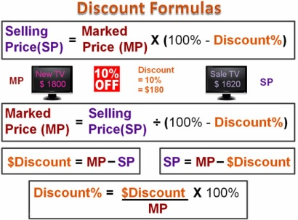source: passyworldofmathematics.com  
Fig: Discount

When a marked price of (M.P) of any article reduces and sells to the customer by shopkeeper then the reduced amount is called the discount.For example,

The marked price of a book is 125 and the shopkeeper reduces the Marked Price by 25. In this case, S.P of book = 125 - 25 = Rs.100.

1. Thus S.P = M.P - Discount
2. And Discount = M.P - S.P

**Discount Percent**

When a shopkeeper allows discount from Marked Price (M.P) of any article. When M.P is considered as Rs. 1000 and discount are calculated from it, then it is called Discount percent. It can be calculated by following formulas,

1. Discount Percent = *DiscountM*.*P*
2. × 100%
3. Discount Amount = Discount percent of M.P

**Value Added Tax (VAT)**

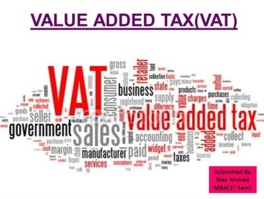source: www.authorstream.comFig: VAT

Value added tax is a tax charged on the actual selling price of goods. So, VAT is charged at a certain percent of S.P.

1. VAT amount = VAT percent of S.P
2. S.P with VAT = S.P + VAT percent of S.P

**Simple Interest**

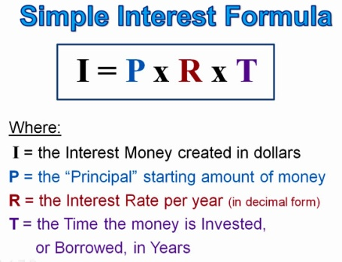source: passyworldofmathematics.comFig: Simple Interest

Generally, simple interest is the interest which is payable on the principal. When we deposit money in the bank for a certain time the bank will pay us some additional amount of money under a certain condition. Such additional amount of money is called interest.

**Calculation of Simple Interest**

The following terms appear in the calculation of simple interest,

1. Principal (P)
2. Rate (R)
3. Time (T)
4. Amount (A)

The formulae for calculating the Simple Interest,

I = *P*.*T*.*R*100

Again, If I =I = *P*.*T*.*R*100

P× T× R = I× 100

P = *I*×100*T*×*R*

T = *I*×100*P*×*R*

R = *I*×100*P*×*T*

Further more, when Amount (A) is the sum Principal (P) and its Intrest (I)

1. A = P + I
2. P = A - I
3. I = A – P

Things to remember

|  |  |
| --- | --- |
| • Profit | S.P - C.P |
| S.P | C.P + profit |
| C.P | S.P - profit |

•

|  |  |
| --- | --- |
| Loss | C.P - S.P |
| C.P | S.P + loss |
| S.P | C.P- loss |

• Profit percent =*profitC*.*P* × 100% or*S*.*P*−*C*.*PC*.*P*

• × 100%

• Loss percent =*LossC*.*P* × 100% or*C*.*P*−*S*.*PC*.*P*

• × 100%

• Actual profit = Profit percent× C.P

• Actual Loss = Loss percent× C.P

• S.P = C.P + Actual profit

• S.P = C.P - Actual loss

• S.P = M.P - Discount

• Discount = M.P - S.P

• Discount Percent = *DiscountM*.*P*

• × 100%

• Discount Amount = Discount percent of M.P

• VAT amount = VAT percent of S.P

• S.P with VAT = S.P + VAT percent of S.P

• I = *P*.*T*.*R*100

Again, If I = I = *P*.*T*.*R*100

P × T × R = I × 100

P = *I*×100*T*×*R*

T = *I*×100*P*×*R*

R = *I*×100*P*×*T*

1. Further more, when Amount (A) is the sum Principal (P) and its Intrest (I)
   1. A = P + I
   2. P = A - I
   3. I = A - P

.

### Questions and Answers

#### Click on the questions below to reveal the answers

**If S.P = Rs 240 and loss percent is 20%, find the C.P.**

Solution:

Let, the required C..P. be Rs x,  
Here,  
Actual loss = 20% of C.P  
= 20100

 × Rs x  
= *x*5  
Now,   
C.P. = S.P. + loss  
or, x = Rs 240 + Rs *x*5   
or, x - *x*5 = Rs 240   
or, 4*x*5 = Rs 240  
or, x = 5×*Rs*2404   
or, x = Rs 300  
So, the required C.P is Rs 300.

**A shopkeeper buys a watch for rs 350 and sells it for 378. Find his profit percentage.**

Solution:

Here,  
C.P. of the watch = Rs 350   
S.P. of the watch = Rs 378   
∴ Profit = S.P. - C.P. = Rs 378 - Rs 350   
= Rs 28  
Now,  
profit percent = *profitC*.*P*.

 × 100%   
= 28350 × 100%   
= 8%  
So, the required profit percent is 8%.

**Kedar bought 100 glass tumblers at the rate of Rs 15 each. 10 of them were broken and he sold the remaining at rate of Rs 16 each. find his profit or loss percent.**

Solution:

Here,  
the remaining number of glass tumblers = 100 - 10 = 90  
C.P. of 100 glass tumblers = 100 × Rs 15 = Rs 1500   
S.P. of 90 glass tumblers = 90 × Rs 16 = Rs 1440  
∴ Loss = C.P. - S.P.  = Rs 1500 - Rs 1440 = Rs 60  
Now,  
loss percent = *lossC*.*P*

 × 100%  
= *Rs*60*Rs*1500 × 100%   
= 4 %  
So, his loss percentage is 4%

**The marked price of an article is Rs 450. if the shopkeeper gives some discount and sells it for Rs 405, find the discount percentage.**

Solution:

Here,  
M.P. of the article = rs 450   
S.P. of the article = Rs 405   
∴ Discount = M.P - S.P = Rs 450 - Rs 405  
= Rs 45  
Now,   
Discount percentage = *DiscountM*.*P*

 × 100%   
= *rs*45*Rs*450 × 100%   
= 10%  
So, the required discount percentage is 10%

**The marked price of a camera is rs 1800. If the shopkeeper allows 10% discount, how much does a customer pay for it with 10% VAT?**

Solution:

Here,  
M.P. of the camera = Rs 1800   
Discount percent = 10%  
VAT percent = 10%  
Now,  
discount amount = 10% of M.P   
= 10100

 × Rs 960   
= Rs 180  
∴ S.P = M.P - Discount = Rs 1800 - Rs 180  
= Rs 1620  
Again,  
VAT amount = 10%  of S.P  
= 10100 × Rs 1620   
= Rs 162  
∴ S.P with VAT = S.P + VAT amount   
= RS 1620 + Rs 162  
Rs 1833  
So, the customer pays Rs 1822.

**Sunayana deposited a sum of Rs 2500 in a bank at the rate of 77% per year. Find the amount received by her at the end of 5 years.**

Solution:

Here,  
Principle (P) = Rs 2500   
Rate (R) = 7% per year   
Time (T) = 5 years  
Now,  
Interest (I) = *P*×*T*×*R*100

= Rs 2500×5×7100   
= Rs 875  
Again,  
Amount (A) = P + I   
= Rs 2500 + Rs 875   
= Rs 3375  
So, she received an amount of Rs 3375.

**In how many years a sum of Rs 3600 amount to Rs 5328 at 12% per year simple interest?**

Solution:

Here,  
Principle (P) = Rs 3600   
Amount (A) = Rs 5328  
Rate (R) = 12% per year   
Now,  
Interest (I) = A - P   
= Rs 5328 - Rs 3600  
Rs 1728  
Again,  
Time (T) = *I*×100*P*×*R*

= 1728×1003600×12   
= 4 years   
So, the required time is 4 years.

**A shopkeeper buys a watch for Rs 350 and sells its for Rs 378. Find his profit percentage.**

8%  
20%  
17%  
12%

**A shopkeeper sold a radio for Rs 336 at 5% profit. At what price did he purchase the radio?**

Rs 330  
Rs 320  
Rs 310   
Rs 300

**The marked price of a camera is Rs 1800. If the shopkeeper allows 10% discount, how much does a customer pay for it with 10% VAT?**

Rs 1300  
Rs 1033  
Rs 1822  
Rs 1434

**Find the S.P if M.P = Rs 540 and discount = 5%**

Rs 529  
Rs 518  
Rs 513  
Rs 525

**Find the discount percentage if M.P = 850 and S.P = Rs 680**

20%  
35%  
30%  
25%

**Find the S.P with 10% VAT if M.P. = Rs 1200 and discount = 10%**

Rs 1187  
Rs 1189  
Rs 1186  
Rs 1188

**In how many years a sum of Rs 3600 amounts to rs 5328 at 12% per year simple interest?**

3 years   
5 years   
6 years  
4 years

**What will be the simple interest if P = Rs 1600, T = 3 years and R = 9% per year.**

Rs 234  
Rs 432  
Rs 342  
Rs 243

**What will be time if P = 4800, R = 12% per year and I = Rs 1152**

3 years  
2 years  
4 years  
5 years

**What will be the rate of interest if P = Rs 1400, T = 3 years and I = Rs 210**

5%  
6%  
7%  
8%