**Some special type of Quadrilaterals**

Quadrilaterals are the polygons having four sides. Parallelogram, rectangle, square, rhombus, trapezium, and kite have some special properties. So, they are called special types of a quadrilateral. Some types of quadrilateral are as follows

1. **Parallelogram**  
     
   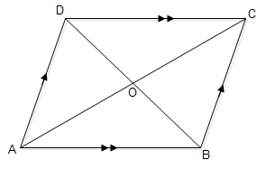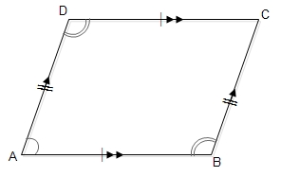  
   Its opposite sides are equal and parallel.   
   ∴

AB= DC and AB//DC, AD = BC and AD//BC.  
Its opposite angles are equal.   
∴ ∠A = ∠C and ∠B = ∠D  
Its diagonal bisect each other.  
∴

• Diagonals AC and BD bisect each other ar O.  
i.e AO = OC and BO = OD.

• **Rectangle**  
  
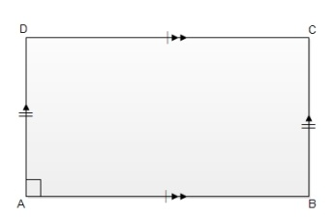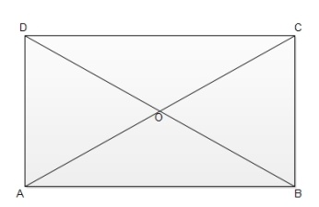  
Its opposite sides are equal and parallel.  
∴ AB = DC and AB//DC, AD = BC and AD//BC.  
Its all angles are equal andeach of them is 90°.   
∠A = ∠B = ∠C = ∠D = 90°.  
Its diagonalsare equal and they bisect each other.  
∴

• Diagonals AC = BD, AO = OC and BO = OD.

• **Square**  
  
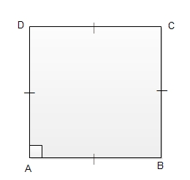  
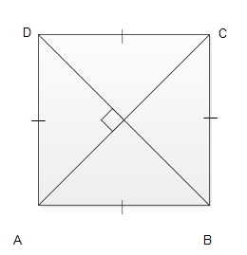ts all sides are equal.  
∴ AB = BC = CD = DA  
Its all angles are equal and they are 90°.  
∴ ∠A = ∠B = ∠C = ∠D = 90.  
Its diagonal are equal and they bisect each other at right angle.  
∴

• AC = BD and they bisect each other at O at a right angle.  
i.e AO = OC, BO = OD and BD⊥AC at O.

• **Rhombus**  
Its all sides are equal and opposite sides are parallel.  
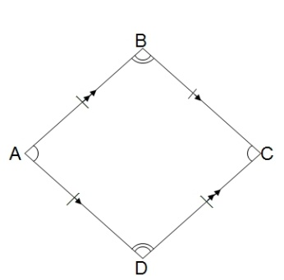  
∴ AB = BC = CD = DA and AB//DC, AD//BC  
Its opposite angles are equal.  
∴ ∠A = ∠C and ∠B = ∠D  
Its diagonals are not equal but they bisect each other at right angle.  
∴

• AC and BD bisect each other at O at right angle.  
i.e AO = OC, BO = OD and BD⊥AC at O.

• **Trapezium**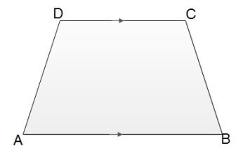  
Its any one pair of opposite sides are parallel.  
∴

• AB//DC.

• **Kite**  
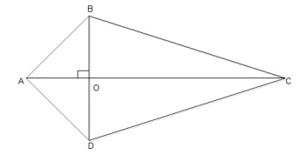  
Its particular pairs of adjacent sides are equal.  
AB = AD and BC = DC  
The opposite angles formed by each pair of unequal adjacent sides are equal.  
∠ABC = ∠ADC  
Diagonals intersect each other at O at a right angle.  
i.e BD⊥AC at O.

Things to know

* Opposite sides of a parallelogram are equal and parallel.
* The sides of rhombus are equal and opposite sides are parallel.
* The particular pairs of adjacent sides are equal.

### Questions and Answers

#### Click on the questions below to reveal the answers

**If the angles of a quadrilateral are in the ratio 1:2:3:4, find them.**

Solution:

Let the angles of the quadrilateral be x°, 2x°, 3x° and 4x° respectively.

Here, x° + 2x° + 3x° + 4x° = 360°

or, 10x° = 360°

or, x° = 360°10

= 36°

∴

x° = 36°, 2 × 36° =72°, 3x° = 3 × 36° = 108° and 4x° = 4 × 36° = 144°.

**Find the unknown sizes of angles in the following figure:**

Solution:

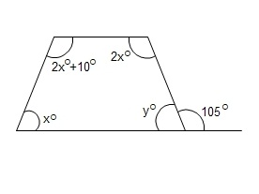

 y° + 105° = 180° [Being the sum of a straight angle]

or, y° = 180° - 105° = 75°

Now, x° + (2x° + 10°) + 2x° + y° = 360° [The sum of the angles of a quadrilateral]

or, 5x° + 10° + 75° = 360°

or, 5x° = 360° - 85°

or x° = 275°5

= 55°

∴

x° = 55°, 2x° + 10° = 2×55° + 10° = 120°, 2x° = 2×55° = 110° and y° = 75°.

**If 2x°, 3x°, (2x+10)° and (x+30)° are the angles of a quadrilateral, find them.**

Solution:

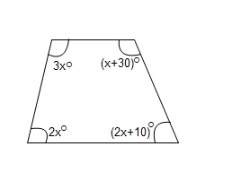

Here, 2x° + 3x° + (2x+10)° + (x+30)° = 360° [Sum of the angles of quadrilateral]

or, (8x + 40)° = 360°

or, 8x° = 360° -40°

or, x = 320°8

= 40°

∴

2x° = 2×40° = 80°, 3x° = 3×40° = 120°, (2x + 10)° = 2×40° + 10° = 90° and (x + 30)° = 40° + 30° = 70°

**Find the unknown sizes of angles in the following figure:**

Solution:

Here,

w° = 25° [Being alternate angles]

x° = 20° [Being alternate angles]

Now, w° + 20° = 25° + 20° = 45°

x° + 25° = 20° + 25° = 45°

Again, y° + 45° = 180° [Being the sum of co-interior angles]

or, y° = 180° - 45°

or, y° = 135°

Also, z° = y° = 135° [Being the opposite angles of a parallelogram]

∴

w° = 25°, x° = 20°, y° = z° = 135°.

**The sides of the square are ______ .**

joint  
adjacent  
diffierent  
equal

**In parallelogram the opposite sides are ______ .**

different  
joint  
equal  
adjacent

**Rhombus all sides are equal and opposite sides are ______ .**

adjacent  
perpendicular  
parallel  
disjoint

**In the kite, opposite angles formed by each pair of unequal adjacent sides are _______ .**

perpendicular  
parallel  
adjacent  
equal

**The diagonals of a rectangle are equal and they ______  each other.**

circular  
bisect  
perpendicular  
parallel