**Rational and Irrational Numbers**

**Rational Numbers**

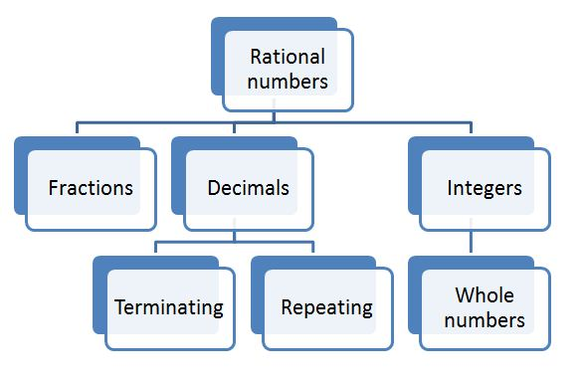Fig: Rational Numbers source:[kwizoo.com](http://kwizoo.com/rational-numbers.aspx" \t "_blank)

In general, A number that can be made by dividing two numbers is called rational number. Any numbers which can be expressed in the form of *ab*

where a and b are integers and b ≠ 0 are called rational numbers. The set of rational numbers is denoted by the letter 'Q'. For examples Q = ( 12, 34, 212100, 2012

, etc.. )

The set of the rational number is the set that includes the sets of natural numbers (N), whole numbers (W), and integers (Z). Therefore, the sets of natural numbers, whole numbers and integers are the proper subsets of the set of rational number.∴N < Q, W < Q and Z < Q.

**Terminating and Non-Terminating rational numbers**

When the rational number gets decimalised, the obtained decimal may be terminating or non-terminating decimal. Terminating rational number as decimal generally comes to an end and doesn't repeat after decimal. For example 12

= 0.5, 14 = 0.25, 38

= 0.375 etc.) are the examples of terminating decimal.

Non-Terminating rational number as decimal goes on repeating in a pattern after the decimal. For examples ( 13

= 0.333333..., 115

= 0.0666666.... etc. are non-terminating rational number as decimal.

**Irrational Numbers**

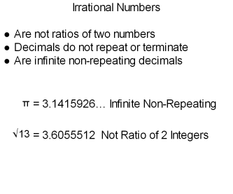Fig: Irrational Number  
*source:[www.digitmath.com](http://www.digitmath.com/rational-and-irrational-numbers.html" \t "_blank)*

The numbers which are not rational and that cannot be made by dividing two integers are called irrational numbers . If the irrational numbers are decimalised, the decimals are non-terminating non-recurring that goes on forever without repeating. For example ( 5–√

= 2.2360679775,( 2–√

= 1.41423562 etc. are the examples of irrational numbers.

**Real Number System**

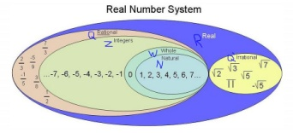Fig: Real Numbers  
source:[karenbrannon.weebly.com](http://karenbrannon.weebly.com/algebra-ii-sections-11-and-12-real-numbers-and-real-number-operations.html" \t "_blank)

The sets of number system i.e Natural numbers, Whole numbers, Integers, Rational numbers and Irrational numbers are defined under the set of real number system. The following chart shows the real number system :-

Things to remember

* A  number that can be made by dividing two numbers is called rational number.
* The numbers which are not rational and that cannot be made by dividing two integers are called irrational numbers .

### Questions and Answers

#### Click on the questions below to reveal the answers

**[Find any two rational numbers between 2 and 3.](file:///D:\\Project%20materail\\test.html" \l "collapse31900)**

Rational number at the middle of 2 and 3 = 12

(2+3)=52

Rational number at the middle of 2 and 52

= 12 (2+52 = 12 x 92 =94

So , 52

and 94 are any two rational numbers between 2 and 3.

* Quiz
* **Which one of the following is a rational number?**
* (sqrt{18})  
  (sqrt{42})  
  (sqrt{8})  
  (sqrt{32})
* **Find which is the rational number?**
* (sqrt{2})  
  3  
  (sqrt{5})  
  (sqrt{3})
* **Which one of the following is irrational number?**
* (sqrt{9})  
  (sqrt{3})  
  (sqrt{16})  
  (sqrt{4})
* **What could be the rational number of (sqrt{4})?**
* 16  
  8  
  2  
  4
* **What will be the any two rational numbers between 2 and 3?**
* (frac{5}{2}), (frac{9}{4})  
  (frac{5}{2}), (frac{9}{2})  
  (frac{5}{4}), (frac{9}{4})  
  (frac{5}{3}), (frac{9}{4})