**Fraction**

#### Fraction

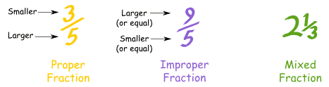Fig: Fraction   
source:[www.mathsisfun.com](https://www.mathsisfun.com/improper-fractions.html" \t "_blank)

A fraction is a number which is usually expressed in the form of *ab*

. For examples ( 34, 53, 97

, etc.)

**Comparison of fraction**

A fraction can be compared to their likes and unlike terms. We can compare like fractions by comparing their numerators and to compare unlike fractions, we should convert them into like fractions. By comparing those like fractions, as a result, we can find greater and the smaller fraction. For example, Let's compare 53

and 74

Here, the L.C.M of denominators 3 and 4 = 3×4 = 12

Now, 53

= 5×43×4 = 2012

And, 7×34×3

= 2112

Here, 2112

> 2012, So, 73 > 43

**Addition and Substraction of Fraction**

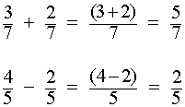Fig: Addition and Subtraction of Fraction   
source:[math.info](http://math.info/Arithmetic/Fractions_Add_Sub/" \t "_blank)

If the like fraction is given, we can add or substract them just by adding or substracting their numenator. For example, 56

+ 76 = 126

= 2

107

- 97 = 10−97 = 17

ans.

In case of unlike fraction, at first we should convert them into like fractions with the least common denominator, then we add or substract their numenator. For example,

or,45

- 37 = 4×75×7 - 3×57×5

= 2135

- 1535

= 21−1535

= 635

ans.

**Multiplication of fraction**

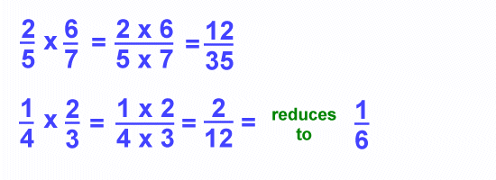Fig: Multiplication of Fraction   
source:[www.ducksters.com](http://www.ducksters.com/kidsmath/fractions_multiplying_dividing.php" \t "_blank)

Multiplication of fraction can be done by the product of a whole number and a fraction as well as product of a two fraction. For example 3× 43

31

× 43 = 123

=4

13

× 65 = 1×63×5 = 615 = 25

ans.

**Division of fraction**

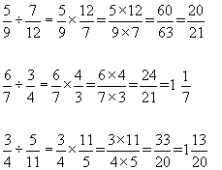Fig: Division of Fraction  
source:[cribbd.com](http://cribbd.com/learn/maths/number/calculate-with-fractions/resource/fractions-revise-number-gcse-maths" \t "_blank)

To divide a whole number by a fraction, we should multiply the whole number by the reciprocal of the fraction. For example,

4÷ 16

= 4× 16 = 46 = 23 ans.

Things to Remember

* To divide a whole number by a fraction, we should multiply the whole number by the reciprocal of the fraction.
* By comparing those like fractions, as a result, we can find greater and the smaller fraction.

### Questions and Answers

#### Click on the questions below to reveal the answers

**[If 27](file:///D:\\Project%20materail\\test.html" \l "collapse31844)**

**[of a sum is Rs. 120, find the sum.](file:///D:\\Project%20materail\\test.html" \l "collapse31844)**

Solution:

Let the required sum be x.

Now, 27

of x = Rs. 120

or, 27

× x = Rs. 120

or, 2x = 7 × Rs. 120

or, x = 7×*Rs*.1202

 = Rs. 420

So the required sum is Rs. 420.

#### [A man had some milk. When he sold 34](file:///D:\Project%20materail\test.html#collapse31846)

**[parts of the quantity of milk, 15 l was left. How much milk did he have in the beginning?](file:///D:\\Project%20materail\\test.html" \l "collapse31846)**

Solution:

Let, he had x l of milk in the begining.

Remaining parts of the quantity of milk = 1 - 34

= 14

part.

Now, 14

of x = 15 l

or, 14

 × x = 15 l

or, x = 4 × 15 l = 60 l

So, he had 60 l of milk in the begining.

#### [Kamala can do 112](file:///D:\Project%20materail\test.html#collapse31849)

**[part a piece of work in 1 day. She worked for 3 days and left. The remaining parts of the work is done by Reeta. How much work is done by Reeta?](file:///D:\\Project%20materail\\test.html" \l "collapse31849)**

Solution:

In 1 day, Kamala can do 112

part of a piece of work.

In 3 days, Kamala can do 3 × 112

part of work = 14

parts of a piece of work

Now, the remaining parts of the work done by Reeta = (1-14

) = 34

parts.

So, 34

parts of the work is done by Reeta.

Quiz

**What is the sum, if (frac{2}{7}) of a sum is Rs. 120?**

400  
520  
420  
320

**What is the value if (frac{3}{5}) of Rs. 750?**

550  
450  
400  
400

**What is the fraction of decimal 0.45?**

(frac{9}{15})  
(frac{8}{20})  
(frac{9}{20})  
(frac{8}{15})

**What is the fraction of decimal 0.3?**

(frac{2}{3})  
(frac{1}{3})  
(frac{3}{2})  
(frac{4}{3})

**A man had some milk. When he sold (frac{3}{4}) parts of the quantity of milk, 15 litres was left. How much milk did he have in the beginning?**

55 litres  
50 litres  
65 litrs  
60 litres

**What will be the sum if (frac{1}{4}) part of the sum is Rs. 75?**

Rs. 200  
Rs. 500  
Rs. 300  
Rs. 400

**If a girl obtained 32.8 marks in Nepali and failed by 7.2 marks, then what was the pass marks of the subject?**

32.5  
40  
35  
45

**The circumference of the wheel of a bus is 2.8 m. How many revolutions does ir make to cover 3.5 km?**

1150  
1350  
1250  
1050

**Simplify : (frac{2}{3}) + (frac{3}{4})**

(frac{6}{7})  
1(frac{4}{7})  
1(frac{5}{12})  
(frac{6}{12})

**Simplify : (frac{5}{6}) -  (frac{3}{7})**

(frac{8}{13})  
(frac{15}{36})  
(frac{17}{42})  
(frac{2}{-1})

**Simplify : 5 - (frac{2}{3})**

2(frac{2}{3})  
1(frac{2}{3})  
4(frac{2}{3})  
3(frac{2}{3})

**Simplify : 8 × (frac{3}{4})**

6  
5  
8  
7

**Simplify : (frac{7}{9}) × 15**

2(frac{5}{7})  
1(frac{2}{3})  
11(frac{2}{3})  
3(frac{4}{3})

**Simplify : (frac{6}{5}) ÷ (frac{8}{15})**

2(frac{1}{4})  
1(frac{1}{2})  
2(frac{2}{3})  
1(frac{2}{3})

## Decimal

#### Decimal

The denominators of the fractions which have the power of 10 then such fractions are called decimal fractions. For example,

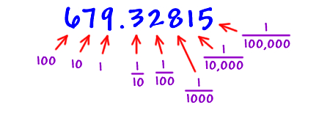Source :worldartsme.com  
Fig :Decimal

810

= 0.8

13100

= 0.13

**Terminating and Non-Terminating recurring decimal**

When a fraction is expressed in decimal and the decimal part is terminated with a certain number of digits, it is called terminating decimal.

13

= 0.3333....

16

= 0.16666......

87

= 1.1428571....

Similarly, when the fraction is expressed in decimal and the decimal part is never terminated it is called non-terminating decimal. For example,

23

= 0.666....

79

= 0.7777...

67

= 0.857114285......

**Four Fundamental operations on decimals**

1. **Addition and Subtraction of decimals**  
   While adding and subtracting decimals, we should arrange them in such a way that the digits at the same places should lie in the same 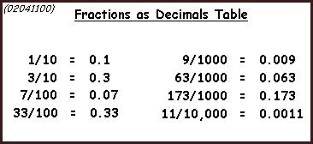Souce :student.passassured.com  
   Fig :Calculations, Fractions, Decimals column.  
   Add: 2.5  
   +9.08  
   11.58¯¯¯¯¯¯¯¯¯¯¯

Subtract: 18.79  
- 7.843  
10.947¯¯¯¯¯¯¯¯¯¯¯¯¯¯

• • **Multiplication of decimals**  
In the case of multiplying a decimal number by 10 or the power of 10. We should simplify shift the decimal point to the right of as many numbers of digits as there are number of zeros in 10, 100, 1000, etc, For example:  
Multiply8.367 by 10  
8.367× 10 = 83.67

• **Division of decimals**  
To divide a decimal by another decimal, we should first eliminate the decimal point from the divisor multiplying it by some power of 10. In the same time, the dividend should also be multiplied by the same power of 10. Then we should proceed the division.  
Divide 74 by 10  
7410 = 7.4

Things to remember

* Four Fundamental operations on decimals
  1. Addition and Subtraction of decimals
  2. Multiplication of decimals
  3. Division of decimals

### Questions and Answers

#### Click on the questions below to reveal the answers

**[Simplify : 234](file:///D:\\Project%20materail\\test.html" \l "collapse31950)**

#### [+ 158](file:///D:\Project%20materail\test.html#collapse31950)

#### [-313](file:///D:\Project%20materail\test.html#collapse31950)

Solution :

234

+ 158 -313

= 114

+ 138 -103

=11*x*6+13*x*3−10*x*824

=66+39−8024

=105−8024

=2524

=1124

Quiz

* **You scored /10**

•   
[Take test again](https://www.kullabs.com/classes/subjects/units/lessons/notes/note-detail/6200)

• **Express the 0.3 decimals in fractions.**

(frac{1}{3})  
(frac{1}{2})  
(frac{3}{2})  
(frac{2}{3})

**Add :   
0.236 + 0.579**

0.672  
0.733  
0.934  
0.815

**Subtract:  
0.9 - 0.45**

0.45  
0.9  
0.36  
0.-36

**Simplify:  
18.8 - 6.23 + 5.94**

18.115  
18.51  
18.443  
18.62

**Express (frac{3}{5}) fraction into decimal.**

0.3  
0.5  
0.6  
0.4

**Express the 0.3 decimal into fractions.**

(frac{1}{3})   
(frac{2}{3})   
1  
(frac{3}{2})

**Add:  
0.236 + 0.579**

0.235  
0.815   
0.343  
0.678

**Subtract:   
24.3 - 15.072**

8.235  
10.01  
7.352  
9.288

**Simplify:   
18.8 - 6.23 + 5.94**

20.65  
17.45  
19.23  
18.51

**Multiply:   
7.68 by 8**

58.32  
61.44  
59..43  
61.54