**Symmetry, Design and Tessellations**

The dotted line which is the half part of each shape to one side of a dotted line is the mirror image of the other parts is called the line of symmetry . In another word, it is also called the axis of symmetry , so the figure is said to have bilateral symmetry or to be symmetrical by reflection in the dotted line and a line of symmetry shape can be turned so as it exactly into its outline.

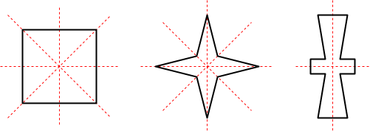Source : math.cmu.edu  
Fig :Symmetry

**Rotational symmetry**

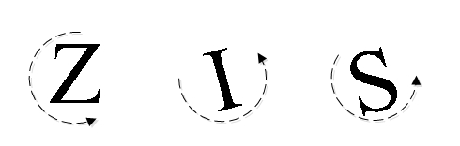

When a shape can be mapped onto itself by a rotation of less than a complete turn (360o) about a point the shape is said to have a rotational symmetry .

**Order of rotational symmetry**

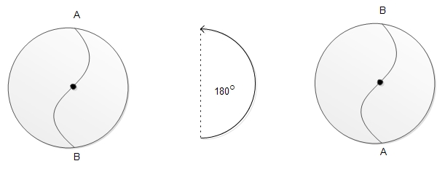order of rotation

When the shape is rotated through a half -turn it can be fitted to the original shape . It means , when it is rotated through 2 times half-turns , it reaches its original position .

∴

It has rotational symmetry of order 2.

When the equilateral triangle is rotated through a 13

of turn 120o, it can fit over the original shape. When it is rotated through3 times 13

and then it will reach its original place.

∴

It has rotational symmetry of order 3.

When the square is rotated through quarter-turn 14

of the turn 90o. Which can be fitted over the original shape . It means when it is rotated through 4time 14

of turn , it reaches its original position .

∴

It has rotational symmetry of order 4.

**Tessellation**

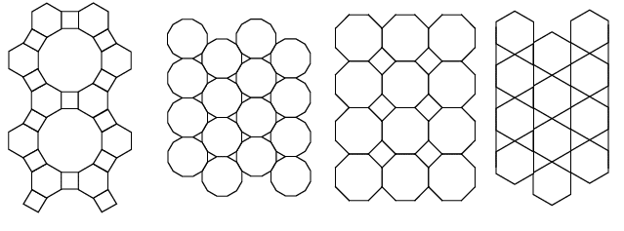

A tessellation is known as tiling . It is covering of the plane with congruent geometrical shape un which a repeating pattern without leaving any gaps and without overlapping each other.The shape is polygons in it . It may be an equilateral triangle , regular hexagon or square . To make a tessellation :

* We should not leave any gaps.
* We should not have any overlaps.
* We should use the sets of congruent figures .

**Types of tessellation**

* **Irregular tessellation :** In this case , we use irregular types of polygons.
* **Semi-regular tessellations:**In this case , we use two or more regular polygons . In the adjoining tessellation , regular octagons and squares are used .
* **Regular tesselation :** In this case, we use the same types of regular polygons . The polygons that we use may be equilateral triangle, regular hexagon etc.

Things to remember

* When the shape is rotated through a half -turn it can be fitted to the original shape .
* To make a tessellation we should use the sets of congruent figures .
* A tessellation is known as tiling .

. **The process of covering of the plane with congruent geometrical shapes in a repeating pattern without leaving any gaps and without overlapping each other is known as ______.**

symmetry  
tessellation  
design  
graph

**Tessellation is also known as ______ .**

gaps  
tiling  
covering  
polygons

**When a shape can be mapped into itself by a rotation of less than a complete turn around a point, the shape is said to be ______ .**

rotational symmetry   
axis of symmetry  
line of symmetry   
bilateral symmetry

**Tessellation should not have any gaps and ______ .**

joint  
overlaps  
color  
order

**Tessellation is done on the surface of floor and ______ .**

cupboard  
carpet  
window  
door