**Sets**

A well-defined collection of things (objects or numbers, etc) is called set. For examples: 'prime numbers less than 10'. It defines a noticeably

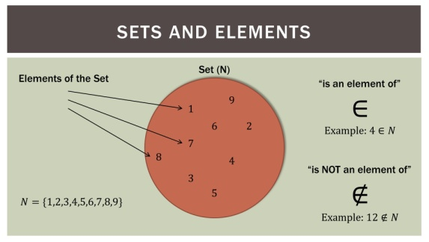source :1080.plus  
Fig :Introduction to Set Concepts & Venn Diagrams

different object which is to be included in the collection. So, 1, 2, 3, 5, and 7 comes under the collection.

**Member of a set**

The objects belonging to the set are called the members or elements of the set. The membership of a member of a set is denoted by 'belong to' symbol or sign (i.e '∈

').  
For example:  
Let's takes set, A = {3, 6, 9, 12, 15}.  
In the set A: 6, 9, 12 and 15 are the members or elements of set A. So, '3 ∈ A' which is read as '3 belongs to set A' or '3 is a member of set A'. Whereas, the number except 3, 6, 9, 12 and 15 does not belong to set A.  
(**Note:** The symbol '∈

' is used when any elements is not a member of any given set).

**Methods of Describing a Set**

Generally, set is described by the following three methods:

* Description method
* Listing method
* Set-builder method

1. **Description Method:**  
   In this method, the set is described by the common property of a member of set in a sentence inside the braces. For example;  
   A = {odd numbers less than 10}  
   E = {even numbers between 7 and 20}
2. **Listing Method:**  
   In this method, the set is represented by writing/including its elements inside the braces. For examples:  
   A = {1, 3, 5, 7, 9}  
   E = {8, 10, 12, 14, 16, 18}
3. **Set-builderMethod:**  
   In this method, the members of a set are represented by a variable like x, y, z, etc. and the variable describes the unique/common property shared by all members (elements) of a set. For examples:  
   A = {x : x is an odd number less than 10} where is read as A is the set of all values of x, such tat x is an odd number less than 10.  
   Similarly,  
   E = { z : z is an even number between 7 and 20}.

**Cardinal Number of a Set**

The number of elements in a finite set is called the cardinal number of a set. It is denoted by n(A), n(B) n(C) etc. For examples:  
A = {2, 4, 6, 8, 10}  
Here, the number of elements of sets A is 5. So, the cardinal number of set A is, n(A) = 5  
Similarly, M = {5, 10, 15}  
∴ The cardinal number of a set M is n(M) = 3.

**Subset**

If A and B are two sets, and every element of set A is also an element of set B, then A is called a subset of B. It is denoted by the symbol '⊆'as A ⊆ B. For examples:  
A = {whole number less than 6}  
i.e. A = {0, 1,2, 3, 4, 5}

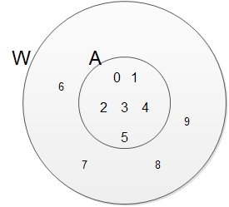

B = {odd numbers less than 10}  
i.e. B = {1, 3, 5, 7}

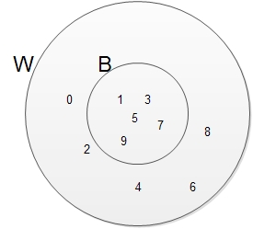

C = {even numbers less than 9}  
i.e. C = {2, 4, 6, 8}

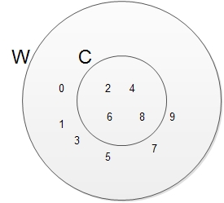

D = {prime numbers between 1 and 8}  
i.e. D = {1, 2, 3 5, 7}

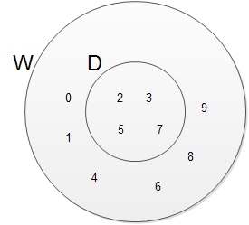

Here, every element of the sets B, C and D is also an element of set A. So B, set C and set D are the subsets of set A.  
(**Note:**An empty set (Φ) is a subset of every set. Every set is a subset of itself)

1. **Superset**If a set is a subset of set A, then set A is said to be a superset of B.If is denoted as A⊇ B.
2. **Proper Subset**A set 'A' is said to be a proper subset of the set B if it contains at least one element less than set B. It is denoted by the symbol 'C'. Symbolically, we write ABC for A is a proper subset of B. For example:  
   A = {whole number less than 6}  
   i.e. A = {0, 1, 2, 3, 4, 5, 6}  
   B = {odd number less than 7}  
   i.e. B = {1, 3, 5}  
   Here, B is a subset of B and the set B is not equal to set A. So, B is a proper subset of B i.e. A⊂ B.  
   (**Note:** No set is a proper subset of itself. Null set or empty set is a proper subset of every set).
3. **Number of Subsets of a given set**The number of subsets of a given set can be obtained by using the formula '2n', where x is the cardinal number of the given set. For example:  
   Set A = {a, b}  
   i.e. n(A) = 2  
   Here the possible subsets of set A are {a}, {b}, {a, b} andΦ. So, it has 4 subsets.  
   i.e. 2n = 22 = 4

**Universal Set**

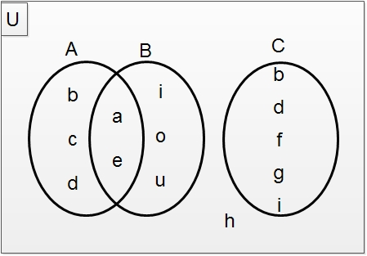

The universal set is a that has all the elements of other given sets. It is denoted by the symbol U or ξ (pxi). For example:  
U = {a, b, c, d, e, f, g, h, i, o,u}  
A = {a, b, c, d, e}  
B = {a, e, i, o, u}  
C = {b, d, f, g, i}  
Here, set U is a universal set which is the set of alphabets from a to j and A, B and C are the subsets of universal set 'U'.

**Venn - diagram**

The diagrammatic representation of sets is called Venn-diagram. It was developed by the British Mathematician John Venn. The universal set

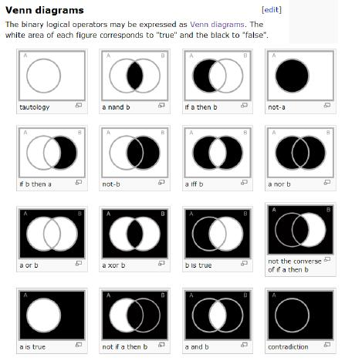*source :finitegeometry.org*  
Fig: Venn Diagrams and Finite Geometry

'U' is usually represented by a rectangle and another set is represented by a circle.

**Symbols and their Meaning**

|  |  |
| --- | --- |
| ∈ | |
|  | 'an element of' or 'belongs to' or 'is a member of content' |
| ∉ | 'not an element of' or 'does not belong to' or 'is not a member of' |
| ⇒ | implies that |
| Iff | If and If only |
| /or | such that |

Things to remember

* A collection of well-defined objects is called set.
* Listing method, Description method, and Set builder method are the methods f representing a set.
* Finite or infinite set, null or empty set, singleton or unit set, and universal set are the types of set.

### Questions and Answers

**Represent the sets H = {h, e, a, d, s} and T = {t, a, i, l, s} in a Venn-diagram and write H∩T by listing method.**

Solution:

Here,  
H = {h, e, a, d, s}  
T = {t, a, i, l, s}  
∴ H∩T = {h, e, a, d, s} ∩{t, a, i, l, s}  
= {a, s}

In venn diagram,

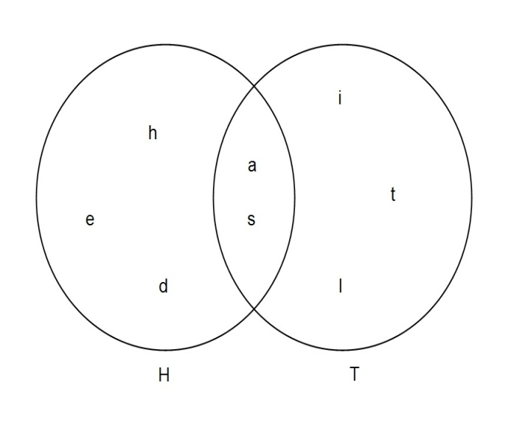

Hence, the shaded region represents H∩T.

**[Draw a Venn diagram to illustrate the relation among the given sets:  
U = {Students of Nepal}  
K = {Students of Kathmandu valley}  
M = {Students of morning shift of Kathmandu}  
D = {Students of day shift of Kathmandu}](file:///D:\\Project%20materail\\test.html" \l "collapse31022)**

Solution:

Here, the relation between M and D, M∩D = Φ  
Relation between K and M; M ⊂ K  
Relation between K and D; D ⊂ K  
Relation between K, M, and D; M∪D = K

D and M are subsets of K and K is subsets of U  
K, M and D all are subsets of U.   
Now,  
the above relation in Venn diagram as is shown below,

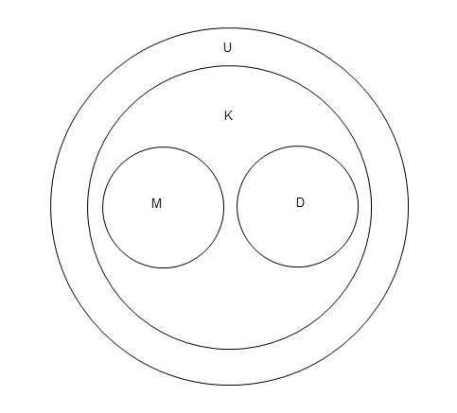

**If P = {a, e, i, o, u} and Q = {a, b, c, d, e} find Q - P and P - Q..**

Solution:

Here,   
P = {a, e, i, o, u}  
Q = {a, b, c, d, e}  
Now,  
Q - P = {b, c, d}  
The shaded region represents the elements of Q - P.

P - Q = {i, o, u}  
The shaded region represents the elements of P - Q.

Quiz

**Which symbol is used to indicate the Equivalent sets?**

 A ∼ Q  
A ≈ B  
A ≡ B  
A ↔ B

**Universal set is denoted by ______ .**

µ  
ξ  
Ω  
ς

**The sets which have all the elements of other given sets, that is known as ______.**

Equal set  
Equivalent set  
Overlapping set  
Universal set

**An empty set is denoted by ______.**

∞  
℘  
ο  
Φ

**An empty set is also known as ______.**

Cardinal set  
Singleton set  
Disjoint set  
Null set

**If the sets have at least one common elements then it is said to be _______ sets.**

overlapping  
equal  
disjoint  
equivalent

**If A = {2, 4, 6, 8, 10} and B = {1, 2, 3, 4, 5, 6, 7}, then find A ∪ B.**

A ∪ B = {1, 3, 5, 7, 9,}  
A ∪ B = {2, 4}  
A ∪ B = {1, 2, 3, 4, 5, 6, 7, 8, 9, 10}  
A ∪ B = {1, 2, 3, 4, 5, 6, 7, 8, 10}

**A = {0, 1, 2, 3, 4, 5, 6, 7, 8, 9} is a ______ set.**

universal  
finite   
equivalent  
unit

**The number of elements in a finite set is called ______ of a set**

relation  
method  
the cardinal number  
membership

**How many types of sets are there ?**

5  
4  
2  
3

## Set Operations

There are four fundamental or basic set operations. They are given below:

* Union of sets
* Intersection of sets
* Difference of sets
* Complement of a set

1. **Union of sets**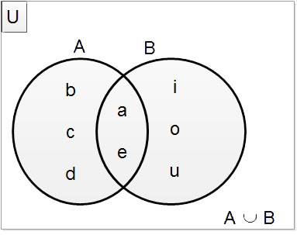The union of any two sets A and B is the set of all elements belonging either to A or to B or to both. It is denoted by (AUB) which is read as 'A union B'. The symbol 'U' (cup) is used to denote the union of sets. For example,  
   A = {a, b, c, d, e}  
   B = {a, e, i, o, u}  
   AUB = {a, b, c, d, e} U {a, e, i, o, u}  
   = {a, b, c, d, e, i, o, u}
2. **Intersection of sets**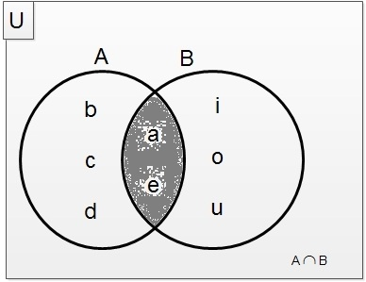The intersection of any two sets A and B is the set of all elements of both A and B. It is the set of all elements of both A and B. It is denoted by (A∩B) which is read as 'An intersection B'. The symbol '∩' (cup) is used to denote the intersection of sets. For examples:  
   A = {a, b, c, d, e}  
   B = {a, e, i, o, u}  
   A∩B = {a, b, c, e, d}∩ {a, e, i, o, u}  
   = (a, e}
3. **Different of sets**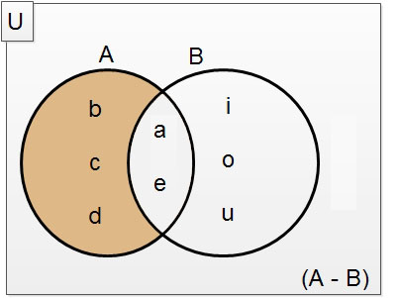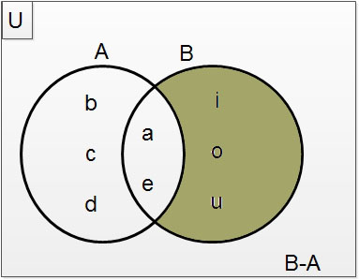  
     
     
     
     
     
     
     
     
   Two sets A and B is called different if the sets. of all the elements that belong to A does not belong to B. It can be written as(A - B). For examples:  
   A = (a, b, c, d, e}  
   B = {a, e, i,o, u}  
   A - B = {a, b, c, d, e} - {a, e, i, o, u}  
   = {b, c, d}  
   B - A = {a, b, c, d, e} - {a, e, i, o, u}  
   = {i, o, u}
4. **Complement of a sets**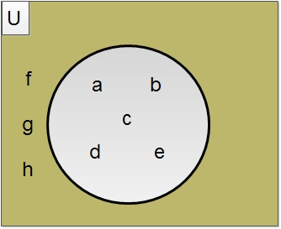If 'U' be the universal set and A is its subset, then the complement to A is the set of all elements that belong to 'U' but not to A. It can be written as A' or *A*¯¯¯¯

or Ac. For example:  
U = {a, b, c, d, e, f, g, h}  
A = {a, b, c, d, e}  
*A*¯¯¯¯

1. = U - A  
   = {a, b, c, d, e, f, g, h} - {a, b, c, d, e}  
   = {f, g, h}

Things to remember

1. There are four fundamental or basic set operations. They are Union of sets, Intersection of sets, Difference of sets, and Complement of a set.
2. The intersection of any two sets A and B is the set of all elements of both A and B.
3. Two sets A and B is called different if the sets. of all the elements that belong to A does not belong to B. It can be written as(A - B).
4. If 'U' be the universal set and A is its subset, then the complement to A is the set of all elements that belong to 'U' but not to A.
5. The union of any two sets A and B is the set of all elements belonging either to A or to B or to both. It is denoted by (AUB)

### Questions and Answers

**If P = {a, e , i , o, u} and Q = {a, b, c, d, e}, find P∪Q,  P∩Q, P - Q and Q - P.**

Solution:

Here,

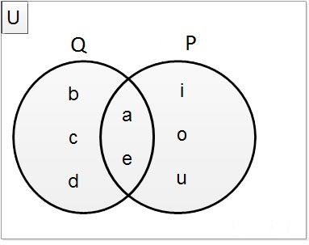

P = {a, e, i, o, u}  
Q = {a, b, c, d, e}  
Now,  
P∪Q = {a, b, c, d, e, i, o, u}  
The shahded region represents the elements of P∪Q.  
  
P∩Q = {a, e}  
The shahded region represents the elements of P∩Q  
  
P - Q = {i, o, u}  
The shahded region represents the elements of P - Q  
  
Q - P = {b, c, d}  
The shahded region represents the Q - P

**If A = {2, 4, 6, 8, 10, 12}, B = {1, 2, 3, 4, 5, 6} and C = {2, 3, 5, 7, 11}, show that A∪(B∪C) = (A∪B)∪C**

Solution:

Here,  
A = {2, 4, 6, 8, 10, 12}  
B = {1, 2, 3, 4, 5, 6}   
C = {2, 3, 5, 7, 11}  
Now,   
B∪C = {1, 2, 3, 4, 5, 6, 7, 11}  
∴ A∪(B∪C) = {1, 2, 3, 4, 5, 6, 7, 8, 10, 11, 12}  
Again,  
A∪B = {1, 2, 3, 4, 5, 6, 8, 10, 12}  
∴ (A∪B)∪C = {1, 2, 3, 4, 5, 6, 7, 8, 10, 11, 12}  
∴ A∪(B∪C) = (A∪B)∪C proved.

**From the given Venn diagram list the following sets using listing method:**

#### A∪B¯¯¯¯¯¯¯¯¯¯¯¯¯

#### and A¯¯¯¯

#### ∩ B¯¯¯¯

#### • • A∩B¯¯¯¯¯¯¯¯¯¯¯¯¯

#### and A¯¯¯¯

#### ∪ B¯¯¯¯

Solution:

Here,   
*A*∪*B*¯¯¯¯¯¯¯¯¯¯¯¯¯

= {4, 6, 7}  
*A*¯¯¯¯ ∩ *B*¯¯¯¯ = {4, 5, 6, 7, 8, 9} ∩ {1, 3, 4, 6, 7}   
*A*¯¯¯¯ ∩ *B*¯¯¯¯

= {4, 6, 7}

Again,  
*A*∩*B*¯¯¯¯¯¯¯¯¯¯¯¯¯

= {1, 3, 4, 5, 6, 7, 8, 9}  
*A*¯¯¯¯ ∪ *B*¯¯¯¯ = {4, 5, 6, 7, 8, 9} ∪ {1, 3, 4, 6, 7}  
*A*¯¯¯¯ ∪ *B*¯¯¯¯ = {1, 3, 4, 5, 6, 7, 8, 9}

Quiz

**There are ______ fundamental or basic set operations.**

two  
four  
five  
six

**Union of set is denoted by _______.**

∏  
µ  
∪  
Ü

**Intersection of a set is denoted by ______.**

∩  
η  
Ω  
Π

• **If P = {a, e, i, o, u} and Q = {a, b, c,d, e} find P - Q.**

### 

P - Q = {b, c, d}  
P - Q = {i, o, u}  
P - Q = {a, e}  
P - Q = {a,b, c, d, e, i, o, u}

**If A = {2, 4, 6, 8, 10} and B = {1, 2, 3, 4, 5, 6, 7} find A∩B.**

A∩B = {2, 4, 6}  
A∩B = {1, 2, 4, 6, 8}  
A∩B = {1, 3, 5, 7}  
A∩B = {1, 2, 3, ,5, 7}

## Types of Set and Set Relation

#### Types of Sets

Depending on the number of elements contained by the sets, they are classified into the following types:

* Empty or Null set
* Unit or Singleton set
* Finite and Infinite set

1. **Empty or Null Set:** 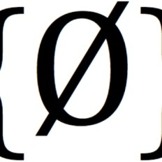Source :weirdtrianglerecords.bandcamp.com  
   Fig:0}EmptySets|WeirdTriangle Records  
   A set which does not contain any elements is called empty or null set. It is denoted by a symbolΦ called 'Phi'. For example:  
   A = {prime number between 8 and 10}  
   Since there is no prime number between 8 and 10. So, set A =Φ
2. **Unit or Singleton Set:**  
   A set containing only one element is called a unit set or singleton set. For example:  
   N = {whole number less than 1}  
   Since the whole number, less than 1 is 0 which is a single term. i.e N = {0}. So, the set N is said to be a unit or singleton set.
3. **Finite and Infinite Set:**  
   A set which contains a finite number of elements is called a finite set. For example:  
   A = {odd number between 5 and 15}  
   Here, A = {7, 9, 11, 13}  
   Since we can express the given set in cardinal number i.e. n(A) = 4, It is said to be a finite set.  
   A set containing never-ending elements (i.e. infinite number of elements) is called an infinite set. For example:  
   P = {x : x is a set of prime numbers} i.e. P = {1, 2, 3, 5, 7, 11, 13,.....................}.  
   The given set P is so large that we cannot express it in cardinal form. It has an infinite number of elements. So, it is an infinite set.  
   (**Note:** Infinite sets cannot be expressed in roster form)

#### Set Relations

Depending on the types of elements containing by two or more than two sets, the relationship between them can be presented in the following ways:

* Equal sets
* Equivalent sets
* Overlapping sets
* Disjoint sets

1. **Equal Sets:**  
   Two sets are equal to be equal if both the sets have exactly the same elements. The equals set is denoted by the symbol '='. For examples:  
   A = {a, b, c, d, e}  
   B = {e, d, c, b, a}  
   Here, n(A) = 4 and n(B) = 4. Hence sets A and B are said to be equal set and expressed as A = B.
2. **Equivalent Sets:**Two sets are said to be equivalent sets if they contain the same number of elements. It is denoted by the symbol '↔' or '∼'. For examples:  
   A = {1, 2, 3, 4 ,5}  
   B = {p, q, r, s, t}  
   Here, n(A) = 5 and n(B) = 5. Since they have the same cardinal number so they are said to be equivalent set and is expressed as A∼ B.
3. **Overlapping Sets:**  
   Two or more than two sets are said to be overlapping sets if they consist at least one common element. For examples:  
   A = {2, 4, 6, 8, 10, 12}  
   B = {3, 6, 9, 12, 15}  
   In both sets A and B, 6 and 12 are common, so sets A and B are overlapping sets.
4. **Disjoint Sets:**  
   Two or more than two sets are said to be disjoint if they do not have any of the elements common. For example:  
   A = {1, 2, 3, 5, 7, 11}  
   B = {4, 12, 16, 20}  
   In both sets, A and B none of the elements are common so set, A and B are disjoint.

Things to remember

• Empty set is denoted by a symbolΦ called 'Phi'.

• The equals set is denoted by the symbol '='.

• It is denoted by the symbol '↔' or '∼'.

### Questions and Answers

#### Click on the questions below to reveal the answers

**If P={a,e,i,o,u } and Q={a,b,c,d,e}, find (a)P ∪ Q  ( b) P ∩ Q  (c)P - Q  (d) Q-R .Represent them in venn diagrams.**

Solution :

Here , P = { a,e,i,o,u} and Q={a,b,c,d,e}

a) Now , P ∪ Q = { a,b,c,d,e,i,o,u }

The shaded region represents the elements of P ∪ Q.

b) P ∩ Q = { a,e}

The shaded region represents the elements of P ∩ Q.

c) P - Q = { i,o,u}

The sheded region represents the elements of P - Q .

d) Q - P={b,c,d}

The shaded region represents the elements of Q -P .

**Depending on the number of elements contained by the sets, they are classified into _______.**

4 types  
5 types  
3 types  
2 types

**A set which does not contain any elements is called _______.**

finite set  
infinite set  
unit or singleton set  
empty or null set

**Empty or Null Set is denoted by a symbol _____**

φ  
ø  
Θ  
Φ

**A set containing only one element is called ______.**

finite set  
null set  
infinite set  
unit set

**A set which contains a finite number of elements is called ______.**

empty set   
infinite set  
singleton set  
finite set

**A set containing never-ending elements (i.e. infinite number of elements) is called _______.**

null set  
finite set  
 unit set  
infinite set

**The equals set is denoted by the symbol ______.**

∈  
≡  
=  
⇔

**Equivalent set  is denoted by the symbol ______.**

≡  
≅  
≈  
∼