**Statistics**

#### Collection of data - Review

1 , 5, 6 ,5 ,8 ,7 ,5 ,10 ,0 , 2

1 ,2 , ,3,10 ,22, 8 ,7 ,9 ,15

The above are the marks obtain by the students of class 7 in math in dictation . The numerical figures are called data. Statistics is a branch of mathematically related with the collection of different thing which is shown by figures . It analysis the data. The data should be always shown proper order so that it will be easier to get the important and necessary information for which they are collected . The data are always arranged in ascending or descending order , which is known as a proper order.

The data which arranged properly are called arrayed data. If the data are not arranged properly then they are said raw data . Data are always can be present in a bar graph or in a line graph.

8 6 7 9 8 6 7 8

8 6 8 8 7 8 7 9

#### ( Raw Data)

6 6 6 7 7 7 7 8

8 8 8 8 8 8 9 9

#### ( Arrayed Data)

Here ,

* Rs 6 is repeated three times. So , its frequency is 3.
* Rs 7 is repeated four times . So, its frequency is 4.
* Rs 8 is repeated seven times . So , its frequency is 7.
* Rs 9 is repeated two times . So , its frequency is 2.

|  |  |  |
| --- | --- | --- |
| Wages (in Rs ) | Tally marks | Frequency |
| 6 | ||| | 3 |
| 7 | |||| | 4 |
| 8 | \enclose*horizontalstrike*|||| |  |

|  |  |
| --- | --- |
| || | 7 |
| Total |  | 14 |

The data and their frequencies can be shown in the table called frequency table . So, the above wages of 14workers in the frequency table . It is the system of showing frequencies by using diagonal lines grouped in five when each time five is reached , there is a horizontal line is drawn with the tally marks to make a group of five . For example :

|  |  |
| --- | --- |
| 1 | | |
| 2 | | | |
| 3 | ||| |
| 4 | |||| |
| 5 | \enclose*horizontalstrike*|||| |
|  |
| 6 | \enclose*horizontalstrike*|||| |

|  |
| --- |
| | |
| 7 | \enclose*horizontalstrike*|||| |

|  |
| --- |
| || |
| 8 | \enclose*horizontalstrike*|||| |

|  |
| --- |
| ||| |
| 9 | \enclose*horizontalstrike*|||| |

|  |
| --- |
| |||| |
| 10 | \enclose*horizontalstrike*|||| |

\enclose*horizontalstrike*||||

|  |
| --- |
|  |

**Bar graph**

There are mainly two types of a bar graph . They are described below :

Simple bar graph : The data which is presented single or the graph which is drawn to present single type of data is called simple bar graph . In a simple bar, data are equally wide . The height of the bars represents the frequency at the data.

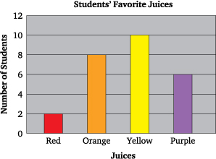source :illuminations.nctm.org  
Fig : Bargraph

* Construct the bars of the same width and at equal distance.
* Decide how wide the bars will be and how much space you will leave between them.
* Choose a suitable scale to represent the whole data . Mention the frequencies in the y-axis.

Multiple bar graph : Multiple bar graph is drawn to or more than two related components of the given data.

**Average ( or mean )**

The single number which represents the central value of a set of data is known as average . It indicated or show the quality of the data . It is calculated by adding them together and dividing the sum by the number of data.

**Average =** *TotalsumofdataNumberofdata*

If x is used to represent the data and n is used to represent the number of data , then,

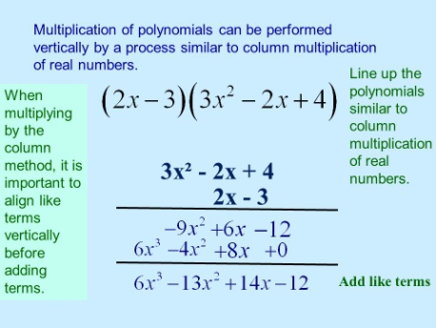Source:passyworldofmathematics.com  
Fig :Mean

**Average** = ∑*xn*

Here , the symbol '∑' means the summation of whole data.

**Mean or average of ungrouped repeated data**

Following are the steps given below to calculate the mean of ungrouped repeated data .

* Draw a table with 3 columns and Write down the items (**x)** in the first column .
* Write the corresponding frequency (**f)**of each item in the second column and find the produce of each item(**x)** and its frequency (**f** ) in the third (**fx )** column.
* Find the total of column and**fx** column and divide the sum of**fx** by the sum of**f ,** the quotient is the required means .

Things to khow

• The single number which represents the central value of a set of data is known as average .

•  The data which is presented single or the graph which is drawn to present single type of data is called simple bar graph

• Mean is calculated by **Average** = ∑*xn* this formula.

**The data given below are the daily wages (in Rs.) of 16 workers of a factory. Present that in the frequency table:**

**80, 60, 70, 90, 80, 60, 70, 80**

**80, 60, 80, 80, 70, 80, 70, 90**

Solution:

Let's present the above data of 16 workers in frequency table:

|  |  |  |
| --- | --- | --- |
| Wages () | Tally Marks | Frequency |
| 60 | ||| | 3 |
| 70 | |||| | 4 |
| 80 | ~~||||~~ || | 7 |
| 90 | || | 2 |
| Total |  | 16 |

**The data which are presented properly are called ______ data .**

frequency  
raw  
arrayed  
bar

**A ______ is drawn to show two or more related components of the given data.**

timeline  
simple bar graph  
multiple bar graph  
bar graph

**A ______ is drawn to present a single type of data.**

bar graph  
simple bar graph  
timeline   
multiple bar graph

**The systematical numerical figures are called ______ .**

mean  
bar   
data  
frequency

**A ______ is the number of times of a value occurs.**

 mean  
data  
frequency  
bar graph