**Triangles**

Triangles is a closed figure with three straight sides and three angles.

**Properties of Triangle**

1. 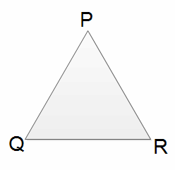The sum of the length of any two sides of a triangle is always greater than the length of its third side.  
   On △

• PQR  
PQ + QR > PR, QR + PR > PQ and PQ + PR > QR  
  
  
  
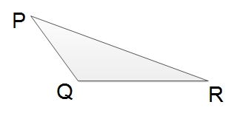

• The angle opposite to the longest side of a triangle is the greatest in size and the angle opposite to the shortest side is the smallest in size.  
In△PQR, the longest side is PR and its opposite angle is ∠Q. The shortest side is PQ and its opposite angle sis R.  
So, ∠ is the greatest and ∠R is the smallest angles of △

• PQR.  
Conversely, the side opposite to the greatest angle of a triangle is the longest one and the side opposite to the smallest angle is the shortest one.  


• The sum of the angles of a triangle is always 180.  
In△PQR, ∠P + ∠Q + ∠

• R = 180

• Thhe exterior angle of a triangle is equal to the sum of its two opposite interior angles.  
In△PQR, △PQR, ∠PRS = ∠PQR + ∠

1. QPR

**Congruent Triangles**

Those triangles which have exactly the same three sides and exactly the same three angles. If the figures have exactly the same shape and size are called congruent figures.

**Conditions of congruency of triangles**

Two triangles will be congruent under the following conditions

1. **Side-SIde-SIde (S.S.S) axiom**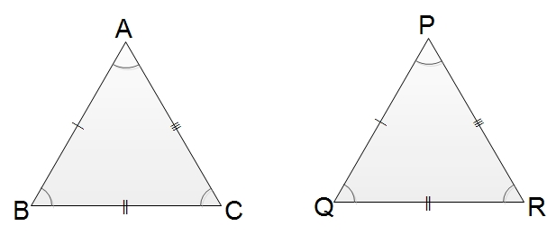  
   If three sides of one triangle are respectively equal to three corresponding sides of another angle, the triangles are said to be congruent.  
   In△

ABC and△PQR  
AB = PQ (S)  
BC = QR (S)  
CA = RP (S)  
∴△ABC≅△

• PQR (S.S.S axiom)

• **Side-Angle-Side (S.A.S axiom)**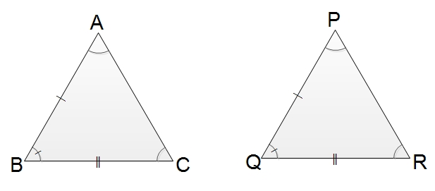  
If two sides of one triangle are respectively equal to two sides of another triangle and the angle made by them are also equal, the triangle is said to be congruent.  
In△ABCand△PQR  
AB = PQ (S)  
∠B = ∠Q (A)  
BC = QR (S)  
∴△ABC≅△

• PQR (S.A.S axiom)

• **Angle-side-Angle (A.S.A axiom)**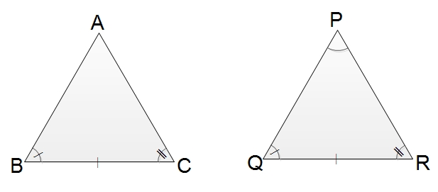  
If two angles of one triangle are respectively equal to two angles of another triangle and the adjacent sides of the angles are also equal, the triangles are said to be congruent.  
In △ABC and △PQR  
∠B = ∠Q (A)  
BC = QR (S)  
∠C = ∠R (A)  
∴ △ABC≅△

• PQR (A.S.A axiom)

• **Right angle - Hypotenuse - Side (R.H.S axiom)**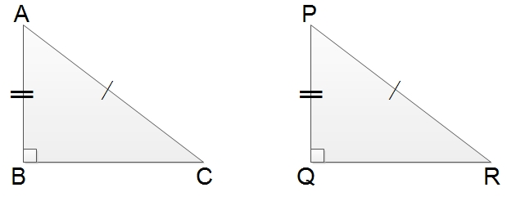  
If hypotenuse and one of two other sides of a right angled triangle are respectively equal to the hypotenuse and a side of other right angled triangle, the triangles are said to be congruent.  
In Right angles triangles ABC and PQR  
∠B = ∠Q (R)  
AC = PR (H)  
AB = PQ (S)  
∴△ABC≅△

1. PQR (R.H.S axiom)

**Similar Triangles**

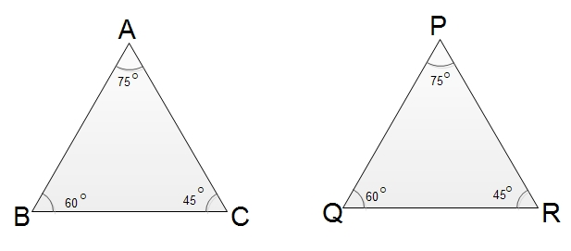

The figures which are exactly the same in the shape but sizes may be different are known as similar figures. In the given figure,△

ABC and△

PQR are similar triangles because they have equal angles and the same shape.

Thus, if three angles of one triangle are respectively equal to three angles of another triangle the are said to be similar.△

ABC is similar to△PQR is written as△ABC∼△

PQR. The symbol '∼' is used to denote is similar to.

Here AB and PQ, BC and QR, CA and RP are the corresponding sides of the similar triangle.

The corresponding sides of similar triangles are always proportional, i.e the ratios of the corresponding sides are equal.

∴

*ABPQ* =*BCQR* =*CARP*

**Properties of Triangle**

1. The sum of the length of any two sides of a triangle is always greater than the length of its third side.  
   On △

• PQR  
PQ + QR > PR, QR + PR > PQ and PQ + PR > QR

• The angle opposite to the longest side of a triangle is the greatest in size and the angle opposite to the shortest side is the smallest in size.  
In △PQR, the longest side is PR and its opposite angle is ∠Q. The shortest side is PQ and its opposite angle sis R.  
So, ∠ is the greatest and ∠R is the smallest angles of △

• PQR.  
Conversely, the side opposite to the greatest angle of a triangle is the longest one and the side opposite to the smallest angle is the shortest one.

• The sum of the angles of a triangle is always 180.  
In △PQR, ∠P + ∠Q + ∠

• R = 180

• Thhe exterior angle of a triangle is equal to the sum of its two opposite interior angles.  
In △PQR, △PQR, ∠PRS = ∠PQR + ∠QPR

### Questions and Answers

#### Click on the questions below to reveal the answers

**If x°  and 2x° are two acute angles of a right-angled triangle, find them.**

#### [Fig: Right-angled Triangle](file:///D:\Project%20materail\test.html%23collapse31883)Fig: Right-angled Triangle

Solution:

Here, x° + 2x° + 90° = 180° [Being the sum of the angles of right-angled triangle.]

or, 3x° = 180° - 90°

or, x° = 90°3

= 30°

∴

x° = 30° and 2x° = 2×30° = 60°

**If the angles of a triangle are in the ratio 3:4:5, find them.**

Solution:

Let the angles of the triangle are 3x°, 4x° and 5x° respectively.

Now, 3x° + 4x° + 5x° = 180° [Being the sum of the angles of a triangle.]

or, 12x° = 180°

or, x° = 180°12

= 15°

∴

3x° = 3×15 = 45°, 4x° = 4×15° =60° and 5x° = 5×15° = 75°.

**Find the sizes of unknown angles in the following figure:**

**[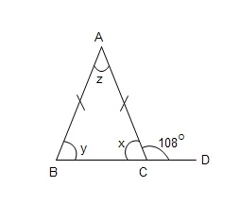](file:///D:\Project%20materail\test.html%23collapse31888)**

Solution:

x+108° = 180° [Being the sum a straight angle]

or, x = 180° - 108° = 72°

y = x = 72° [Being the base angles of an isoceles triangle]

Again, y + z = 108° [Being the sum equal to exterior angle of the triangle]

or, 72°+z = 108°

or, z = 108° - 72° = 36°

∴

x= y = 72° and z = 36°.

**Use necessary axiom and show that △**

**ABC ≅ △**

**PQR. Also, write their corresponding sides and angles.**

**[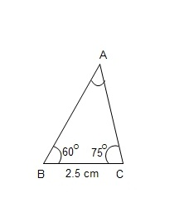](file:///D:\Project%20materail\test.html%23collapse31891)  [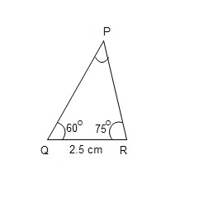](file:///D:\Project%20materail\test.html)**

Solution:

In △

sABC and PQR,

1. ∠

B = ∠

• Q = 60° (A)

• BC = QR = 2.5 cm (S)

• ∠C = ∠

• R = 75° (A)

• ∴ △ABC ≅ △

• PQR (A.S.A Axiom)

• AB = PQ and AC = PR [Corresponding sides of congruent triangles]

• ∠A = ∠P [Corresponding sides of congruent triangles]

**In the figure, △**

**DEF ∼ △**

**XYZ. Find the length of YZ.**

**[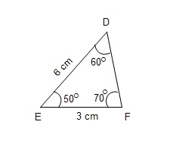](file:///D:\Project%20materail\test.html%23collapse31898)[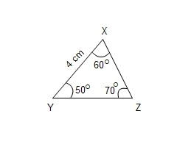](file:///D:\Project%20materail\test.html)**

Solution:

Here, △

DEF ∼ △

XYZ

∴

*DEXY* = *EFYZ*

or, 64

= 3*YZ*

or, 6YZ = 12

or, YZ = 126

= 2 cm

Question

**If all sides are equal in a triangle then it is known as _____ triangle.**

acute  
isosceles   
scalene  
equilateral

**The triangle having any two sides are equal is known as ______ triangle.**

equilateral   
scalene  
obtuse   
isosceles

**If the triangle having different-different sides is known as ______ triangle.**

isosceles   
right angled   
equilateral   
scalene

**If x° and 2x° are two acute angles of right-angled triangle find the value of x.**

40°  
20°  
30°  
10°