STAT-TRIAGE AI
  - Evidence Report: RSNA Intracranial Hemorrhage Slice-Level Pilot
Authors: Yukti Madan, Barkha Sahu, Sumit Masirkar
Faculty advisor: Dr. Monali Gulhane
Run date: 30 September 2026 | Kaggle Tesla T4
Evidence status: First locked test evaluation of a 2,400-slice, patient-separated pilot. This report supports a research prototype; it does not establish 3D study-level performance, population calibration, clinical efficacy, or regulatory readiness.

Executive summary
A six-output EfficientNet-B0 baseline was trained on three Hounsfield Unit window channels derived from RSNA 2019 head CT slices. The model checkpoint was selected using validation data, the operating threshold was fixed on a separate calibration split, and the test set was evaluated once. The primary endpoint was slice-level detection of any intracranial hemorrhage.
Test endpoint | Estimate | Patient-bootstrap 95% CI
ROC-AUC | 0.842 | 0.786-0.891
Sensitivity | 88.3% | 80.7%-94.4%
Specificity | 50.9% | 43.6%-58.6%
Negative predictive value | 90.3% | 84.0%-95.7%

At the locked threshold, the system detected 68 of 77 positive test slices and missed 9. It also generated 81 false alerts among 165 negative slices. The result supports continued research but shows that alert burden remains a central engineering and workflow problem.

1. Study design and evidence chain
Split | Slices | Patients | Any ICH + | Positive share
Train | 1682 | 1554 | 567 | 33.7%
Validation | 232 | 222 | 77 | 33.2%
Calibration | 244 | 222 | 79 | 32.4%
Test | 242 | 222 | 77 | 31.8%

The pilot contains 2,400 sampled slices: 800 hemorrhage-positive and 1,600 negative. Sampling deliberately increased prevalence before splitting. Patients were kept within a single split; the exported manifest also shows no study or series overlap. Because the pilot is slice-sampled, it does not represent full volumes or the original RSNA prevalence.
Locked sequence: Train on 1,682 slices; select the epoch on 232 validation slices; choose the threshold on 244 calibration slices; evaluate once on 242 test slices from 222 patients. The test result is not used for further tuning.

2. Input pipeline and model
DICOM pixels were transformed with RescaleSlope and RescaleIntercept and mapped to three normalized channels: brain (center 40, width 80), subdural/blood (center 75, width 215), and bone (center 600, width 2,800). Images were resized to 224 x 224 and normalized with the ImageNet statistics recorded in the run configuration. The model produced independent sigmoid scores for epidural, intraparenchymal, intraventricular, subarachnoid, subdural, and any hemorrhage.
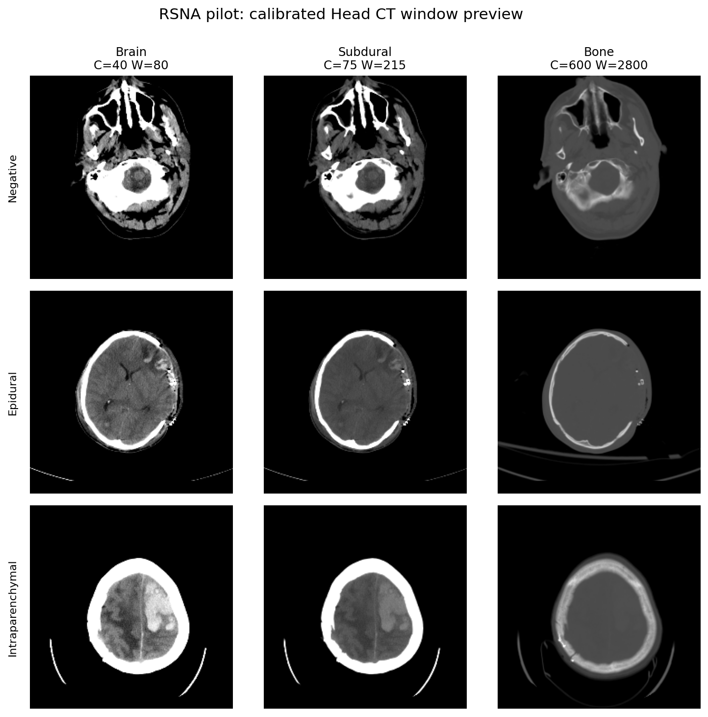
Figure 1a. De-identified negative, epidural, and intraparenchymal examples after physical HU conversion and three-window projection.
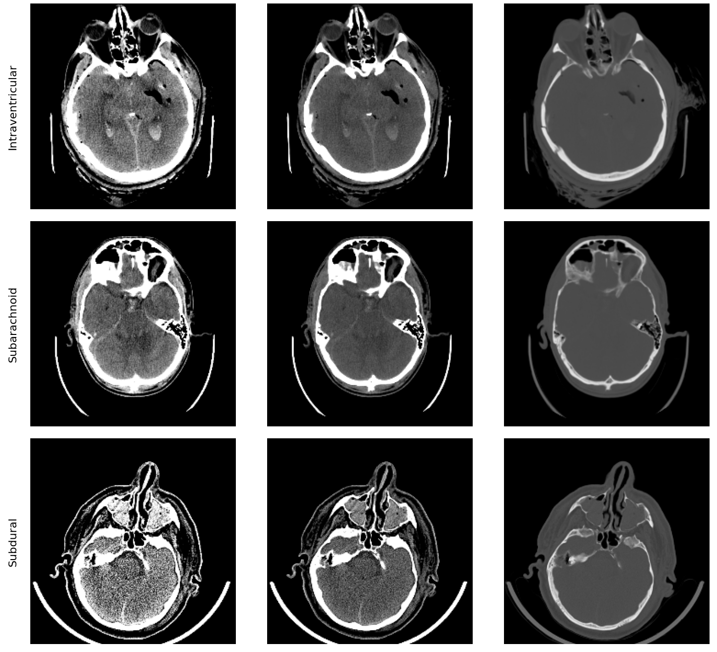
Figure 1b. De-identified intraventricular, subarachnoid, and subdural examples. Slice labels do not constitute lesion localization annotations.
The ImageNet-pretrained EfficientNet-B0 classifier was trained for two frozen-backbone epochs followed by six upper-backbone fine-tuning epochs. Positive class weighting was capped at 20 for the sparse epidural label. Epoch 4 was selected with validation any-hemorrhage ROC-AUC 0.8553. Validation loss rose afterward while training loss continued to decline, indicating overfitting.

3. Locked evaluation
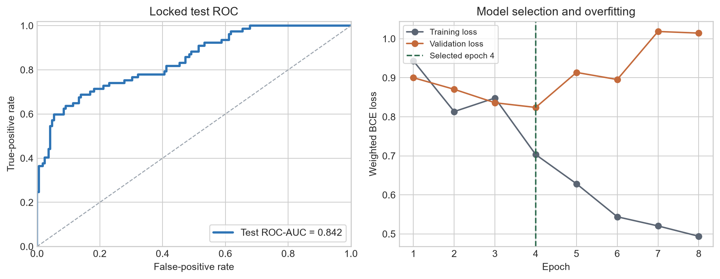
Figure 2. Locked test ROC curve and training history. The vertical marker shows the validation-selected checkpoint; later epochs were not retained.
Primary endpoint metric | Estimate (patient-bootstrap 95% CI)
ROC-AUC | 0.842 (0.786-0.891)
Average precision | 0.777 (0.686-0.849)
Sensitivity | 0.883 (0.807-0.944)
Specificity | 0.509 (0.436-0.586)
PPV | 0.456 (0.374-0.538)
NPV | 0.903 (0.840-0.957)
Accuracy | 0.628 (0.567-0.688)

 | Predicted negative | Predicted positive
Actually negative | 84 | 81
Actually positive | 9 | 68

The threshold 0.253861 was chosen on calibration data to target at least 90.0% sensitivity. Calibration sensitivity/specificity were 91.1% and 55.2%; test sensitivity/specificity were 88.3% and 50.9%. The sigmoid value is an operating score, not a population-calibrated probability.

4. Exploratory subtype results
Subtype | Positive test slices | ROC-AUC | Interpretation
Epidural | 3 | 0.599 | insufficient positives
Intraparenchymal | 24 | 0.915 | exploratory
Intraventricular | 17 | 0.906 | insufficient positives
Subarachnoid | 30 | 0.757 | exploratory
Subdural | 35 | 0.843 | exploratory

All subtype analyses are secondary and exploratory. Epidural has only three positive test slices; intraventricular has 17. Their point estimates are too unstable for a validated subtype claim. The comparatively strong intraparenchymal and intraventricular AUCs are hypotheses for a larger prespecified evaluation.

5. Throughput and reproducibility
The 242-slice test cohort completed in 2.061 seconds at batch size 32, an average of 8.52 ms per image. This measurement includes batched DICOM decode, preprocessing, device transfer, and inference. It is a cohort-throughput measurement and must not be presented as single-study clinical latency or evidence of real-time scanner integration.
Artifact | Size | SHA-256 prefix
test_metrics.json | 3.0 KB | a0fb02479f9f3e50...
test_predictions.csv | 40.4 KB | 3a9a1b49e9c70e0c...
operating_point.json | 0.9 KB | 24b5a0a2b93f485b...
training_history.csv | 2.2 KB | 16ef7efa26b94136...
run_config.json | 1.5 KB | 5811f31090c38de0...
rsna_pilot_manifest_split.csv | 511.5 KB | 4335d70dded5351b...
best_efficientnet_b0.pt | 15982.0 KB | 4a15c605bb1481de...

The model checkpoint SHA-256 is 4a15c605bb1481de7f12a4881f9c9b5adb36d9386ecac0aa6eb3ae7c3ae805b1. The report generator verifies every bundled artifact against bundle_manifest.json before producing this document.

6. Limitations and claim boundaries
- The endpoint is slice-level any-hemorrhage detection, not complete 3D study-level triage.
- The cohort was enriched before splitting; PPV, NPV, accuracy, average precision, and raw scores do not represent source-population calibration.
- The test cohort contains 242 slices from 222 patients, producing wide uncertainty intervals and sparse subtype counts.
- The checkpoint was initialized from ImageNet EfficientNet-B0 weights. BiomedCLIP, axial-transformer, SPRT, conformal, chest X-ray, and knee MRI claims were not evaluated in this locked run.
- The study does not measure radiologist outcomes, clinical workflow benefit, external-site generalization, or regulatory safety/effectiveness.
- The locked test result must not be used for additional model or threshold tuning.
Interpretation: This run replaces prior synthetic 1.0000-AUC demonstrations as the project's only artifact-backed real-image performance result. The synthetic tri-modal benchmark remains useful for software demonstrations but is not clinical evidence.

7. Next validated milestone
- Build complete CT studies from DICOM metadata and preserve all slices per patient and series.
- Train and evaluate a study-level baseline on a larger patient-separated cohort with a new untouched test set.
- Measure calibration on a cohort sampled to match the intended use population and report reliability diagnostics.
- Quantify alert burden and time-to-review in a prespecified queue simulation using the measured operating point.
- Evaluate any sequential-stopping design through actual incremental inference before claiming saved compute or latency.

Sources
- RSNA Intracranial Hemorrhage Detection, 2019 competition data and description: https://www.kaggle.com/c/rsna-intracranial-hemorrhage-detection
- DICOM Standard, PS3.5 Data Structures and Encoding: https://dicom.nema.org/medical/dicom/current/output/html/part05.html
- Torchvision EfficientNet-B0 model documentation: https://pytorch.org/vision/stable/models/efficientnet.html

