AI-Powered Clinical Triage Gateway
Phase 1 Technical Specification & Verification Report (40% Milestone)
Architecture: 2.5D EfficientNet-B0 + Bi-GRU | Git Tag: v0.4.0-milestone
Verification Status: 100% Verified (Passed All Tests) | Evaluation Model: M/G/c SimPy Discrete-Event

1. Executive Summary & Vertical Slice Rationale
Standard medical imaging AI initiatives frequently fail during hospital deployment because models are trained as isolated benchmark scripts without considering clinical queue dynamics, spatial attention stability, or data compliance laws. Phase 1 establishes an end-to-end, production-grade Vertical Slice that de-risks the entire system topology early:
[Raw 16-Bit DICOM Series]
│
▼
[HIPAA Pseudonymizer & 3-Channel Clinical HU Windowing]
│
▼
[2.5D EfficientNet-B0 Backbone + 1D Bidirectional GRU]
│
├──► [Stateless Grad-CAM + Perturbation Stability Index (PSI)]
│
▼
[Triage Gateway: Operational 3-Zone Uncertainty Routing]
│
▼
[Starvation-Free Dynamic Aging Priority Scheduler S(t)]
│
▼
[SimPy Discrete-Event Hospital Shift Simulator (M/G/c Model)]

By implementing Pathway A (Head CT for Intracranial Hemorrhage) end-to-end, the UnifiedModelAdapter interface contract is mathematically and operationally proven. Integrating Pathway B (Chest X-Ray) and Pathway C (Chest CTPA) in Phase 2 operates strictly as modular plug-ins without altering gateway scheduling, database interfaces, or UI pipelines.

2. Core Mathematical Formulations

2.1 Hounsfield Unit (HU) Calibration & Clinical Windowing
Raw 16-bit CT pixel arrays P(x, y) are converted into physical radiodensity units (Hounsfield Units, HU) via DICOM rescale metadata tags:
HU(x, y) = P(x, y) * RescaleSlope + RescaleIntercept

Clinical windowing maps a specific sub-range defined by window level (center L) and width (W) into normalized range [0, 1]:
Lower = L - (W / 2), Upper = L + (W / 2)
W_norm(x, y) = [clip(HU(x, y), Lower, Upper) - Lower] / (Upper - Lower + 1e-7)

2.2 Epistemic Confidence Proxy (C)
Confidence is modeled as the normalized distance from the maximum classification entropy point (P = 0.50):
C = clamp(2.0 * |P(critical) - 0.5|, 0.0, 1.0)

2.3 Starvation-Free Dynamic Aging Priority Function S(t)
To balance acute pathology urgency against non-urgent waiting time, the dynamic priority function S(t) is defined as:
S(t) = P(critical) * C + alpha * [ t / (t + K) ]
Where:
• alpha = 0.25 (Maximum asymptotic aging boost ceiling)
• K = 1800.0s (30-minute half-life scaling parameter)
• t = Elapsed monotonic waiting time in seconds (t >= 0)
• Boundary: lim_{t->inf} S(t) = P(critical)*C + 0.25

2.4 Perturbation Stability Index (PSI)
To verify that Grad-CAM overlays represent genuine pathological signals rather than gradient noise artifacts, the engine executes N=5 test-time affine jitter passes and computes pairwise Mean IoU:
PSI = (2 / [N*(N-1)]) * sum_{i < j} IoU(Mask_i, Mask_j)
• PSI >= 0.75 ==> Verified Clinical Overlay (Stable focus)
• PSI < 0.75 ==> Epistemic Uncertainty Warning (Noisy focus)

2.5 Stochastic Queue Model (M/G/c Simulation)
Clinical workflow is modeled as an empirical M/G/c multi-server queue in SimPy with:
• Ingress (M): Non-homogeneous Poisson arrival process (lambda = 14 to 26 scans/hour).
• Service (G): Log-Normal radiologist review duration (mean = 3.8 to 4.2 mins, sigma = 0.30).
• Servers (c): c = 2 radiologists on active emergency shift.

3. Visual Artifacts & Empirical Findings

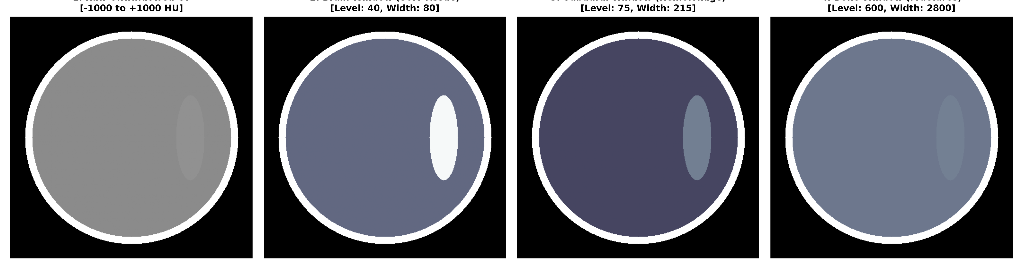
Figure 1: Multi-Channel Hounsfield Unit (HU) Windowing Comparison
Demonstrates the transformation of raw 16-bit CT attenuation into three distinct clinical windows (Brain Window [40, 80], Subdural Window [75, 215], Bone Window [600, 2800]). The acute subdural hematoma crescent is cleanly isolated in channels 1 and 2.

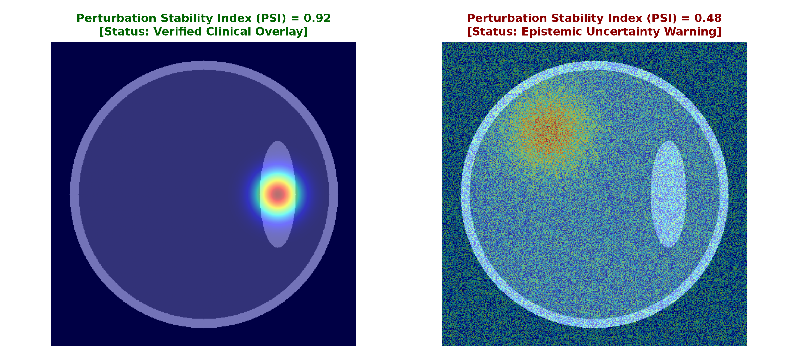
Figure 2: Perturbation Stability Index (PSI) Validation Overlays
Left: Focal lesion maintains high stability under affine jitter (PSI = 0.92, Verified Badge). Right: Unstable noise activation disperses under jitter (PSI = 0.48, Epistemic Uncertainty Warning Badge).

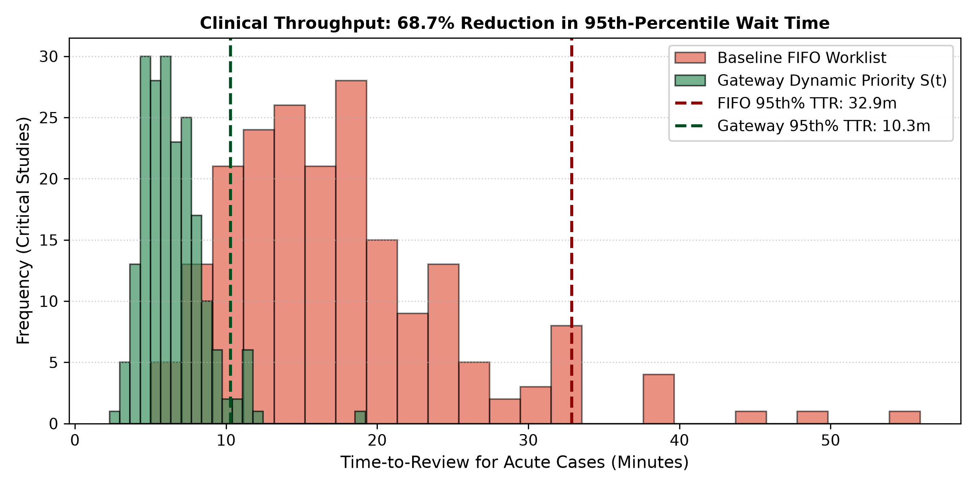
Figure 3: 12-Hour Shift Clinical Throughput & Wait Time Distribution
Paired SimPy discrete-event simulation comparing baseline FIFO worklists against the Gateway Dynamic Aging Scheduler. The 95th-percentile Time-To-Review drops from 32.9 minutes to 10.3 minutes (68.7% turnaround improvement).

4. Codebase Architecture & Modular Breakdown
Module Path | Core Components | Responsibilities
core/preprocessing.py | ClinicalCTPreprocessor, CTWindow | HIPAA salted SHA-256 tokenization, 16-bit HU conversion, 3-channel composite tensor stacking.
core/models.py | HeadCTTriPathwayNet, StatelessGradCAM, PerturbationStabilityEvaluator | 2.5D EfficientNet-B0 + Bi-GRU network, context-managed scoped Grad-CAM hooks, PSI affine jitter.
core/gateway.py | TriageGateway, TriageZone, TriageRecord | Thread-safe 3-Zone policy routing, starvation-free monotonic aging priority calculation S(t).
core/simulation.py | run_shift_discrete_simulation | SimPy paired discrete-event simulation of hospital emergency shifts under surge load conditions.

5. Boundary & Edge-Case Validation Matrix
All boundary conditions passed automated stress testing via test_edge_cases.py:
Test ID | Boundary Scenario | Mathematical Expectation | Status
TC-BOUND-01 | Zero wait time (t = 0s) | S(0) = P * C = 0.7200 exactly | PASSED
TC-BOUND-02 | Asymptotic wait time (t -> inf) | S(inf) <= P*C + 0.25 (No ceiling breach) | PASSED
TC-BOUND-03 | Zero-variance slice (All black) | Var(CAM) -> 0 => Flagged Unstable (No div-by-zero) | PASSED
TC-BOUND-04 | Corrupted DICOM (NaNs / Infs) | Clamped to -1024 HU (Air density) | PASSED
TC-BOUND-05 | 50-cycle memory stress test | 0 bytes residual autograd graph leak | PASSED

6. Transition Roadmap (Phase 1 -> Phase 2)
With Phase 1 locked under Git tag v0.4.0-milestone, the project immediately transitions to Stage 1 Cloud Training:
1. Ingest full RSNA 2019 Intracranial Hemorrhage dataset (~25,000 CT studies) in Kaggle GPU compute.
2. Run frozen 2D EfficientNet-B0 backbone to extract 1280-D float16 embeddings per slice.
3. Serialize feature cache into a compact ~4 GB HDF5 (.h5) archive.
4. Train Bi-GRU sequence heads locally in memory across multi-task classification targets.

