Assignment 3

Q1. Define a function overlapping () that takes two lists and returns True if they have at least one member in common, False otherwise.

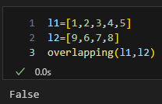

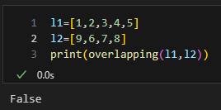

def overlapping(l1,l2):

    len1=len(l1)

    len2=len(l2)

    s=set(l1+l2)

    len3=len(s)

    if len3!=len1+len2:

        return True

    elif len3==len1+len2:

        return False

Q.2. Write a function find_longest_word() to find the longest word from the list of words

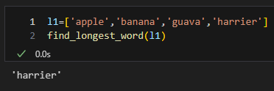

def find_longest_word(l1):

    longest_word=''

    for i in l1:

        if len(i)>len(longest_word):

            longest_word=i

    return longest_word

Q.3.In English, present participle is formed by adding suffix -ing to infinite form: go -> going. A simple set of rules can be given as follows:

a. If the verb ends in e, drop the e and add ing

b. If the verb ends in ie, change ie to y and add ing

Write a function make_ing_form() which accepts a list of verbs and returns a dictionary with verb : present participle

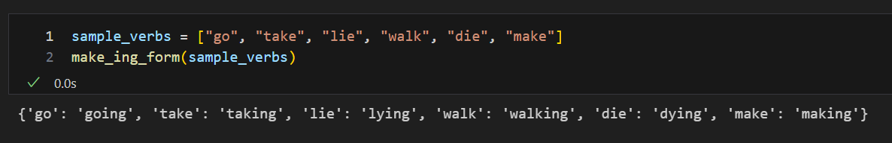

def make_ing_form(l1):

    d1={}

    for i in l1:

        word=i

        if word[-1]=='e':

            word=word[:-1]

        if word[-1]=='i':

            word=word[:-1]+'y'

        word=word+'ing'

        d1[i]=f'{word}'

    print(d1)

Q.4. Decorate the display_greeting() function using a decorator so that greeting is displayed in uppercase

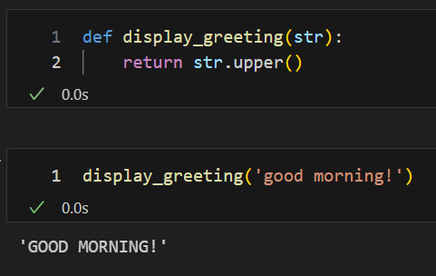

def display_greeting(str):

    return str.upper()

Q. 5. Create a infinite series on fib numbers and print first few

Q.6

1.Find employees that know 'python'

2. Add a new skill - 'test' in skillset of all employees

3. Sort employees by skills

for the given dictionary of employees

emp_data = {'Amol': ['C', 'C++', 'Java'], 'Aditya': ['Angular', 'Java'],

'Aditi': ['Python', 'PHP', 'Database']}

Q.7

Following data displays min/max/average temp for cities

weather= [{'Mumbai' : [28, 30, 32]},.....]

1. Print the weather data

2. Print the city with maximum/min temp

3. Print all the cities that expereince min temp more than 30 degree

4. Create a dictionary to print 'City':'Ave temp'

[Rotate Array](https://www.geeksforgeeks.org/problems/rotate-array-by-n-elements-1587115621/1)

