Assignment 4

Q 1. Create a class 'Student' with rollno, studentName, course ,dictionary of

marks(subjectName -> marks [5]). Provide following functionalities

A. initializer

B. override __str__ method

C. accept student data

D. Print student data for given id.

E. Print Student who has failed in any subject.

Write menu driven program to test

above functionalities.( accept records of 5 students and store those in list )

2. Write a menu driven program to maintain student information. for every student

store studetid, sname, and m1,m2,m3 marks for 3 subject. also store gpa in

student list, add a function in student class to return GPA of a student

- Calculate GPA()

gpa=(1/3)*m1+(1/2)*m2+(1/4)*m3

Create list to store Multiple students.

1. Display All Student

2. Search by id

3. Search by name

4. Calculate GPA of a student

5. Exit

[Missing And Repeating](https://www.geeksforgeeks.org/problems/find-missing-and-repeating2512/1)

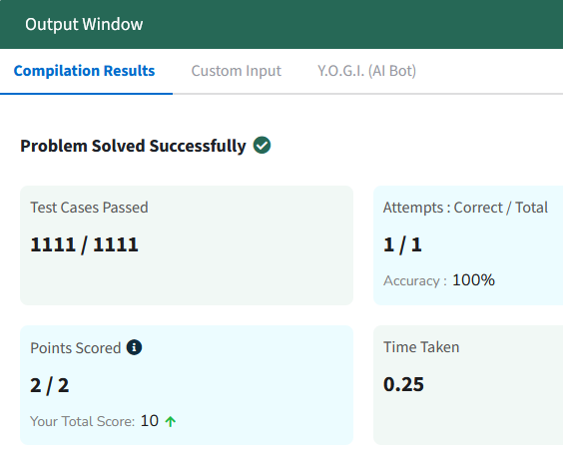

def RepeatingAndMissingNumbers(arr):

    n=arr_len=len(arr)

    m=0

    r=0

    s=(n*(n+1))//2 #expected_sum

    s2=(n*(n+1)*(2*n+1))//6 #expected_sum_sq

    arrs=sum(arr) #arr_sum

    arrs2= sum(i**2 for i in arr) #arr_sum_sq

    d1=arrs-s

    d2=arrs2-s2

    m=int(((d2/d1)-d1)//2)

    r=int(((d2/d1)+d1)//2)

return (r,m)

[Peak Element](https://www.geeksforgeeks.org/problems/peak-element/1)

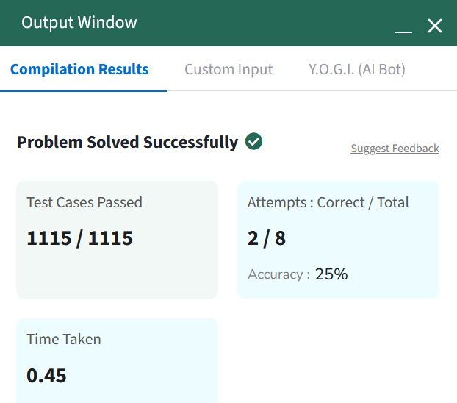

def peak(arr):

    n=len(arr)

    # For array size 1

    if n==1:

        return 0

    # if the 1st value is peak

    if arr[0]>arr[1]:

        return 0

    # if the last value is peak

    if arr[n-1]>arr[n-2]:

        return n-1

    # for array size != (1 or 2)

    # the iteration should not iterate in the polar elements

    # therefore the range(1 to n-1)

    iterr=range(1,n-1)

    for i in iterr:

        # if the element is greater than max of both,

        # it will be greater than both of them

        if arr[i] > max(arr[i-1], arr[i+1]):

            return i