**SETL ESE 2023**

**PRN: 2020BTECS00033**

**Name: Prathamesh Santosh Raje**

**Batch: T6**

**Problem Statement:**

Create and execute testcases using TestLink for Myntra.com like e-commerce website.

**Installation of TestLink:**

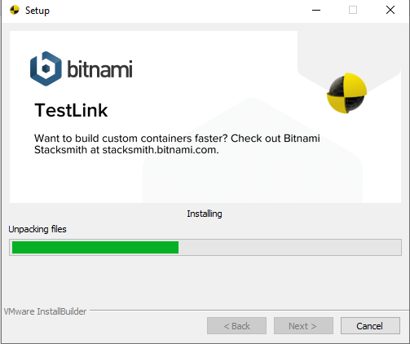

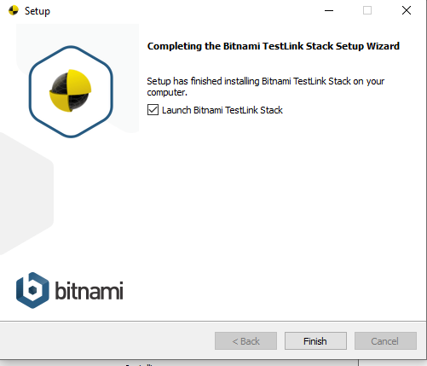

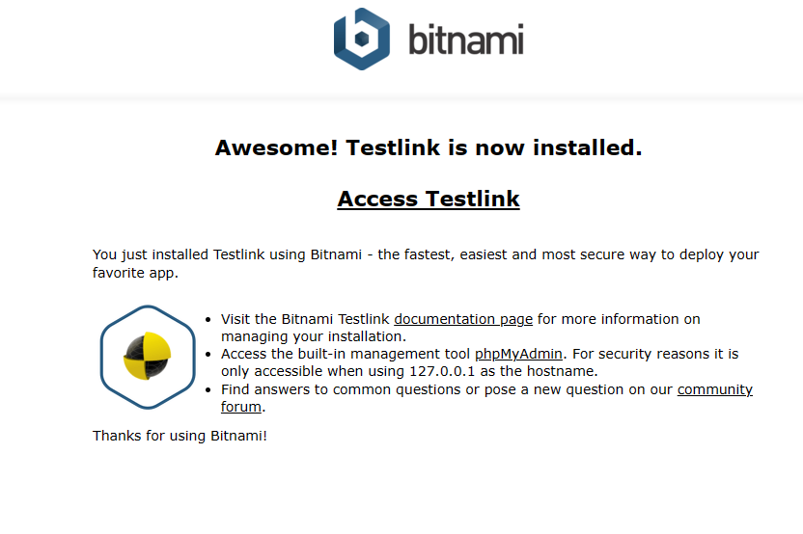

Login:

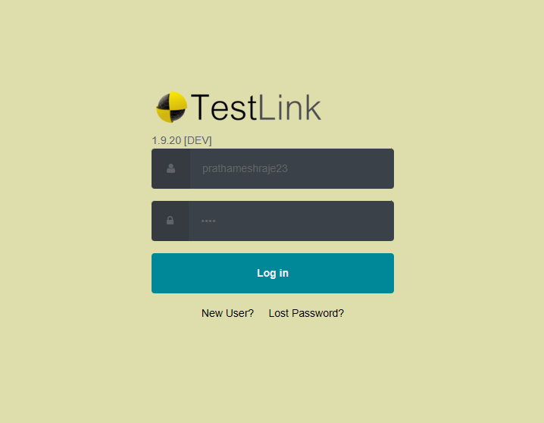

TestLink UI:

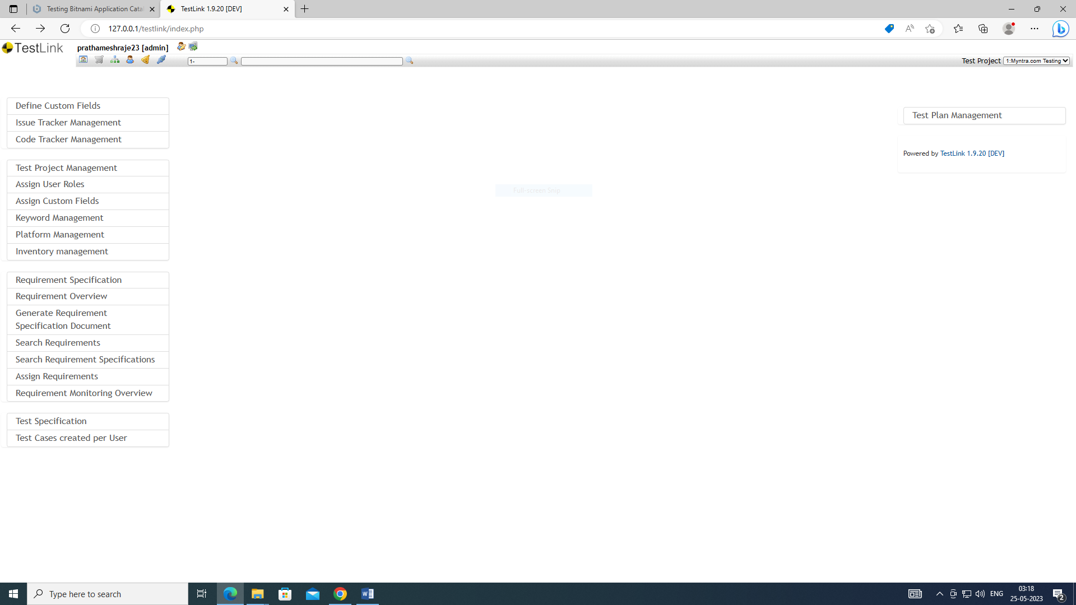

Creating a new project:

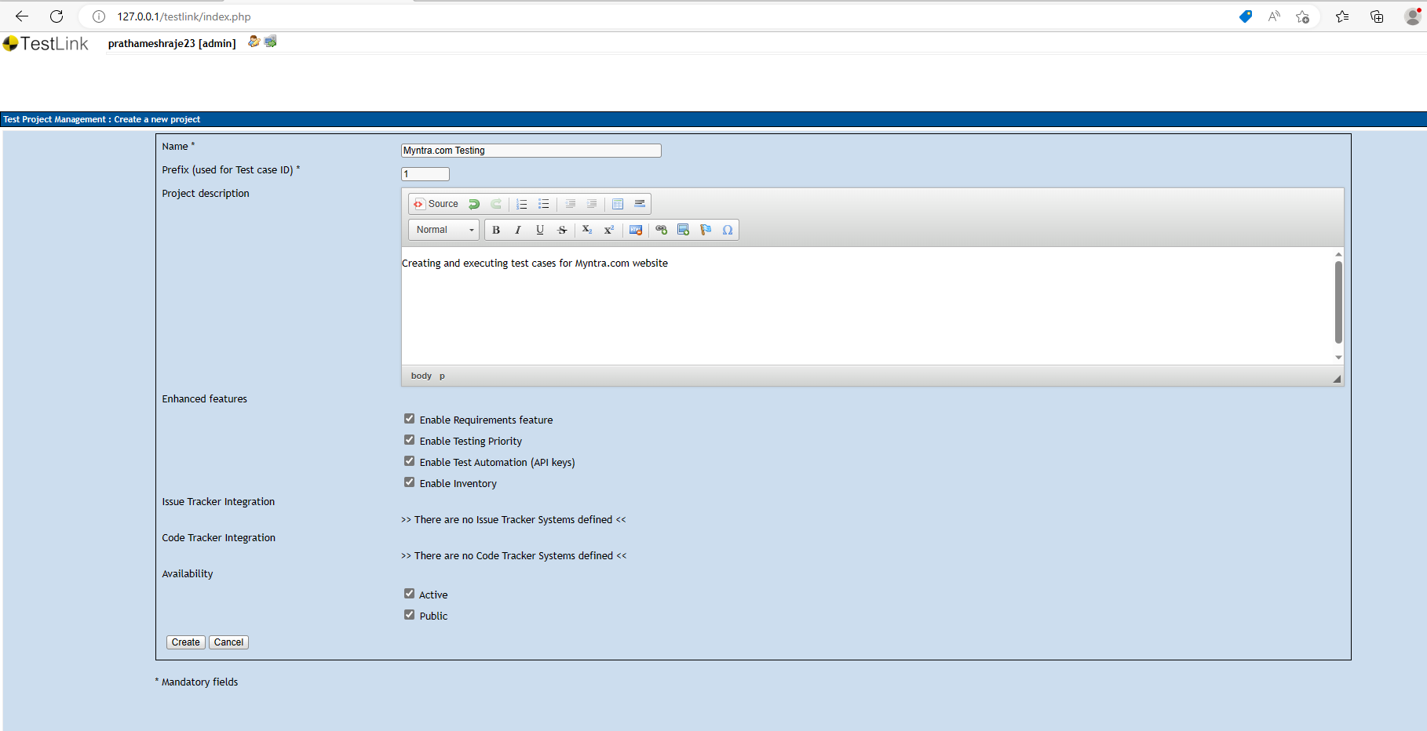

Created Project:

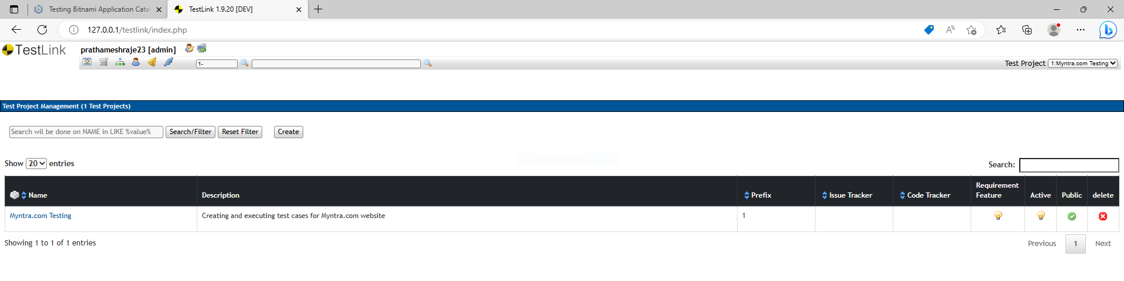

Creating a Test Plan:

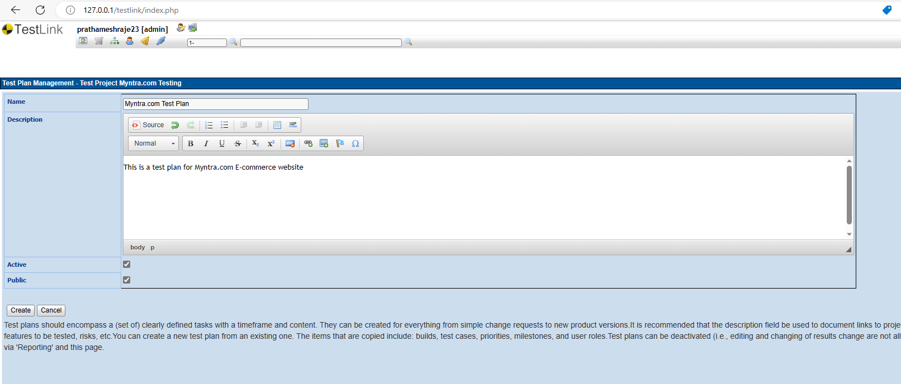

Created Test plan:

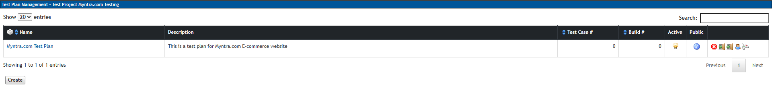

Creating a Build:

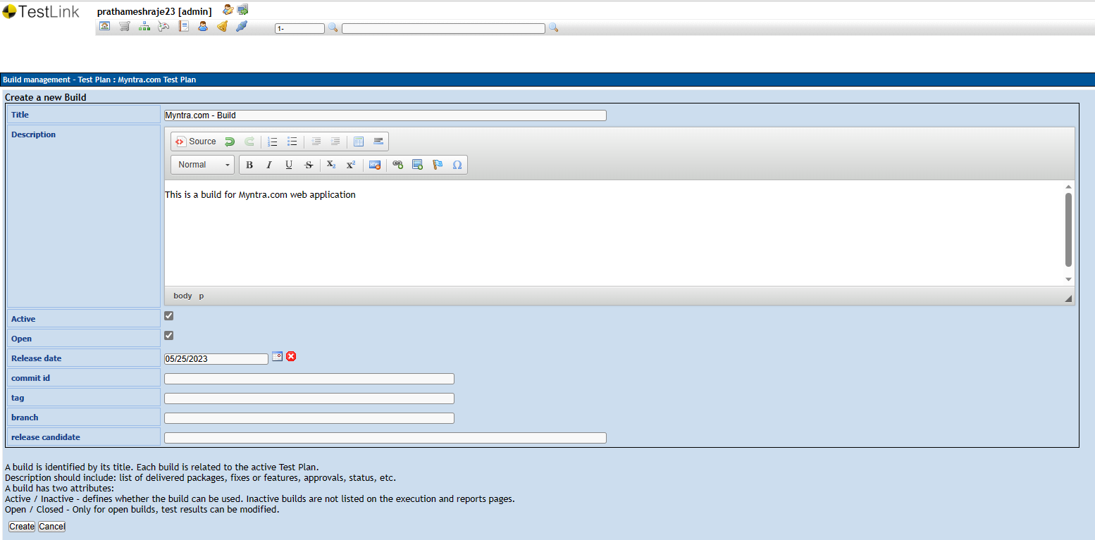

Created Build:



Creating testsuite:

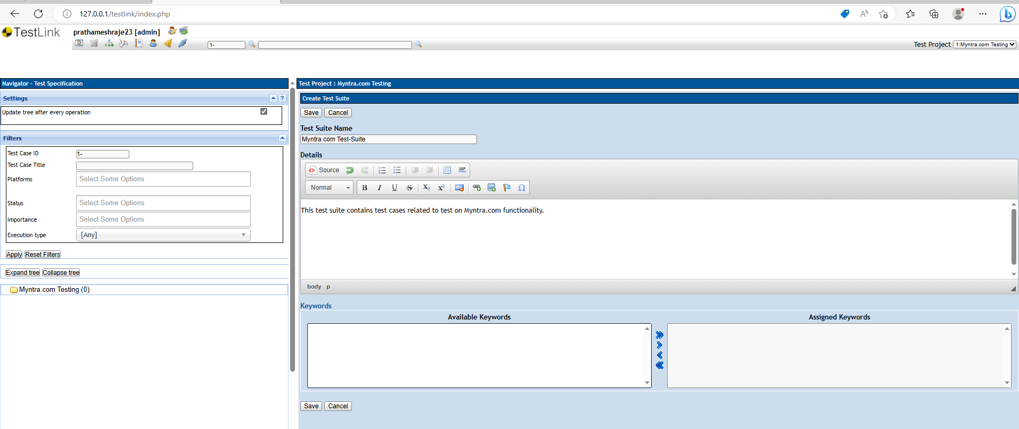

Created testsuite:

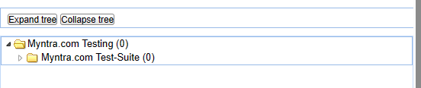

Creating Test Case:

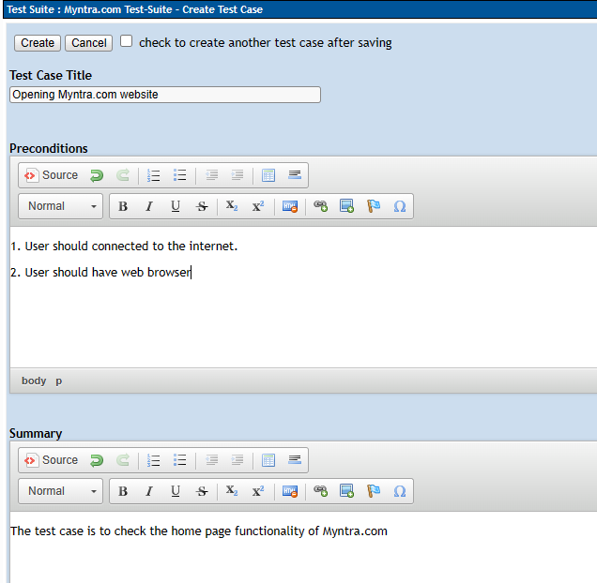

Created Test cases:



Creating steps for test case:

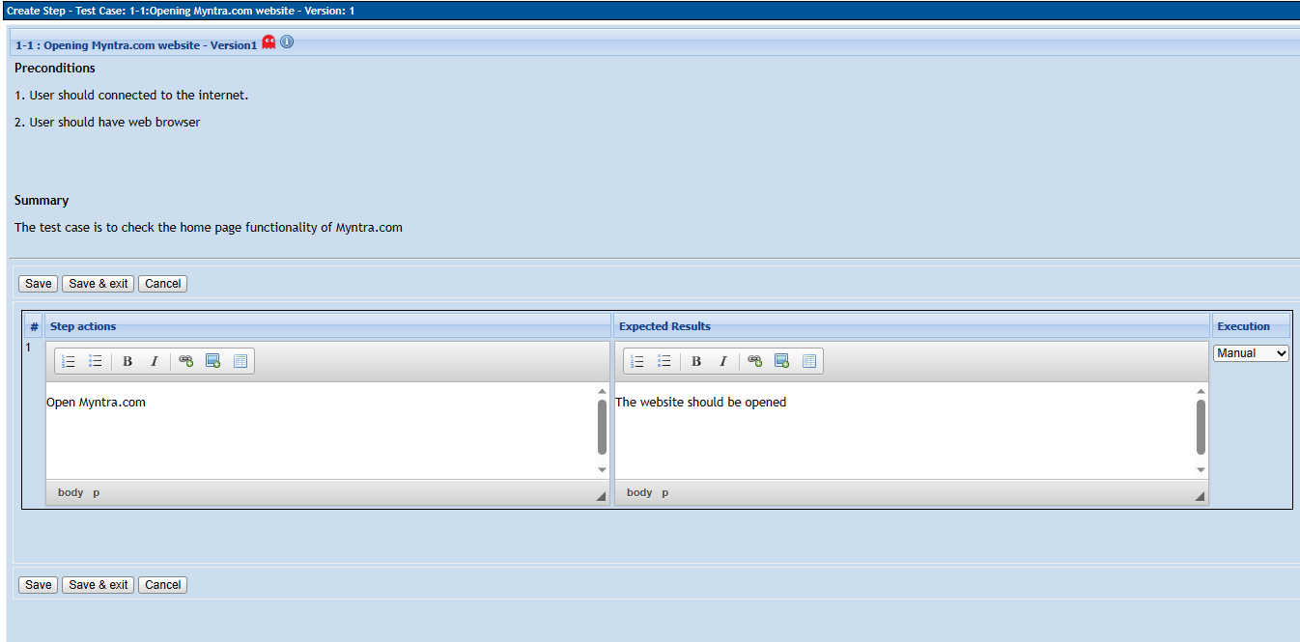

Created all test cases and their steps as done above:

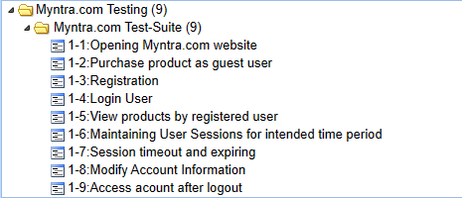

Assigning Test cases to Test Plan:

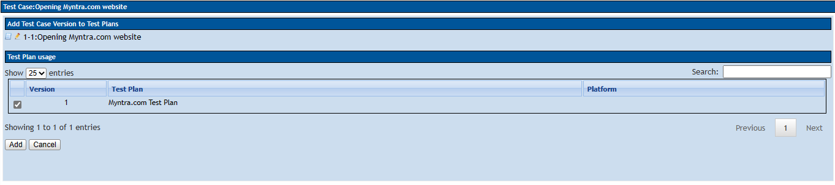

Creating users and assigning Roles:

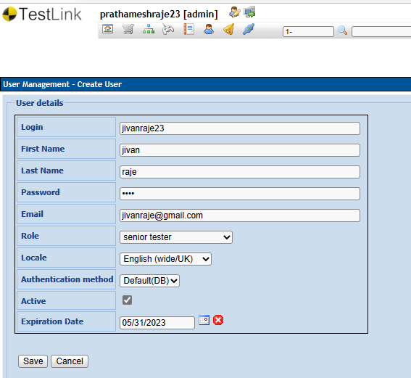

All Users:

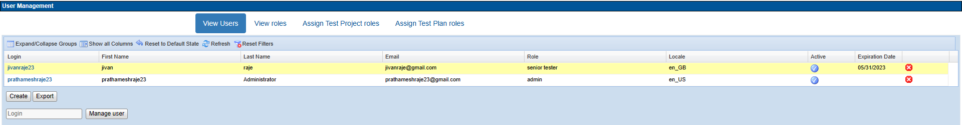

Assigning Test Project Roles:

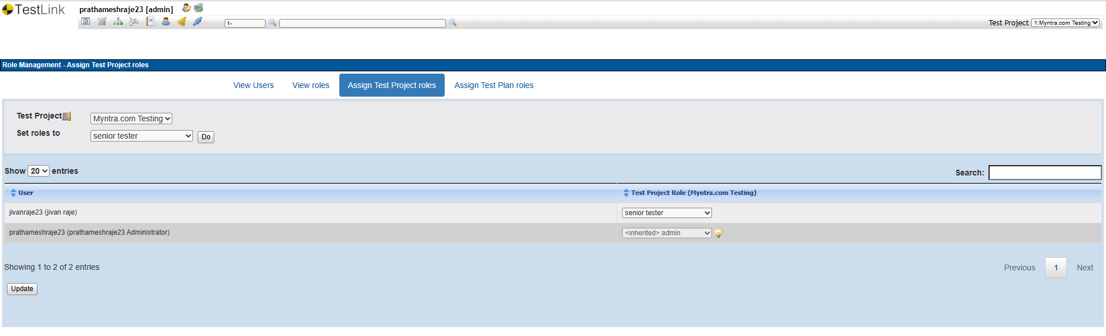

Executing Test Case:

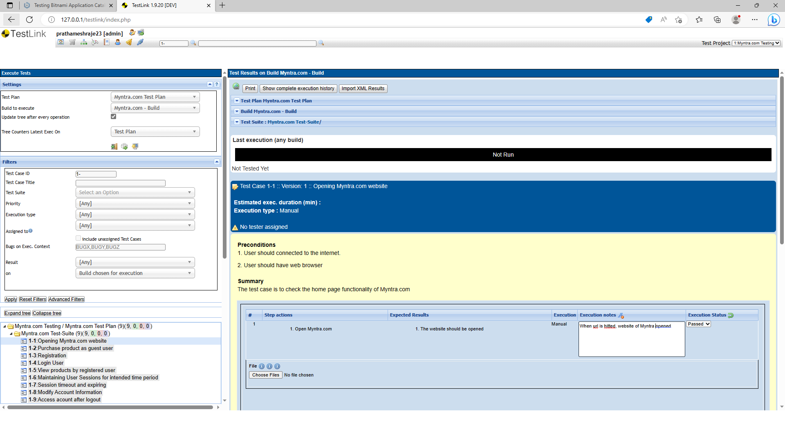

Passed first Test Case:

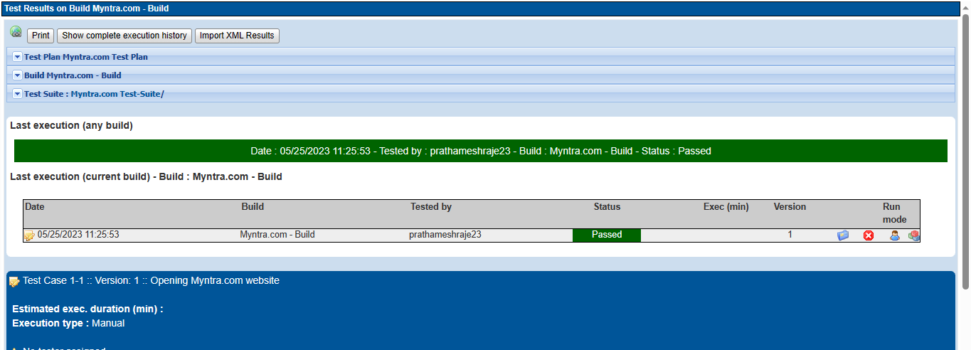

Similarly, other test cases passed.

Generating Test Reports:

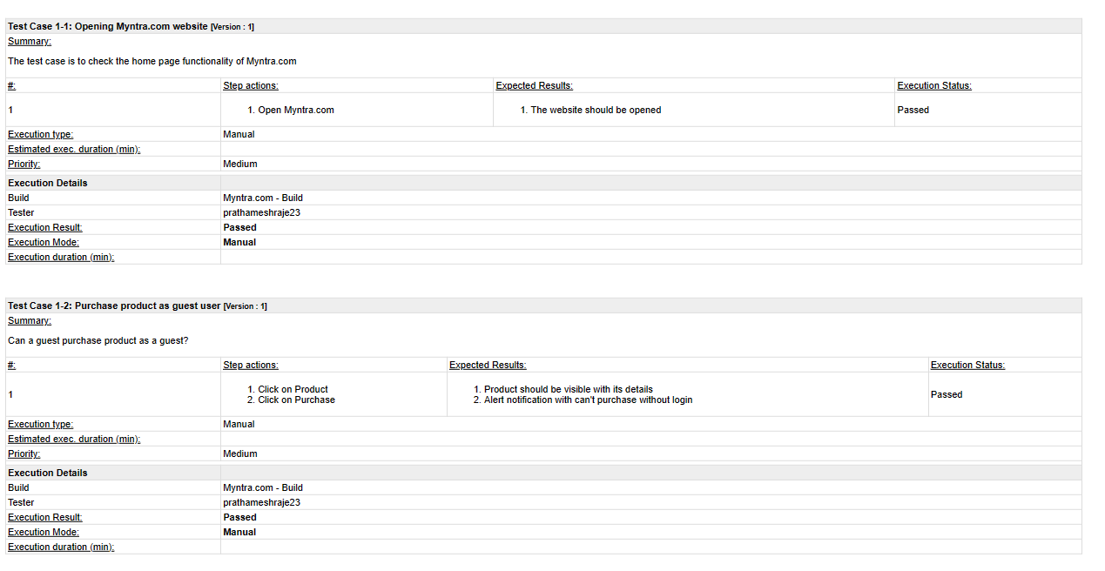

General test plan matrix:

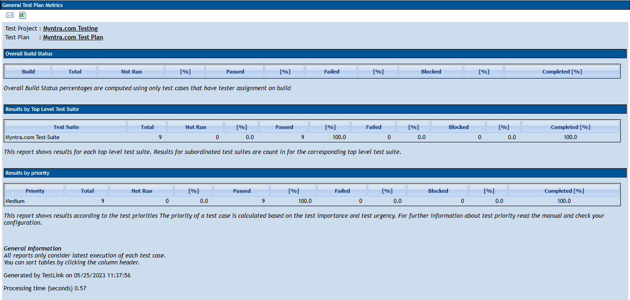

**Conclusion:**

1. User can’t purchase product as guest user
2. User can register easily
3. User can login successfully.
4. Registered user is able to view all products
5. Session for user is maintained for intended time period
6. Session is timing out and expiring after defined time
7. Registered user can modify account information
8. After logout user can’t access account without login

Testing for Myntra.com using TestLink done successfully.