# QUESTION 1.

Grep is a command used to search pattern line by line in document. grep stands for GLOBAL REGULAR EXPRESSION PRINT . This filters the searched pattern from the document line by line. In example I already created a document ques1document and then insert some text in that and search ‘am’ with grep command.-i is used with grep to search for uppercase pattern also.

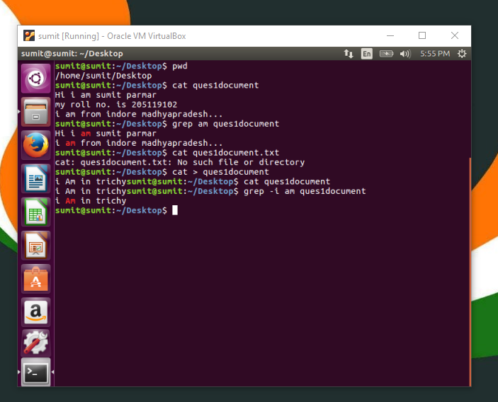

**QUESTION 2**

*As linux is a multiuser operating system so for security reason user had to set permissions for groups and others . mainly there are three types of permissions read ,write and execute denotes as r w and x . Read permission is to open and read a file. write permission gives an authority to add remove and rename a file. Execute permission is for running a file.*

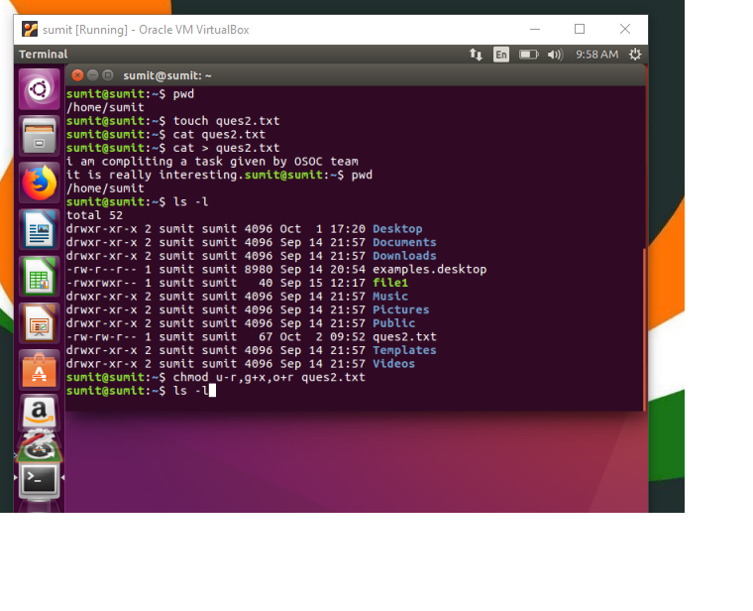

*I created a file named as ques2 and insert some text in that and than check the permissions of that file by ls command and than change the permission for user group and others by using chmod command as explained in below image.*

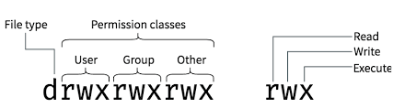

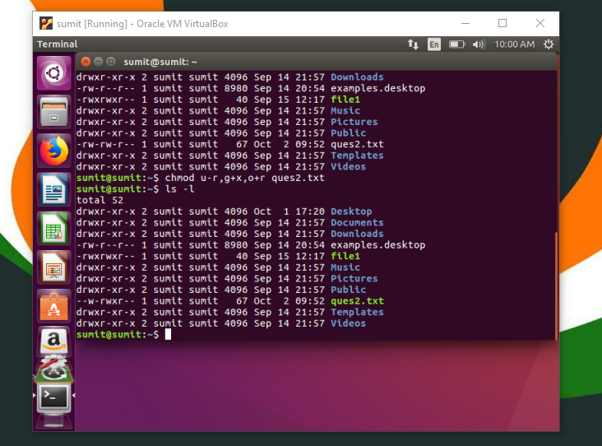

**QUESTION 3**

*First I make folder OSOC by using mkdir command , than by cd command I entered to folder OSOC and make another folder inductions with the help of mkdir comm..*

*By using touch I made a text file named as task with the help of cat command I entered some text to task.txt and returned to OSOC by cd .. command and created another folder Workshop in OSOC folder by using mkdir command.*

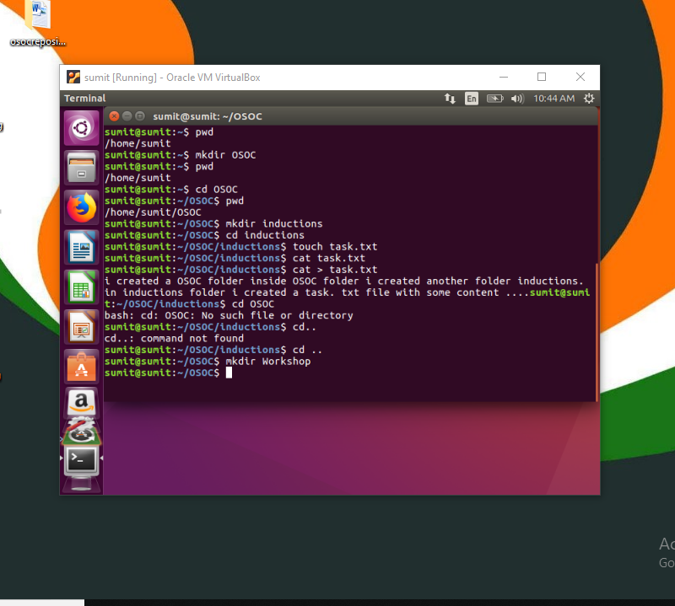

In below window, By pwd command I check my working directory and entered to OSOC and inductions folder with the help of cd command and ,than I see the file details with the help of ls command and ,than by using cp command I copy the file From the initial position to its destination position. As you can see the syntax in below picture that how you have , to put the address of initial position of file and final position of file in the cp command.

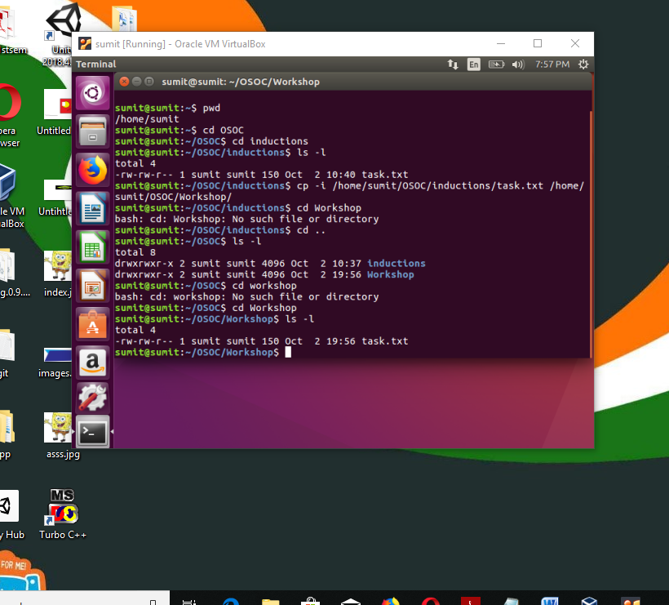

**Question 4**

*ping and ifconfig commands are used to check the network connection of the*

*internet excess on virtual machine .*

*Ping is used to check the network connectivity .*

*And ifconfig is used to display the configuration for a network .*

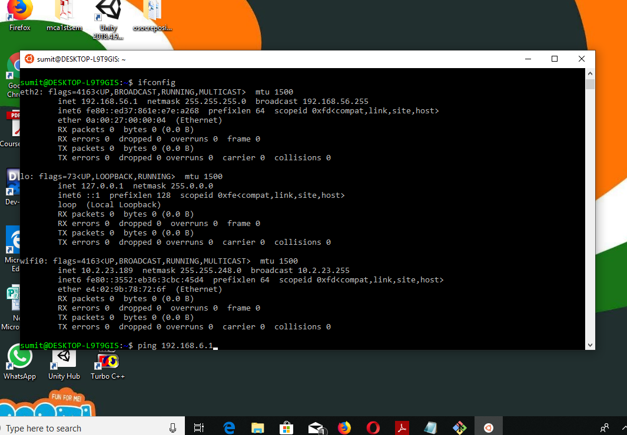

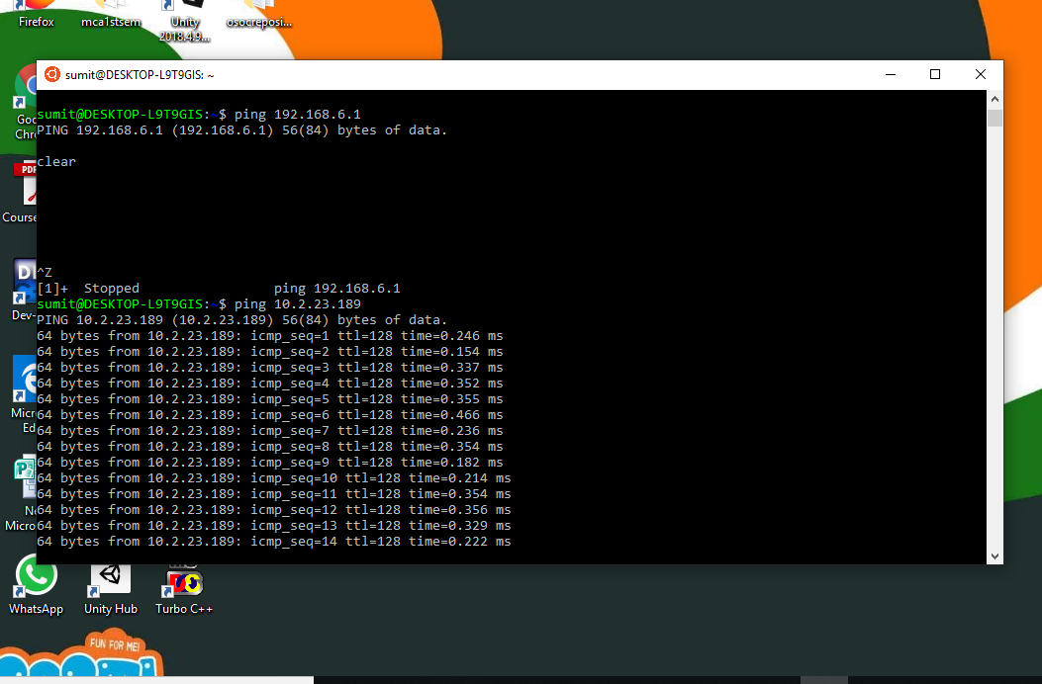

**Question 5**

*To change the password of another user who is using the machine we use the following command .*

*Syntax:*

***sudo passwd nameofuser***

*Example :*

*If there is a user named as OSOC and we want to change the password for this user than we run a command as*

*sudo passwd OSOC*

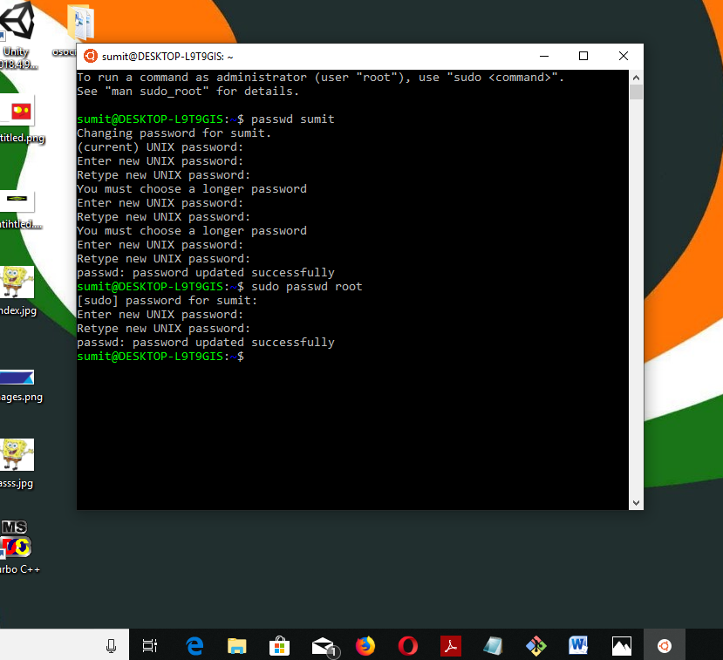

**Question 6**

**Question 7**

**Question 8**

*Branching is the process in which we create a copy of each and every programs or objects in development to work on them in parallel versions , In which we either retain the original programs or objects or either make different changes to each.*

*It is useful in many ways as when you want to add or make changes to any program or object or fix a bug no matter how big or how small it is you have to make a new branch to makes changes as mentioned above .*

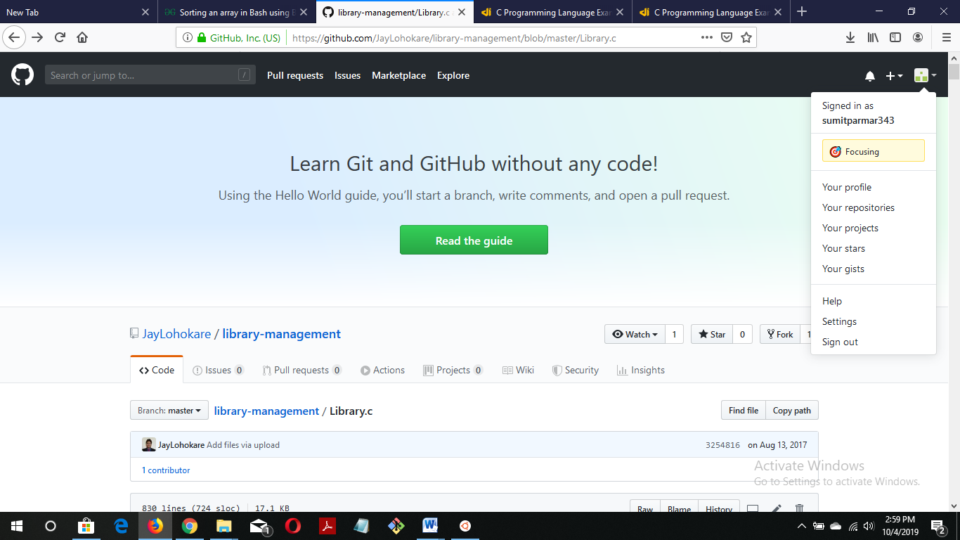

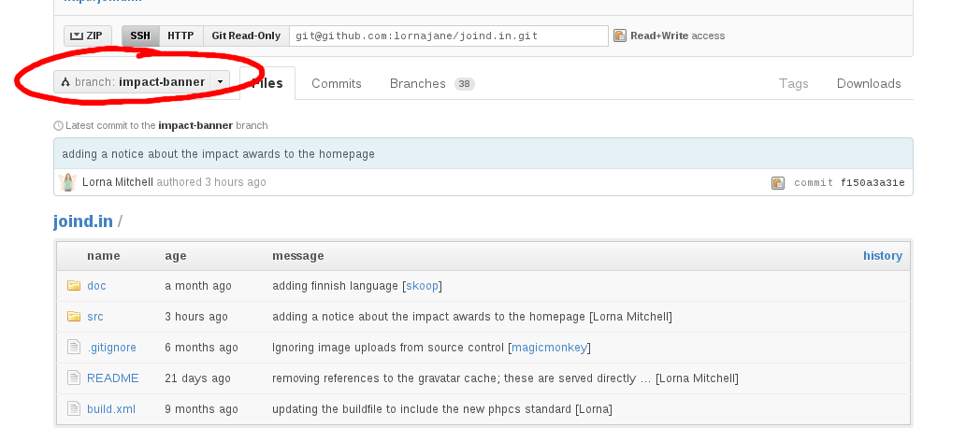

*As we can see the above example that the branch master of library management is created by user there and if any user want to make changes to that program than the user has to create the separate branch for the same and make changes to that new branch that the user created.*

**Question 9**

*Push is used to transfer the last commit to a remote server and also it creates the named branch in the remote repository if it does not exit .*

*For example :*

*git push <remote name > <branchname>*

*git push origin master*

*Commit is used to add changes to the local repository or it is used to record our changes to local repository .*

*For example :*

*git commit*

*Pull command is used to fetch and download content from a remote repository and immediately update the local repository to match that content.*

*For example :*

*Git pull <remote>*

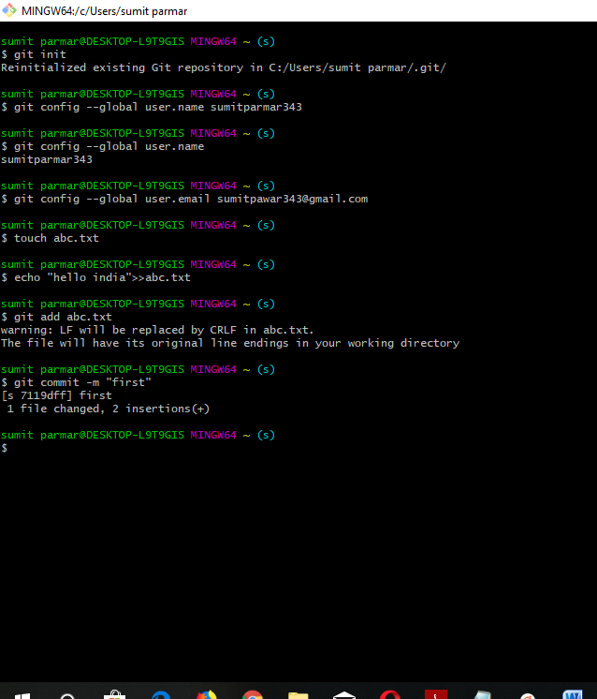

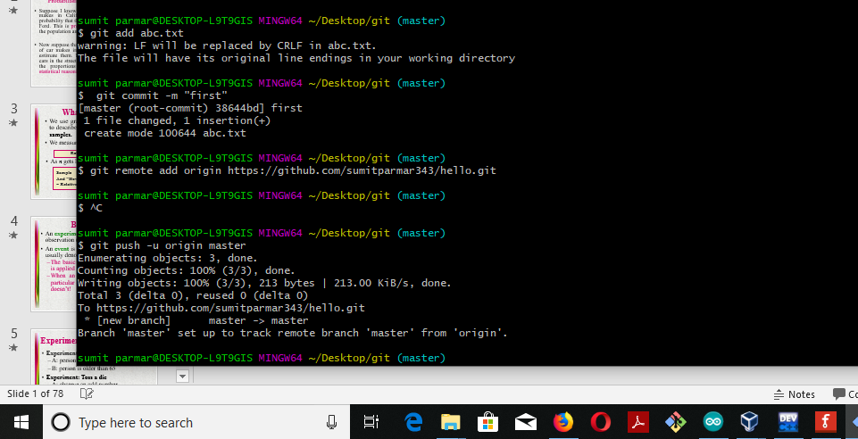

**Question 10**

**Question 11**

**Question 12**

**Question 13**

**Question 14**