Front End Engineering-II

Project Report Semester-IV (Batch-2022)

Digital & Analog Clock



**Supervised By:**

Raveesh Samkaria

**Submitted By:**

Sumit Parsad

Roll Number: -2210990873

Group - 13

## Department of Computer Science and Engineering Chitkara University Institute of Engineering & Technology,

**Chitkara University, Punjab**

FEE-II, 22CS0014

1

# Abstract

"Samay-verse" is a multifaceted web project showcasing analog and digital clocks alongside a dark mode feature. The website offers a unique blend of traditional and modern timekeeping displays, catering to diverse user preferences. Its dark mode functionality enhances usability in low-light environments and adds a stylish aesthetic dimension to the user experience.

Key features of "Samay-verse" include:

Clock Displays: Integration of analog and digital clocks, providing users with versatile time presentation options.

Dark Mode: Implementation of a dark mode feature for enhanced readability and visual appeal in darker settings.

Customization: Options for users to customize clock styles, colors, and layouts according to personal preferences.

Responsive Design: Utilization of responsive design principles to ensure optimal viewing across devices and screen sizes.

User-Friendly Interface: Intuitive navigation and interactive elements designed to facilitate seamless clock exploration and interaction. The project's development prioritizes accessibility, usability, and aesthetic appeal, aligning with contemporary web design standards. By offering a range of clock display options and customization features, Samay-verse aims to provide users with a delightful and personalized timekeeping experience.

This abstract encapsulates the essence of Samay-verse, highlighting its innovative approach to clock displays and user interface design.

FEE-II, 22CS0014

2

# Table of Contents

|  |  |  |
| --- | --- | --- |
| **Sr.no** | **Section** | **Page No.** |
| **1** | **Introduction** | 4 |
| **2** | **Problem Statement** | 5 |
| **3** | **Technical Details** | 6 |
| **5** | **File Structure** | 7 |
| **6** | **Result** | 8-19 |
| **7** | **References** | 20 |
|  |  |  |

FEE-II, 22CS0014

3

# Introduction

In today's digital landscape, online presence is paramount for effective service delivery and user engagement. "Samay-verse" embodies this ethos by offering a unique blend of analog and digital clocks with a dark mode feature, catering to diverse user preferences.

This project showcases the fusion of HTML, Bootstrap, and JavaScript to create a visually appealing and functional website. The inclusion of dark mode not only enhances usability but also adds a touch of elegance to the user interface.

"Samay-verse" prioritizes user interaction and customization, reflecting a deep understanding of user needs. Through its commitment to accessibility and user-centric design, the project delivers a seamless and personalized timekeeping experience for all users.

Join us as we explore the innovative journey of "Samay-verse," where technology and design converge to redefine the art of timekeeping in the digital age.

FEE-II, 22CS0014

4

# Problem Statement

Crafting an immersive online platform like "Samay-verse" in the digital timekeeping domain presents a myriad of challenges. Achieving a harmonious blend between captivating visual aesthetics and functional usability is paramount, ensuring that users not only find the design appealing but also experience seamless interaction. Moreover, the intricate task of ensuring the website's adaptability across diverse devices, coupled with strict adherence to accessibility standards, poses a significant technical hurdle.

One of the key challenges lies in designing a user interface that seamlessly integrates analog and digital clock displays with a dark mode feature, catering to diverse user preferences while maintaining a cohesive and visually appealing experience. This requires careful consideration of color schemes, layout optimization, and interactive elements to enhance usability. Additionally, ensuring consistent performance and accessibility across devices, including desktops, laptops, tablets, and smartphones, demands a meticulous approach to responsive design and accessibility standards. Overcoming these challenges is crucial for "Samay-verse" to deliver a compelling and inclusive timekeeping solution that resonates with a wide range of users in today's digital landscape.

FEE-II, 22CS0014

5

# Technical Details

The website for "Samay-verse" was developed with a strategic approach, utilizing essential technologies to create a responsive and efficient user interface. Here are the key technical aspects of the project:

**HTML Structure:** Semantic HTML was employed to structure the website, enhancing accessibility and readability. Each page was organized with appropriate tags to facilitate smooth navigation and present timekeeping features clearly.

**Bootstrap Framework:** The Bootstrap framework was utilized to implement responsive design principles seamlessly. Leveraging Bootstrap's grid system and components ensured that the website layout adjusts smoothly to different screen sizes, enhancing user experience across devices.

**CSS Styling:** Cascading Style Sheets (CSS) were used to style the website's layout, typography, and color scheme. Custom CSS rules were applied to maintain a consistent visual identity while optimizing page load times and ensuring code simplicity.

**JavaScript Implementation:** JavaScript played a crucial role in enhancing the website's functionality and interactivity. Key features included dynamic clock displays, dark mode toggle, and user-friendly interactions for seamless navigation and customization options.

FEE-II, 22CS0014

6

# File Structure: -

**index.html:** This file acts as the core structure of the website, housing the HTML markup that defines the layout and content. It includes sections like the header, clock displays (analog and digital), dark mode toggle. Each section is meticulously designed to ensure a seamless and intuitive user experience.

**style.css:** The CSS file is responsible for styling the visual elements of the website. It contains rules for colors, spacing, responsiveness, and overall aesthetics. Selectors within this file target specific HTML elements or classes to apply consistent and appealing styles, ensuring a cohesive and visually pleasing design across the site.

**script.js:** This JavaScript file adds dynamic functionality and interactivity to the website. It handles clock functionalities, dark mode toggle implementation, user interactions for customizing clocks, and any animations or transitions for a smooth user experience. The script optimizes performance and ensures that the website responds effectively to user actions.

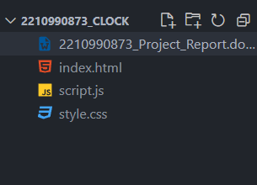

FEE-II, 22CS0014

7

**Result:-**

**HTML:-**

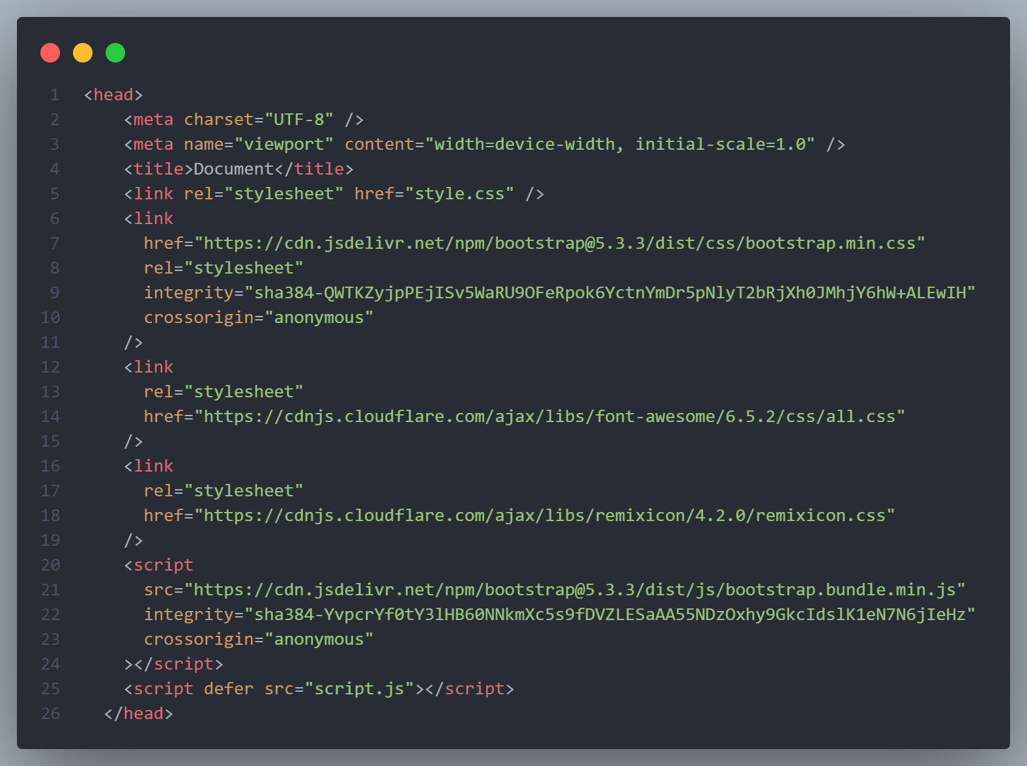

**Head Tag**

FEE-II, 22CS001

8

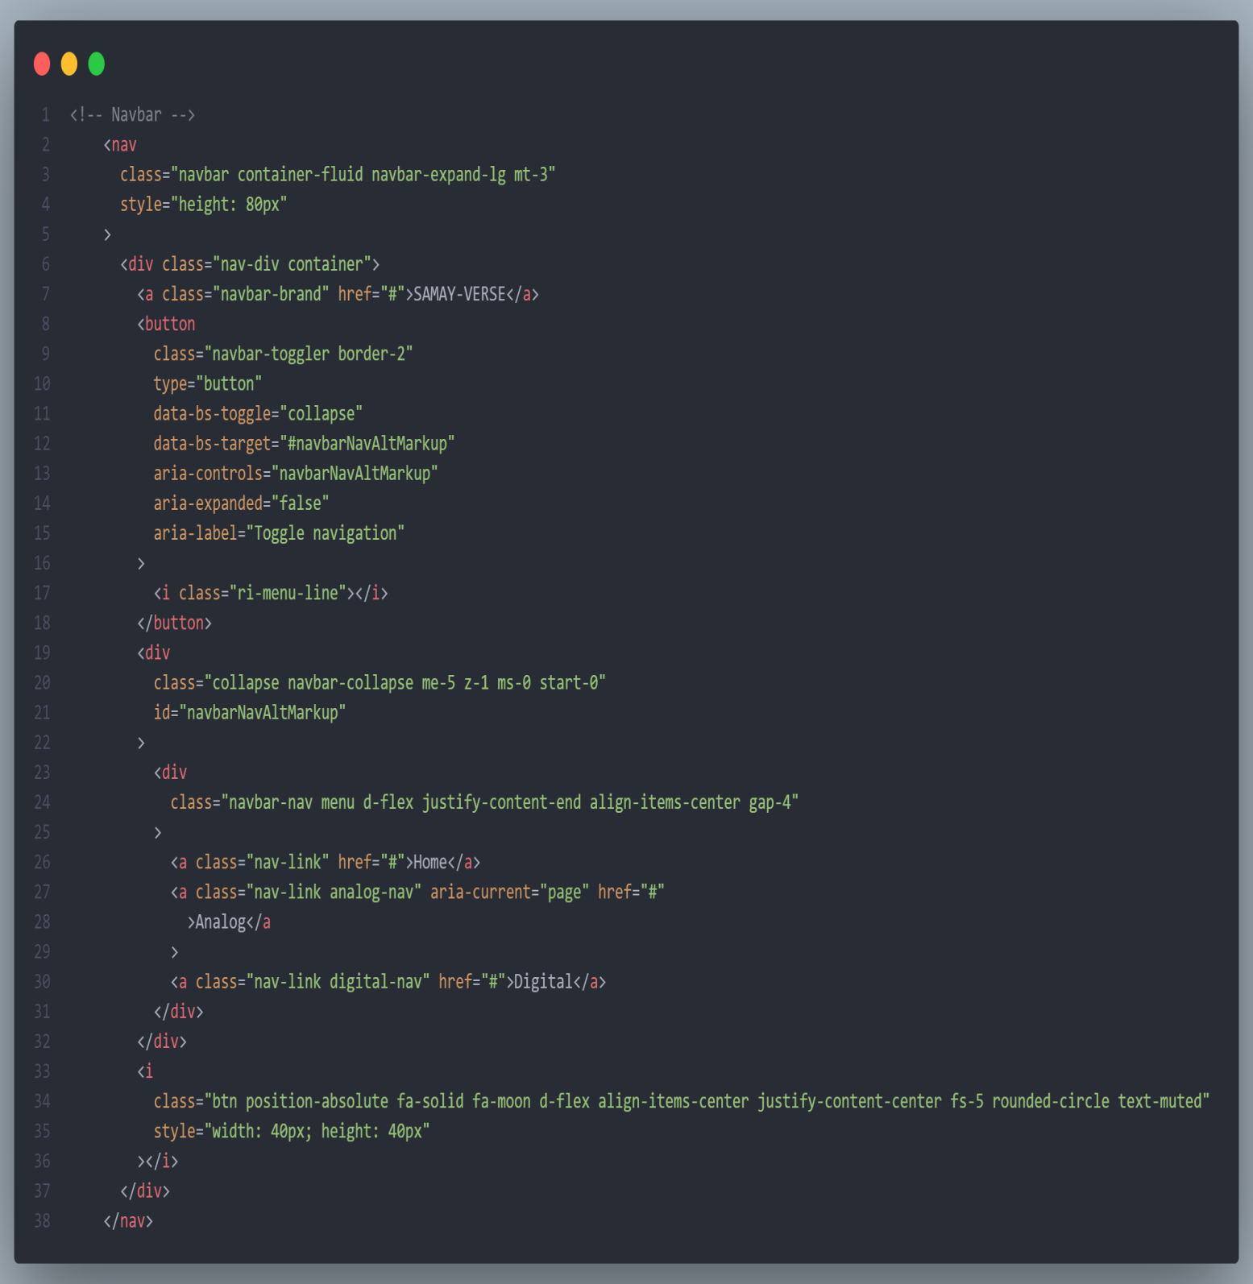

**Navbar**

FEE-II, 22CS001

9

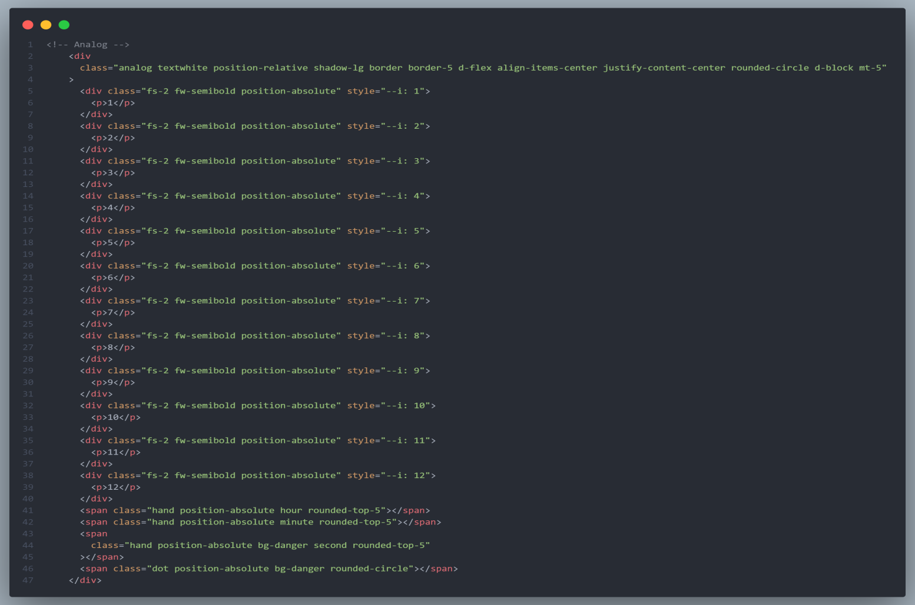

**Analog Clock**

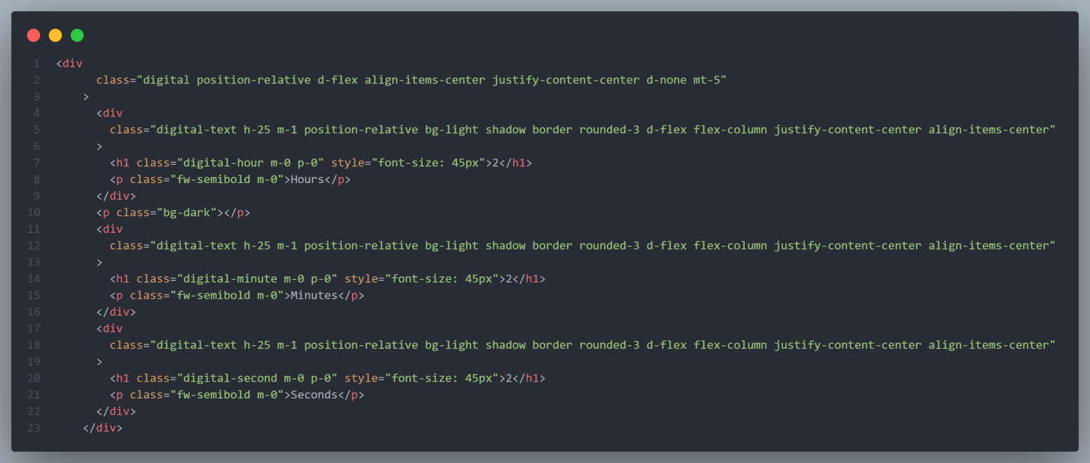

**Digital Clock**

FEE-II, 22CS0014

10

**CSS:-**

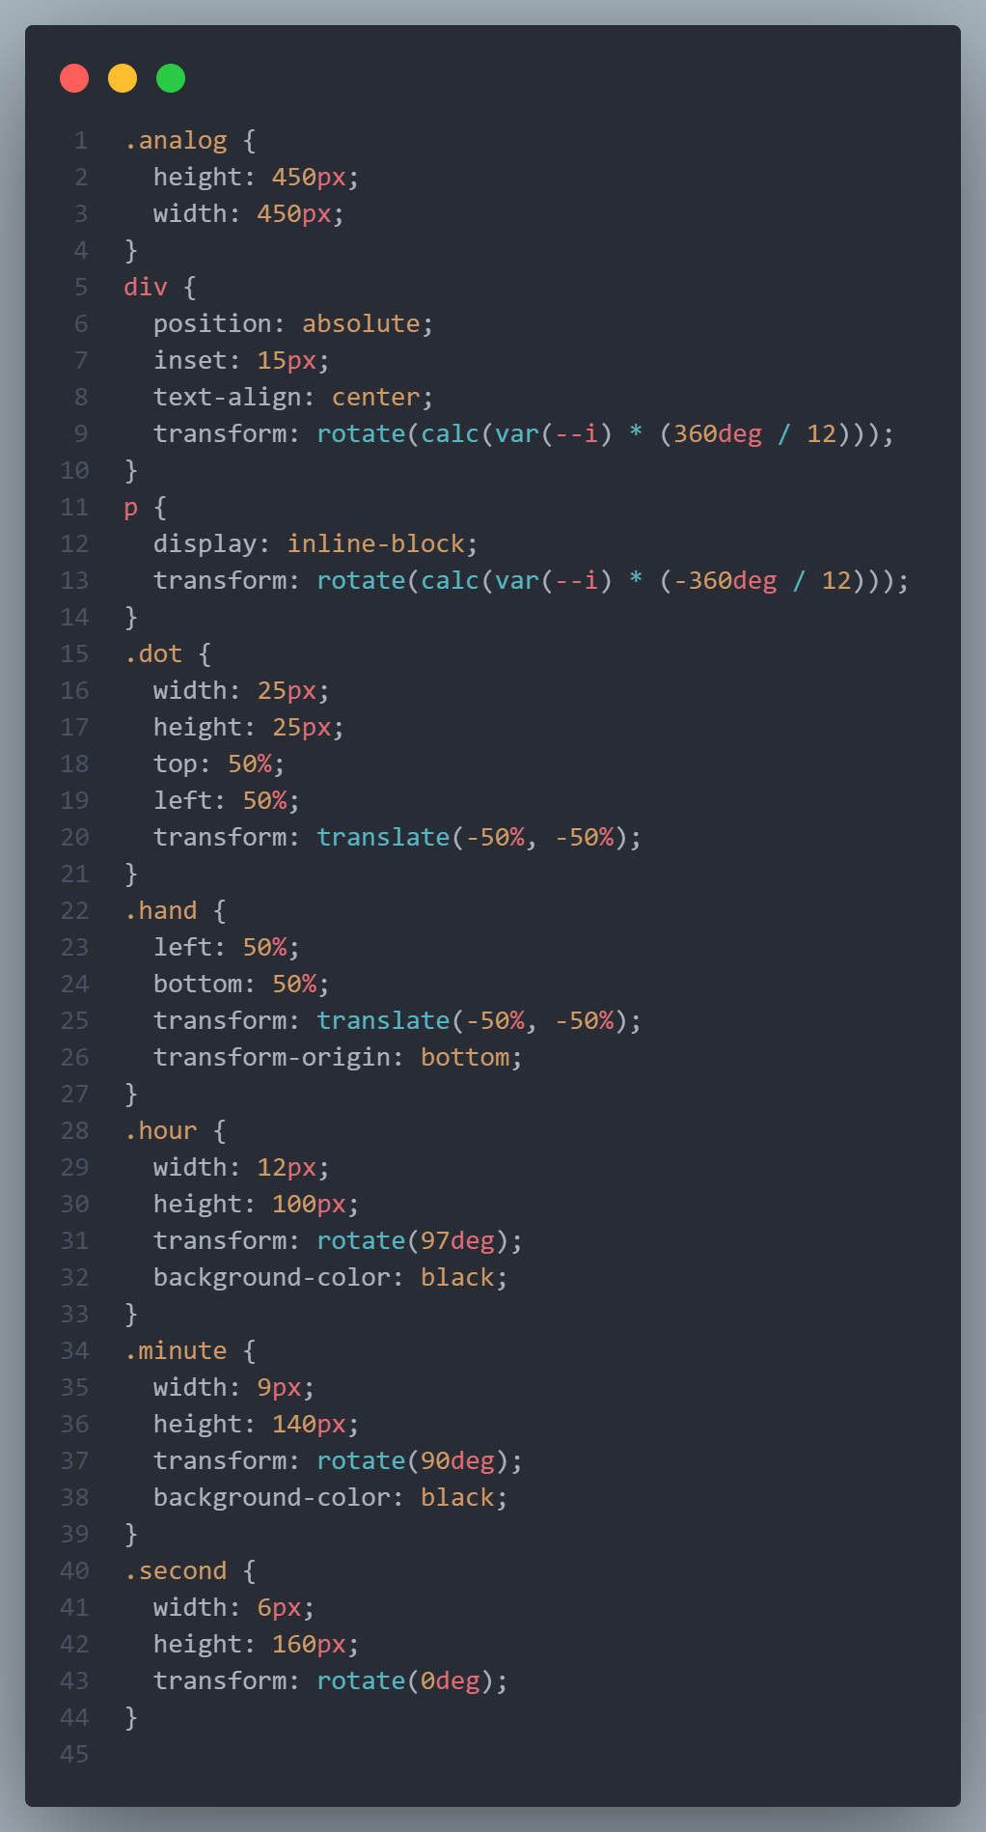

**CSS: Figure 1**

11

FEE-II, 22CS0014

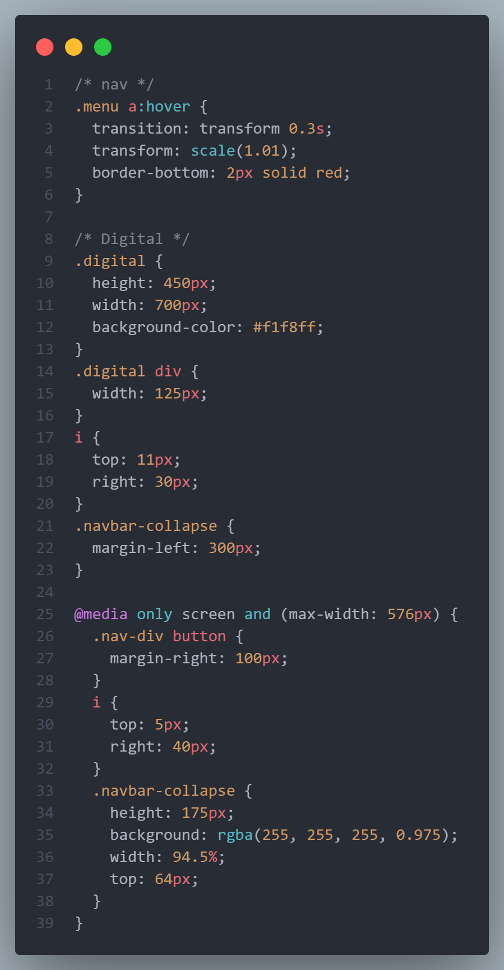

**CSS: Figure 2**

FEE-II, 22CS0014

12

**Javascript:-**

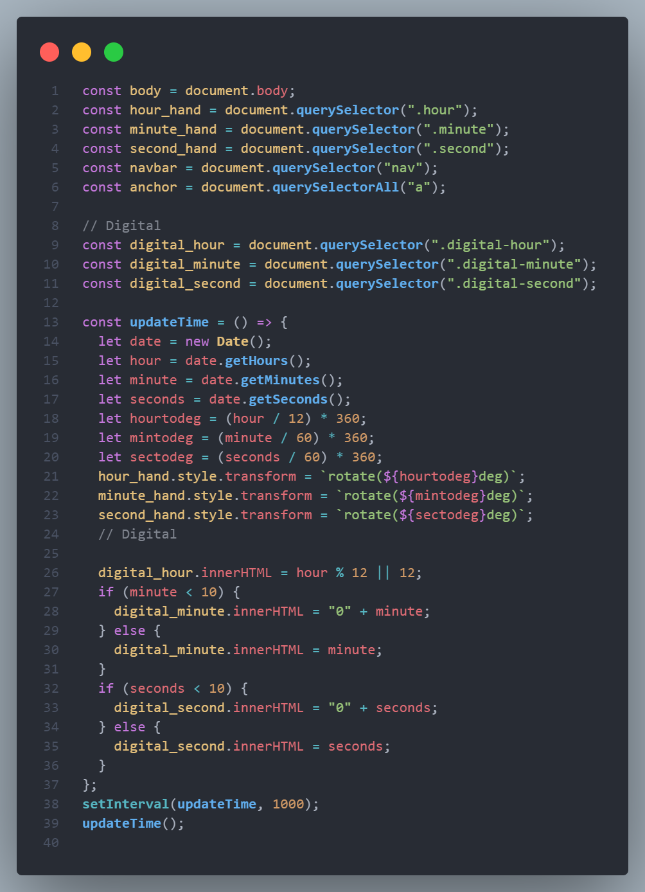

**Javascript: Figure 1**

FEE-II, 22CS0014

13

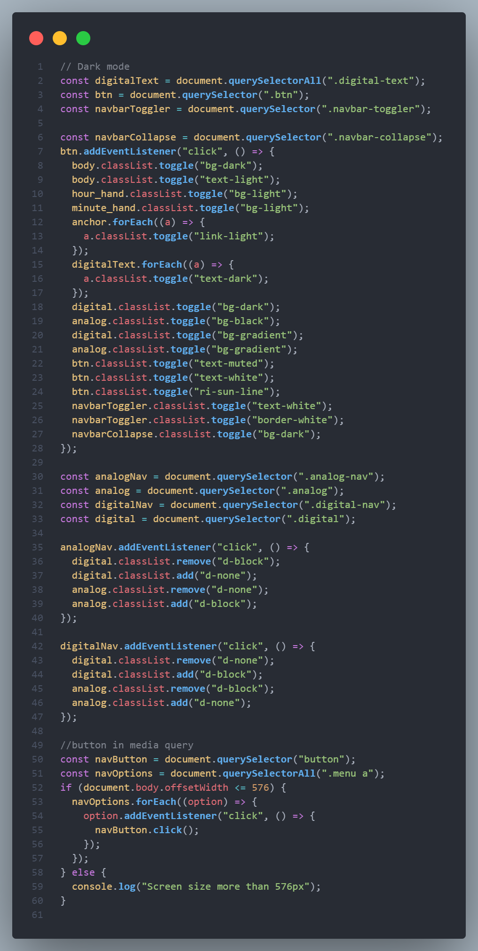

**Javascript: Figure 2**

FEE-II, 22CS0014

14

**Desktop View Output:-**

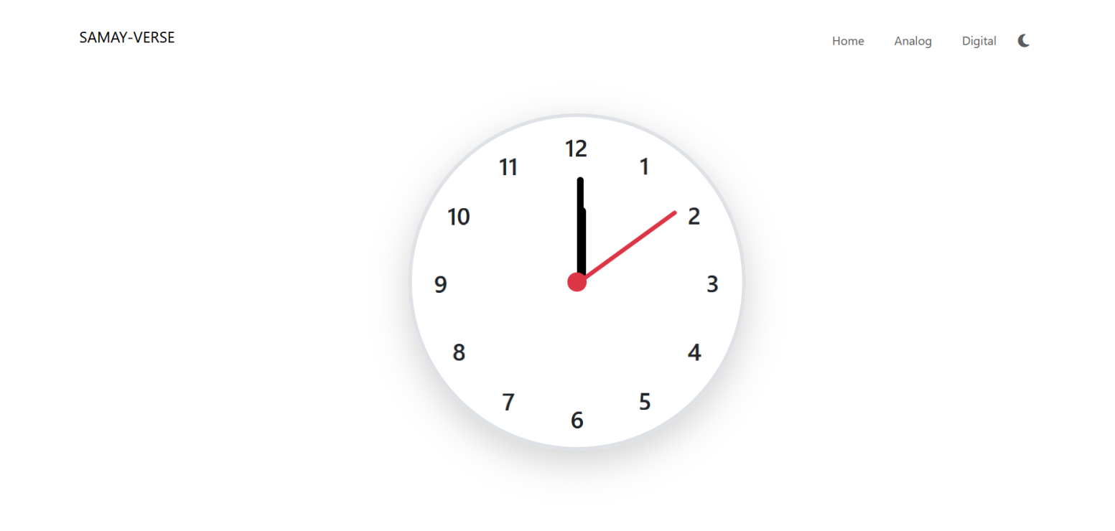

Analog Clock: Light mode

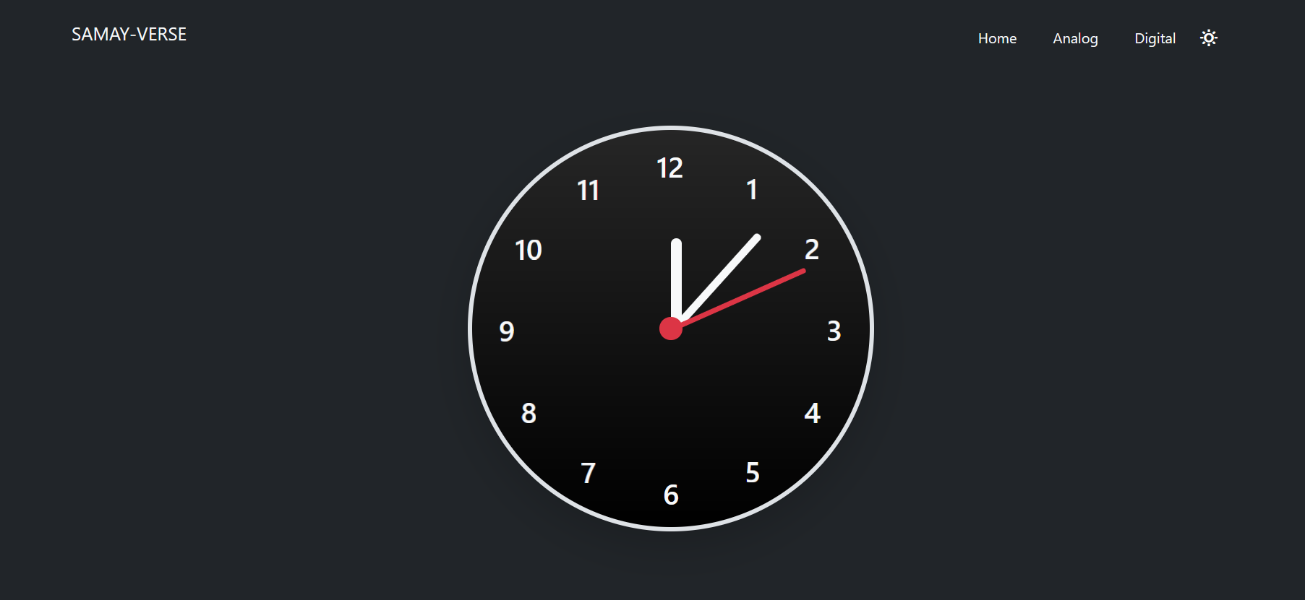

Analog Clock: Dark Mode

FEE-II, 22CS0014

15

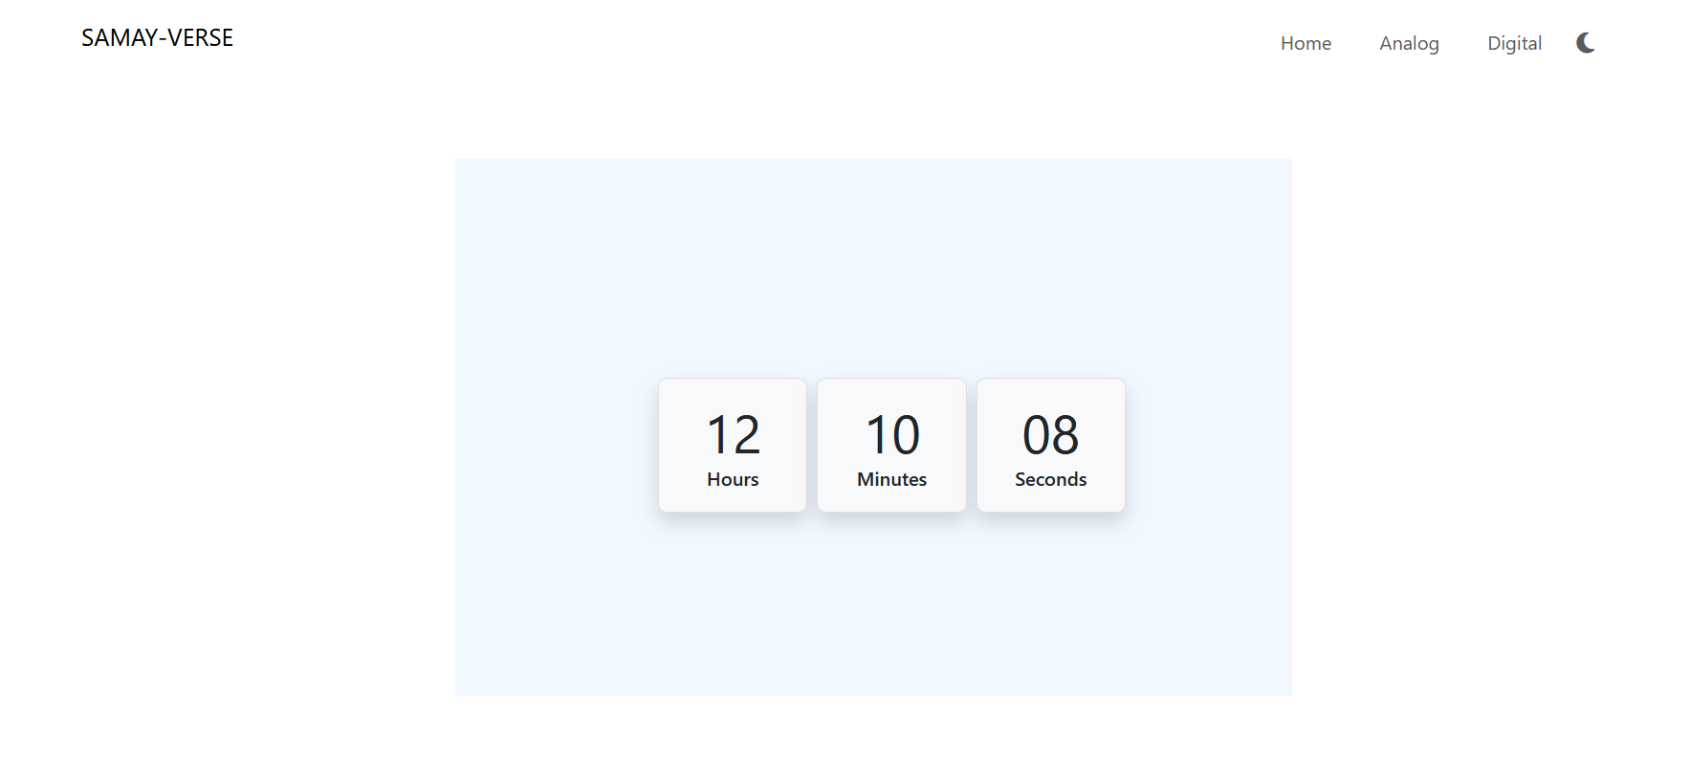

Digital Clock: Light mode

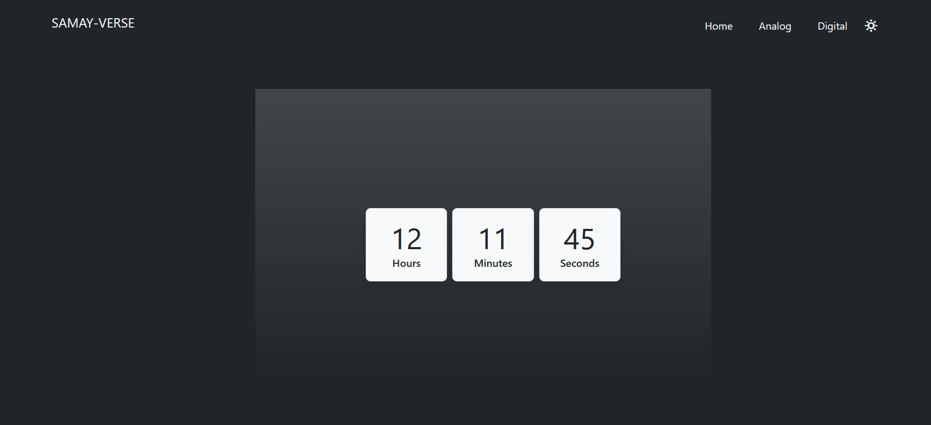

Digital Clock: Dark mode

FEE-II, 22CS0014

16

**Mobile View Output:-**

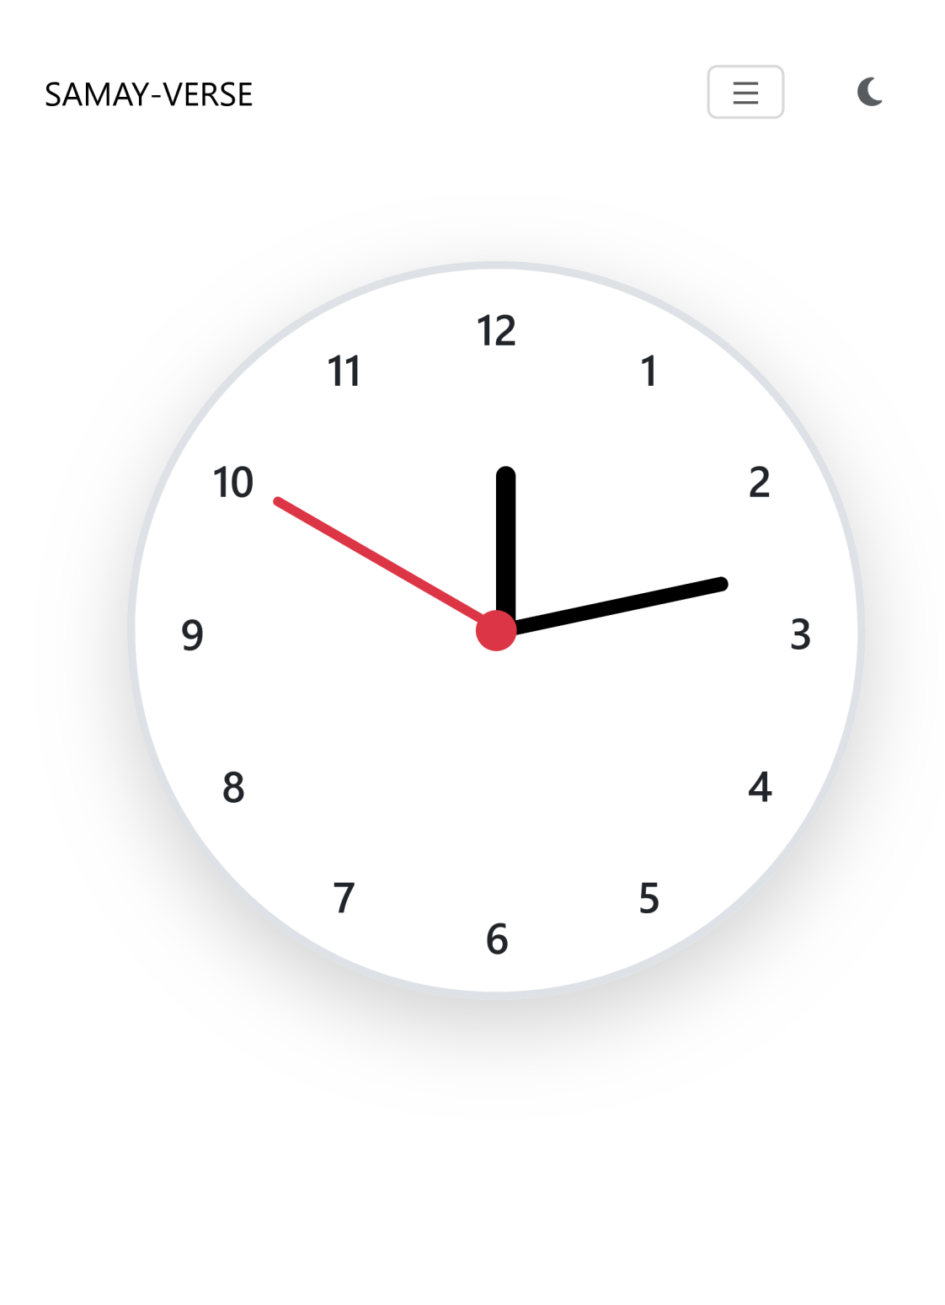

**Analog Clock: Light mode**

17

FEE-II, 22CS0014

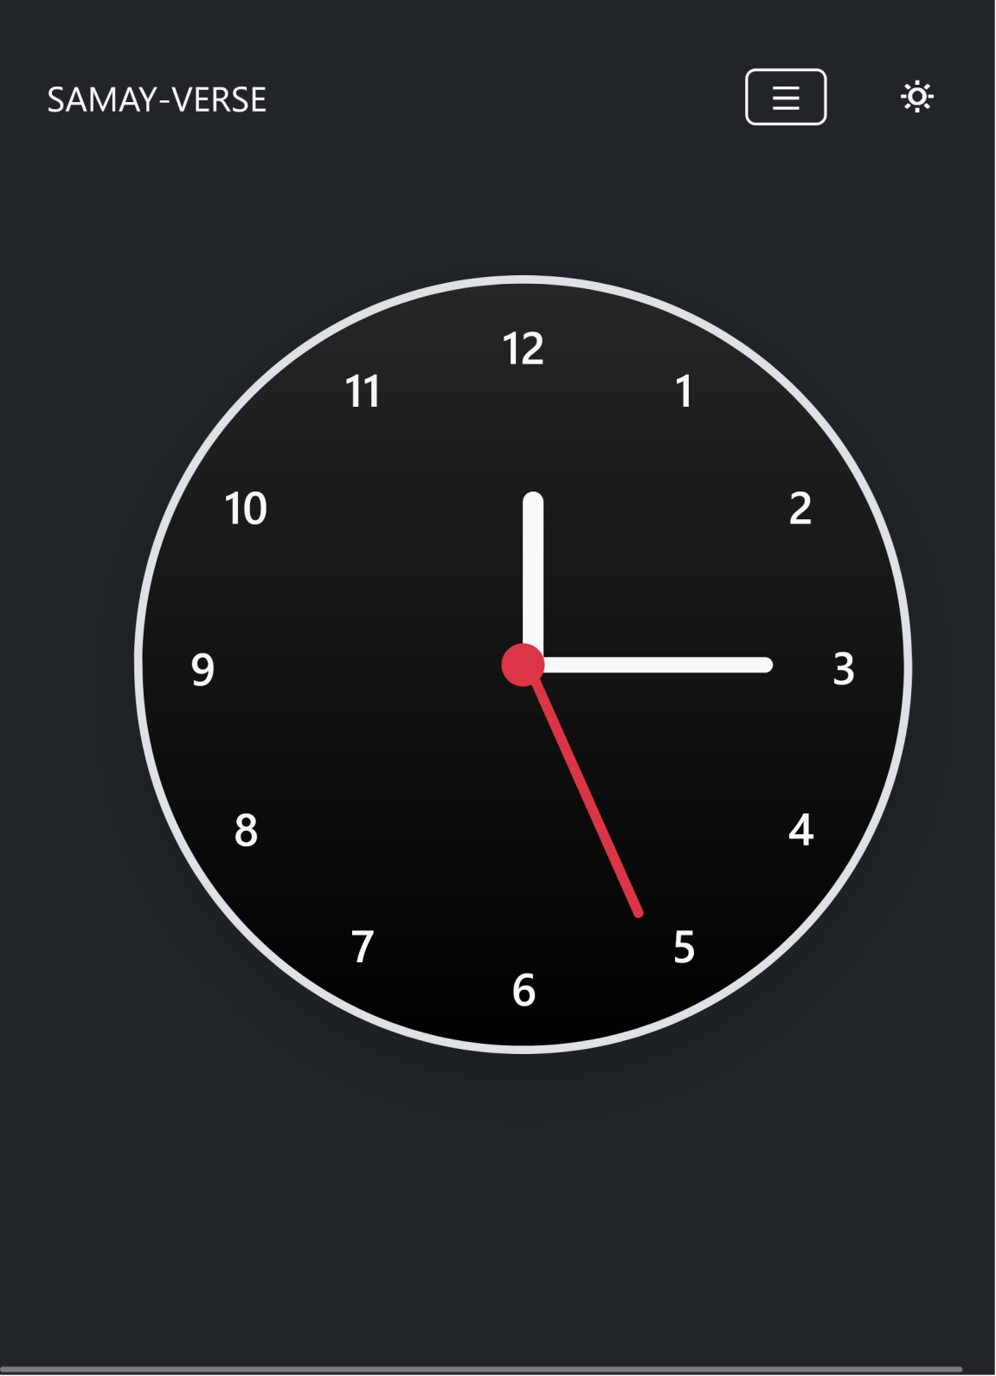

**Analog Clock: Dark mode**

FEE-II, 22CS0014

18

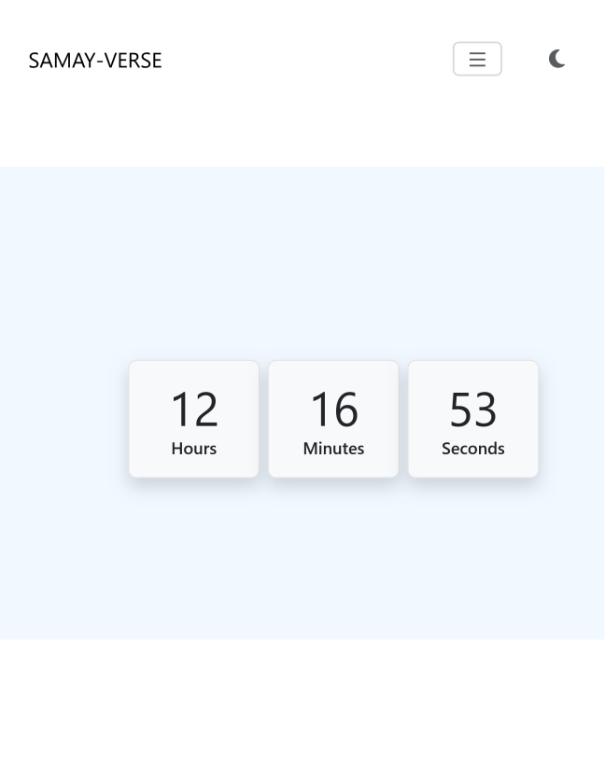

Digital Clock: Light mode

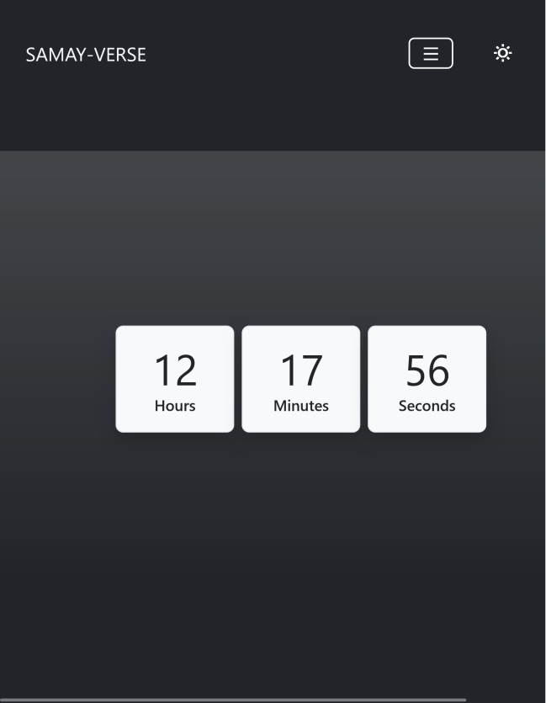

Digital Clock: Light mode

FEE-II, 22CS0014

19

**References:-**

1. Bootstrap Documentation
2. Dribble
3. Figma

FEE-II, 22CS0014

20