Machine Learning for Business Intelligence
HW1

Sumit Deshmukh

Total grade: _______

There are 4 numbered questions. Please answer them all.
1) Choose the data technology (Q,H,U, or S) that is most appropriate for each of the following business questions/scenarios. (24pts)
Q – SQL Querying
H – Statistical Hypothesis Testing
U – Unsupervised Learning
S – Supervised Learning

a) ___ For my on-line advertising the decision tree model yields a response rate of 0.5% and the old, manual targeting model yields 0.3%. Is the decision tree model really better? (4pts)
Ans:- S Supervised Learning (Yes)

b) _ I want to know which of my customers are the most profitable. (4pts)
Ans:- Q SQL Querying

c) __ I need to get data on all my on-line customers who were exposed to the special offer, including their registration data, their past purchases, and whether or not they purchased in the 15 days following the exposure. (4pts)
Ans:- Q SQL Querying

d)___ I would like to segment my customers into groups based on their demographics and prior purchase activity. I am not focusing on improving a particular task, but would like to generate ideas. (4pts)
Ans:- S Supervised Learning

e) ___ I have a budget to target 10,000 existing customers with a special offer. I would like to identify those customers most likely to respond to the special offer. (4pts)
Ans:- H Statistical Hypothesis Testing

f) ___ I want to know what characteristics differentiate my most profitable customers. (4pts)
Ans:- S Supervised Learning

2) MTC (MegaTelCo) has decided to use supervised learning to address its problem of churn in its wireless phone business. As a consultant to MTC, you realize that a main task in the business understanding/data understanding phases of the data mining process is to define the target variable. In one or two sentences, please suggest a definition for the target variable. Be as precise as possible—someone else will be implementing your suggestion. (Remember: it should make sense from a business point of view, and it should be reasonable that MTC would have data available to know the value of the target variable for historical customers.) (15pts)
Target Variable: It is the output or result of a business case. It is the outcome under study. It can be in the binary form(Yes/No) or any continuous value (Stock price of a company). For MegaTelCo the churn problem is the result that has to be analyzed. So churn becomes a target variable.
The company must have maintained the data of all its customers even if they have left the company in the past. The different scenarios under which the customers made their choices are the areas under study.
3) Plumbing Inc. has been selling plumbing supplies for the last 20 years. The owner, Joe, decides that next year it is time to diversify by adding gardening tools to the products. Having had success using customer data to build predictive models to guide direct mail campaigns for special plumbing offers, he considers that data mining could help him to identify a subset of customers who should be good prospects for his new set of products. Is Joe ready to solve this as a supervised learning problem? (15pts)
If yes – what would you suggest as the target variable?

If no - why not?
No, he is not ready to solve this problem by using supervised learning technique of Data Mining. Joe has the historical data of those customers who have bought plumbing equipment from Plumbing Inc. Joe does not have data whether all his customers have backyard garden or not. Are they involved in farming business or not? this information is not there with Joe. Many of his customers might have used Plumbing Inc. equipment to fix their plumbing needs in normal houses which may or may not have a garden.
If Plumbing Inc. have sold tools that are not used as daily household tools, then finding those customers who have bought specialized equipment for gardening needs, would lead us to some information. But that is not mentioned in this question. So Joe cannot solve this problem by using supervised learning on existing data with Plumbing Inc.

4) Predict the churn for MegaTelCo using a Decision Tree. MegaTelCo’s customer data is provided with this homework. See the variables below for this data set. Share your model with your TA. Your model will be tested against a separate test set that is not available to you. Top performing 5 models will get the following bonus points. Provide your answers to the sections from a to f below. (46 pts)

- 5 pts
- 4 pts
- 3 pts
- 2 pts
- 1 pt

Variable | Explanation
College | Is the customer college educated?
Income | Annual income
Overage | Average overcharges per month
Leftover | Average number of leftover minutes per month
House | Estimated value of dwelling (from census tract)
Handset_Price | Cost of phone
Long_Calls_Per_Month | Avg number of long calls (15+ mins) per month
Average_Call_Duration | Avg duration of a call
Reported_Satisfaction | Reported level of satisfaction
Reported_Usage_Level | Self-reported usage level
LEAVE (Targe variable) | Did the customer stay or leave (churn)?

- Plot (bar graph) the absolute value of correlation coefficient between each independent variable and target variable. (5 pts)

Attribute with CHURN | Correlation Coefficient
COLLEGE | -0.0152769909573
INCOME | -0.0883277396641
OVERAGE | -0.233333572485
HOUSE | 0.212367594309
LEFTOVER | -0.0635255542862
HANDSET | -0.0880982001934
LONG CALLS | -0.203478046289
AVERAGE USE | 0.0148228140348
SATISFACTION | 0.0135321078208
USAGE LEVEL | -0.00822125324669
CONSIDERATION | 0.000171592951392

Negative values are shown in red color.

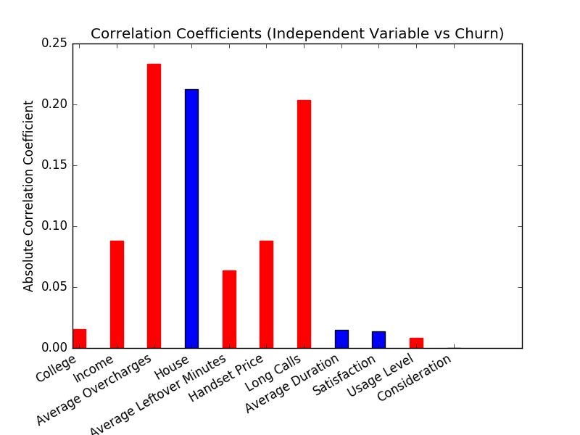

- Plot (bar graph) the information gain for each independent variable. (5 pts)

Attributes | Information Gain
Income | 0.00907945114017883
House | 0.047956490913769745
Leftover | 0.007258570335911818
Overage | 0.03883946029687402
Handset | 0.003669395614960047
long_calls_per_month | 0.031593573474428815
Average_Use_per_month | 0.005289648195758945
College | 0.0001683602385276206
Satisfaction | 0.0003488528464248297
Usage_LEVEL | 0.00011598419271008353
Consideration | 0.00023220994937123152

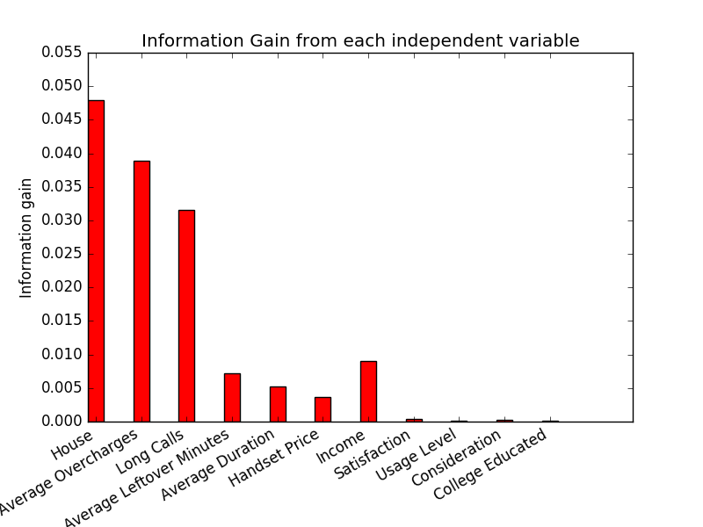

- Separate 30% of your data for testing and do not use this data while training your model. (5pts)

- Use your training data (70% of the data provided to you) to build a decision tree model for predicting churn. (10)
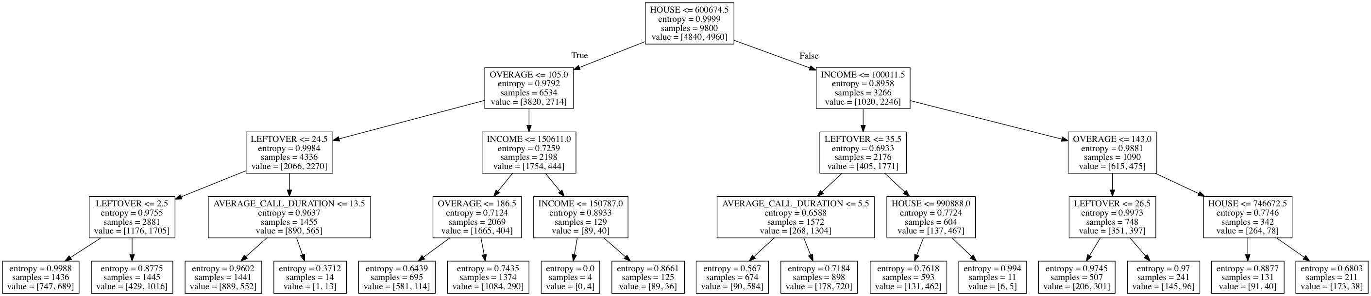

- What is the accuracy of your model on the training data? (5pts)

Accuracy in % 70.45918367346938
Error in % 29.54081632653061

- What is the accuracy of your model on the testing data? (6pts)

Accuracy in % 69.85714285714286
Error in % 30.142857142857142

