**1.** Design and implement C/C++ Program to find Minimum Cost Spanning Tree of a given connected undirected graph using Kruskal’s algorithm.

**PROGRAM:**

*#define* INF 999

*#define* MAX 100

int p[MAX], c[MAX][MAX], t[MAX][2];

int find(int *v*)

{

*while* (p[v])

v = p[v];

*return* v;

}

void union1(int *i*, int *j*)

{

p[j] = i;

}

void kruskal(int *n*)

{

int i, j, k, u, v, min, res1, res2, sum = 0;

*for* (k = 1; k < n; k++)

{

min = INF;

*for* (i = 1; i < n - 1; i++)

{

*for* (j = 1; j <= n; j++)

{

*if* (i == j) *continue*;

*if* (c[i][j] < min)

{

u = find(i);

v = find(j);

*if* (u != v)

{

res1 = i;

res2 = j;

min = c[i][j];

}

}

}

}

union1(res1, find(res2));

t[k][1] = res1;

t[k][2] = res2;

sum = sum + min;

}

printf("\nCost of spanning tree is=%d", sum);

printf("\nEdgesof spanning tree are:\n");

*for* (i = 1; i < n; i++)

printf("%d -> %d\n", t[i][1], t[i][2]);

}

int main()

{

int i, j, n;

printf("\nEnter the n value:");

scanf("%d", & n);

*for* (i = 1; i <= n; i++)

p[i] = 0;

printf("\nEnter the graph data:\n");

*for* (i = 1; i <= n; i++)

*for* (j = 1; j <= n; j++)

scanf("%d", & c[i][j]);

kruskal(n);

*return* 0;

}

**OUTPUT:**

Enter the n value:5

Enter the graph data:

1 3 4 6 2

1 7 6 9 3

5 2 8 99 45

1 44 66 33 6

12 4 3 2 0

Cost of spanning tree is=11

Edgesof spanning tree are:

2 -> 1

1 -> 5

3 -> 2

1 -> 4

**2.**Design and implement C/C++ Program to find Minimum Cost Spanning Tree of a given connected undirected graph using Prim’s algorithm.

**PROGRAM:**

*#include*<stdio.h>

*#define* INF 999

int prim(int c[10][10],int *n*,int *s*)

{

int v[10],i,j,sum=0,ver[10],d[10],min,u;

*for*(i=1; i<=n; i++)

{

ver[i]=s;

d[i]=c[s][i];

v[i]=0;

}

v[s]=1;

*for*(i=1; i<=n-1; i++)

{

min=INF;

*for*(j=1; j<=n; j++)

*if*(v[j]==0 && d[j]<min)

{

min=d[j];

u=j;

}

v[u]=1;

sum=sum+d[u];

printf("\n%d -> %d sum=%d",ver[u],u,sum);

*for*(j=1; j<=n; j++)

*if*(v[j]==0 && c[u][j]<d[j])

{

d[j]=c[u][j];

ver[j]=u;

}

}

*return* sum;

}

void main()

{

int c[10][10],i,j,res,s,n;

printf("\nEnter n value:");

scanf("%d",&n);

printf("\nEnter the graph data:\n");

*for*(i=1; i<=n; i++)

*for*(j=1; j<=n; j++)

scanf("%d",&c[i][j]);

printf("\nEnter the souce node:");

scanf("%d",&s);

res=prim(c,n,s);

printf("\nCost=%d",res);

getch();

}

**OUTPUT:**

Enter n value:4

Enter the graph data:

4 5 2 1

7 5 9 2

1 7 6 9

0 2 8 5

Enter the souce node:4

4 -> 1 sum=0

4 -> 2 sum=2

1 -> 3 sum=4

Cost=4

**3A.** Design and implement C/C++ Program to solve All-Pairs Shortest Paths problem using Floyd’s algorithm.

**PROGRAM:**

*#include*<stdio.h>

*#include*<conio.h>

*#define* INF 999

int min(int *a*,int *b*)

{

*return*(a<b)?a:b;

}

void floyd(int p[][10],int *n*)

{

int i,j,k;

*for*(k=1; k<=n; k++)

*for*(i=1; i<=n; i++)

*for*(j=1; j<=n; j++)

p[i][j]=min(p[i][j],p[i][k]+p[k][j]);

}

void main()

{

int a[10][10],n,i,j;

printf("\nEnter the n value:");

scanf("%d",&n);

printf("\nEnter the graph data:\n");

*for*(i=1; i<=n; i++)

*for*(j=1; j<=n; j++)

scanf("%d",&a[i][j]);

floyd(a,n);

printf("\nShortest path matrix\n");

*for*(i=1; i<=n; i++)

{

*for*(j=1; j<=n; j++)

printf("%d ",a[i][j]);

printf("\n");

}

getch();

}

**OUTPUT:**

Enter the n value:4

Enter the graph data:

0 999 3 999

2 0 999 999

999 7 0 1

6 999 999 0

Shortest path matrix

0 10 3 4

2 0 5 6

7 7 0 1

6 16 9 0

**3B.**Design and implement C/C++ Program to find the transitive closure using Warshal’s algorithm.

**PROGRAM:**

*#include*<stdio.h>

void warsh(int p[][10],int *n*)

{

int i,j,k;

*for*(k=1; k<=n; k++)

*for*(i=1; i<=n; i++)

*for*(j=1; j<=n; j++)

p[i][j]=p[i][j] || p[i][k] && p[k][j];

}

int main()

{

int a[10][10],n,i,j;

printf("\nEnter the n value:");

scanf("%d",&n);

printf("\nEnter the graph data:\n");

*for*(i=1; i<=n; i++)

*for*(j=1; j<=n; j++)

scanf("%d",&a[i][j]);

warsh(a,n);

printf("\nResultant path matrix\n");

*for*(i=1; i<=n; i++)

{

*for*(j=1; j<=n; j++)

printf("%d ",a[i][j]);

printf("\n");

}

*return* 0;

}

**OUTPUT:**

Enter the n value:4

Enter the graph data:

0 1 0 0

0 0 0 1

0 0 0 0

1 0 1 0

Resultant path matrix

1 1 1 1

1 1 1 1

0 0 0 0

1 1 1 1

**4.**Design and implement C/C++ Program to find shortest paths from a given vertex in a weighted connected graph to other vertices using Dijkstra’s algorithm.

**PROGRAM:**

*#include*<stdio.h>

*#define* INF 999

void dijkstra(int c[10][10],int *n*,int *s*,int d[10])

{

int v[10],min,u,i,j;

*for*(i=1; i<=n; i++)

{

d[i]=c[s][i];

v[i]=0;

}

v[s]=1;

*for*(i=1; i<=n; i++)

{

min=INF;

*for*(j=1; j<=n; j++)

*if*(v[j]==0 && d[j]<min)

{

min=d[j];

u=j;

}

v[u]=1;

*for*(j=1; j<=n; j++)

*if*(v[j]==0 && (d[u]+c[u][j])<d[j])

d[j]=d[u]+c[u][j];

}

}

int main()

{

int c[10][10],d[10],i,j,s,sum,n;

printf("\nEnter n value:");

scanf("%d",&n);

printf("\nEnter the graph data:\n");

*for*(i=1; i<=n; i++)

*for*(j=1; j<=n; j++)

scanf("%d",&c[i][j]);

printf("\nEnter the souce node:");

scanf("%d",&s);

dijkstra(c,n,s,d);

*for*(i=1; i<=n; i++)

printf("\nShortest distance from %d to %d is %d",s,i,d[i]);

*return* 0;

}

**OUTPUT:**

Enter n value:4

Enter the graph data:

444 767 987 12

999 87 56 45

1 0 999 678

444 678 235 0

Enter the souce node:1

Shortest distance from 1 to 1 is 444

Shortest distance from 1 to 2 is 247

Shortest distance from 1 to 3 is 247

Shortest distance from 1 to 4 is 12

**5.**Design and implement C/C++ Program to obtain the Topological ordering of vertices in a given digraph.

**PROGRAM:**

*#include*<stdio.h>

*#include*<conio.h>

int temp[10],k=0;

void sort(int a[][10],int *id*[],int *n*)

{

int i,j;

*for*(i=1; i<=n; i++)

{

*if*(id[i]==0)

{

id[i]=-1;

temp[++k]=i;

*for*(j=1; j<=n; j++)

{

*if*(a[i][j]==1 && id[j]!=-1)

id[j]--;

}

i=0;

}

}

}

void main()

{

int a[10][10],id[10],n,i,j;

printf("\nEnter the n value:");

scanf("%d",&n);

*for*(i=1; i<=n; i++)

id[i]=0;

printf("\nEnter the graph data:\n");

*for*(i=1; i<=n; i++)

*for*(j=1; j<=n; j++)

{

scanf("%d",&a[i][j]);

*if*(a[i][j]==1)

id[j]++;

}

sort(a,id,n);

*if*(k!=n)

printf("\nTopological ordering not possible");

*else*

{

printf("\nTopological ordering is:");

*for*(i=1; i<=k; i++)

printf("%d ",temp[i]);

}

getch();

}

**OUTPUT:**

****************************************OUTPU1****************************************

Enter the n value:6

Enter the graph data:

0 0 1 1 0 0

0 0 0 1 1 0

0 0 0 1 0 1

0 0 0 0 0 1

0 0 0 0 0 1

0 0 0 0 0 0

Topological ordering is: 1 2 3 4 5 6

****************************************OUTPU2****************************************

Enter the n value:4

Enter the graph data:

1 4 3 2

5 4 2 1

5 3 4 2

4 1 2 3

Topological ordering not possible

**6.** Design and implement C/C++ Program to solve 0/1 Knapsack problem using Dynamic Programming method.

**PROGRAM:**

*#include*<stdio.h>

int w[10],p[10],n;

int max(int *a*,int *b*)

{

*return* a>b?a:b;

}

int knap(int *i*,int *m*)

{

*if*(i==n) *return* w[i]>m?0:p[i];

*if*(w[i]>m) *return* knap(i+1,m);

*return* max(knap(i+1,m),knap(i+1,m-w[i])+p[i]);

}

int main()

{

int m,i,max_profit;

printf("\nEnter the no. of objects:");

scanf("%d",&n);

printf("\nEnter the knapsack capacity:");

scanf("%d",&m);

printf("\nEnter profit followed by weight:\n");

*for*(i=1; i<=n; i++)

scanf("%d %d",&p[i],&w[i]);

max_profit=knap(1,m);

printf("\nMax profit=%d",max_profit);

*return* 0;

}

**OUTPUT:**

Enter the no. of objects:4

Enter the knapsack capacity:5

Enter profit followed by weight:

12 3

43 5

45 2

55 3

Max profit=100

**7.** Design and implement C/C++ Program to solve discrete Knapsack and continuous Knapsack problems using greedy approximation method.

**PROGRAM:**

*#include* <stdio.h>

*#define* MAX 50

int p[MAX], w[MAX], x[MAX];

double maxprofit;

int n, m, i;

void greedyKnapsack(int *n*, int *w*[], int *p*[], int *m*)

{

double ratio[MAX];

*// Calculate the ratio of profit to weight for each item*

*for* (i = 0; i < n; i++)

{

ratio[i] = (double)p[i] / w[i];

}

*// Sort items based on the ratio in non-increasing order*

*for* (i = 0; i < n - 1; i++)

{

*for* (int j = i + 1; j < n; j++)

{

*if* (ratio[i] < ratio[j])

{

double temp = ratio[i];

ratio[i] = ratio[j];

ratio[j] = temp;

int temp2 = w[i];

w[i] = w[j];

w[j] = temp2;

temp2 = p[i];

p[i] = p[j];

p[j] = temp2;

}

}

}

int currentWeight = 0;

maxprofit = 0.0;

*// Fill the knapsack with items*

*for* (i = 0; i < n; i++)

{

*if* (currentWeight + w[i] <= m)

{

x[i] = 1; *// Item i is selected*

currentWeight += w[i];

maxprofit += p[i];

}

*else*

{

*// Fractional part of item i is selected*

x[i] = (m - currentWeight) / (double)w[i];

maxprofit += x[i] * p[i];

*break*;

}

}

printf("Optimal solution for greedy method: %.1f\n", maxprofit);

printf("Solution vector for greedy method: ");

*for* (i = 0; i < n; i++)

printf("%d\t", x[i]);

}

int main()

{

printf("Enter the number of objects: ");

scanf("%d", &n);

printf("Enter the objects' weights: ");

*for* (i = 0; i < n; i++)

scanf("%d", &w[i]);

printf("Enter the objects' profits: ");

*for* (i = 0; i < n; i++)

scanf("%d", &p[i]);

printf("Enter the maximum capacity: ");

scanf("%d", &m);

greedyKnapsack(n, w, p, m);

*return* 0;

}

**OUTPUT:**

Enter the number of objects: 4

Enter the objects' weights: 56 78 98 78

Enter the objects' profits: 23 45 76 78

Enter the maximum capacity: 100

Optimal solution *for* greedy method: 78.0

Solution vector *for* greedy method: 1 0 0 0

*#include*<stdio.h>

*#define* MAX 10

int s[MAX],x[MAX],d;

void sumofsub(int *p*,int *k*,int *r*)

{

int i;

x[k]=1;

*if*((p+s[k])==d)

{

*for*(i=1; i<=k; i++)

*if*(x[i]==1)

printf("%d ",s[i]);

printf("\n");

}

*else* *if*(p+s[k]+s[k+1]<=d)

sumofsub(p+s[k],k+1,r

-s[k]);

*if*((p+r

-s[k]>=d) && (p+s[k+1]<=d))

{

x[k]=0;

sumofsub(p,k+1,r

-s[k]);

}

}

int main()

{

int i,n,sum=0;

printf("\nEnter the n value:");

scanf("%d",&n);

printf("\nEnter the set in increasing order:");

*for*(i=1; i<=n; i++)

scanf("%d",&s[i]);

printf("\nEnter the max subset value:");

scanf("%d",&d);

*for*(i=1; i<=n; i++)

sum=sum+s[i];

*if*(sum<d || s[1]>d)

printf("\nNo subset possible");

*else*

sumofsub(0,1,sum);

*return* 0;

}

**OUTPUT:**

Enter the n value:9

Enter the set in increasing order:1 2 3 4 5 6 7 8 9

Enter the max subset value:9

1 2 6

1 3 5

1 8

2 3 4

2 7

3 6

4 5

9

**8.**Design and implement C/C++ Program to find a subset of a given set S = {s1 , s2,…..,sn} of n positive integers whose sum is equal to a given positive integer d.

**PROGRAM:**

*#include*<stdio.h>

*#define* MAX 10

int s[MAX],x[MAX],d;

void sumofsub(int *p*,int *k*,int *r*)

{

int i;

x[k]=1;

*if*((p+s[k])==d)

{

*for*(i=1; i<=k; i++)

*if*(x[i]==1)

printf("%d ",s[i]);

printf("\n");

}

*else* *if*(p+s[k]+s[k+1]<=d)

sumofsub(p+s[k],k+1,r

-s[k]);

*if*((p+r

-s[k]>=d) && (p+s[k+1]<=d))

{

x[k]=0;

sumofsub(p,k+1,r

-s[k]);

}

}

int main()

{

int i,n,sum=0;

printf("\nEnter the n value:");

scanf("%d",&n);

printf("\nEnter the set in increasing order:");

*for*(i=1; i<=n; i++)

scanf("%d",&s[i]);

printf("\nEnter the max subset value:");

scanf("%d",&d);

*for*(i=1; i<=n; i++)

sum=sum+s[i];

*if*(sum<d || s[1]>d)

printf("\nNo subset possible");

*else*

sumofsub(0,1,sum);

*return* 0;

}

**OUTPUT:**

Enter the n value:9

Enter the set in increasing order:1 2 3 4 5 6 7 8 9

Enter the max subset value:9

1 2 6

1 3 5

1 8

2 3 4

2 7

3 6

4 5

9

**BCSL404 Program 9**

**9.**Design and implement C/C++ Program to sort a given set of n integer elements using Selection Sort method and compute its time complexity. Run the program for varied values of n> 5000 and record the time taken to sort. Plot a graph of the time taken versus n. The elements can be read from a file or can be generated using the random number generator.

**Step 1: Implement the Selection Sort Algorithm**

The Selection Sort algorithm works by repeatedly finding the minimum element from the unsorted part and putting it at the beginning.

**PROGRAM:**

*#include* <stdio.h>

*#include* <stdlib.h>

*#include* <time.h>

*// Function to perform selection sort on an array*

void selectionSort(int *arr*[], int *n*)

{

int i, j, min_idx;

*for* (i = 0; i < n-1; i++)

{

min_idx = i; *// Assume the current element is the minimum*

*for* (j = i+1; j < n; j++)

{

*if* (arr[j] < arr[min_idx])

{

min_idx = j; *// Update min_idx if a smaller element is found*

}

}

*// Swap the found minimum element with the current element*

int temp = arr[min_idx];

arr[min_idx] = arr[i];

arr[i] = temp;

}

}

*// Function to generate an array of random numbers*

void generateRandomNumbers(int *arr*[], int *n*)

{

*for* (int i = 0; i < n; i++)

{

arr[i] = rand() % 10000; *// Generate random numbers between 0 and 9999*

}

}

int main()

{

int n;

printf("Enter number of elements: ");

scanf("%d", &n); *// Read the number of elements from the user*

*if* (n <= 5000)

{

printf("Please enter a value greater than 5000\n");

*return* 1; *// Exit if the number of elements is not greater than 5000*

}

*// Allocate memory for the array*

int *arr = (int *)malloc(n * sizeof(int));

*if* (arr == NULL)

{

printf("Memory allocation failed\n");

*return* 1; *// Exit if memory allocation fails*

}

*// Generate random numbers and store them in the array*

generateRandomNumbers(arr, n);

*// Measure the time taken to sort the array*

clock_t start = clock();

selectionSort(arr, n);

clock_t end = clock();

*// Calculate and print the time taken to sort the array*

double time_taken = ((double)(end - start)) / CLOCKS_PER_SEC;

printf("Time taken to sort %d elements: %f seconds\n", n, time_taken);

*// Free the allocated memory*

free(arr);

*return* 0;

}

**Step 2: Measure Time Taken**

The above program generates n random numbers, sorts them using the Selection Sort algorithm, and measures the time taken for the sorting process.

**Step 3: Run the Program for Various Values of n**

To collect data, run the program with different values of n greater than 5000, such as 6000, 7000, 8000, etc., and record the time taken for each.

**Step 4: Plot the Results**

You can use a graphing tool like Python with matplotlib to plot the results.

*import* matplotlib.pyplot *as* plt

*# data collected*

n_values = [6000, 7000, 8000, 9000, 10000]

time_taken = [0.031000, 0.034000, 0.047000, 0.052000, 0.077000] *# replace with actual times recorded*

plt.plot(n_values, time_taken, *marker*='o')

plt.title('Selection Sort Time Complexity')

plt.xlabel('Number of Elements (n)')

plt.ylabel('Time taken (seconds)')

plt.grid(True)

plt.show()

**OUTPUT:**

Enter number of elements: 6000

Time taken to sort 6000 elements: 0.031000 seconds

********************************************************************

Enter number of elements: 7000

Time taken to sort 7000 elements: 0.034000 seconds

********************************************************************

Enter number of elements: 8000

Time taken to sort 8000 elements: 0.047000 seconds

********************************************************************

Enter number of elements: 9000

Time taken to sort 9000 elements: 0.052000 seconds

********************************************************************

Enter number of elements: 10000

Time taken to sort 10000 elements: 0.077000 seconds

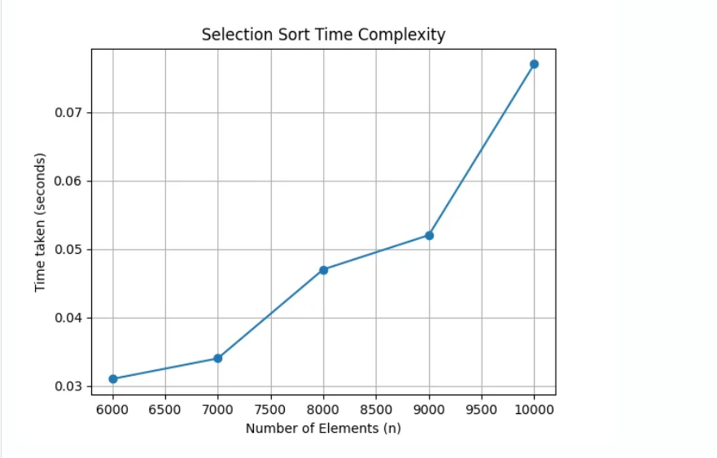

**10.**Design and implement C/C++ Program to sort a given set of n integer elements using Quick Sort method and compute its time complexity. Run the program for varied values of n> 5000 and record the time taken to sort. Plot a graph of the time taken versus n. The elements can be read from a file or can be generated using the random number generator.

**Step 1: Implement the Quick Sort Algorithm**

Quick Sort is a divide-and-conquer algorithm that works by selecting a ‘pivot’ element and partitioning the array into elements less than and greater than the pivot.

**PROGRAM:**

*#include* <stdio.h>

*#include* <stdlib.h>

*#include* <time.h>

*// Function to swap two elements*

void swap(int* *a*, int* *b*)

{

int t = *a;

*a = *b;

*b = t;

}

*// Partition function for Quick Sort*

int partition(int *arr*[], int *low*, int *high*)

{

int pivot = arr[high]; *// Pivot element*

int i = (low - 1); *// Index of smaller element*

*for* (int j = low; j <= high - 1; j++)

{

*if* (arr[j] < pivot)

{

i++; *// Increment index of smaller element*

swap(&arr[i], &arr[j]);

}

}

swap(&arr[i + 1], &arr[high]);

*return* (i + 1);

}

*// Quick Sort function*

void quickSort(int *arr*[], int *low*, int *high*)

{

*if* (low < high)

{

int pi = partition(arr, low, high);

*// Recursively sort elements before and after partition*

quickSort(arr, low, pi - 1);

quickSort(arr, pi + 1, high);

}

}

*// Function to generate random numbers*

void generateRandomNumbers(int *arr*[], int *n*)

{

*for* (int i = 0; i < n; i++)

{

arr[i] = rand() % 100000; *// Generate random numbers between 0 and 99999*

}

}

int main()

{

int n;

printf("Enter number of elements: ");

scanf("%d", &n); *// Read the number of elements from the user*

*if* (n <= 5000)

{

printf("Please enter a value greater than 5000\n");

*return* 1; *// Exit if the number of elements is not greater than 5000*

}

*// Allocate memory for the array*

int *arr = (int *)malloc(n * sizeof(int));

*if* (arr == NULL)

{

printf("Memory allocation failed\n");

*return* 1; *// Exit if memory allocation fails*

}

*// Generate random numbers and store them in the array*

generateRandomNumbers(arr, n);

*// Measure the time taken to sort the array*

clock_t start = clock();

quickSort(arr, 0, n - 1);

clock_t end = clock();

*// Calculate and print the time taken to sort the array*

double time_taken = ((double)(end - start)) / CLOCKS_PER_SEC;

printf("Time taken to sort %d elements: %f seconds\n", n, time_taken);

*// Free the allocated memory*

free(arr);

*return* 0;

}

**Step 2: Measure Time Taken**

This program generates n random numbers, sorts them using the Quick Sort algorithm, and measures the time taken for the sorting process.

**Step 3: Run the Program for Various Values of n**

To collect data, run the program with different values of n greater than 5000, such as 6000, 7000, 8000, etc., and record the time taken for each if you didn’t get time then increase the value of n for example 20000, 40000, 60000 etc….

**Step 4: Plot the Results**

You can use a graphing tool like Python with matplotlib to plot the results.

*import* matplotlib.pyplot *as* plt

*# Example data collected*

n_values = [10000, 20000, 30000, 35000, 50000]

time_taken = [0.0000, 0.015000, 0.011000, 0.003000, 0.015000] *# replace with actual times recorded*

plt.plot(n_values, time_taken, *marker*='o')

plt.title('Quick Sort Time Complexity')

plt.xlabel('Number of Elements (n)')

plt.ylabel('Time taken (seconds)')

plt.grid(True)

plt.show()

**OUTPUT:**

Enter number of elements: 10000

Time taken to sort 10000 elements: 0.0000 seconds

********************************************************************

Enter number of elements: 20000

Time taken to sort 20000 elements: 0.015000 seconds

********************************************************************

Enter number of elements: 30000

Time taken to sort 30000 elements: 0.011000 seconds

********************************************************************

Enter number of elements: 35000

Time taken to sort 35000 elements: 0.003000 seconds

********************************************************************

Enter number of elements: 50000

Time taken to sort 50000 elements: 0.015000 seconds

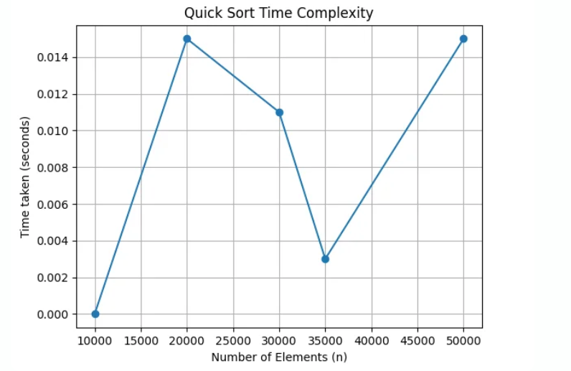

**11.** Design and implement C/C++ Program to sort a given set of n integer elements using Merge Sort method and compute its time complexity. Run the program for varied values of n> 5000, and record the time taken to sort. Plot a graph of the time taken versus n. The elements can be read from a file or can be generated using the random number generator.

**Step 1: Implement the Merge Sort Algorithm**

Merge Sort is a divide-and-conquer algorithm that splits the array into values, sorts each half, and then merges the sorted values.

**PROGRAM:**

*#include* <stdio.h>

*#include* <stdlib.h>

*#include* <time.h>

*// Function to merge two sorted arrays*

void merge(int *arr*[], int *left*, int *mid*, int *right*)

{

int i, j, k;

int n1 = mid - left + 1;

int n2 = right - mid;

int *L = (int *)malloc(n1 * sizeof(int));

int *R = (int *)malloc(n2 * sizeof(int));

*for* (i = 0; i < n1; i++)

L[i] = arr[left + i];

*for* (j = 0; j < n2; j++)

R[j] = arr[mid + 1 + j];

i = 0;

j = 0;

k = left;

*while* (i < n1 && j < n2)

{

*if* (L[i] <= R[j])

{

arr[k] = L[i];

i++;

}

*else*

{

arr[k] = R[j];

j++;

}

k++;

}

*while* (i < n1)

{

arr[k] = L[i];

i++;

k++;

}

*while* (j < n2)

{

arr[k] = R[j];

j++;

k++;

}

free(L);

free(R);

}

*// Function to implement Merge Sort*

void mergeSort(int *arr*[], int *left*, int *right*)

{

*if* (left < right)

{

int mid = left + (right - left) / 2;

mergeSort(arr, left, mid);

mergeSort(arr, mid + 1, right);

merge(arr, left, mid, right);

}

}

*// Function to generate random integers*

void generateRandomArray(int *arr*[], int *n*)

{

*for* (int i = 0; i < n; i++)

arr[i] = rand() % 100000; *// Generate random integers between 0 and 99999*

}

int main()

{

int n;

printf("Enter the number of elements: ");

scanf("%d", &n);

*if* (n <= 5000)

{

printf("Please enter a value greater than 5000\n");

*return* 1; *// Exit if the number of elements is not greater than 5000*

}

int *arr = (int *)malloc(n * sizeof(int));

*if* (arr == NULL)

{

printf("Memory allocation failed\n");

*return* 1; *// Exit if memory allocation fails*

}

generateRandomArray(arr, n);

*// Repeat the sorting process multiple times to increase duration for timing*

clock_t start = clock();

*for* (int i = 0; i < 1000; i++)

{

mergeSort(arr, 0, n - 1);

}

clock_t end = clock();

*// Calculate the time taken for one iteration*

double time_taken = ((double)(end - start)) / CLOCKS_PER_SEC / 1000.0;

printf("Time taken to sort %d elements: %f seconds\n", n, time_taken);

free(arr);

*return* 0;

}

**Step 2: Measure Time Taken**

This program generates n random numbers, sorts them using the Merge Sort algorithm, and measures the time taken for the sorting process.

**Step 3: Run the Program for Various Values of n**

To collect data, run the program with different values of n greater than 5000, such as 6000, 7000, 8000, etc., and record the time taken for each.

**Step 4: Plot the Results**

You can use a graphing tool like Python with matplotlib to plot the results.

*import* matplotlib.pyplot *as* plt

*# data collected (replace with actual data)*

n_values = [6000, 7000, 8000, 9000, 10000, 11000, 12000, 13000, 15000]

time_taken = [0.000709, 0.000752, 0.000916, 0.001493, 0.001589, 0.002562, 0.001944, 0.002961, 0.003563] *# Replace with actual times recorded*

plt.plot(n_values, time_taken, *marker*='o')

plt.title('Merge Sort Time Complexity')

plt.xlabel('Number of Elements (n)')

plt.ylabel('Time taken (seconds)')

plt.grid(True)

plt.show()

**OUTPUT:**

Enter number of elements: 6000

Time taken to sort 6000 elements: 0.000709 seconds

********************************************************************

Enter number of elements: 7000

Time taken to sort 7000 elements: 0.000752 seconds

********************************************************************

Enter number of elements: 8000

Time taken to sort 8000 elements: 0.000916 seconds

********************************************************************

Enter number of elements: 9000

Time taken to sort 9000 elements: 0.001493 seconds

********************************************************************

Enter number of elements: 10000

Time taken to sort 10000 elements: 0.001589 seconds

********************************************************************

Enter number of elements: 11000

Time taken to sort 11000 elements: 0.002562 seconds

********************************************************************

Enter number of elements: 12000

Time taken to sort 12000 elements: 0.001944 seconds

********************************************************************

Enter number of elements: 13000

Time taken to sort 13000 elements: 0.002961 seconds

********************************************************************

Enter number of elements: 15000

Time taken to sort 15000 elements: 0.003563 seconds

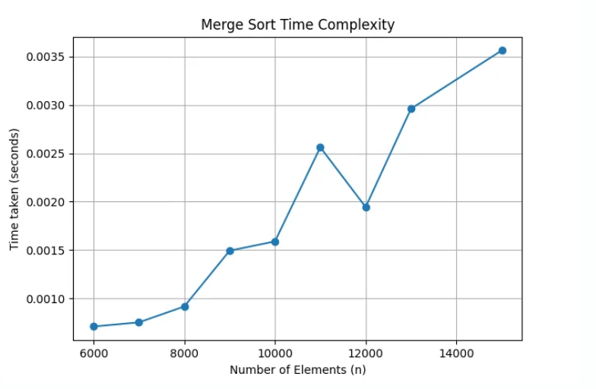

**12.**Design and implement C/C++ Program for N Queen’s problem using Backtracking.

**PROGRAM:**

*#include* <stdio.h>

*#include* <stdlib.h>

*#include* <stdbool.h>

*// Function to print the solution*

void printSolution(int \*\**board*, int *N*)

{

*for* (int i = 0; i < N; i++)

{

*for* (int j = 0; j < N; j++)

{

printf("%s ", board[i][j] ? "Q" : "#");

}

printf("\n");

}

}

*// Function to check if a queen can be placed on board[row][col]*

bool isSafe(int \*\**board*, int *N*, int *row*, int *col*)

{

int i, j;

*// Check this row on left side*

*for* (i = 0; i < col; i++)

{

*if* (board[row][i])

{

*return* false;

}

}

*// Check upper diagonal on left side*

*for* (i = row, j = col; i >= 0 && j >= 0; i--, j--)

{

*if* (board[i][j])

{

*return* false;

}

}

*// Check lower diagonal on left side*

*for* (i = row, j = col; j >= 0 && i < N; i++, j--)

{

*if* (board[i][j])

{

*return* false;

}

}

*return* true;

}

*// A recursive utility function to solve N Queen problem*

bool solveNQUtil(int \*\**board*, int *N*, int *col*)

{

*// If all queens are placed, then return true*

*if* (col >= N)

{

*return* true;

}

*// Consider this column and try placing this queen in all rows one by one*

*for* (int i = 0; i < N; i++)

{

*if* (isSafe(board, N, i, col))

{

*// Place this queen in board[i][col]*

board[i][col] = 1;

*// Recur to place rest of the queens*

*if* (solveNQUtil(board, N, col + 1))

{

*return* true;

}

*// If placing queen in board[i][col] doesn't lead to a solution,*

*// then remove queen from board[i][col]*

board[i][col] = 0; *// BACKTRACK*

}

}

*// If the queen cannot be placed in any row in this column col, then return false*

*return* false;

}

bool solveNQ(int *N*)

{

int **board = (int **)malloc(N * sizeof(int *));

*for* (int i = 0; i < N; i++)

{

board[i] = (int *)malloc(N * sizeof(int));

*for* (int j = 0; j < N; j++)

{

board[i][j] = 0;

}

}

*if* (!solveNQUtil(board, N, 0))

{

printf("Solution does not exist\n");

*for* (int i = 0; i < N; i++)

{

free(board[i]);

}

free(board);

*return* false;

}

printSolution(board, N);

*for* (int i = 0; i < N; i++)

{

free(board[i]);

}

free(board);

*return* true;

}

int main()

{

int N;

printf("Enter the number of queens: ");

scanf("%d", &N);

solveNQ(N);

*return* 0;

}

**OUTPUT:**

************************OUTPUT-1************************

Enter the number of queens: 4

# # Q #

Q # # #

# # # Q

# Q # #

************************OUTPUT-2************************

Enter the number of queens: 3

Solution does not exist