WEEK 3 TASK
Advanced Data Analysis and Visualization in Logistics
EDA and Visual Diagnostics on a Simulated QuickRoute Logistics Shipment Dataset
Prepared by: Sumeet Rai | Data Analyst

1. Objective
This task extends the QuickRoute Logistics scenario (Weeks 1–2) into advanced exploratory data analysis and visualization. A hypothetical shipment-level dataset is simulated in Python to represent 90 days of last-mile delivery activity, then analyzed using descriptive statistics, correlation analysis, and seven purpose-built visualizations. Each visualization is chosen deliberately for what it reveals about operational efficiency, cost drivers, or bottlenecks, and every chart is followed by a written interpretation rather than left to speak for itself.

2. Data Simulation
Since QuickRoute does not have a live data feed, a synthetic dataset of 3,000 shipments is generated in Python (NumPy/pandas) with structure and relationships modeled on real last-mile logistics behavior: delivery time and cost both scale with distance, cost also scales with shipment volume, and one hub (Delhi Hub) is deliberately given a higher congestion factor to simulate a realistic operational bottleneck.
Variable | Type | Description
shipment_id | String | Unique shipment identifier
order_date | Date | Date the shipment was placed (90-day window)
hub_id | Category | Fulfillment hub: Delhi, Gurugram, or Noida
zone_id | Category | One of 12 delivery zones
distance_km | Float | Hub-to-customer distance (right-skewed, 1–45 km)
shipment_volume | Integer | Units in the shipment (log-normal, 1–60)
delivery_time_hours | Float | Actual delivery time, driven by distance + hub congestion
promised_hours | Float | SLA-promised delivery window
on_time | Boolean | Whether delivery_time_hours ≤ promised_hours
transportation_cost | Float (₹) | Cost driven by distance + volume + noise
import numpy as np, pandas as pd
np.random.seed(42)
N = 3000

distance_km = np.clip(np.random.gamma(3.0, 3.2, N) + 1, 1, 45)
hub_load = {'Delhi Hub': 1.25, 'Gurugram Hub': 1.05, 'Noida Hub': 0.9}
hub_id = np.random.choice(list(hub_load), N, p=[0.40, 0.35, 0.25])
load_factor = np.array([hub_load[h] for h in hub_id])

delivery_time_hours = np.clip(
2.0 + 0.55 * distance_km * load_factor + np.random.normal(0, 1.8, N),
0.5, 48)
transportation_cost = np.clip(
60 + 18.5 * distance_km + 9.0 * shipment_volume
+ np.random.normal(0, 40, N), 80, None)

3. Exploratory Data Analysis

3.1 Central Tendency and Dispersion
Variable | Mean | Median | Std Dev | Skew
Distance (km) | 10.66 | 9.52 | 5.46 | 1.13 (right-skewed)
Shipment Volume (units) | 5.81 | 5.00 | 3.50 | 1.85 (right-skewed)
Delivery Time (hrs) | 8.43 | 7.94 | 3.89 | 0.88 (right-skewed)
Transportation Cost (₹) | 310.84 | 292.90 | 112.23 | 0.88 (right-skewed)
All four numeric variables are right-skewed — mean consistently exceeds median — which is expected for distance, cost, and time in a real delivery network: most shipments are short-range and low-cost, with a long tail of distant, expensive, slow deliveries pulling the mean upward. This directly informs the outlier-handling approach from Week 2 (capping rather than deleting), since these tails are a real feature of the process, not noise.

3.2 On-Time Delivery Rate (OTDR) Baseline
Overall simulated OTDR is 40.0%, well below the 95% industry benchmark used in Week 1. Breaking this down by hub reveals the pattern is not uniform:
Hub | OTDR
Delhi Hub | 27.5%
Gurugram Hub | 42.0%
Noida Hub | 57.2%

3.3 Correlation Analysis
Pairwise correlation among the four numeric variables was computed to understand what actually drives cost and delivery time:
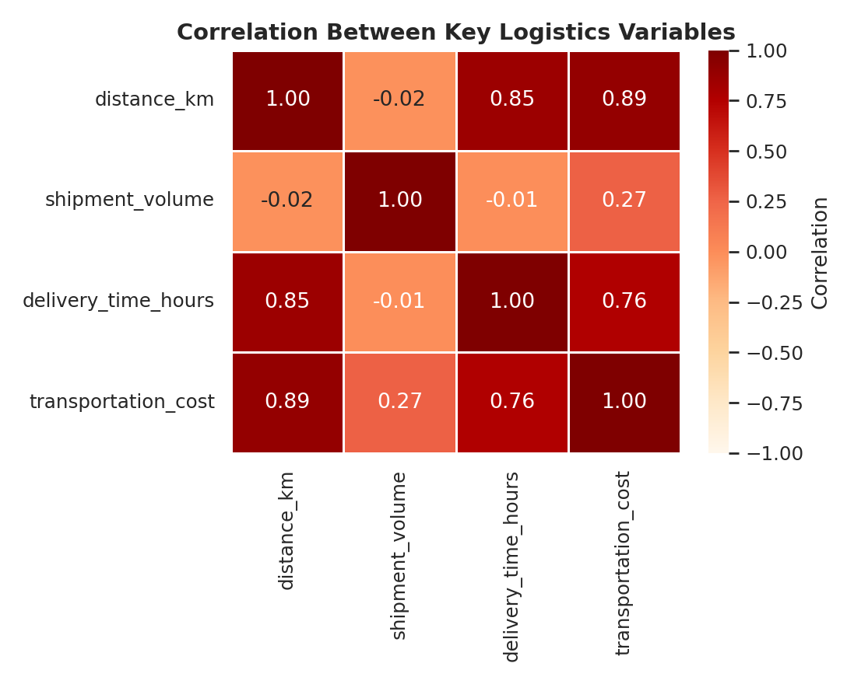
Figure 1 — Correlation matrix of key numeric logistics variables.
Distance is the dominant driver of both delivery time (r = 0.85) and transportation cost (r = 0.89), while shipment volume has only a weak relationship with cost (r = 0.27) and essentially none with delivery time (r = -0.01). This matters operationally: cost-control efforts aimed at consolidating shipment volume will have limited effect, whereas route-distance reduction (Week 1's clustering + VRP approach) is the lever most likely to move both KPIs together.

4. Visualizations

4.1 Distribution of Delivery Times
A histogram with overlaid KDE curve shows the shape of the delivery-time distribution — chosen because central-tendency statistics alone hide the shape (skew, tail thickness) that a raw mean/median table cannot convey.
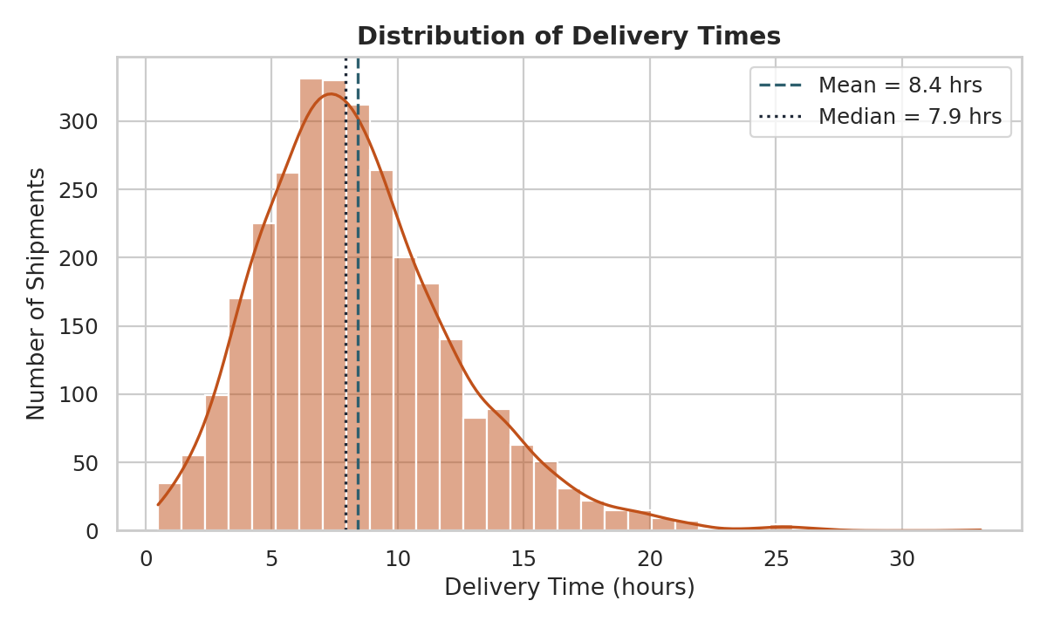
Figure 2 — Distribution of delivery times across all shipments.
The distribution peaks around 6–8 hours but carries a long tail past 20 hours. That tail — not the typical shipment — is what is dragging OTDR down; the median delivery (7.9 hrs) is reasonably close to typical SLA windows, but a meaningful minority of shipments take two to three times longer.

4.2 Delivery Time Spread by Hub
A boxplot was chosen over a simple bar of averages because it exposes both the median and the spread/outliers per hub simultaneously — critical for diagnosing whether a hub's problem is consistently slow service or occasional bad days.
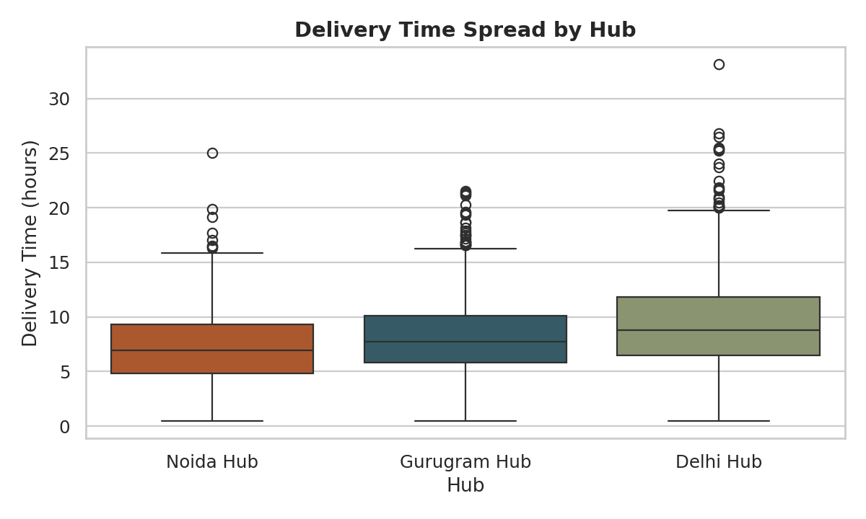
Figure 3 — Delivery time distribution, compared across the three hubs.
Delhi Hub shows both a higher median delivery time and a wider spread than Noida Hub, confirming that its poor OTDR (27.5%) is a systemic congestion issue rather than a handful of outlier shipments.

4.3 Transportation Cost vs. Distance
A scatter plot with a fitted trend line was chosen specifically to test and visualize the strength of the distance-cost relationship implied by the correlation matrix.
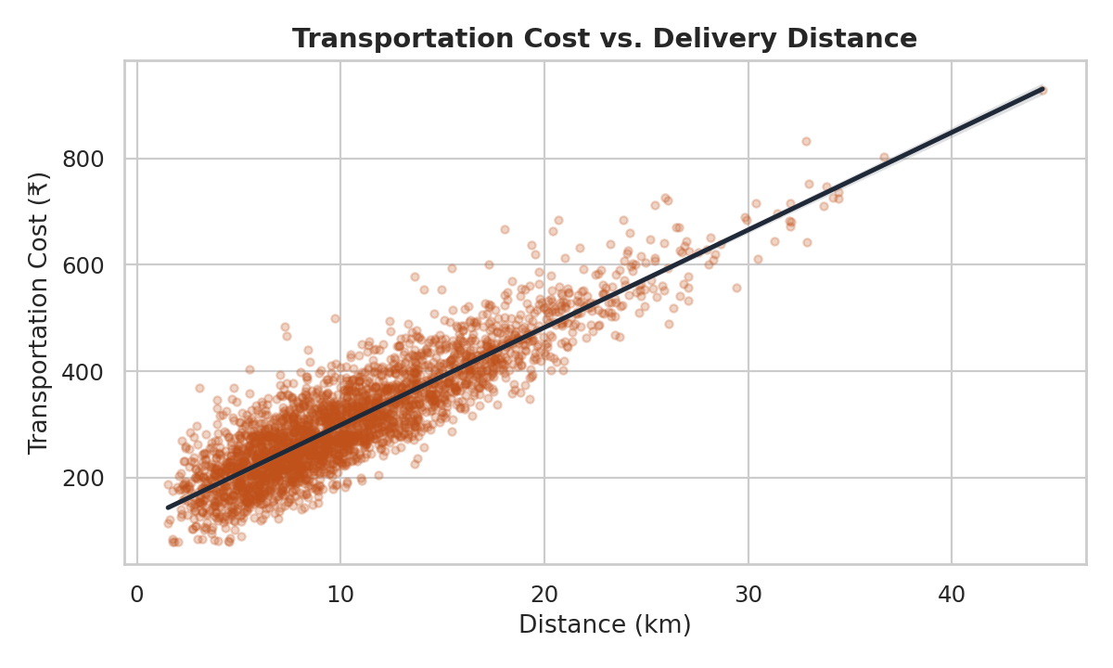
Figure 4 — Transportation cost rises near-linearly with distance.
The near-linear relationship confirms distance as the primary cost driver. The scatter also shows increasing variance at longer distances (a 'fan' shape), suggesting that cost predictability itself degrades on long-haul deliveries — a secondary planning risk worth flagging beyond the average trend.

4.4 Average Shipment Volume by Zone
A bar chart ranks the 12 delivery zones by average shipment volume, chosen because it's the clearest way to compare a single metric across many discrete categories.
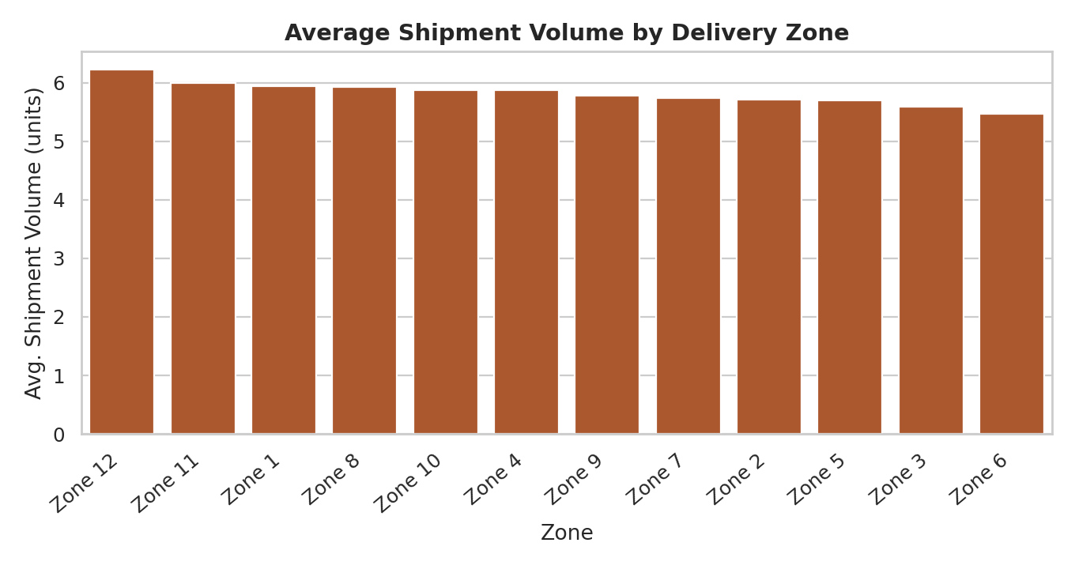
Figure 5 — Average shipment volume across the 12 delivery zones.
Zone-level average volume is remarkably flat (5.47–6.23 units, std. dev. only 0.20), which is itself a useful negative finding: demand is evenly spread across zones, so inventory imbalance (flagged in Week 1) is not being driven by geographic demand concentration. This points investigation back toward hub-level replenishment logic rather than zone-level demand forecasting.

4.5 Daily Transportation Cost Trend
A time series with a 7-day rolling average was chosen to separate real trend from daily noise — a raw daily line alone is too volatile to read.
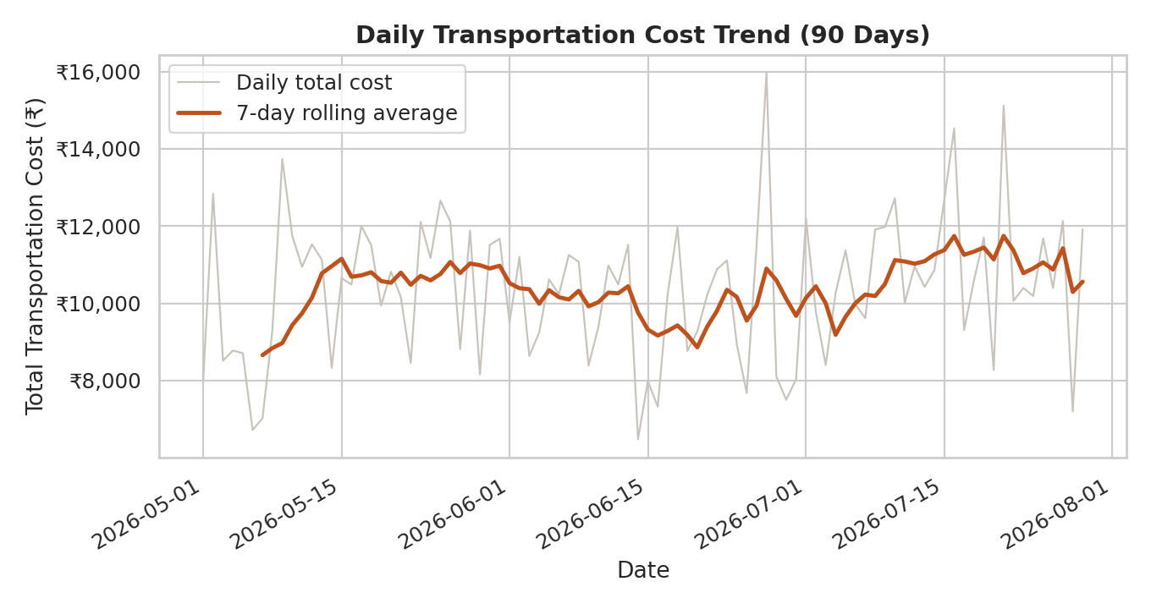
Figure 6 — Daily total transportation cost, May–August 2026, with 7-day rolling average.
The rolling average drifts upward over the 90-day window, from roughly ₹9,000/day in early May to ₹11,000+/day by late July. Since the volume-per-zone finding above rules out a demand-side explanation, this rising cost trend is more likely tied to route inefficiency accumulating over time — reinforcing the case for the route-optimization work proposed in Week 1.

4.6 On-Time Delivery Rate by Hub
A bar chart with a benchmark reference line was chosen to make the SLA gap immediately visible at each hub, which a table of percentages would understate.
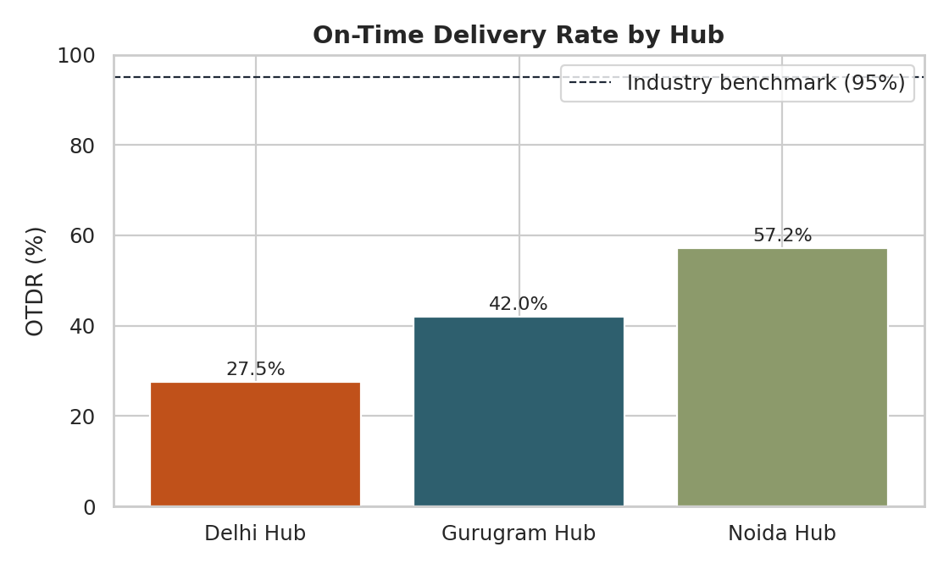
Figure 7 — OTDR by hub against a 95% industry benchmark.
Every hub sits far below the 95% benchmark, but the gap is not uniform: Delhi Hub is nearly 30 points behind Noida Hub. This is the single clearest operational signal in the dataset — if QuickRoute can only fix one hub first, Delhi Hub is the highest-leverage target.

5. Analytical Insights and Recommendations
- Distance, not volume, is the primary cost and time driver. Efforts to batch or consolidate shipment volume will have limited payoff (r = 0.27 with cost); route-distance reduction is the higher-leverage lever, directly supporting the Week 1 zone-clustering and VRP route-optimization plan.
- Delhi Hub is the clearest operational bottleneck. At 27.5% OTDR versus Noida's 57.2%, and a visibly wider delivery-time spread, Delhi Hub should be the first target for the delivery-time regression model and dispatch-level intervention proposed in Week 1.
- Zone-level demand is balanced, so the stockout/inventory problem is not geography-driven. Since shipment volume barely varies across the 12 zones, inventory imbalance investigation should focus on hub-level replenishment cadence rather than zone-level demand forecasting.
- Long-tail deliveries are the real threat to OTDR, not the typical shipment. The median delivery time (7.9 hrs) is reasonable; it's the right tail past 20 hours dragging the aggregate down. This favors targeted SLA-risk flagging (Week 1's regression-based flagging) over broad, network-wide changes.
- Cost is drifting upward over time independent of demand. A rising 7-day rolling cost average, combined with flat zone-level volume, points to accumulating route inefficiency rather than growth — a trend worth monitoring monthly once real data replaces this simulation.

6. Conclusion
This EDA and visualization pass turns the Week 1 KPI framework and Week 2 cleaning pipeline into a set of concrete, prioritized actions: fix Delhi Hub's congestion first, invest in distance-reduction (routing) over volume-consolidation, and treat the long delivery-time tail — not the average shipment — as the main OTDR lever. Once QuickRoute's real hub data replaces this simulation, the same seven-chart diagnostic set can be re-run on live data to track whether these interventions actually move the needle.

