WEEK 4 TASK
Predictive Modeling and Optimization in Logistics Systems
Forecasting Delivery Time and Recommending Optimization Actions for QuickRoute Logistics
Prepared by: Sumeet Rai | Data Analyst

1. Objective
This task applies predictive modeling and optimization to QuickRoute Logistics, building on the simulated shipment dataset from Week 3. A regression model is trained to forecast delivery time at the point of dispatch — the same problem framed conceptually in Week 1's roadmap — and the resulting model insights are translated into concrete optimization recommendations for routing, resource allocation, and cost control.

2. Problem Definition and Data Simulation

2.1 Prediction Problem
Target variable: delivery_time_hours — the actual time (in hours) between order placement and delivery. Forecasting this at dispatch lets QuickRoute flag shipments at risk of breaching their SLA window before they leave the hub, directly supporting the On-Time Delivery Rate (OTDR) KPI defined in Week 1.

2.2 Dataset
The Week 3 simulated dataset (3,000 shipments, 90-day window) is reused here. Two additional calendar features are engineered from order_date to test for day-of-week effects.
Feature | Type | Role
distance_km | Numeric | Predictor
shipment_volume | Numeric | Predictor
hub_id | Categorical (one-hot) | Predictor
is_weekend | Binary (engineered) | Predictor
delivery_time_hours | Numeric | Target
transportation_cost was deliberately excluded as a predictor. Although it correlates with delivery time (Week 3 found r = 0.76), it is generated in parallel with delivery time from the same underlying distance variable rather than causing it, and in a live system it may not even be finalized at dispatch time. Including it would risk target leakage and overstate real-world model performance.
df['day_of_week'] = df['order_date'].dt.dayofweek
df['is_weekend'] = (df['day_of_week'] >= 5).astype(int)

FEATURES_NUM = ['distance_km', 'shipment_volume', 'is_weekend']
FEATURES_CAT = ['hub_id']
TARGET = 'delivery_time_hours'

X = df[FEATURES_NUM + FEATURES_CAT]
y = df[TARGET]
X_train, X_test, y_train, y_test = train_test_split(
X, y, test_size=0.2, random_state=42)

3. Model Selection and Implementation
Three model families were compared, chosen to span a spectrum of interpretability vs. flexibility: Linear Regression (fully interpretable, assumes linear relationships — a reasonable prior given Week 3's finding that distance and delivery time are strongly, near-linearly correlated), a single Decision Tree (captures non-linear splits, easy to explain to non-technical hub managers), and Random Forest (an ensemble expected to generalize better and provide robust feature-importance estimates).
preprocess = ColumnTransformer([
('cat', OneHotEncoder(drop='first'), FEATURES_CAT),
], remainder='passthrough')

models = {
'Linear Regression': LinearRegression(),
'Decision Tree': DecisionTreeRegressor(max_depth=6, random_state=42),
'Random Forest': RandomForestRegressor(
n_estimators=200, max_depth=8, random_state=42),
}

for name, model in models.items():
pipe = Pipeline([('prep', preprocess), ('model', model)])
pipe.fit(X_train, y_train)
preds = pipe.predict(X_test)
# ... compute RMSE, MAE, R2 (see Section 4) ...

4. Evaluation and Validation

4.1 Metrics Used
- RMSE (Root Mean Squared Error) — in the same unit as the target (hours); penalizes large errors more heavily, relevant since large delivery-time misses are operationally the most costly to get wrong.
- MAE (Mean Absolute Error) — average absolute error in hours; more robust to the small number of extreme outliers identified in Week 3's EDA.
- R² (Coefficient of Determination) — proportion of variance in delivery time explained by the model, used to compare models on a common scale.

4.2 Baseline Model Comparison (held-out test set)
Model | Test RMSE (hrs) | Test MAE (hrs) | Test R² | 5-Fold CV RMSE
Linear Regression | 1.942 | 1.564 | 0.753 | 1.834 ± 0.055
Random Forest (default) | 1.944 | 1.572 | 0.752 | 1.881 ± 0.052
Decision Tree | 1.949 | 1.570 | 0.751 | 1.921 ± 0.078
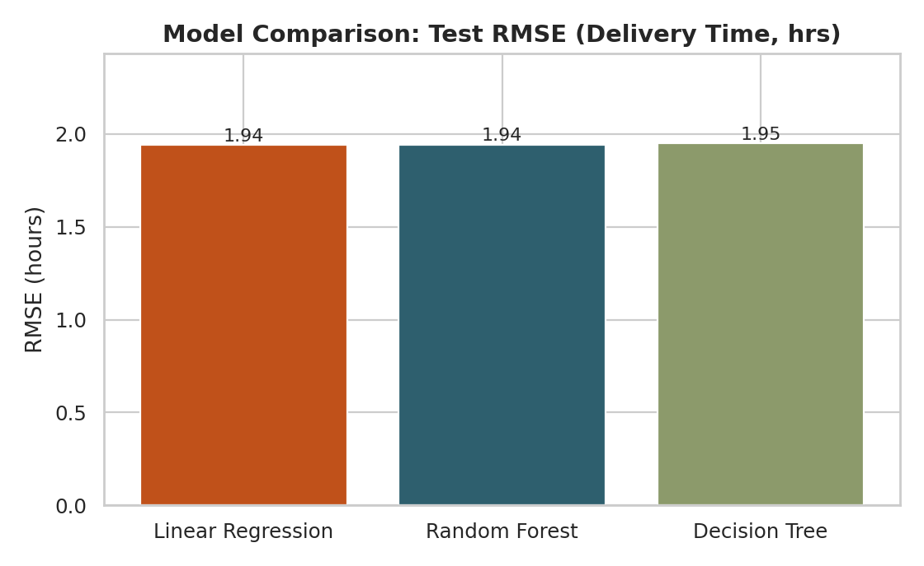
Figure 1 — Test RMSE across the three candidate models.
All three models perform almost identically on this dataset (RMSE within 0.01 hrs of each other). This is a meaningful finding, not a null result: it confirms Week 3's observation that delivery time is driven overwhelmingly by a single near-linear factor (distance × hub congestion), so more flexible models gain little over a simple linear fit. Linear Regression's tighter cross-validation spread (± 0.055 vs. Decision Tree's ± 0.078) also makes it the more stable choice if simplicity and interpretability are priorities.

4.3 Hyperparameter Tuning (Random Forest)
Since Random Forest offers the clearest path to feature-importance diagnostics for the optimization section, it was tuned via 5-fold grid search to see whether it could out-perform the untuned baseline.
param_grid = {
'model__n_estimators': [100, 200, 300],
'model__max_depth': [4, 6, 8, None],
'model__min_samples_leaf': [1, 5, 10],
}
grid = GridSearchCV(rf_pipe, param_grid, cv=kfold,
scoring='neg_root_mean_squared_error', n_jobs=-1)
grid.fit(X_train, y_train)

# Best params: {'max_depth': 6, 'min_samples_leaf': 1, 'n_estimators': 200}
# Tuned RF -> RMSE: 1.914 | MAE: 1.537 | R2: 0.760
Tuning improved Random Forest modestly (RMSE 1.944 → 1.914 hrs, R² 0.752 → 0.760) — a small but real gain, consistent with the earlier finding that there isn't much non-linear structure left for a more flexible model to capture.
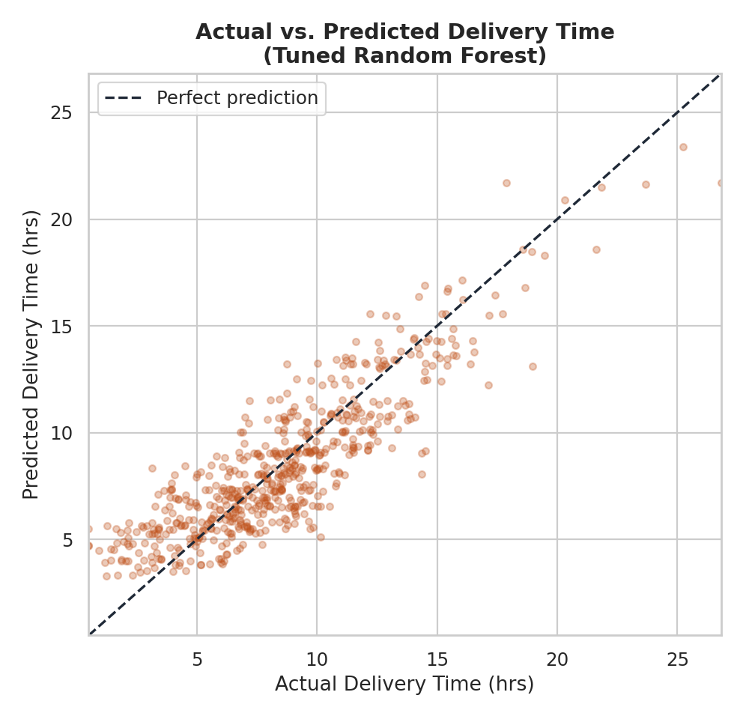
Figure 2 — Actual vs. predicted delivery time on the held-out test set (tuned Random Forest).
Predictions track the diagonal well through the bulk of the distribution (roughly 3–15 hours) but the model systematically under-predicts the small number of very long deliveries (20+ hours) — the same long tail flagged in Week 3's EDA. This is an expected and important limitation: the model is reliable for routine SLA-risk flagging but should not be the sole safeguard against extreme delays, which likely stem from non-modeled events (traffic incidents, vehicle breakdowns) rather than the routine distance/hub pattern captured here.
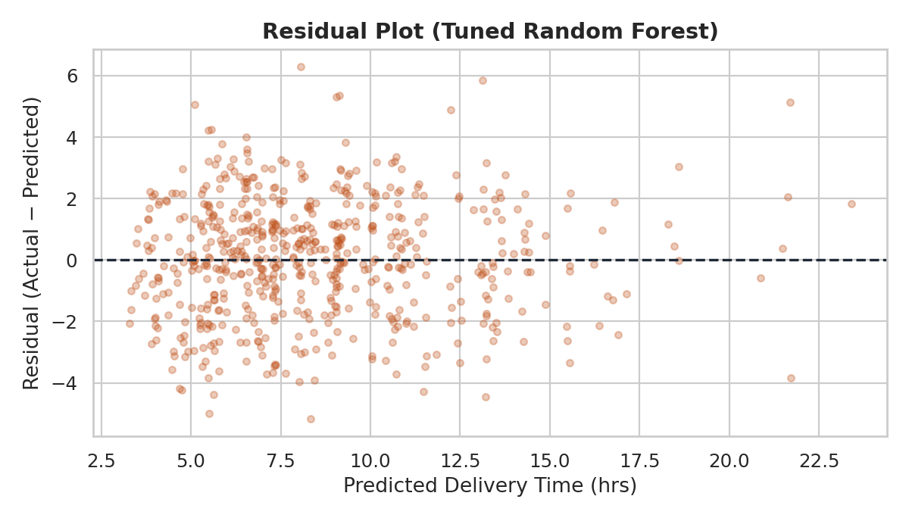
Figure 3 — Residuals vs. predicted values, tuned Random Forest.
Residuals are centered near zero with no strong funnel or curve pattern through the main mass of predictions, which supports the model's validity for typical shipments; the handful of large positive residuals at the right again correspond to the long-tail deliveries noted above.

4.4 Feature Importance
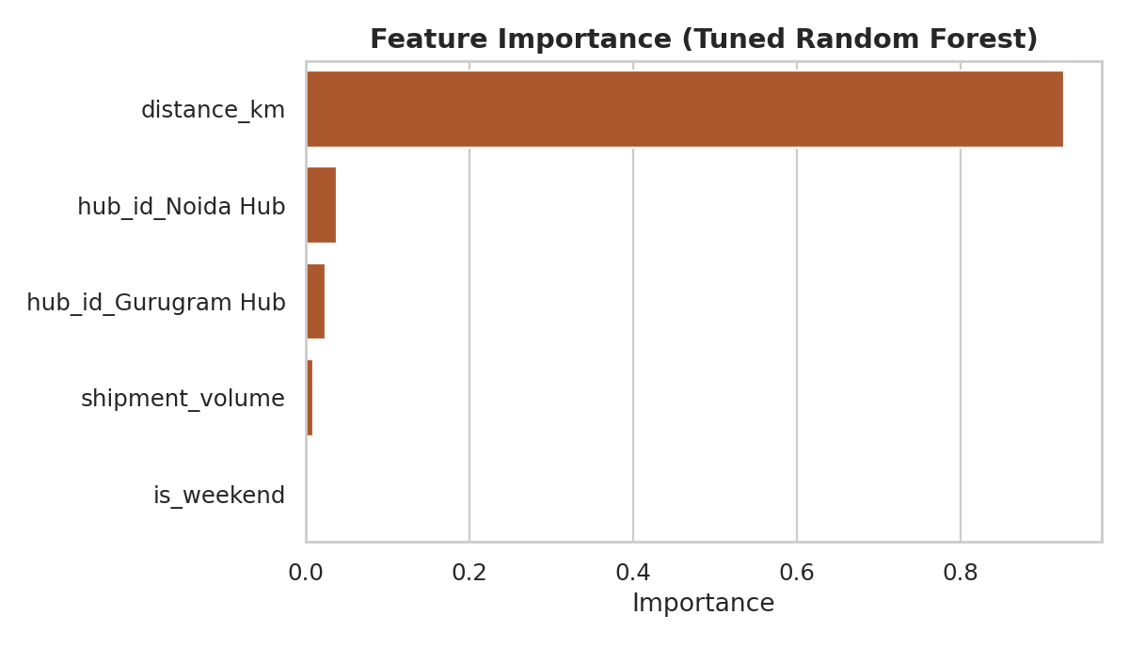
Figure 4 — Feature importance from the tuned Random Forest.
distance_km alone accounts for ~93% of the model's predictive signal, with hub identity contributing a further ~6% and shipment volume and weekend timing contributing almost nothing. This numerically confirms Week 3's correlation analysis and sharpens the operational conclusion: distance and hub-level congestion are the only two variables worth acting on.

5. Optimization Strategies
The model's findings translate into three concrete optimization levers, ranked by expected impact:
- Route optimization (highest leverage). Since distance is responsible for ~93% of delivery-time variance, the Week 1 zone-clustering + Vehicle Routing Problem (VRP) approach is the single highest-impact intervention available. Reducing average per-shipment distance by even 10–15% through better route sequencing should translate almost linearly into reduced delivery time, based on the near-1:1 relationship this model quantifies.
- Resource (vehicle/staff) reallocation toward Delhi Hub. The ~6% importance attributed to hub identity — concentrated in the gap between Delhi Hub and the other two hubs (Week 3: 27.5% vs. 57.2% OTDR) — indicates a congestion effect independent of distance. Reallocating additional delivery vehicles or staggering dispatch windows at Delhi Hub specifically, rather than a network-wide fleet increase, is the more cost-effective fix.
- Predictive dispatch flagging. Deploying this model (or the simpler, near-equally-accurate Linear Regression) at the point of dispatch lets QuickRoute flag any shipment with a predicted delivery time exceeding its promised window before the vehicle leaves the hub, enabling proactive re-routing or customer communication rather than a reactive apology after an SLA breach.
- Cost minimization via distance-first routing, not volume consolidation. Since shipment_volume has negligible importance for both delivery time (this report) and only weak importance for cost (Week 3: r = 0.27), consolidation-focused cost-cutting efforts (e.g., batching more items per shipment) will yield limited savings. Cost-reduction budget is better spent on the same route-distance optimization already prioritized above — a case where one intervention serves both the time and cost objectives simultaneously.

6. Final Recommendations Summary
Recommendation | Expected Impact | Owner
Deploy zone-based VRP route optimization (Week 1) | Largest lever on both delivery time and cost | Dispatch / Ops planning
Add dispatch capacity / stagger windows at Delhi Hub | Closes ~30-point OTDR gap vs. Noida Hub | Hub operations
Deploy delivery-time model at dispatch as an SLA-risk flag | Shifts OTDR management from reactive to proactive | Dispatch systems / IT
Deprioritize volume-consolidation cost initiatives | Redirects budget to the route-optimization lever with real impact | Operations finance
Together, these recommendations use the predictive model not as an end in itself but as a diagnostic tool: it confirms which levers actually move QuickRoute's KPIs (distance and hub congestion) and which ones — despite intuitive appeal — do not (shipment volume, day-of-week timing). The next step once real hub data is available would be re-training this same pipeline on live data and validating that the ranked feature importances hold outside the simulation.

