**Hw Assignment**

1 Create component Manually whose name is student component & display "welcome student component" on web page.

2 Create component through command line whose name is student component & display "welcome student component" on web page.

3 Using String interpolation display "Welcome Hefshine " with the both the ways (template & template url) ,also implement one method whose name is gettitle().

4 Create web page to render Number of authors and display the author name s using Component & services.Refer below image

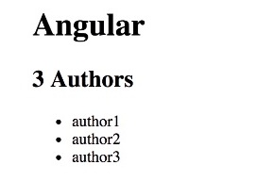

5 Design Log-in web page in angular Apply CSS style for page become attractive.