**#KPI'S**

**### 1. Total Revenue**

SELECT SUM(total_price) AS Total_Revenue FROM pizza_sales;

**OUTPUT**

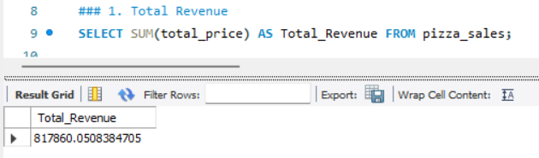

**### 2. Average Order Value**

SELECT (SUM(total_price) / COUNT(DISTINCT order_id)) AS Avg_order_Value

FROM pizza_sales;

**OUTPUT**

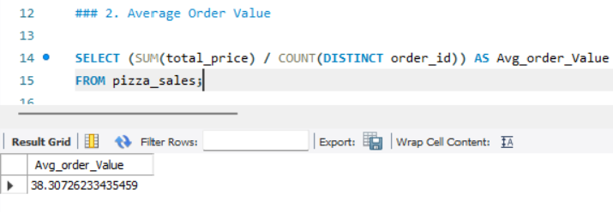

**## 3. Total Pizzas Sold**

SELECT SUM(quantity) AS Total_pizza_sold FROM pizza_sales;

**OUTPUT**

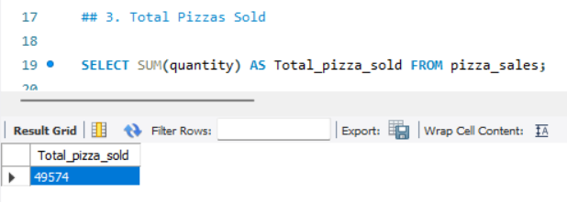

**## 4. Total Orders**

SELECT COUNT(DISTINCT order_id) AS Total_Orders FROM pizza_sales;

**OUTPUT**

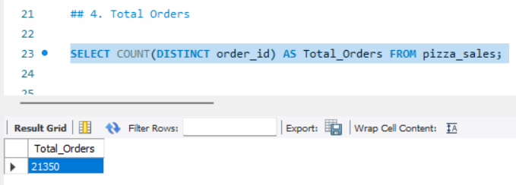

**## 5. Average Pizzas Per Order**

SELECT CAST(CAST(SUM(quantity) AS DECIMAL(10,2)) /

CAST(COUNT(DISTINCT order_id) AS DECIMAL(10,2)) AS DECIMAL(10,2))

AS Avg_Pizzas_per_order

FROM pizza_sales;

**OUTPUT**

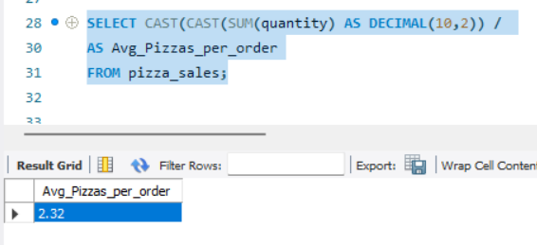

**### DAILY TREND FOR TOTAL ORDERS**

SELECT dayname(order_date) AS order_day, COUNT(DISTINCT order_id) AS total_orders

FROM pizza_sales

GROUP BY dayname(order_date)

order by 2 DESC;

**OUTPUT**

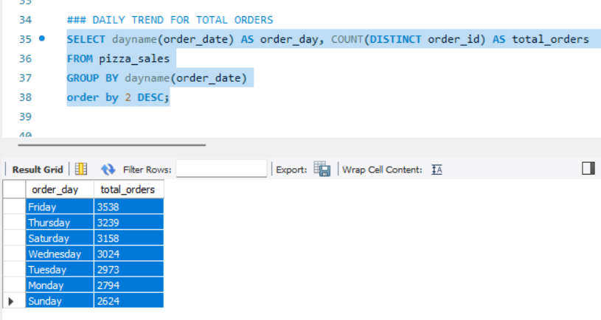

**###C. Monthly Trend for Orders**

select monthname(order_date) as Month_Name, COUNT(DISTINCT order_id) as Total_Orders

from pizza_sales

GROUP BY 1

ORDER BY Total_Orders DESC;

**OUTPUT**

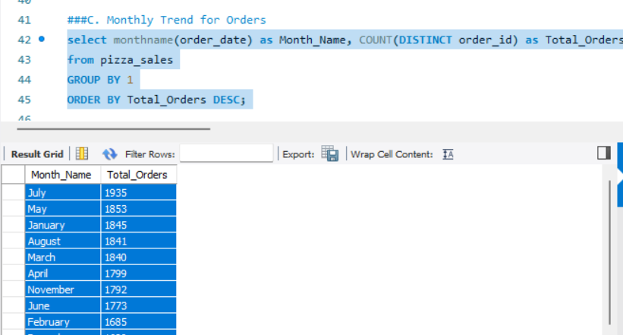

**### D. % of Sales by Pizza Category**

SELECT pizza_category,

CAST(SUM(total_price) AS DECIMAL(10,2)) as total_revenue,

CAST(SUM(total_price) * 100 / (SELECT SUM(total_price) from pizza_sales) AS DECIMAL(10,2)) AS PCT

FROM pizza_sales

GROUP BY pizza_category

ORDER BY PCT DESC;

**OUTPUT**

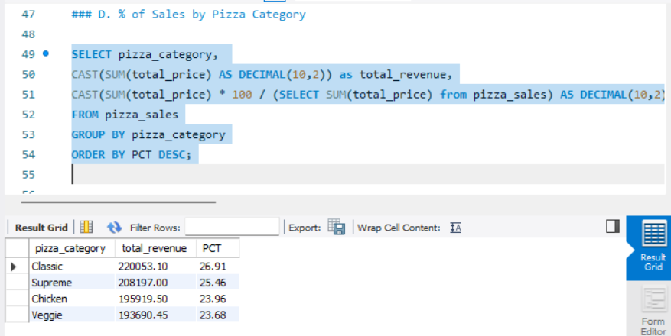

**###E. % of Sales by Pizza Size**

SELECT pizza_size, CAST(SUM(total_price) AS DECIMAL(10,2)) as total_revenue,

CAST(SUM(total_price) * 100 / (SELECT SUM(total_price) from pizza_sales) AS DECIMAL(10,2)) AS PCT

FROM pizza_sales

GROUP BY pizza_size

ORDER BY pizza_size;

**OUTPUT**

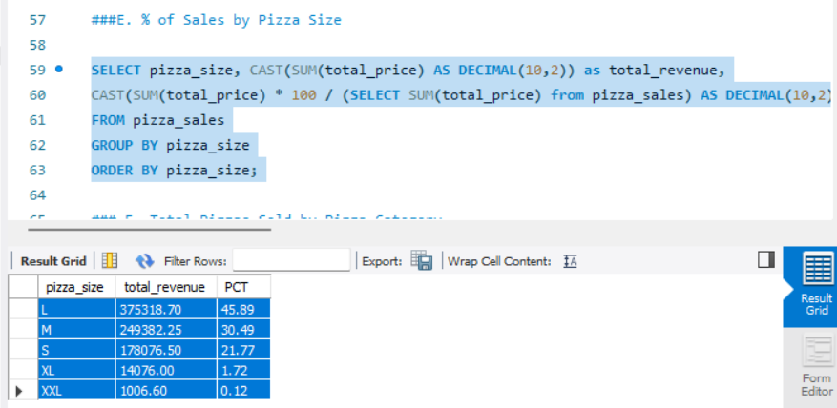

**### F. Total Pizzas Sold by Pizza Category**

SELECT pizza_category, SUM(quantity) as Total_Quantity_Sold

FROM pizza_sales

GROUP BY pizza_category

ORDER BY Total_Quantity_Sold DESC;

**OUTPUT**

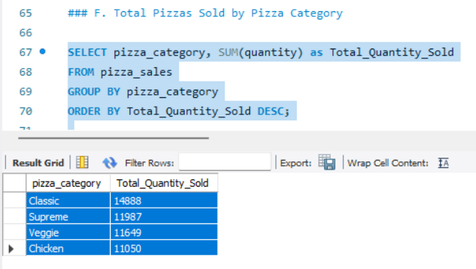

**### G. Top 5 Pizzas by Revenue**

SELECT pizza_name,SUM(total_price) AS Total_Revenue

FROM pizza_sales

GROUP BY pizza_name

ORDER BY Total_Revenue DESC

LIMIT 5;

**OUTPUT**

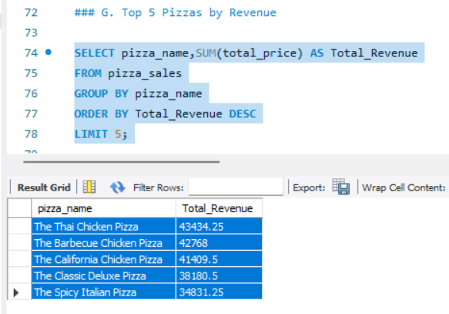

**### H Bottom 5 Pizzas by Revenue**

SELECT pizza_name,SUM(total_price) AS Total_Revenue

FROM pizza_sales

GROUP BY pizza_name

ORDER BY Total_Revenue ASC

LIMIT 5;

**OUTPUT**

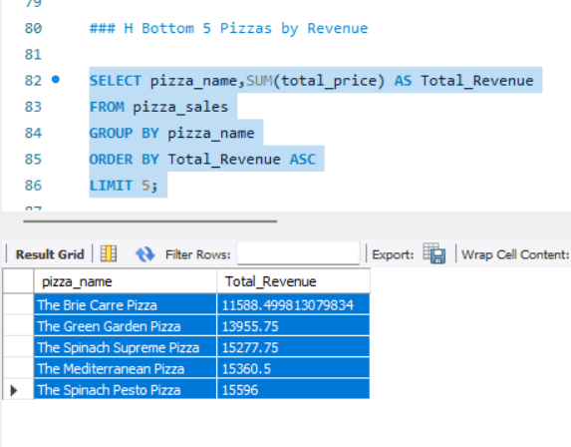

**### I. Top 5 Pizzas by Quantity**

SELECT pizza_name, SUM(quantity) AS Total_Pizza_Sold

FROM pizza_sales

GROUP BY pizza_name

ORDER BY Total_Pizza_Sold DESC

LIMIT 5;

**OUTPUT**

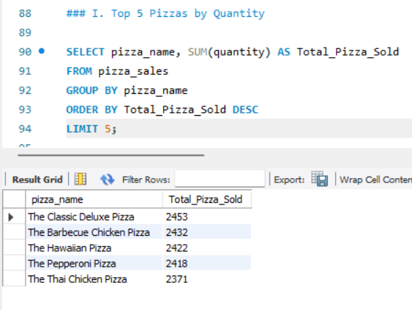

**### J. Bottom 5 Pizzas by Quantity**

SELECT pizza_name, SUM(quantity) AS Total_Pizza_Sold

FROM pizza_sales

GROUP BY pizza_name

ORDER BY Total_Pizza_Sold ASC

LIMIT 5;

**OUTPUT**

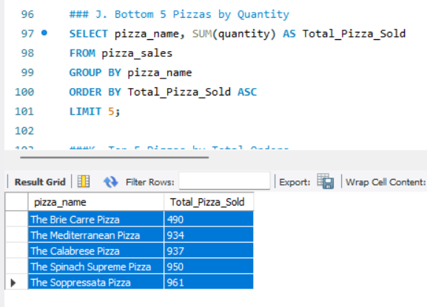

**###K. Top 5 Pizzas by Total Orders**

SELECT pizza_name, COUNT(DISTINCT order_id) AS Total_Orders

FROM pizza_sales

GROUP BY pizza_name

ORDER BY Total_Orders DESC

LIMIT 5;

**OUTPUT**

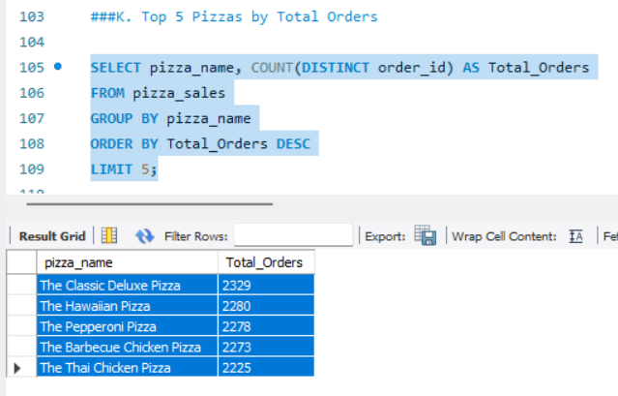

**### L. Bottom 5 Pizzas by Total Orders**

SELECT pizza_name, COUNT(DISTINCT order_id) AS Total_Orders

FROM pizza_sales

GROUP BY pizza_name

ORDER BY Total_Orders ASC

LIMIT 5;

**OUTPUT**

