Dr. D. Y. Patil Educational Federation’s
Dr. D. Y. Patil College of Engineering & Innovation
Approved by AICTE, Recognized by Govt. of Maharashtra,
(An Autonomous Institute Affiliated to Savitribai Phule Pune University)
Accredited by NAAC with “A” Grade
Department of Computer Engineering
Program name :- Computer Engineering Class: S.Y. B. Tech Div:- C
Name of Student: Sumit R Tajne Batch:- C-2 Course Name:- AIFM
PRN No :- Not provided Roll No:- 12332 Sem :- 3rd Course :- BSFI (Online)
SMARTBRIDGE | SKILLWALLET
Finova: AI-Powered Personal Finance Advisor
Project Description :-
Finova (also referred to as SkillWallet) is a web-based personal finance advisor designed to help users understand their monthly income, expenses and savings in a simple, organized way. Users can enter their monthly income, categorize expenses and select a financial goal. The application processes the information and presents a summary of spending, remaining balance, savings rate and personalized suggestions.
The platform is intended for students, beginners and individuals who want to improve their budgeting habits. It provides spending insights, recommended category budgets and practical actions that can help users manage everyday expenses and work toward goals such as building an emergency fund.
The application uses a browser-based interface with a Flask backend and database layer. AI-assisted guidance can be used when the configured service is available; a demo fallback may support basic demonstrations. API credentials should be configured through environment variables.
Technology & AI :-
- Frontend: HTML, CSS and JavaScript
- Backend: Python with Flask
- Database: SQLite with Flask-SQLAlchemy
- AI integration: Google Gemini API (when configured; demo fallback may be used)
- Deployment: Render
- Source code and documentation: GitHub

Key Features :-
- Monthly income and categorized expense entry
- Calculation of total expenses, remaining balance and savings rate
- Category-wise spending analysis with percentage of income and status
- Recommended budgets based on general budgeting guidelines
- Goal-oriented saving suggestions and practical actions
- Add/remove expense rows and reset form controls
- Responsive dark-themed interface for desktop and mobile browsers
- Health-check endpoint for basic service availability testing
Scenarios :-
Scenario 1: A user enters monthly income and expenses such as food, rent and transport. Finova calculates spending and shows the remaining balance and savings-related metrics.
Scenario 2: A student selects “Emergency Fund” as a financial goal. The application provides saving suggestions based on the entered financial details.
Scenario 3: A user spends a large share of income on one category. The spending analysis highlights the category and shows a recommended budget guideline.
Scenario 4: A user opens the deployed website, enters financial details and reviews the generated analysis, recommended budget and saving suggestions.
Website Screenshots :-
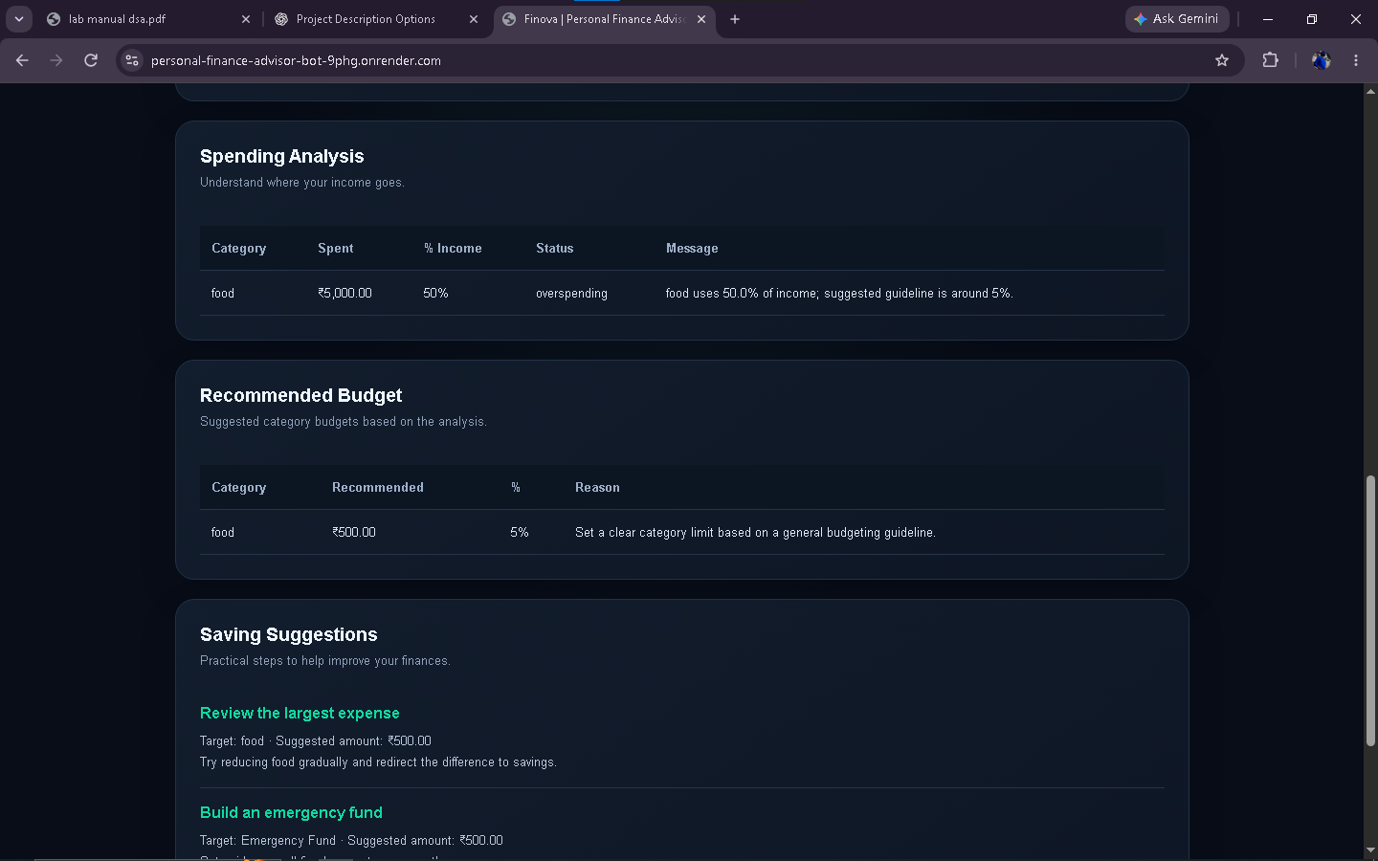
Figure 3: Blank form for entering a new financial analysis.
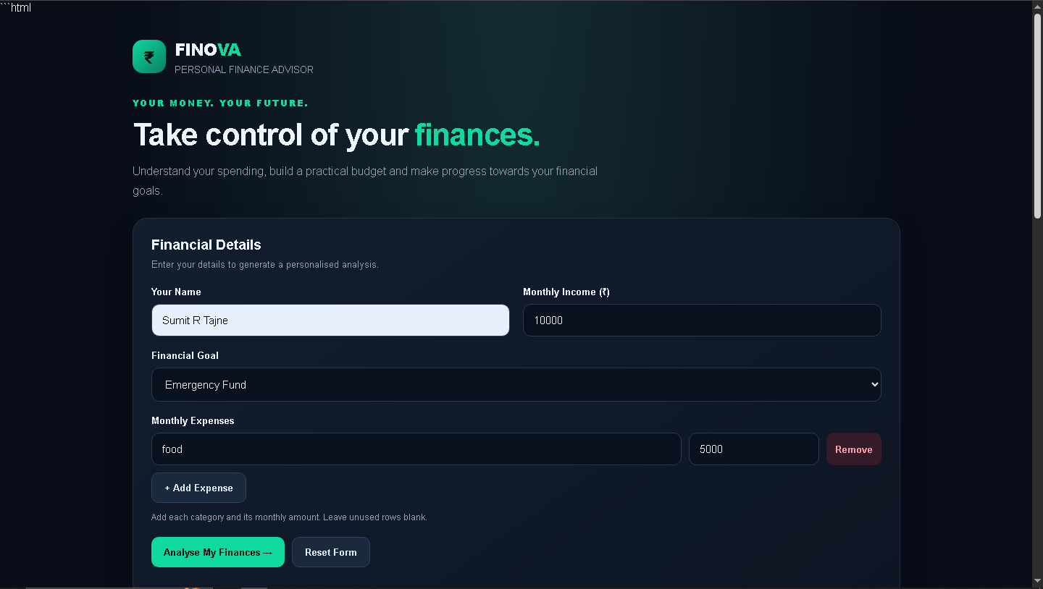
Figure 2: Spending analysis, recommended budget and saving suggestions.

Milestones :-
Milestone 1 – Project Planning & Requirement Analysis
Define the finance-advisor objective, identify target users and outline income, expense, budget and goal workflows.
Milestone 2 – Backend & Data Handling
Develop the Flask application, request handling and database layer for finance-related data.
Milestone 3 – Financial Analysis & Recommendations
Implement calculations for income, expenses, balance, savings rate and category-level spending insights.
Milestone 4 – User Interface & AI Integration
Build the responsive web interface and connect the configured AI service with a fallback for demonstration.
Milestone 5 – Testing & Deployment
Test form inputs and analysis results, check the health endpoint and deploy the application on Render.
Project Links :-
Live Demo: https://personal-finance-advisor-bot-9phg.onrender.com
Health Check: https://personal-finance-advisor-bot-9phg.onrender.com/health
GitHub Repository: https://github.com/sumittajne/Personal-Finance-Advisor-Bot
Conclusion :-
Finova provides a simple way to review personal spending and plan savings. By combining a web interface, backend processing and structured financial analysis, the project helps users identify major expense categories, compare spending with suggested limits and consider practical saving actions. It demonstrates the use of modern web technologies to support basic personal finance planning.
Expected Outcome :-
The expected outcome is a working web-based personal finance advisor that accepts user-entered financial details, calculates useful budget metrics and presents understandable insights and recommendations. The project also demonstrates the development and deployment of a Python-based web application.
Application Interface :-
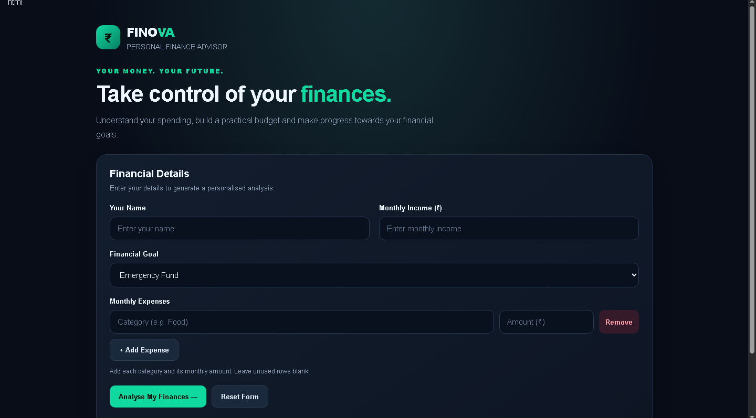
Figure 1: Finova homepage and financial details form.

