SUMIT SAINI  sumitsaini-byte · GitHub linkedin.com/in/sumit-saini-25a340317  sumit.sainisahb@gmail.com 9654007110 Delhi Rohini, India. | 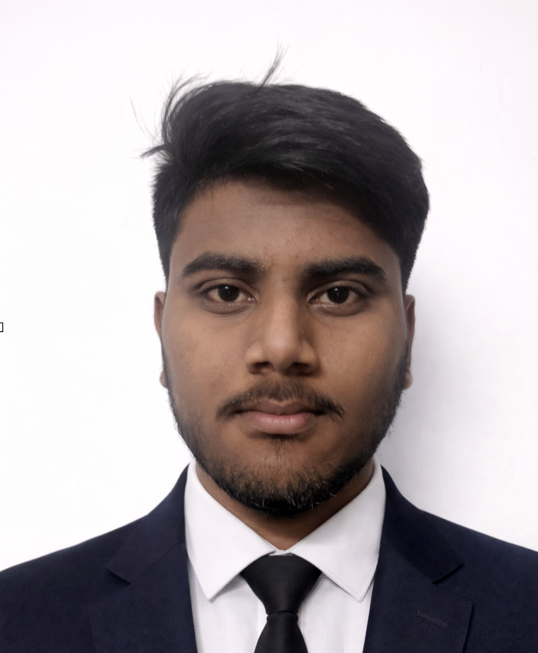
Profile
Motivated MCA student with strong skills in full-stack web development and real-world project experience. Passionate about applying technology in practical scenarios, especially in the finance domain. Quick learner, team-oriented, and open to international opportunities.
Education
Master of Computer Applications (MCA), 2024 - 2026
Jagan Institute of Management Studies (JIMS), Rohini, Delhi
Bachelor of Computer Applications (BCA), Web Development, 2021 - 2024
Sirifort Institute of Management Studies, IP University, Sector 25, Rohini, Delhi
Percentage: 75%
Senior Secondary (XII), Commerce, DAV Public School, Delhi 2020 - 2021
CGPA: 7.25/10
Technical Skills
- Languages: Java, C, JavaScript, Python, C++, PHP
- Web Development: HTML5, CSS, React.js, Angular, Bootstrap
- Backend: Node.js, Express.js, Spring Boot, REST APIs
- Database: MySQL, MongoDB, SQL Server
- Cloud Basics: Git, Docker
- Tools: Postman, VS Code, IntelliJ, GitHub
- Concepts: DSA, OOP
Projects
Hotel Management Website (Mar 2024 - May 2024)
A full-stack hotel management system for customer bookings and admin control.
- Built user login/register, room filtering, booking/cancellation system, and admin dashboard using PHP and MySQL.
- Designed a mobile-responsive UI using Bootstrap, focusing on usability and smooth session handling.
MERN E-commerce Website for Father's Business (Jul 2025 - Sep 2025)
Designed and developed a responsive e-commerce website for my father's men's fashion business.
- Built product catalog, customer authentication, cart, and order flow using MongoDB, Express.js, React.js, and Node.js.
- Implemented both frontend and backend modules with a mobile-friendly UI and business-focused usability for daily operations.
Certifications
- Alpha DSA with Java : Apna College (Shadha Khapra)
- The Complete Web Developer Course 3.0 : Udemy (31 hours, Rob Percival, Lo destars)

