WIRESHARK
PACKET ANALYSIS
Cybersecurity Practical Project – Beginner Level
Prepared by: Sumit Saini
Tool: Wireshark | Environment: Kali Linux | Interface: eth0
────────────────────────────────────────
Project focus: DNS, TCP handshake and flags, HTTP traffic, unusual TCP behavior, and protocol statistics
Submission-ready report with practical evidence screenshots

Table of Contents
1. Project Overview
2. Objective and Requirements
3. Lab Environment and Methodology
4. DNS Packet Analysis
5. TCP Three-Way Handshake Analysis
6. TCP Flags and Packet Structure Analysis
7. HTTP Traffic Analysis
8. Unusual TCP Traffic Analysis
9. Protocol Hierarchy Statistics
10. Key Findings
11. Conclusion
Deliverables covered
Six evidence screenshots are embedded in this report. The report documents the capture process, packet-level observations, findings, and conclusion required for the Wireshark Packet Analysis task.

Project Evidence Checklist
Evidence | File | Status
DNS query/response | 01_dns_capture.png | Complete
TCP three-way handshake | 02_tcp_handshake.png | Complete
TCP flags | 03_tcp_flags.png | Complete
HTTP request/response | 04_http_capture.png | Complete
Unusual TCP traffic (Duplicate ACK) | 05_unusual_tcp_traffic.png | Complete
Protocol hierarchy statistics | 06_protocol_hierarchy.png | Complete

1. Project Overview
Wireshark Packet Analysis is a practical network-analysis exercise that demonstrates how packet captures can be inspected to understand application, transport, and network-layer communication. The project uses a Kali Linux environment and Wireshark to capture and examine DNS, TCP, and HTTP traffic, while also looking for indicators of unusual TCP behavior.
Guideline alignment
The practical evidence directly maps to the assigned requirements: capture HTTP/DNS/TCP traffic, analyze packet structure and TCP flags, and identify unusual or malformed-looking traffic for further investigation.

2. Objective and Requirements

Objective
To capture and analyze network packets using Wireshark in order to identify protocols, understand packet structure, interpret TCP control flags, inspect HTTP and DNS traffic, and investigate unusual TCP behavior.

Assigned Requirements
- Capture traffic for HTTP, DNS, and TCP handshakes.
- Analyze packet structure and TCP flags.
- Identify unusual or malformed packets and explain why they may be unusual.
- Provide Wireshark screenshots and a short analysis report as deliverables.

Scope
The analysis is limited to the packets present in the captured lab traffic. Unusual packets are treated as indicators for investigation rather than automatically classified as malicious activity. This distinction is important in real network monitoring, where packet loss, reordering, congestion, or application behavior can produce similar symptoms.

3. Lab Environment and Methodology
Component | Value
Operating System | Kali Linux (VMware virtual machine)
Packet Analyzer | Wireshark
Capture Interface | eth0
DNS Utility | DNS traffic generated/observed during normal network activity
HTTP Test Traffic | HTTP request generated with curl to example.com
Analysis Scope | DNS, TCP handshake, TCP flags, HTTP, Duplicate ACK behavior, protocol statistics

Methodology
- Start a packet capture on the active eth0 interface.
- Generate or observe normal DNS traffic and filter the capture with dns.
- Generate an HTTP request and observe the underlying TCP connection and HTTP request/response.
- Inspect SYN, SYN-ACK, ACK, and FIN-related TCP flags.
- Search for TCP analysis indicators such as Duplicate ACKs to identify unusual behavior.
- Open Statistics → Protocol Hierarchy with no display filter to summarize all captured protocols.
- Document observations with screenshots and interpret the findings conservatively.
Ethical / safe-lab note
The traffic analyzed in this report is limited to a controlled lab capture and normal network activity. No unauthorized interception, credential collection, or exploitation was performed as part of this project.

4. DNS Packet Analysis
Display filter used: dns
The DNS evidence shows communication between the Kali client (192.168.230.129) and the DNS server (192.168.230.2). The selected response uses UDP source port 53 and is identified by Wireshark as a standard DNS query response with no error. The response also contains CNAME information associated with the requested Facebook-related hostname.
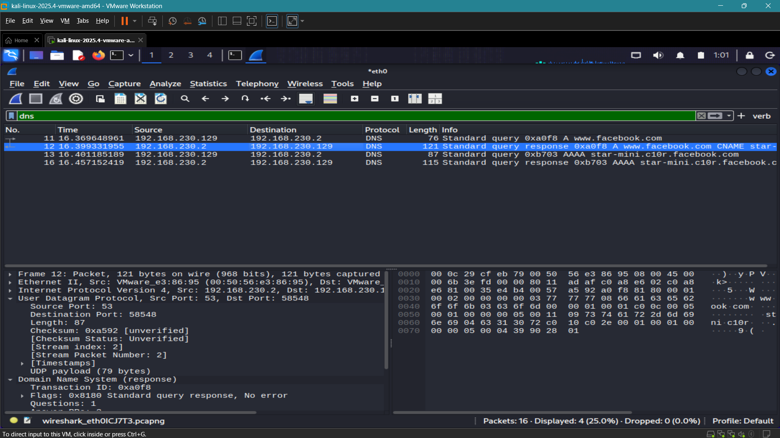
Figure 1 – DNS query/response capture in Wireshark (dns display filter).

Packet observations
- Client IP observed: 192.168.230.129.
- DNS server observed: 192.168.230.2.
- DNS uses UDP source port 53 in the displayed response.
- Wireshark shows “Standard query response, No error,” indicating a successful DNS response.
- The response includes CNAME-related information, demonstrating that DNS can return aliases in addition to address records.

5. TCP Three-Way Handshake Analysis
Display filter used: tcp
The capture contains a complete TCP connection establishment sequence. In the highlighted flow, the client 192.168.230.129 initiates a connection to 104.20.23.154 on TCP port 80. Wireshark shows the SYN, SYN-ACK, and ACK sequence required to establish the connection.
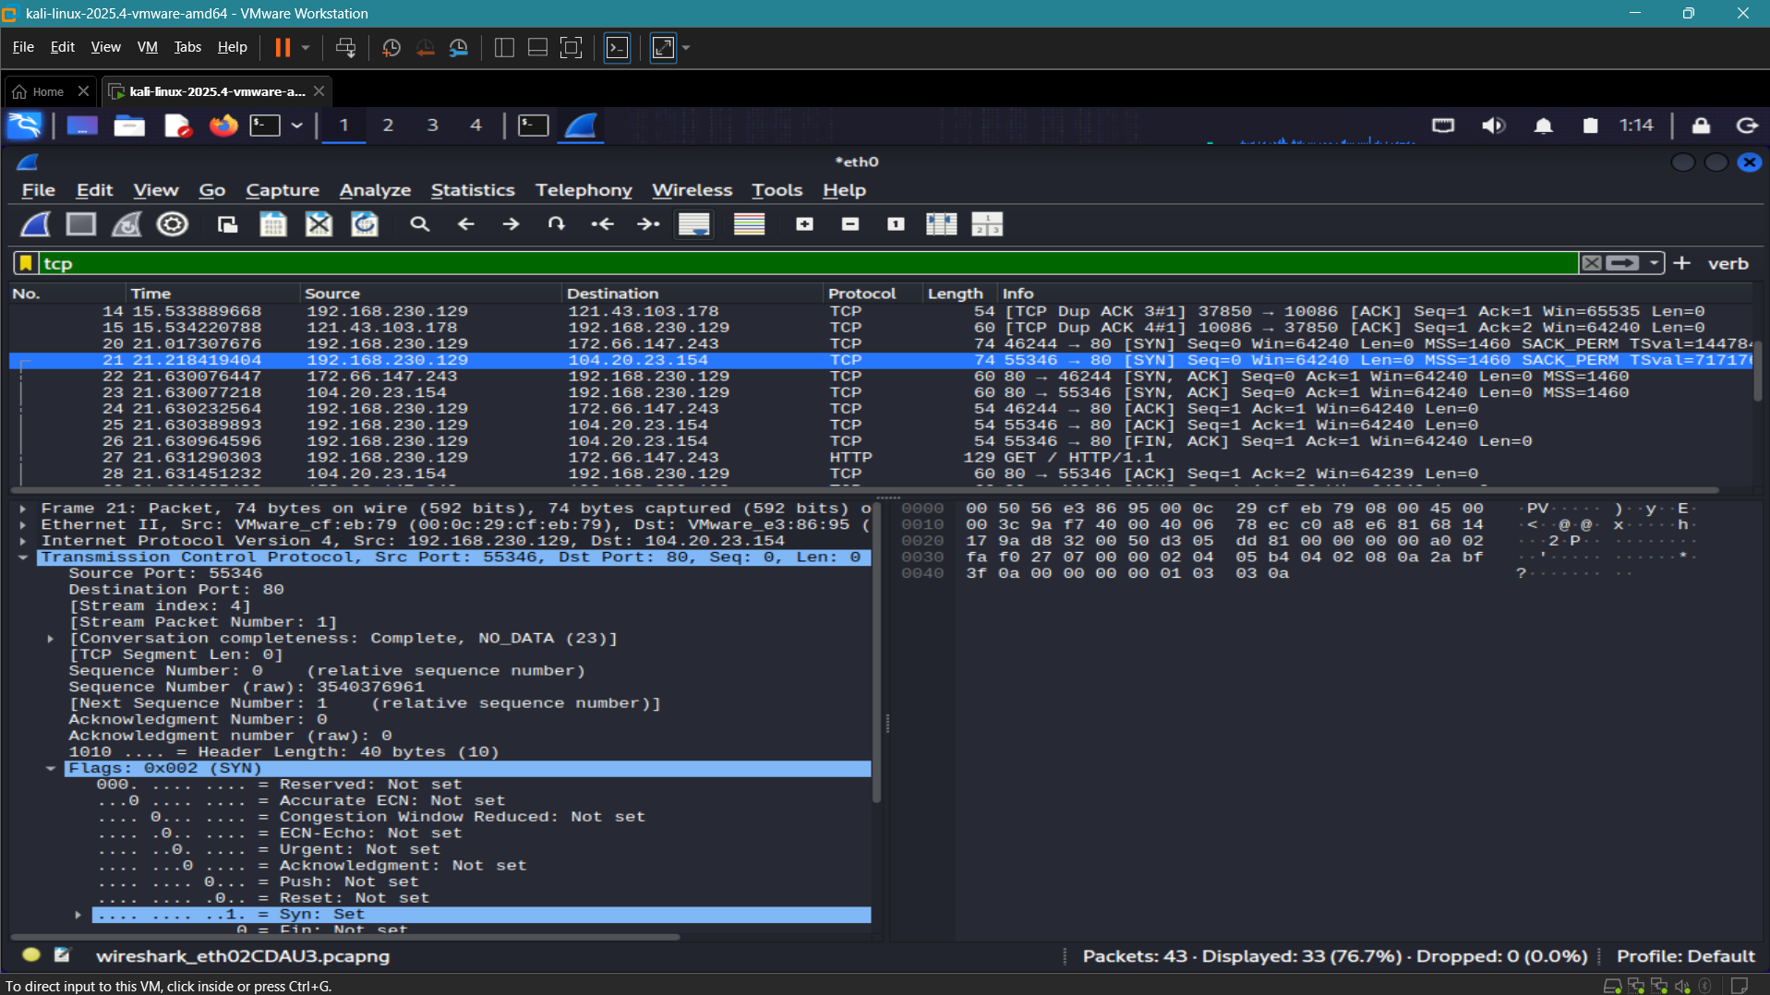
Figure 2 – TCP three-way handshake with the SYN packet selected and TCP flags expanded.
Handshake sequence:
- Packet 21: client → server, SYN. The client requests a new TCP connection.
- Packet 22: server → client, SYN-ACK. The server acknowledges the request and proposes its own initial sequence state.
- Packet 23: client → server, ACK. The client acknowledges the server response, completing the three-way handshake.
Key concept
A successful TCP three-way handshake establishes the state needed for reliable bidirectional communication before application data is exchanged.

6. TCP Flags and Packet Structure Analysis
TCP control flags provide information about the state of a connection. The capture demonstrates SYN, SYN-ACK, ACK, and FIN-related traffic, allowing the connection lifecycle to be observed at packet level.
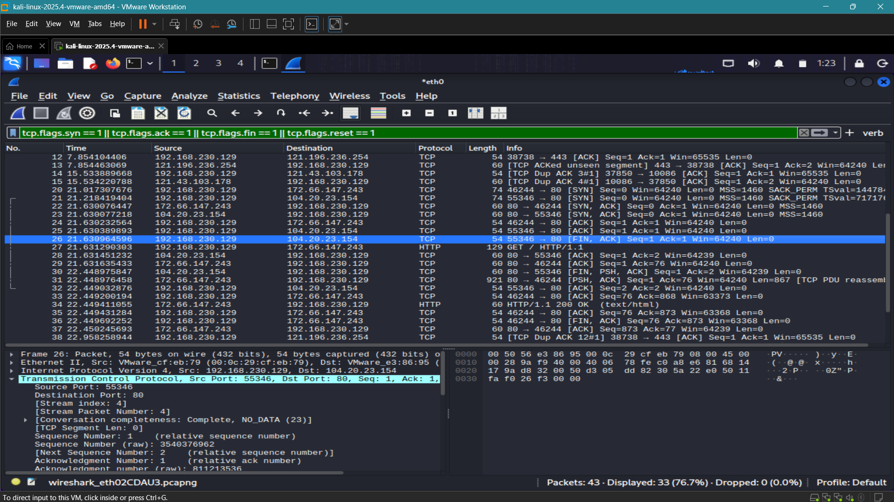
Figure 3 – TCP control flags observed in the capture, including SYN, ACK, and FIN-related packets.
Flag | Meaning | Evidence in capture
SYN | Starts/initiates a TCP connection. | Packet 21
ACK | Acknowledges received TCP data/control information. | Packets 22, 23, 25
FIN | Requests an orderly connection close. | Packet 26 and later FIN-related traffic
PSH | Requests that buffered application data be pushed to the receiving application. | Seen together with FIN/ACK in packet 30
RST | Immediately resets a TCP connection. | Not used as a required finding because a natural RST packet was not needed for this capture

Packet structure
When a TCP packet is selected, Wireshark exposes the transport-layer fields that support interpretation of the session, including source port, destination port, sequence number, acknowledgment number, window information, and flags. These fields are essential for packet-level troubleshooting and network forensics.

7. HTTP Traffic Analysis
Display filter used: http
The capture contains a clear HTTP request/response exchange. Packet 27 carries a GET request to example.com over TCP port 80, while packet 34 shows an HTTP/1.1 200 OK response. The HTTP request also exposes common headers such as Host, User-Agent, and Accept.
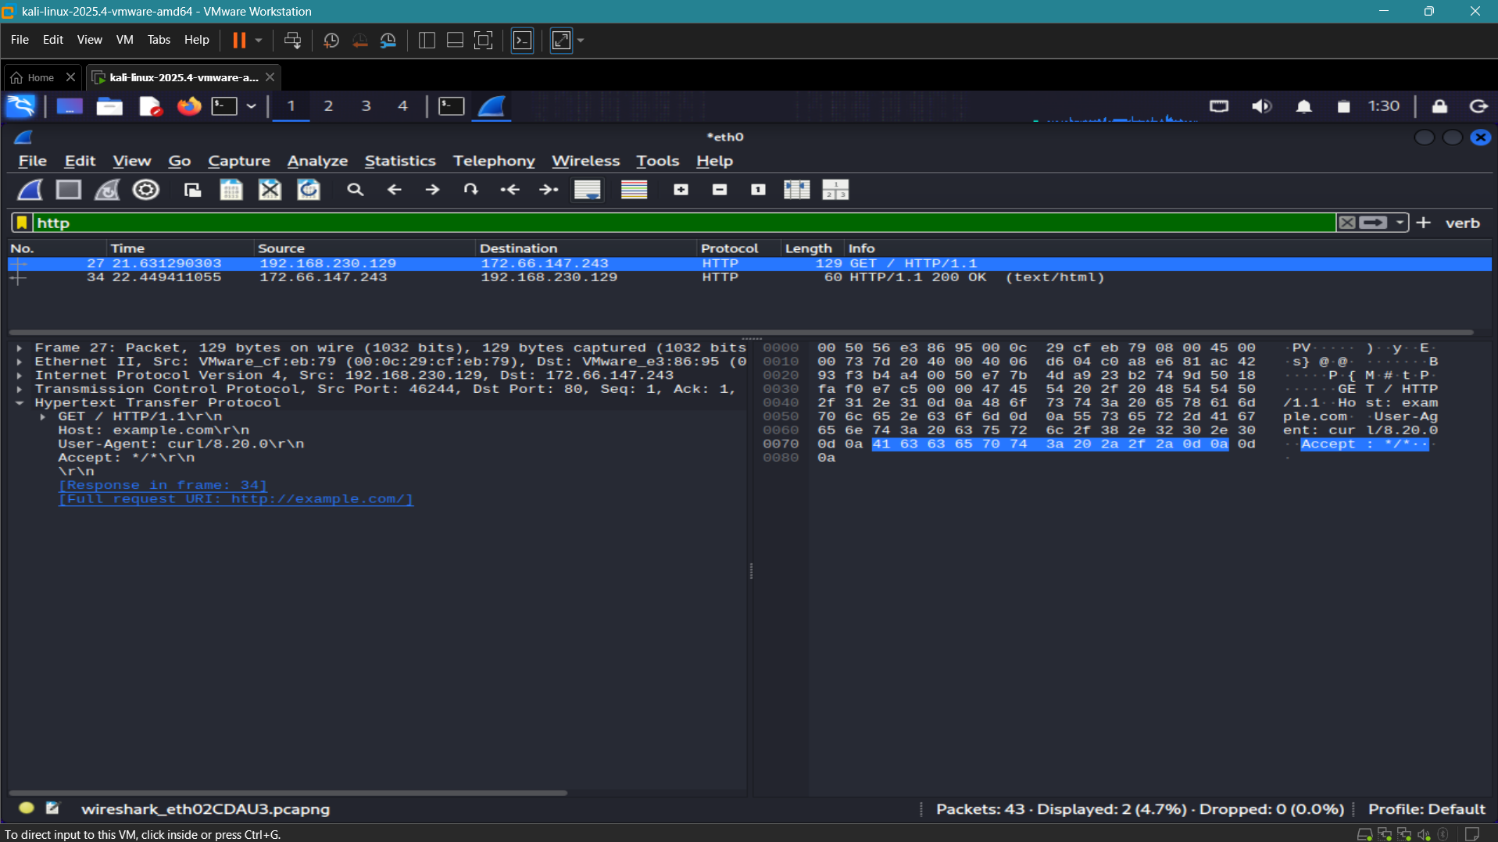
Figure 4 – HTTP GET request and HTTP 200 OK response captured by Wireshark.
- Request method: GET.
- HTTP version: 1.1.
- Host header: example.com.
- User-Agent observed: curl/8.20.0.
- Response: HTTP/1.1 200 OK (text/html).
- Destination port: 80, confirming cleartext HTTP rather than HTTPS for this exchange.
Security observation
Because plain HTTP is unencrypted at the application layer, request metadata and content may be visible in a packet capture. In production environments, HTTPS should normally be preferred for sensitive communication.

8. Unusual TCP Traffic Analysis
Display filter used: tcp.analysis.duplicate_ack
The capture contains multiple TCP Duplicate ACK indicators. Wireshark marks packets 14, 15, 38, and 39 as Duplicate ACKs in the TCP packet list. Duplicate acknowledgments can occur when a receiver receives packets out of order, detects a missing segment, or experiences delayed/reordered traffic.
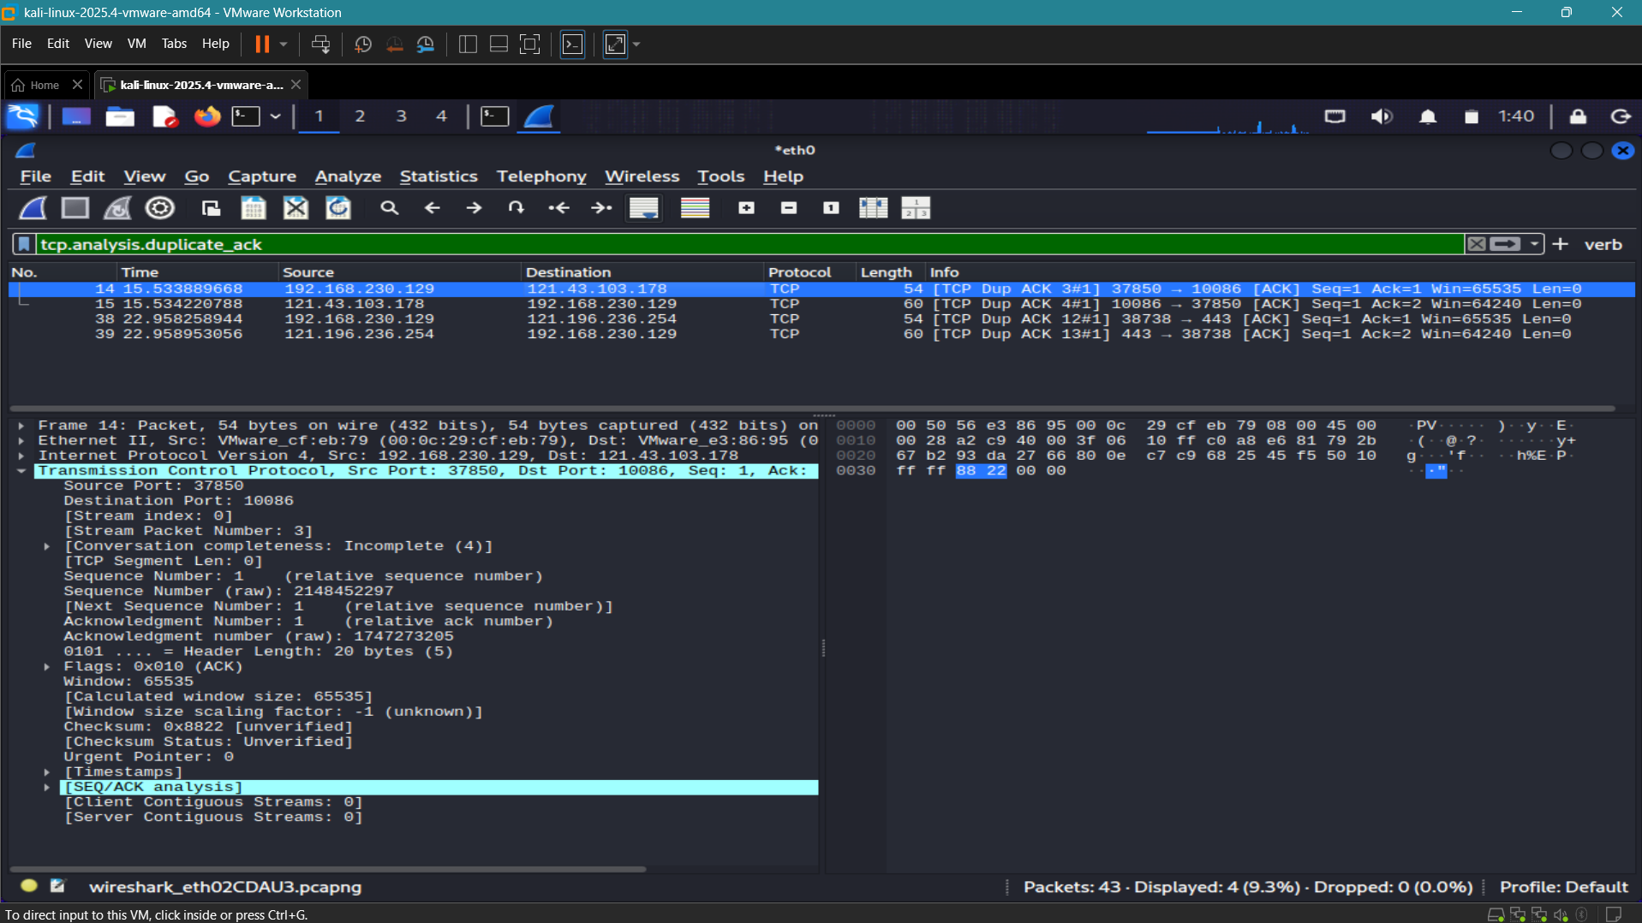
Figure 5 – TCP Duplicate ACK indicators visible in the captured TCP packet list.
- Packets 14 and 15 are marked as Duplicate ACKs in one TCP flow.
- Packets 38 and 39 are marked as Duplicate ACKs in another TCP flow.
- Duplicate ACKs are an anomaly indicator, not proof of an attack by themselves.
- Possible explanations include packet loss, congestion, retransmission, packet reordering, or timing effects.
Finding classification
The observed Duplicate ACKs are best classified as unusual TCP behavior requiring investigation. The evidence does not justify labeling the traffic as malicious solely from the Duplicate ACK indicator.

9. Protocol Hierarchy Statistics
Wireshark’s Protocol Hierarchy view summarizes the protocols represented in the complete capture. The screenshot was taken with no display filter so the statistics describe all packets captured in the file.
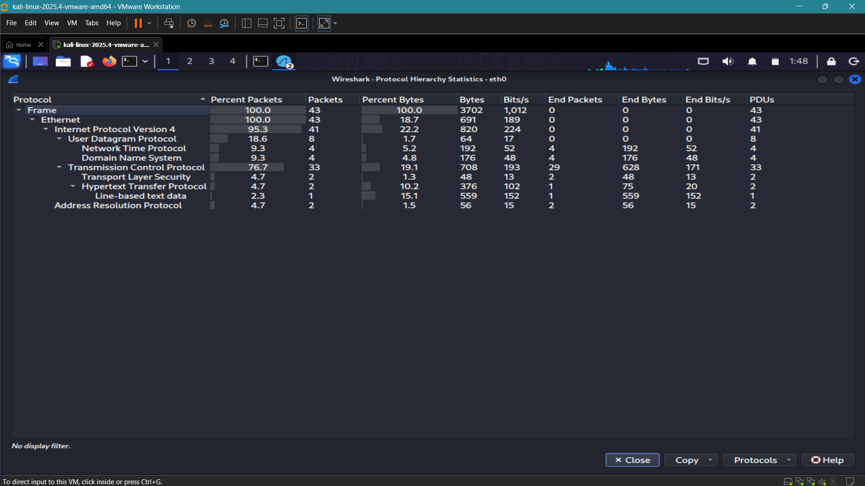
Figure 6 – Wireshark Protocol Hierarchy Statistics for the complete capture (no display filter).
The capture contains 43 frames. Wireshark reports 33 TCP packets, 8 UDP packets, 4 DNS packets, 2 TLS packets, 2 HTTP packets, and 2 ARP packets within the protocol hierarchy shown. IPv4 is present in 41 of the 43 frames.

10. Key Findings
Finding | Analysis
DNS communication | DNS query/response traffic was successfully captured and decoded. The response was a standard query response with no error and included CNAME information.
TCP connection establishment | A complete SYN → SYN-ACK → ACK sequence was observed, confirming successful TCP connection establishment.
TCP control flags | SYN, ACK, and FIN-related flags were visible in the capture. These flags provided evidence of connection setup and orderly termination behavior.
HTTP traffic | An HTTP/1.1 GET request to example.com and a 200 OK response were captured over TCP port 80.
Unusual behavior | Multiple Duplicate ACK indicators were observed. These may point to loss, reordering, congestion, or delayed segments and should be investigated rather than assumed malicious.
Protocol coverage | The complete capture contained multiple protocols across Ethernet, IPv4, UDP, TCP, DNS, TLS, HTTP, and ARP.

11. Conclusion
The Wireshark Packet Analysis project successfully demonstrated practical packet capture and protocol analysis in a Kali Linux lab environment. DNS traffic was decoded, a TCP three-way handshake was verified at packet level, TCP flags were examined, HTTP request and response headers were inspected, and unusual Duplicate ACK behavior was identified for further investigation. The Protocol Hierarchy view confirmed the presence of several protocols in the overall capture.
The exercise also reinforced an important SOC and network-analysis principle: an indicator is not automatically an incident. Duplicate ACKs, retransmissions, resets, or other unusual packet behaviors must be correlated with timing, application context, and additional evidence before concluding that an attack has occurred.
Overall outcome
The project requirements were met with practical Wireshark evidence for DNS, TCP handshake and flags, HTTP traffic, unusual TCP behavior, and complete protocol statistics.

Appendix A – Evidence File List
- 01_dns_capture.png
- 02_tcp_handshake.png
- 03_tcp_flags.png
- 04_http_capture.png
- 05_unusual_tcp_traffic.png
- 06_protocol_hierarchy.png
All screenshots embedded in this report were captured from the same Wireshark session file displayed in the evidence screenshots. The report should be submitted together with the original screenshot files when possible.

