**Steps to run the WordCloud utility –**

1. Place wc_outlook folder anywhere on your desktop
2. pip install pywin32 numpy Pillow wordcloud matplotlib nltk
3. Folder Content –
4. .py file – run the program through cmd terminal or PowerShell.
5. .ipynb – Jupyter notebook for same code (alternative way to run the code through Jupyter notebook)
6. msg folder – In this folder we can keep all outlook messages for which we need to generate wordcloud. (not required if running directly on outlook app)
7. Go inside the wc_outlook folder through terminal and run below command.

**python.exe wc_outlook_app.py (To generate directly from windows outlook app)**

**python.exe wc_outlook.py (To generate from saved message in local folder)**

1. A wordcloud will be generated and saved in the current folder in .png and .pdf format.

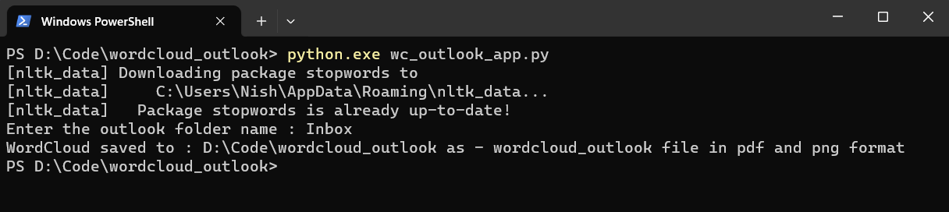

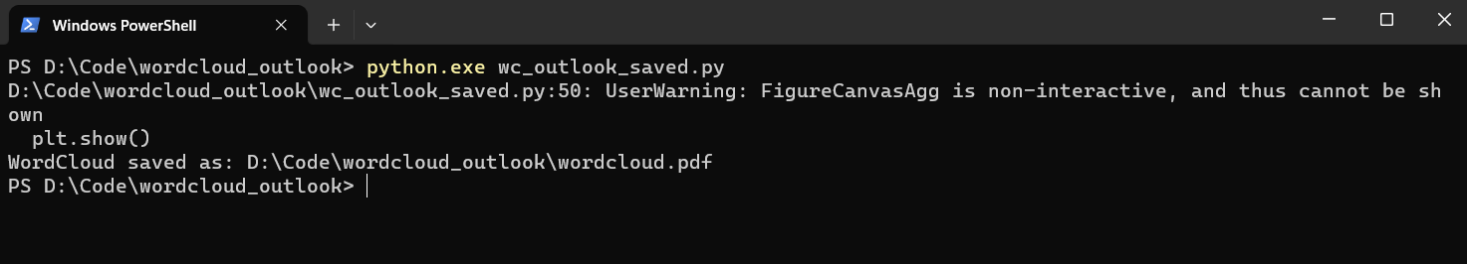

Or Alternatively open the .ipynb file in Jupyter and run the cell. It will generate and save the wordcloud in current folder.