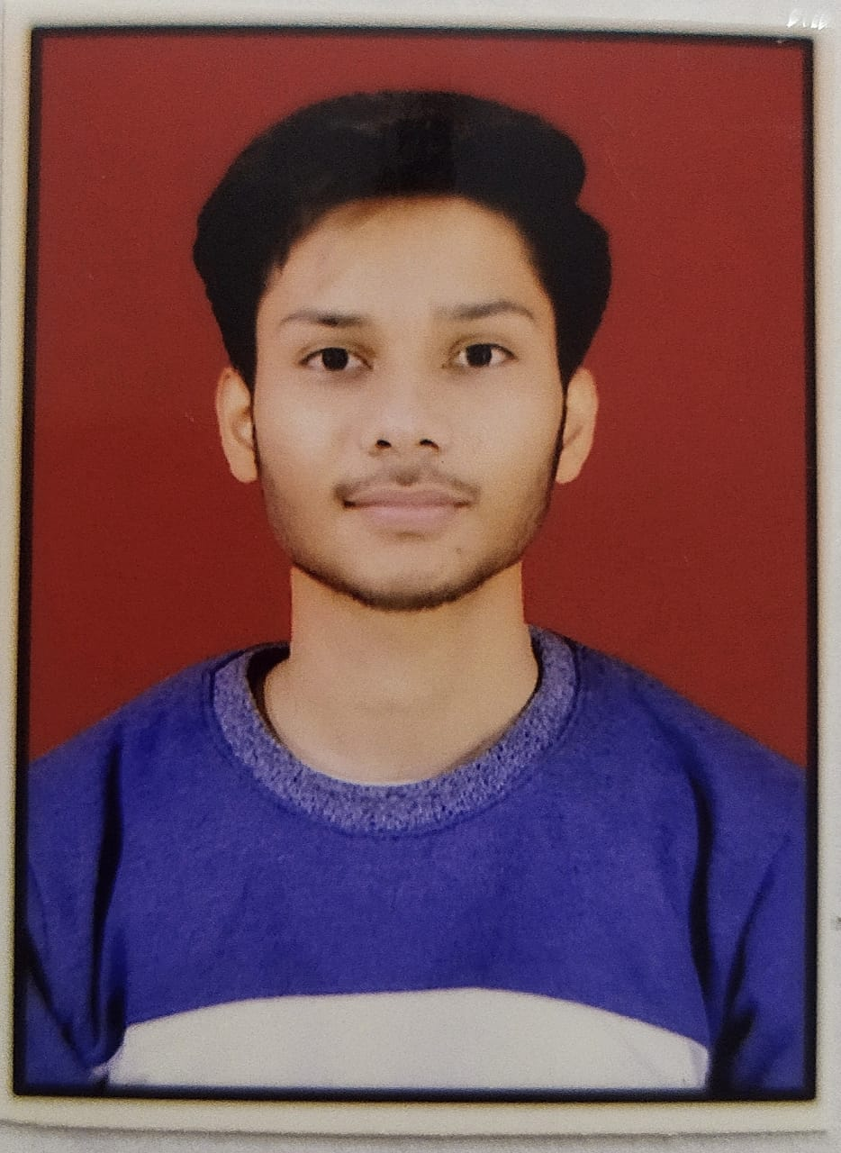

**Sumit Saxena**

Web Developer

Shahjahanpur, Uttar Pradesh

Contact Number-8601495835

[E-mail-sumitsaxena16803@gmail.com](mailto:E-mail-sumitsaxena16803@gmail.com)

**CAREER OBJECTIVE**

Looking for an opportunity that allows me to learn new skills and contribute the organisation's growth,and helps me in broadening and enhancing my current skill and knowledge and to be involved as a part of a team that dynamically works towards the growth of the organization and reach the top with determination, dedication and hard work.

**PROFESSIONAL QUALIFICATION**

|  |  |  |  |
| --- | --- | --- | --- |
| COURSE | BOARD/ UNIVERSITY | Current-CGPA/  PERCENTAGE | YEAR OF  PASSING |
| BCA | Invertis University | 79% | pursuing |

**EDUCATIONAL QUALIFICATION**

* Pursuing BCA From Invertis University, Bareilly in 2023
* 12th From Don and Donna Convent, Shahjahanpur in 2022.
* 10th From Don and Donna Convent, Shahjahanpur in 2020.

INTERNSHIPS

**CERTIFICATIONS**

* Certificate of "SQL and Relational Database" by IBM Developer Skills Network.
* Certificate of Python For Data Science by IBM Developer Skills Network
* Active participation in "WEB DEVELPMENT" workshops at all level.
* Certificate of Training Web Development From Apna College.

# **TECHNICAL SKILLS AND INTERESTS**

* Front-end Technologies- HTML, CSS, Javascript.
* Languages - C programming basics,Python, Java.
* Softwares-MS Word, MS Excel, Powerpoint.
* Softskills-Communications skill

**PROJECT WORK**

* **Academic -info-** I have developed a responsive website for invertis university, bareilly that display acedemic information like events syllabus etc.
* **Portfolio-** I have developed responsive portfolio website added mutiple features navbar, animation and many more.
* **Landing page-** I have developed a responsive website of construction site that display product and services
* **Todo-list** I have developed a responsive todo website where we can add number of task
* **Temperature converter-** I have developed a responsive website that convert the temp unit from unit to another.

**STRENGTHS**

* Highly confident and innovative in the area of expertise.
* Swift in learning and implementing new topics and techniques.
* Determined to learn with practical approach.

**FIELDS OF INTEREST**

* FRONT-END WEB DEVELOPMENT

**LANGUAGE**

* English & Hindi

## **PERSONAL INFORMATION**

|  |  |
| --- | --- |
| Nationality | Indian |
| Date of Birth | 16-08-2003 |
| Gender | Male |
| Marital Status | Single |
| Permanent Address | Behind State Bank Colony, Shahjahanpur |
| Hobbies | Listening Songs, Exporing new things. |