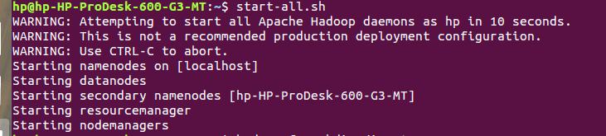------Word Count Program in python Using Hadoop-------

**Step 1**:- Install Hadoop ,Java and Python and make required configuration

We are using hadoop-3.0.3 version, Java-8 version and python -3.6.8 version

**Step 2**:-Open Command and type start-all.sh

**Step 3**:-Make sure you have following output

**Step 4**:- Create mapper.py , reducer.py and a text file.

**Step 5**:- Make directory inside hadoop using following command.

hadoop fs -mkdir /input

**Step 6:-** Copy your text file inside input directory

hadoop fs -put /home/hp/lyrics.txt /input

**Step 7:-** Then run following Command

hadoop fs -ls /input | grep lyrics | awk -F '/' '{print $3}' | cut -d '.' -f1 lyrics

**Step 8**:- Make your mapper.py executable

chmod +x /home/hp/mapper.py

**Step 9**:- Run the following command and confirm your output

hadoop fs -cat /input/lyrics.txt | /home/hp/mapper.py

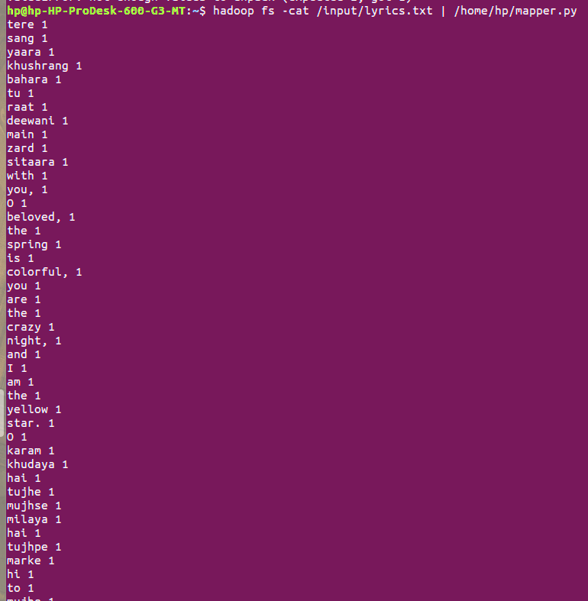

**Step 10**:- Run the following command and make sure your output

hadoop fs -cat /input/lyrics.txt | /home/hp/mapper.py | head -n 100 |sort | /home/hp/reducer.py

