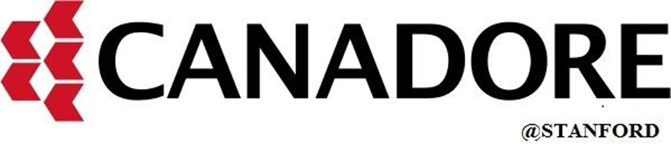

**Mobile Application Development (MAD2005MBB)**

**MAD 400-75 IOS Development**

**Assignment 2 - 18% Marks**

**Prepared By: Submitted to:**

**Gurwinder Kaur: A00114387 Prof. Rajesh Khanna**

**Sumit Kumar: A00114876**

**Parth Singh: A00114875**

**Group no- 20**

**Date: 22-03 -2021**

**Apple Inc.**

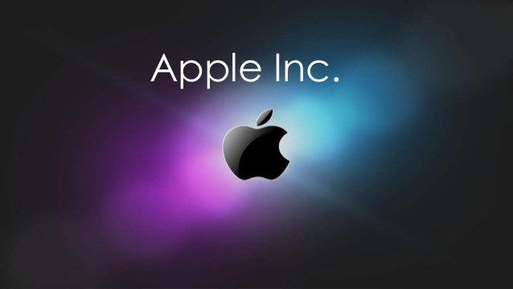

Apple an extraordinary name in the present age this name need not bother with any presentation. An extremely huge name in electronic world. Everywhere on the globe is the most famous organizations. The renowned famous contraptions of this organization are iPad, iPhone, Macs, EarPods, eye watches and some more. This enormous brand established by the programmers, Steve Jobs and Steve Wozniak in 1976. No organization is superior to Apple at building gadgets that are incredible, lovely, and simple to utilize. During the most recent forty years, Apple has created probably the most adored items in the innovation business, including the Macintosh, iPod, iPhone, and iPad.

Jobs and Wozniak employed a staff of PC creators and had a creation line beginning in Jobs' carport. Apple opened to the world in 1980 to moment monetary achievement. Throughout the following not many years, Apple dispatched new PCs including inventive graphical UIs, like the first Macintosh in 1984, and Apple's promoting commercials for its items got far and wide basic approval. Be that as it may, the exorbitant cost of its items and restricted application library caused issues, as fueled battles between heads. In 1985, Wozniak left Apple agreeably and stayed a privileged representative, while Jobs surrendered to establish NeXT, taking some Apple collaborators with him. At that point Jobs drove a terrific recuperation, presenting the iPod in 2001, the iPhone in 2007, and the iPad in 2010. The outcome: Apple acquired nearly $40 billion in benefits in its 2014 financial year. Occupations passed on of pancreatic disease in 2011. From that point forward, the organization has been driven by Tim Cook, Job's long-lasting appointee.

**Steve Jobs.**

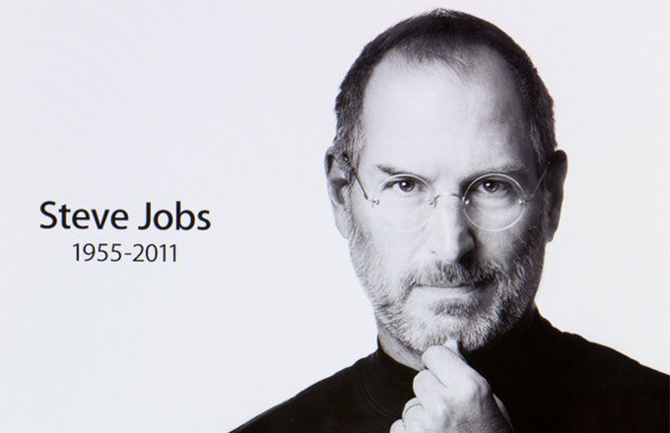

Jobs the most renowned individual was brought into the world in California, San Francisco. He was raised sound territory of San Francisco. He went to Reed College in 1972 preceding exiting that very year and went through India in 1974 looking for edification and considering Zen Buddhism. Jobs and Wozniak helped to establish Apple in 1976 to sell Wozniak's Apple I PC. Together the team acquired notoriety and abundance a year later with the Apple II, one of the primary exceptionally fruitful mass-delivered microcomputers. Jobs saw the business capability of the Xerox Alto in 1979, which was mouse-driven and had a graphical UI. Jobs was constrained out of Apple in 1985 after a long force battle with the organization's board and its then-CEO John Sculley. That very year, Jobs took a couple of Apple's individuals with him to establish NeXT, a PC stage improvement organization that spent significant time in PCs for advanced education and business markets. Moreover, he assisted with building up the enhanced visualizations industry when he financed the PC illustrations division of George Lucas' Lucasfilm in 1986.

The new organization was Pixar, which created the principal 3D PC enlivened element film Toy Story, and proceeded to turn into a significant activity studio, delivering more than 20 movies from that point forward. Jobs became CEO of Apple in 1997, following his organization's obtaining of NeXT. He was to a great extent liable for resuscitating Apple, which had been nearly chapter 11. In 2001, the first Mac OS was supplanted with the totally new Mac OS X, in view off’s NeXT Step stage, giving the OS an advanced Unix-based establishment interestingly. Jobs was determined to have a pancreatic neuroendocrine tumor in 2003. He died of respiratory capture identified with the tumor at age 56 on October 5, 2011.

**Swift**

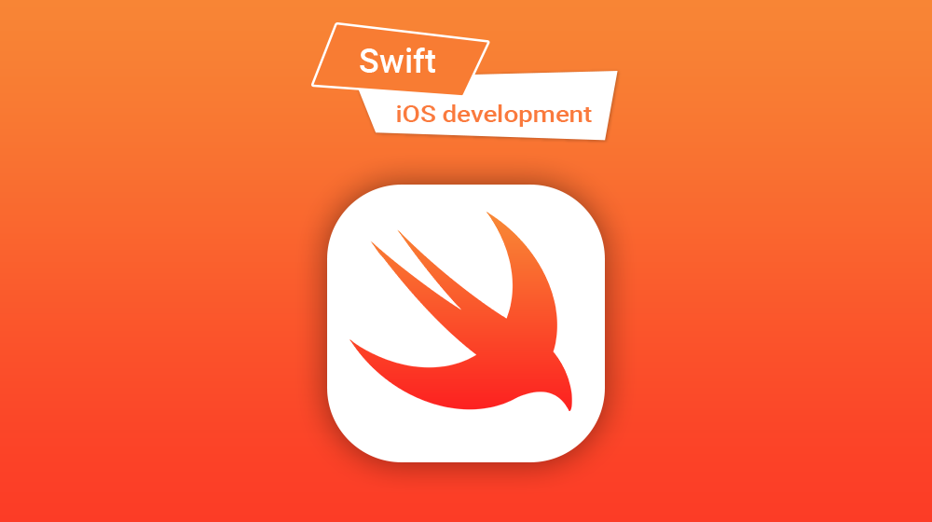

Swift is a universally useful programming language fabricated utilizing an advanced way to deal with wellbeing, execution, and programming configuration designs. The objective of the Swift undertaking is to make the best accessible language for utilizes going from frameworks programming to portable and work area applications, scaling up to cloud administrations. Above all, Swift is intended to make composing and keeping up right projects simpler for the designer. To accomplish this objective, we accept that the clearest approach to compose Swift code should likewise be:

**Safe:** The clearest approach to compose code ought to likewise act in a protected way. Indistinct conduct is the foe of security, and engineer slip-ups ought to be gotten before programming is underway. Picking security occasionally implies Swift will feel severe, yet we accept that lucidity saves time over the long haul.

**Quick:** Swift is planned as a swap for C-based dialects. Accordingly, Swift should be practically identical to those dialects in execution for most errands. Execution should likewise be unsurprising and steady, not simply quick in short blasts that require tidy up later. There are loads of dialects with novel highlights — being quick is uncommon.

**Expressive:** Swift advantages from many years of headway in software engineering to offer linguistic structure that is a delight to use, with present day highlights designers anticipate. Yet, Swift is rarely done. We will screen language headways and embrace what works, ceaselessly advancing to make Swift far better. Devices are a basic piece of the Swift biological system. We endeavor to incorporate well inside an engineer's toolset, to fabricate rapidly, to introduce phenomenal diagnostics, and to empower intelligent improvement encounters. Devices can make programming a lot more remarkable, like Swift-based jungle gyms do in Xcode, or an online REPL can when working with Linux worker side code.

Features

Swift incorporates highlights that make code simpler to peruse and compose, while giving the engineer the control required in a genuine frameworks programming language. Swift backings construed types to make code cleaner and less inclined to missteps, and modules take out headers and give namespaces. Memory is overseen naturally, and we do not have to type semi-colons. It additionally gets from different dialects, for example named boundaries presented from Objective-C are communicated in a spotless language structure that makes APIs in Swift simple to peruse and keep up.

The highlights of Swift are intended to cooperate to make a language that is incredible yet amusing to utilize. Some extra highlights of Swift include:

* Closures brought together with work pointers.
* Tuples and different bring values back.
* Fast and compact cycle over a reach or assortment.
* Structs that help techniques, expansions, and conventions.
* Functional programming designs, e.g., guide and channel.
* Powerful mistake taking care of underlying.

Safety

Swift was planned from the beginning to be more secure than C-based dialects and wipes out whole classes of perilous code. Factors are constantly instated before use, clusters and whole numbers are checked for flood, and memory is overseen consequently. Linguistic structure is tuned to make it simple to characterize your goal for instance, basic three-character watchwords characterize a variable or consistent. Another wellbeing highlight is that as a matter of course Swift items can never be nil and attempting to make or utilize a nil object brings about an assemble time mistake. This makes composing code a lot of cleaner and more secure and forestalls a typical reason for runtime crashes. Be that as it may, there are situations where nil is proper, and for these circumstances Swift has an inventive component known as discretionary. A discretionary may contain nil, however Swift linguistic structure drives you to securely manage it utilizing? to show to the compiler you comprehend the conduct and will deal with it securely.

**Objective-C**

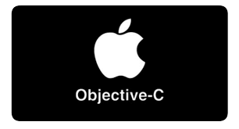

Objective-C is the fundamental programming language you use when making programming for OS X and iOS. It is a superset of the C programming language and gives object-arranged capacities and a dynamic runtime. Objective-C gets the sentence structure, unrefined sorts, and stream control decrees of C and adds accentuation for describing classes and strategies. It in like manner adds language-level assistance for object outline the load up and article literals while giving exceptional forming and confining, yielding various obligations until runtime. It was the essential programming language maintained by Apple for macOS, iOS, and their different application programming interfaces (APIs), Cocoa and Cocoa Touch, until the introduction of Swift in 2014.

The language was at first advanced during the 1980s. It was along these lines picked as the essential language used by NeXT for its Next Step working structure, from which macOS and iOS are resolved. Minimized Objective-C tasks that do not use Apple libraries, or those using parts that may be ported or reimplemented for various structures, can similarly be gathered for any system maintained by GNU Compiler Collection or Clang. Objective-C source code 'execution' program archives ordinarily have .m filename extensions, while Objective-C 'header/interface' records have .h increases, comparable to C header records. Objective-C++ archives are connoted with a .mm record expansion.

**TestFlight**

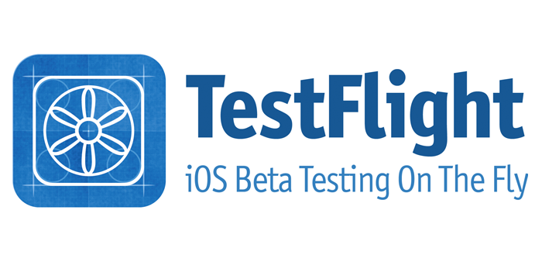

TestFlight makes it simple to welcome clients to test your applications and application cut encounters and gather significant input prior to delivering your applications on the App Store. You can welcome up to 10,000 analyzers utilizing only their email address or by sharing a public connection. To test beta forms of applications and App Clips utilizing TestFlight, you should acknowledge an email or public connection greeting from the designer and have a gadget that you can use to test.

Individuals from the designer's group can be offered admittance to all forms of the application. Any remaining welcomed analyzers can get to construct that the designer makes accessible to them. An engineer can welcome you to test with an e mail or a public connection.

**Required stages.**

• iOS applications: iPhone, iPad, or iPod contact running iOS 8 or later. Application Clips require iOS 14 or later. iMessage applications and sticker packs require iOS 10 or later.

• tvOS applications: Apple TV running tvOS 9 or later.

• watchOS applications: Apple Watch running watchOS 2 or later.