1.
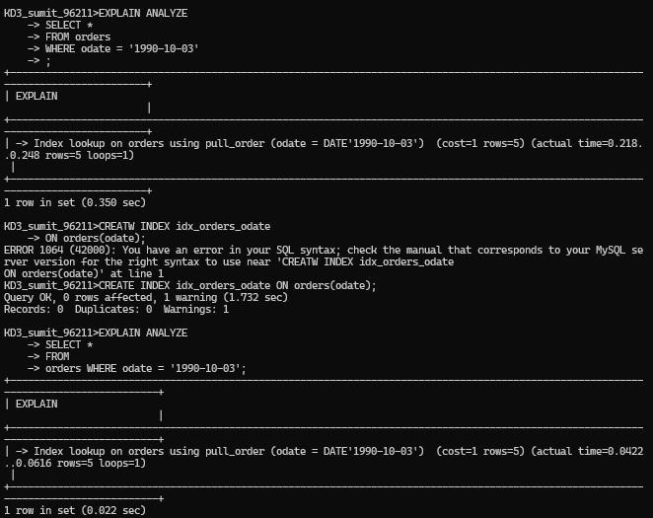v

2.
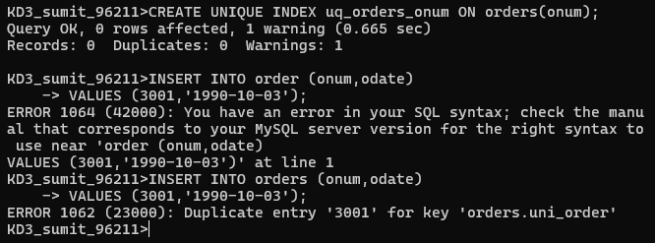

3,
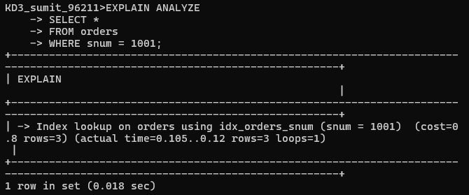

4.
CREATE UNIQUE INDEX uq_salesperson_rating
ON Customers (snum, rating);
5.
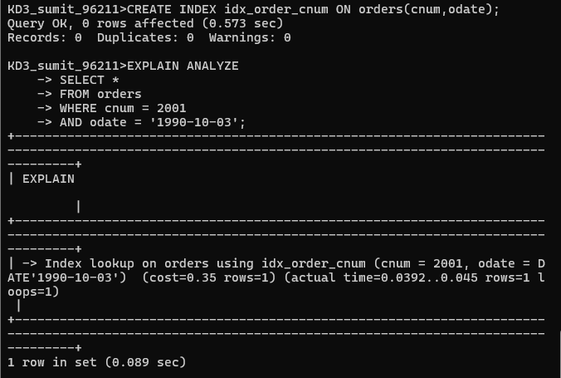

2

3.
