**MYSQL ASSIGNMENT 5**

use assignment3;

Create table Employees(

emp_id int,

emp_name varchar(50),

department_id int);

insert into Employees(emp_id, emp_name, department_id)

values(1, "Alice", 10),

(2, "Bob", 20),

(3, "Charlie", 30),

(4, "David", 10),

(5, "Eve", 40);

select * from Employees;

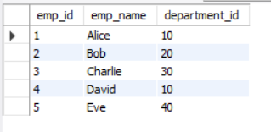

use assignment3;

create table Departments(

department_id int,

department_name varchar(50));

insert into Departments(Department_id, Department_name)

Values(10, "HR"),

(20, "Finance"),

(30, "IT"),

(40, "Admin"),

(50, "Marketing");

select * from Departments;

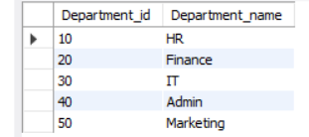

use assignment3;

Create table Projects(

project_id int,

emp_id int,

project_name varchar(50));

insert into Projects(project_id, emp_id, project_name)

values(101, 1 , "Alpha"),

(102, 2, "Beta"),

(103, 3, "Gamma"),

(104, 4, "Delta");

select * from Projects;

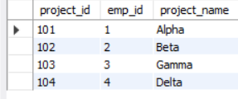

#1.Write a query to get Employee and Department details using join.

SELECT Employees.emp_id, Employees.emp_name, Departments.Department_id, Departments.Department_name FROM Employees INNER JOIN Departments ON Employees.Department_id = Departments.Department_id;

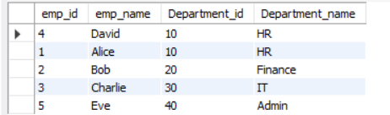

#2.Write a query to retrieve all employees with their departments, even if the department is missing.

select Employees.emp_id, Employees.emp_name, Departments.Department_id, Departments.Department_name from Employees left JOIN Departments on Employees.department_id = Departments.Department_id ;

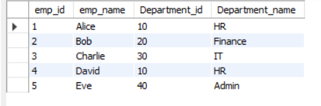

#3.Write a query to get department details even if there are no employees in that department.

select Departments.Department_id, Departments.Department_name, Employees.emp_name from Employees INNER JOIN Departments on Employees.department_id = Departments.Department_id;

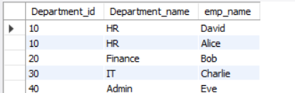

#4.Write a query to get all employees and departments, whether matched or not.

SELECT e.emp_id,

e.emp_name,

d.department_name,

p.project_id,

p.project_name

FROM Employees e LEFT JOIN Departments d ON e.department_id = d.department_id LEFT JOIN Projects p ON e.emp_id = p.emp_id;

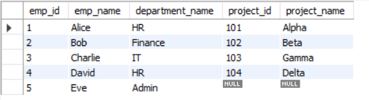

#6.Find employees who are not assigned to any projects.

SELECT Employees.* FROM Employees LEFT JOIN Projects ON Employees.emp_id = Projects.emp_id WHERE Projects.project_id IS NULL;



#7.Find departments with no employees using a RIGHT JOIN.

select count(Employees.emp_id), Departments.Department_name from Employees right join Departments on Employees.Department_id = Departments.department_id group by Departments.Department_name having count(Employees.emp_id) = 0;

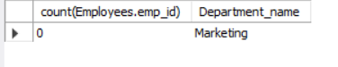

#8.Write a query to get Employee and Department details using join with aliases.

select * from Employees right join Departments on Employees.Department_id = Departments.department_id;

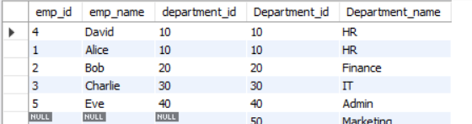

#9.Write a query to find employees in the same department as other employees.

SELECT p.project_id,

p.project_name,

e.emp_id,

e.emp_name,

d.department_name FROM Projects p JOIN Employees e ON p.emp_id = e.emp_id JOIN Departments d ON e.department_id = d.department_id WHERE d.department_name = 'IT';

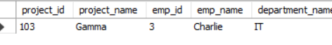

#10.Write a query to find projects managed by employees in the 'IT' department.

SELECT p.project_id,

p.project_name,

e.emp_id,

e.emp_name,

d.department_name

FROM Projects p JOIN Employees e ON p.emp_id = e.emp_id JOIN Departments d ON e.department_id = d.department_id WHERE d.department_name = 'IT';

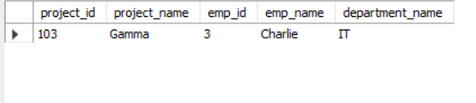

#11.Write a query to show employees and their project information (even if not assigned to a project).

SELECT e.emp_id,

e.emp_name,

e.department_id,

p.project_id,

p.project_name

FROM Employees e LEFT JOIN Projects p ON e.emp_id = p.emp_id;

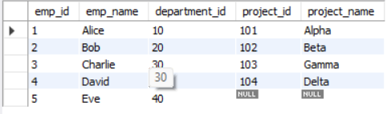

#12.Find employees who work in departments with names starting with 'A'.

SELECT e.emp_id,

e.emp_name,

e.department_id,

d.department_name

FROM Employees e JOIN Departments d ON e.department_id = d.department_id WHERE d.department_name LIKE 'A%';

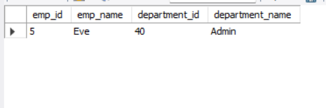

#13.Find the total number of employees in each department using GROUP BY and JOIN.

SELECT d.department_id,

d.department_name,

COUNT(e.emp_id) AS total_employees

FROM Departments d LEFT JOIN Employees e ON d.department_id = e.department_id GROUP BY d.department_id, d.department_name;

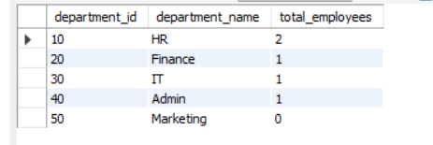

#14.Get the list of departments with more than one employee.

SELECT d.department_id,

d.department_name,

COUNT(e.emp_id) AS total_employees

FROM Departments d JOIN Employees e ON d.department_id = e.department_id GROUP BY d.department_id, d.department_name HAVING COUNT(e.emp_id) > 1;

