**Name:** Sumitkumar Vishwakarma

**Class:** FY IT (H3)

**Roll No.:** 1914130

1. Component name: **Plunger**

Component image:

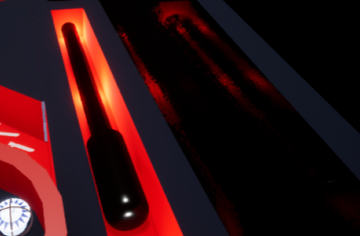

**Approach**:

* Now the plunger changes from normal variable to an array because I have two in the game.
* I used a ‘*foreach loop*’ to get both the plunger's charge and stop simultaneously using a spacebar key.
* I added a sound when plunger hits the ball.

1. Component name: **Bonus Region**

Component image:

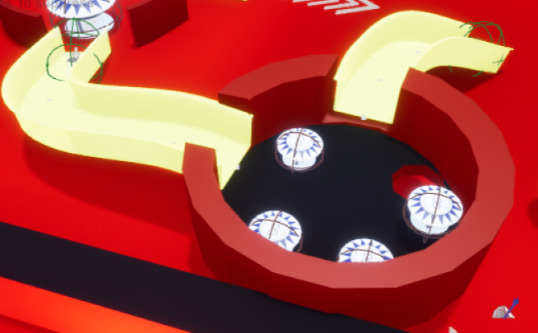

**Approach**:

* I made the main region with two cylinders (of 20 sides for a circular look).
* The smaller one is made subtractive to create space for the small bumpers.
* An exit for the ball is made using a subtractive cylinder.
* I made two triggers which makes the ball move into the bonus region.

**Difficulties faced**:

* Making ramp work properly was a challenge. Discussed with my friend, but to no avail. Finally, I tried ‘trigger’ to give an impulse in an upward direction :(

1. Component name: **Center Region**

Component image:

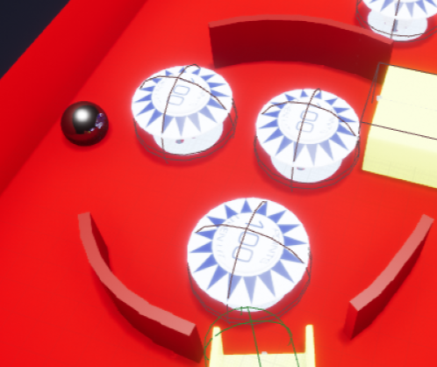

**Approach**:

* I selected boxes from geometry class for making each part of the region.
* I placed the boxes adjacently at an angle of 5 degrees to each other.
* It consists of an actor which tells the location of the ball after teleportation.

**Difficulties faced**:

I could not think of other ways at that time. But later I thought it could be easier with additive and subtractive brushes. My bad!

4) Component name: **Teleportation Object**

Component image:

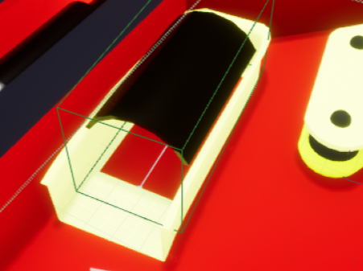

**Approach**:

* I used a *Trigger Box* for the teleporting of the ball.
* As the ball overlaps the trigger box, a teleport function is executed which locates the ball to another location.

**Difficulties faced**:

Could not understand the trigger initially.

5) Component name: **Cannon**

Component image:

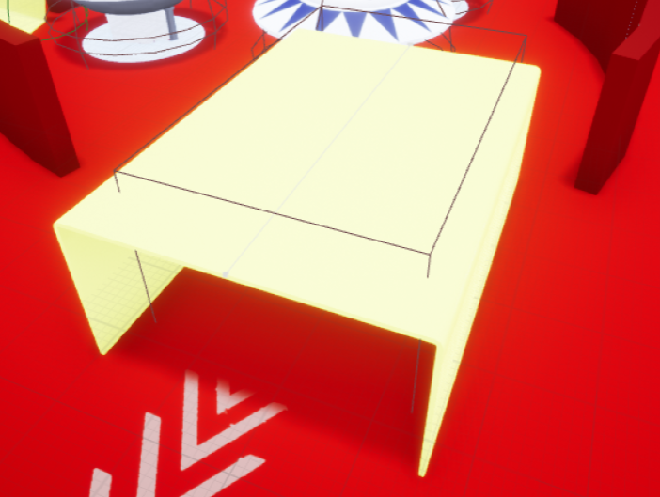

**Approach**:

* I added a box collision to the cannon.
* As the ‘*EventBeginOverlap*’, I added an impulse of 6000 in the negative Y direction to increase the ball velocity suddenly.
* Added a sound to it.

**Difficulties faced**:

Could not shape it like a cannon despite discussing it with my friend a lot.

**OVERALL ISSUES :**

* Slingband sometimes makes the ball bounce off.
* Ball does not climb over the ramp properly and stucks in the middle of it making the game to be replayed.
* GitHub and GitHub desktop were new to me. So I found it difficult to handle repositories and understand its interface.
* The software is quite heavy and often stops unwantedly.