Part A — Classification Report

Network Intrusion Detection Using Machine Learning
Admin No. | Name | Email
9208568W | Sum Kwok Hoong | sumkh2@gmail.com

1. Problem Statement
Modern networks generate very large volumes of flow records. Intrusion Detection Systems (IDS) need to separate legitimate traffic from malicious activity quickly and with a low false-alarm rate. The task here is to build a supervised machine learning model that classifies each network flow as either BENIGN (normal traffic) or DrDoS_DNS (a DNS-based Distributed Reflection Denial-of-Service attack).
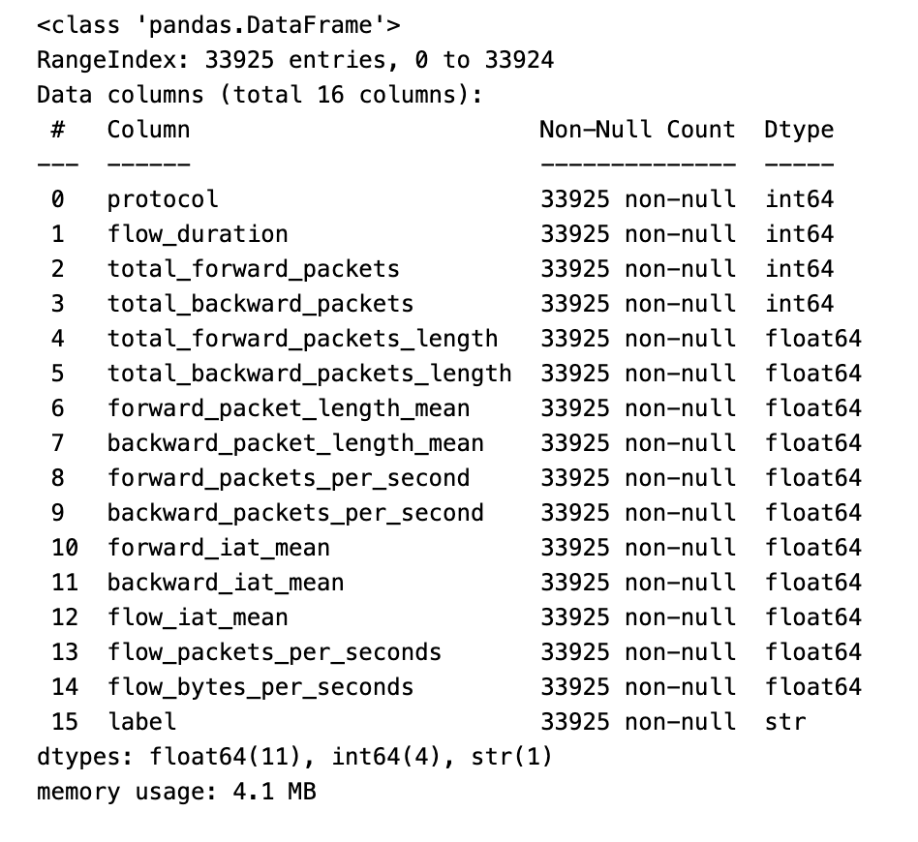
This is framed as a binary classification problem with the attack class encoded as the positive class (DrDoS_DNS = 1, BENIGN = 0).

2. Methodology

2.1 Data Understanding
Property | Value
Records | 33,925
Original columns | 16 (15 numeric + 1 label)
Missing values | None in any column
Duplicate rows | 0
Target | label

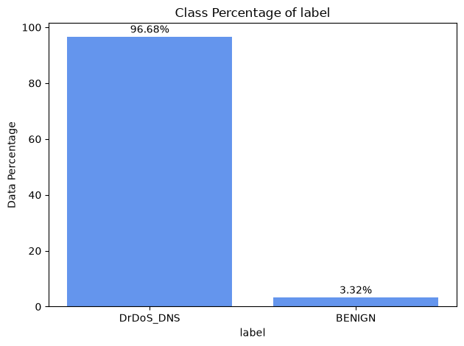
Class distribution — severely imbalanced:
Class | Count | Proportion
DrDoS_DNS (attack) | 32,797 | 96.68 %
BENIGN (normal) | 1,128 | 3.32 %

The imbalance is the single most important characteristic of this dataset. A naive classifier that predicts "attack" for every flow would already score 96.7 % accuracy while detecting nothing useful, so accuracy was rejected as the primary metric in favour of ROC-AUC, Precision-Recall AUC and F1.
2.2 Data Processing and Feature Selection
Feature reduction was driven by descriptive statistics, a Spearman correlation heatmap and box plots of every numeric feature against the target (plotted both with and without outliers). Three features were removed:
Dropped feature | Reason
protocol | Zero variance. Every record has value 17. Carries no discriminative information.
total_forward_packets_length | Redundant. forward_packet_length_mean = this feature divided by total_forward_packets; the mean already encodes the information in a scale-free form. Spearman ρ = 0.88 with total_forward_packets.
total_backward_packets_length | Redundant. Spearman ρ = 1.00 with both total_backward_packets and backward_packet_length_mean — perfectly collinear.
This left 12 predictive features. The correlation heatmap confirmed several other very high collinearities that were deliberately retained because tree ensembles are insensitive to them:
- flow_packets_per_seconds vs forward_packets_per_second: ρ = 1.00
- flow_iat_mean vs forward_packets_per_second: ρ = −0.97
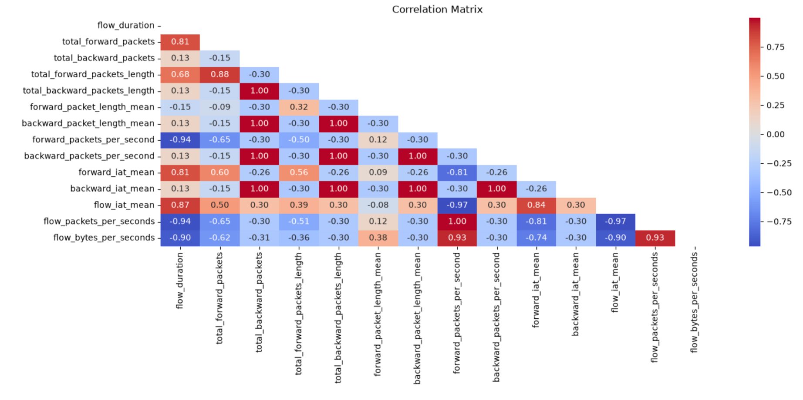
- flow_duration vs forward_packets_per_second: ρ = −0.94

2.3 Train / Test Split and Class Balancing
The order of operations was chosen deliberately to protect the evaluation:
- Stratified 80/20 split first (random_state=42, stratify=y) — 27,140 train / 6,785 test. Stratification preserves the 3.3 % minority rate in both partitions.
- RandomOverSampler placed inside the modelling pipeline, so that the 902 BENIGN training rows are resampled with replacement up to parity with the majority class within each cross-validation training fold only.
Partition | Rows | Attack | Benign
Train, as passed to GridSearchCV | 27,140 | 26,238 (97 %) | 902 (3 %)
Each CV training fold, after in-fold oversampling | ~41,980 | 50 % | 50 %
Full training set if resampled (illustrative only) | 52,476 | 26,238 (50 %) | 26,238 (50 %)
Test (untouched) | 6,785 | 6,559 (97 %) | 226 (3 %)
Two properties of this design protect the evaluation:
- Keeping the test set at its natural, imbalanced distribution means the model is scored against traffic that looks like production traffic, not against an artificially balanced set.
- Resampling inside the cross-validation loop means a duplicated BENIGN row can never appear simultaneously in a training fold and in the validation fold used to score it.

2.4 Modelling Pipeline
All preprocessing was wrapped inside an sklearn Pipeline so that transformations are fitted on training folds only and re-applied to validation/test data, eliminating preprocessing leakage:
ColumnTransformer
└── numeric: SimpleImputer(strategy='mean') → StandardScaler()

imblearn.pipeline.Pipeline
└── preprocessor → RandomOverSampler → model
Scaling is not needed by the tree models but is essential for SGDClassifier. Using one common pipeline keeps the three algorithms directly comparable.
The pipeline is imblearn's rather than scikit-learn's specifically because a scikit-learn Pipeline cannot host a resampler. imblearn.pipeline.Pipeline applies sampler steps during fit: training folds are rebalanced, validation and test data are scored as-is.

2.5 Algorithms and Hyperparameter Search
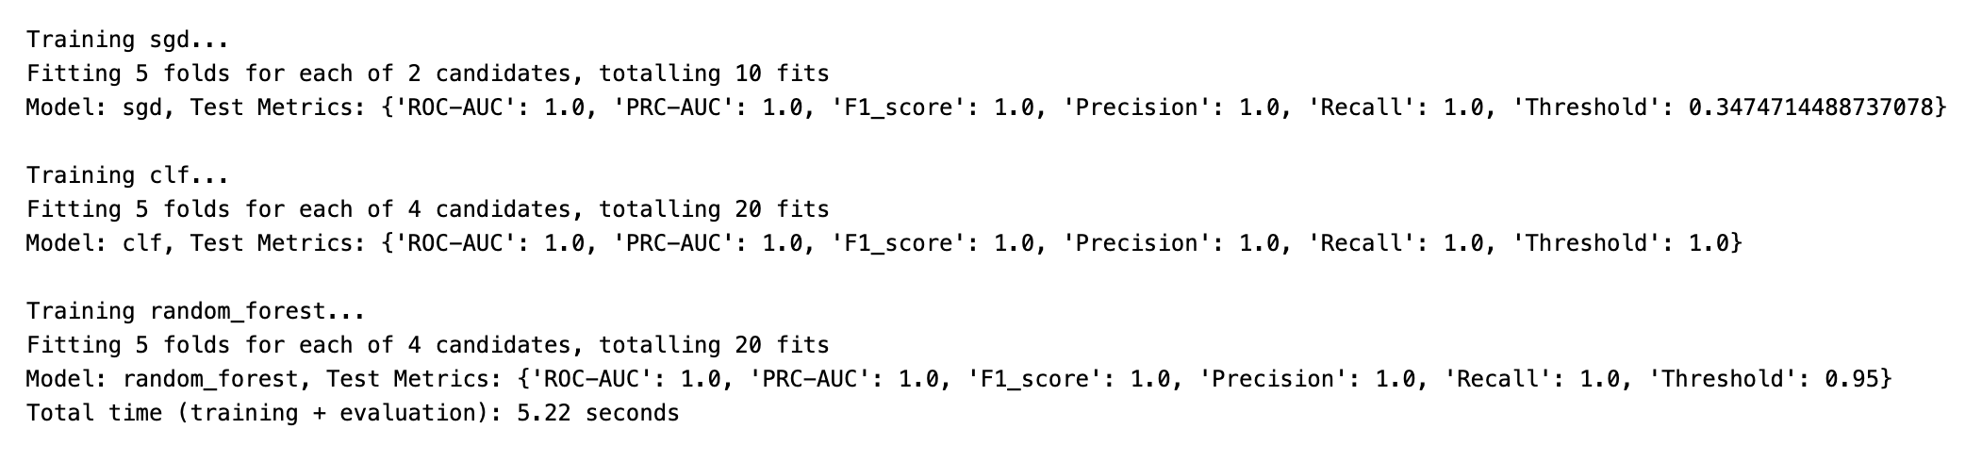
Three algorithms of increasing capacity were compared through GridSearchCV with 5-fold KFold cross-validation, optimising ROC-AUC:
Model | Rationale | Search space
SGDClassifier (loss='log_loss') | Linear/logistic baseline. Fast, interpretable, establishes whether the problem is linearly separable. | penalty ∈ {l1, l2}
DecisionTreeClassifier | Single non-linear learner. Captures threshold rules an analyst could read directly. | max_depth ∈ {None, 10, 20, 30}
RandomForestClassifier | Bagged ensemble. Reduces the variance of a single tree and provides impurity-based feature importances. | max_depth ∈ {None, 10, 20, 30}

2.6 Evaluation Design
Rather than relying on the default 0.5 decision threshold, a helper function derived the threshold that maximises F1 from the precision-recall curve, which is the suitable approach for an imbalanced dataset problem. Metrics reported: ROC-AUC, PRC-AUC, F1, precision, recall, confusion matrix and classification report.

3. Results

3.1 Cross-Validation
Rank | Model | Mean Train ROC-AUC | Mean Validation ROC-AUC
1 | Random Forest | 1.000000 | 0.999998
2 | SGD (logistic) | 0.999940 | 0.999907
3 | Decision Tree | 1.000000 | 0.998802

3.2 Held-Out Test Set (Natural 97:3 Imbalance)
Model | ROC-AUC | PRC-AUC | F1 | Precision | Recall | Optimal threshold
Random Forest | 1.000 | 1.000 | 1.000 | 1.000 | 1.000 | 0.950
SGD (logistic) | 1.000 | 1.000 | 1.000 | 1.000 | 1.000 | 0.347
Decision Tree | 1.000 | 1.000 | 1.000 | 1.000 | 1.000 | 1.000
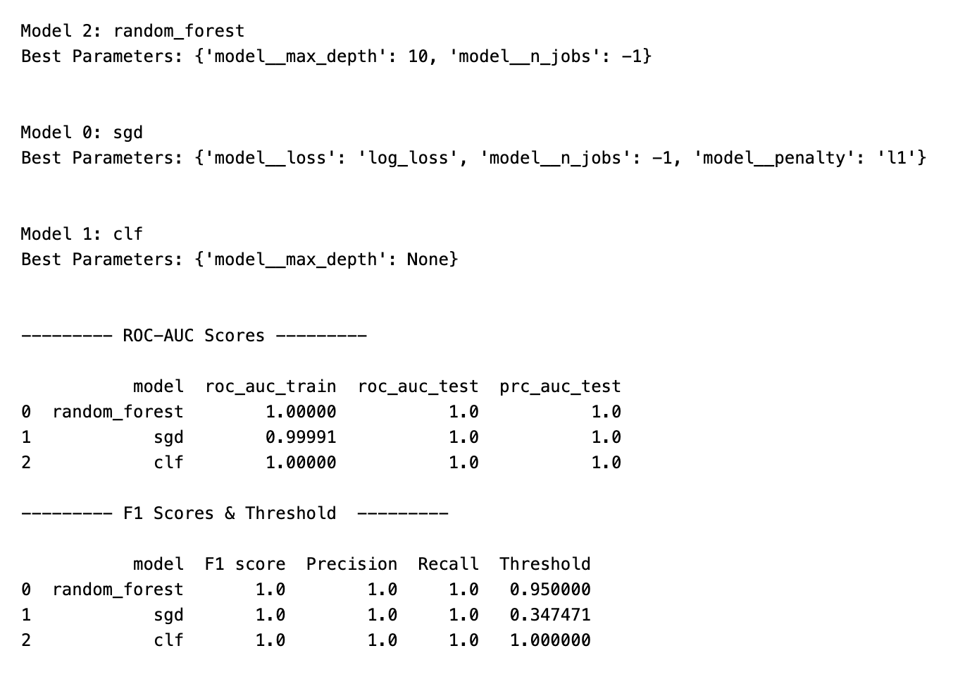
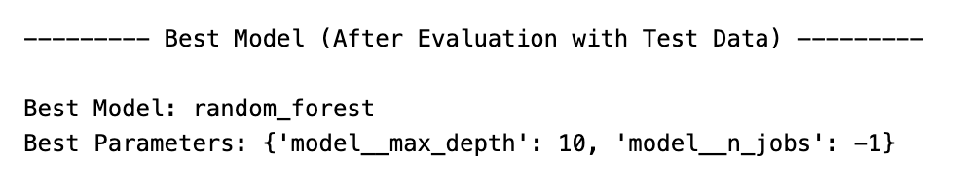Selected model: Random Forest (max_depth=10) — chosen for the highest validation score and, more importantly, for the variance reduction and feature-importance output that a single tree cannot provide as reliably.
Classification report: 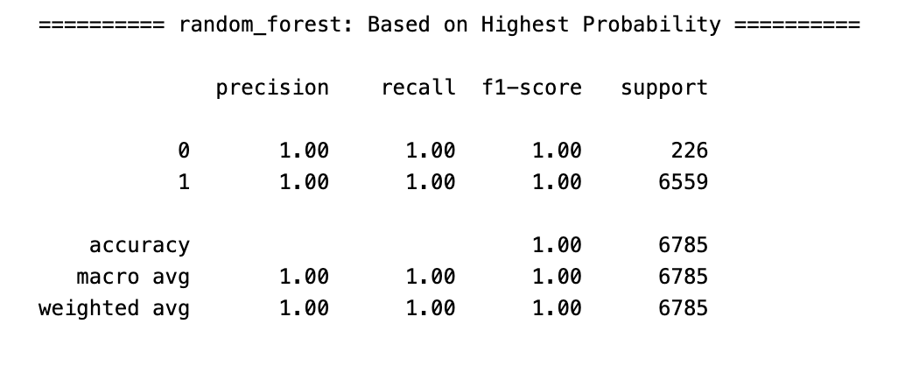
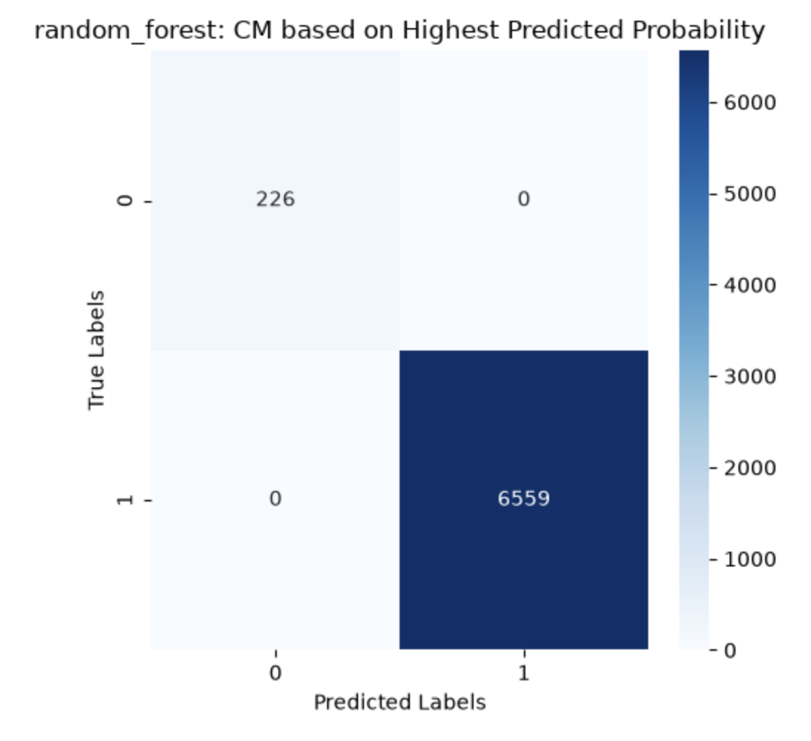

3.3 Feature Importances

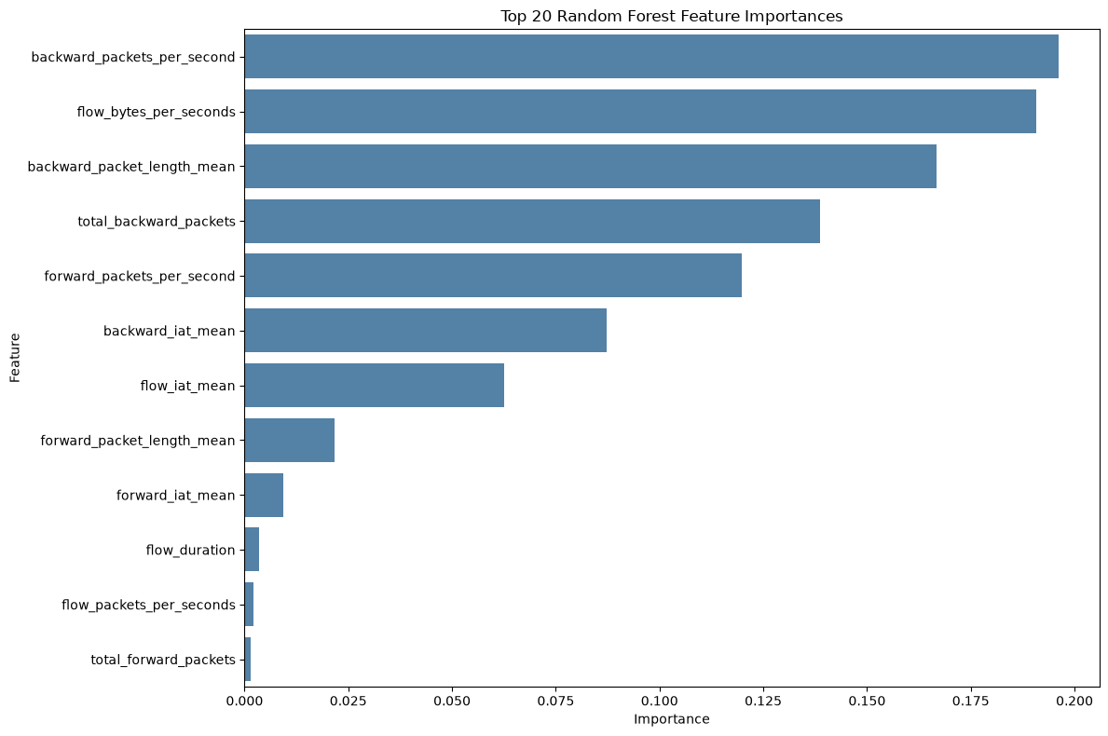
The top five features account for above 80 % of the total importance, and three of the top four describe the backward (server → client) direction of the flow.

4. Discussion of Observations and Findings
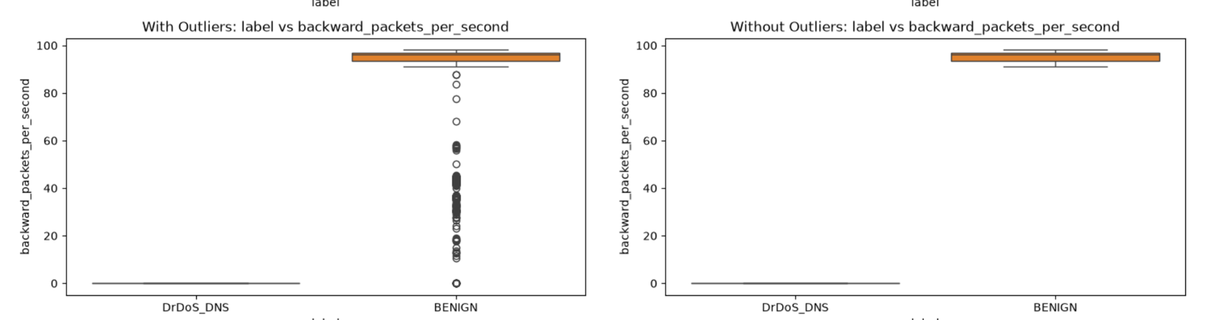
Three algorithms of very different capacity — including a linear classifier — all reached ROC-AUC = 1.000. When a linear model perfectly separates a 34,000-row dataset, the honest conclusion is not "the model is excellent" but "the classes are trivially separable". Investigating the box plot (without Outliers) observed that DrDos_DNS attack has zero to low backward traffic, while majority of the BENIGN flows have non-zero to high backward traffic.
Very distinctive separation
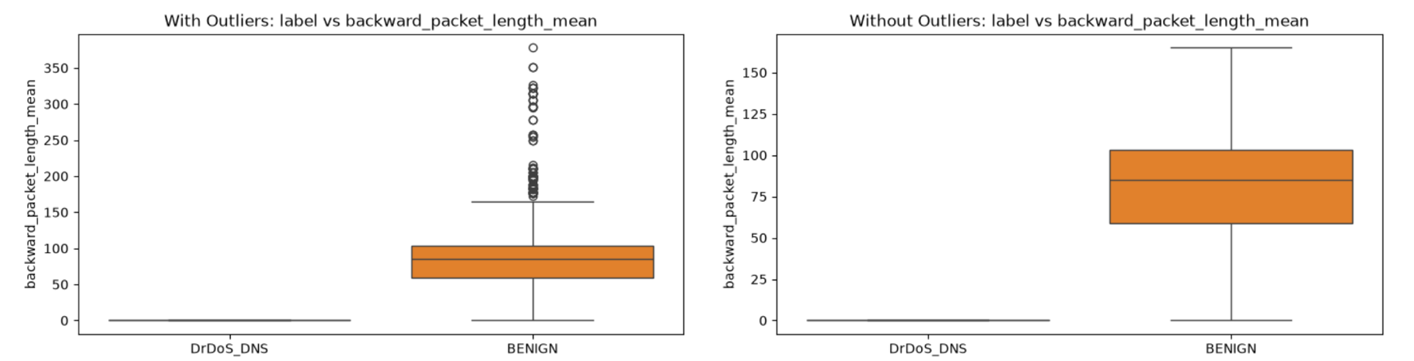
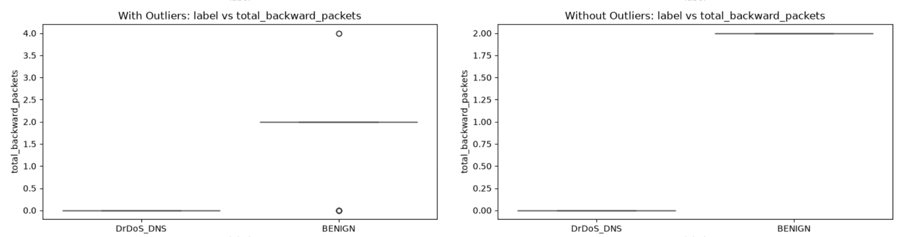

5. Strengths and Weaknesses of the Models

Random Forest
Strengths
- Highest validation score; perfect test performance with zero false positives.
- Bagging averages out the variance of individual trees, so it is less brittle than a single tree.
- Feature importances gave a directly interpretable model narrative.
- Handles the extreme collinearity (ρ = 1.00 pairs) and the wildly different feature scales without any additional treatment.

Decision Tree
Strengths
- Most interpretable model of the three — the learned rules could be exported as firewall logic.

SGDClassifier (Logistic)
Strengths
- Lowest computational cost.
- Coefficients are directly interpretable as log-odds contributions.
Weaknesses
- Requires feature scaling — without the StandardScaler step it would have been dominated by flow_bytes_per_seconds.
- Cannot represent feature interactions.

6. Conclusion

Key Findings
- All three models achieved ROC-AUC = 1.000, PRC-AUC = 1.000 and F1 = 1.000 on a held-out test set of 6,785 flows retaining the natural 97:3 imbalance, with zero false positives and zero false negatives.
- Random Forest was selected (max_depth=10) for its combination of top validation score (0.999998), variance stability and interpretable feature importances.
- The imbalance-handling pipeline - stratified split before any resampling, resampling applied inside each CV training fold via imblearn.pipeline.Pipeline, natural distribution preserved in the test set, and PRC-AUC/F1 used in place of accuracy.

7. Personal Reflection
Challenges faced
The hardest part of this assignment was not writing the code but learning to distrust a good result. My first reaction to three consecutive ROC-AUC scores of 1.000 was that I had made a mistake — most likely leaking the label into the features. I re-checked the train/test split, confirmed the target column was properly excluded from X, and verified that the split happened before any resampling. Only after going back to the raw CSV and comparing the per-class ranges of every feature did I understand that the dataset really is that separable. Getting to that data understanding and explanation took longer than building all three models combined, but it is the part of the assignment I actually learned from.
The second challenge was deciding what "correct" looks like for imbalanced data. With 96.7 % of rows belonging to one class, accuracy is meaningless, and it took some reading to settle on the right combination — stratified splitting, resampling the training partition only, and reporting PRC-AUC and F1 instead. Getting the order right (split first, then resample) was not obvious to me at first; my instinct was to balance the whole dataset up front, which would have quietly put copies of the same rows on both sides of the split and invalidated the entire evaluation.
I got that first ordering right, but then made a subtler version of the same mistake one level down and had to come back and fix it. My original code resampled the entire training set before handing it to GridSearchCV. The train/test split was safe, so I assumed the whole thing was safe — but cross-validation splits that training set again, and because oversampling duplicates rows, copies of the same BENIGN record ended up in a training fold and in the validation fold used to score it. The fix was to move the resampler inside an imblearn.pipeline.Pipeline so it only ever touches a fold's training portion.
Third, structuring the code so that three different algorithms could be compared fairly took several iterations. My initial version fitted the scaler on the full dataset before splitting. It ran fine and produced good numbers, which is exactly what made it dangerous. Rebuilding everything around Pipeline and ColumnTransformer so that preprocessing is refitted inside every CV fold was the single most valuable structural change I made.
Skills learned
- Building leak-resistant sklearn pipelines with ColumnTransformer and Pipeline, and understanding why transformations must be fitted inside the cross-validation loop rather than before it.
- Handling class imbalance end to end: stratified splitting, RandomOverSampler, and choosing metrics (PRC-AUC, F1) that remain informative when one class is 3 % of the data.
- Understanding the difference between sklearn.pipeline.Pipeline and imblearn.pipeline.Pipeline, and why a resampler must live inside the estimator so that it fires on fit but not on predict — the mechanism that keeps cross-validation honest.
- Threshold optimisation from the precision-recall curve instead of accepting the default 0.5, and reading the resulting threshold as a signal about probability calibration.
- Systematic hyperparameter search with GridSearchCV across multiple model families in a single reusable loop, capturing both train and validation scores to inspect the overfitting gap.
8. Future improvements
Switch KFold to StratifiedKFold. Now that the raw imbalanced training set is passed to GridSearchCV (rather than a pre-balanced one), fold composition matters more than it did before: with 902 BENIGN rows across 5 folds, an unlucky shuffle could leave a fold materially short of minority examples. This is the one remaining piece of the leakage fix that has not been applied.

