Part B — Regression Report

Cloud Resource Utilisation Prediction
Admin No. | Name | Email
9208568W | Sum Kwok Hoong | sumkh2@gmail.com

1. Problem Statement
Cloud service providers must anticipate resource demand in order to schedule jobs, size clusters and avoid both over-provisioning (wasted spend) and under-provisioning (SLA breaches). The task is to predict a continuous measure of resource consumption from job metadata using regression.
Target variable selected: Used_Memory(MB).
Memory was chosen over CPU for two reasons. First, Used_CPUs is heavily discretised — it takes a small number of integer values dominated by 1 and 2 (median = 1, 75th percentile = 3), which makes it a poor fit for a continuous regression target and closer to an ordinal/count problem. Second, the log-transformed distribution of memory usage is much better behaved and closer to normal, which suits squared-error-based learners. Used_Memory(MB) ranges from 939 MB to 32,689 MB with a mean of 15,636 MB.
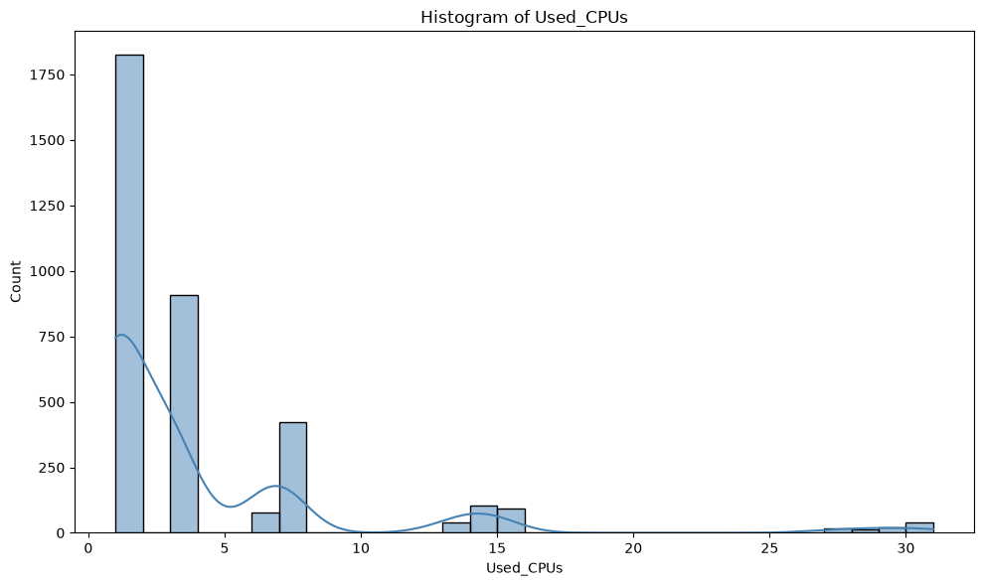
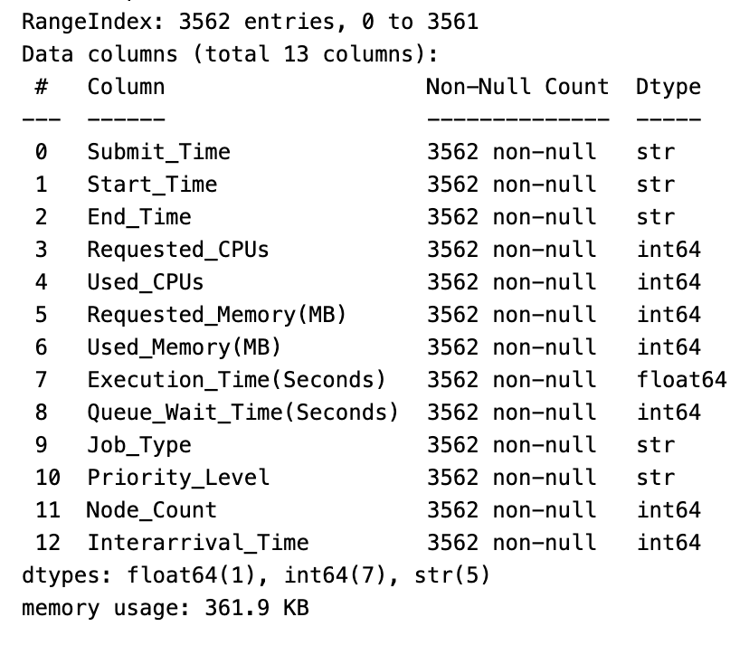
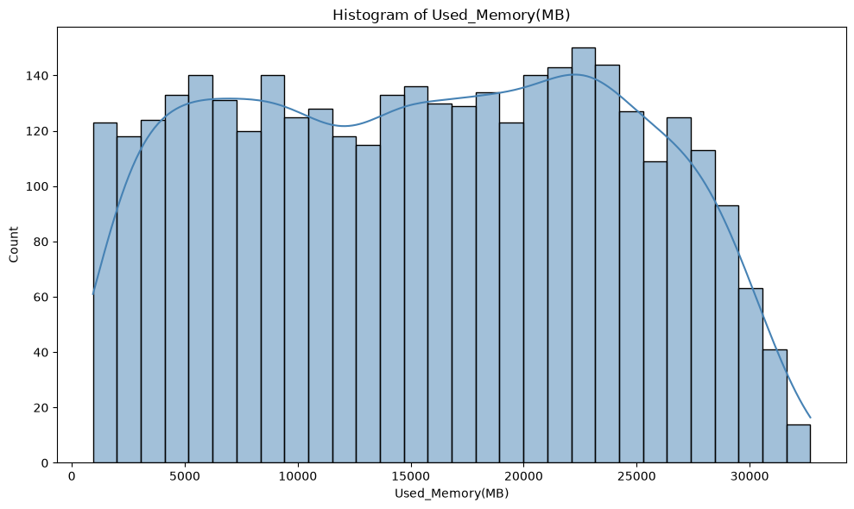
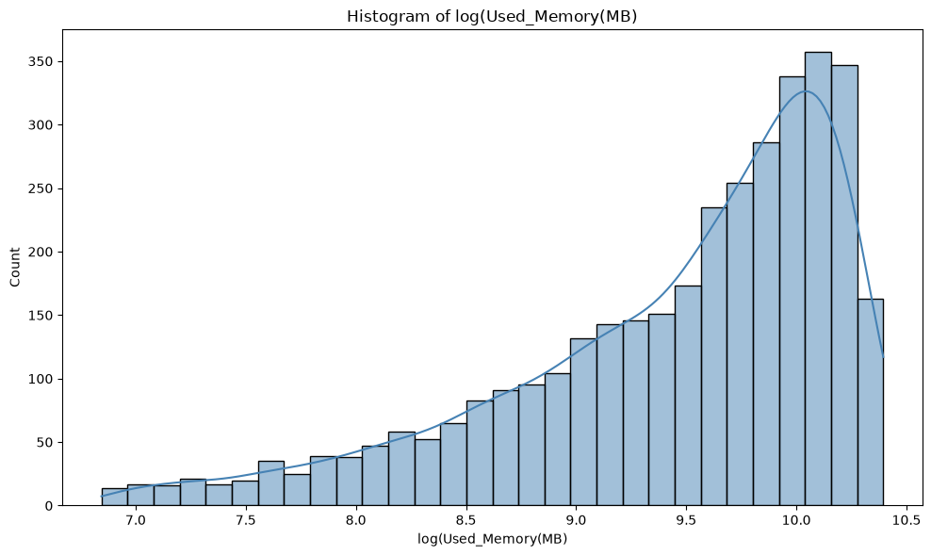

2. Methodology

2.1 Data Understanding
Property | Value
Records | 3,562
Original columns | 15
Missing values | None
Target | Used_Memory(MB)

Descriptive statistics:
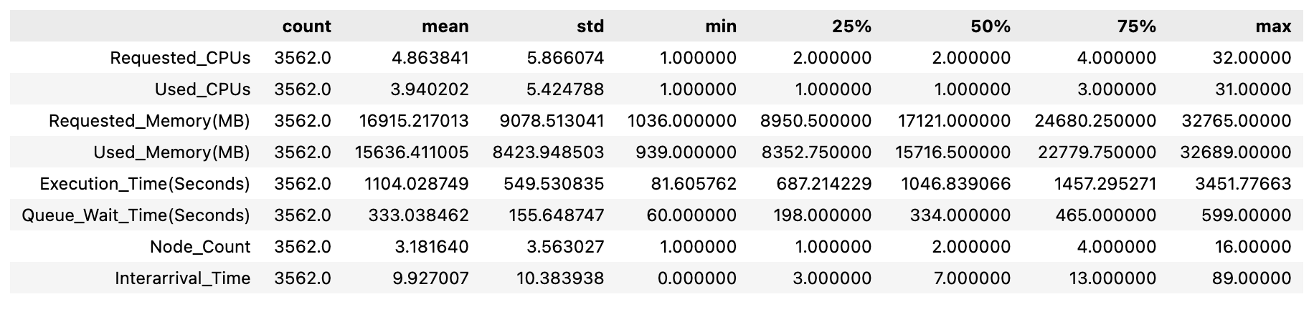
Categorical variables: Job_Type (batch, GPU, interactive, MPI), Priority_Level (high, medium, low).

2.2 Feature Engineering
Identifier removal. Job_ID and User_ID were dropped immediately. These 2 identifiers are unique row key with no predictive content.
Temporal feature extraction. The dataset contains three timestamps — Submit_Time, Start_Time and End_Time. Because this is framed as a regression problem rather than time-series forecasting, raw timestamps are not directly usable: a model cannot extrapolate from an absolute datetime. They were therefore converted into a cyclical calendar feature:
data['Submit_Time'] = pd.to_datetime(data['Submit_Time'], format='%Y-%m-%d %H:%M:%S')
data['day_of_week'] = (data['Submit_Time'].dt.dayofweek + 1) % 7 # Sunday = 0
data['day_of_week'] = data['day_of_week'].astype(str) # treat as categorical
day_of_week was cast to string so that it is one-hot encoded rather than treated as an ordered numeric — day 6 is not "greater than" day 1 in any meaningful sense, and an ordinal encoding would impose a false linear relationship.
The three timestamp columns were then dropped. Start_Time and End_Time are redundant because Execution_Time(Seconds) is exactly their difference, and retaining all three would introduce perfect multicollinearity.

2.3 Feature Selection
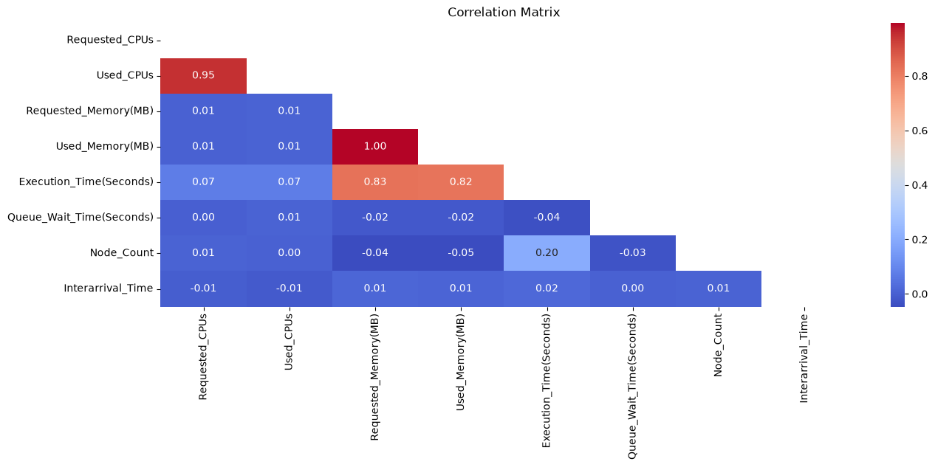
A Spearman correlation heatmap, a full scatter matrix and violin plots of the resource variables against each categorical variable informed the following decisions:

Dropped feature | Reason
Requested_Memory(MB) | Target leakage by proxy. Requested memory is an almost direct restatement of used memory (mean 16,915 vs 15,636 MB — a near-constant). A model using it would be useless for capacity planning, where the whole point is to predict demand rather than echo the user's own request.
Requested_CPUs | Same argument on the CPU dimension; highly correlated with Used_CPUs.

Final feature set (8 predictors):
Numeric | Categorical
Used_CPUs | Job_Type
Execution_Time(Seconds) | Priority_Level
Queue_Wait_Time(Seconds) | day_of_week
Node_Count
Interarrival_Time

Pearson correlations with the target:
Feature | Correlation with Used_Memory(MB)
Execution_Time(Seconds) | 0.779
Used_CPUs | 0.031
Interarrival_Time | 0.019
Queue_Wait_Time(Seconds) | −0.018
Node_Count | −0.037

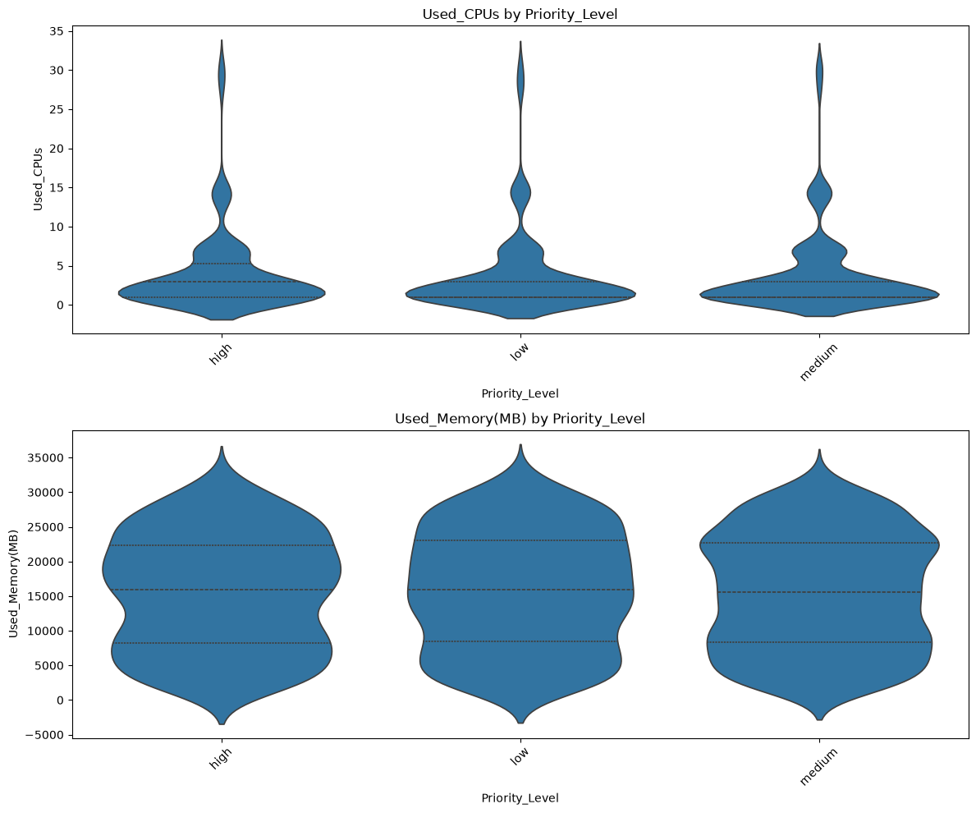
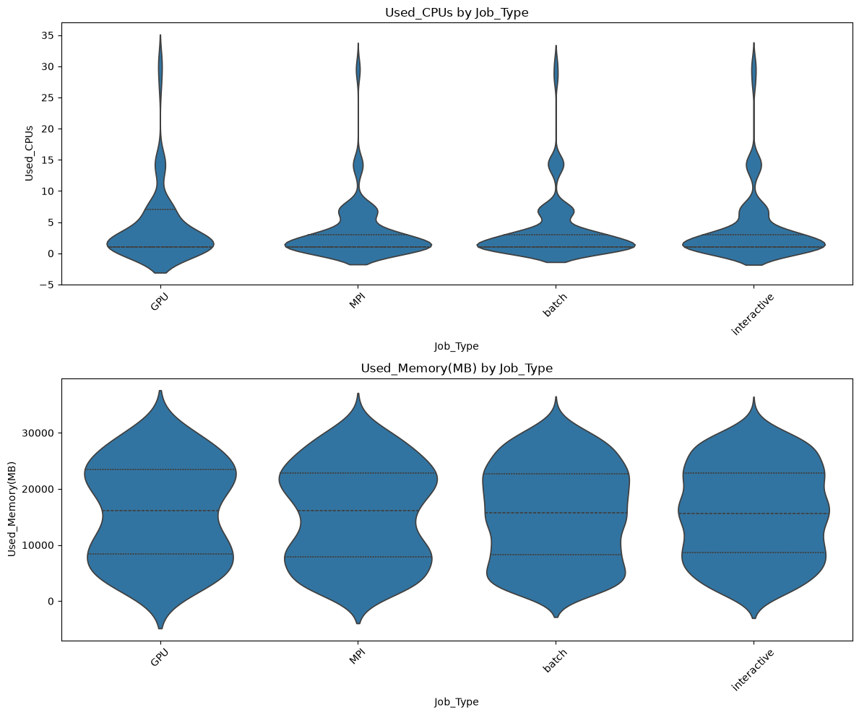
The violin plots showed no observable variation in memory or CPU usage for all 3 categorical variables Job_Type, Priority_Level or day_of_week at the marginal level.
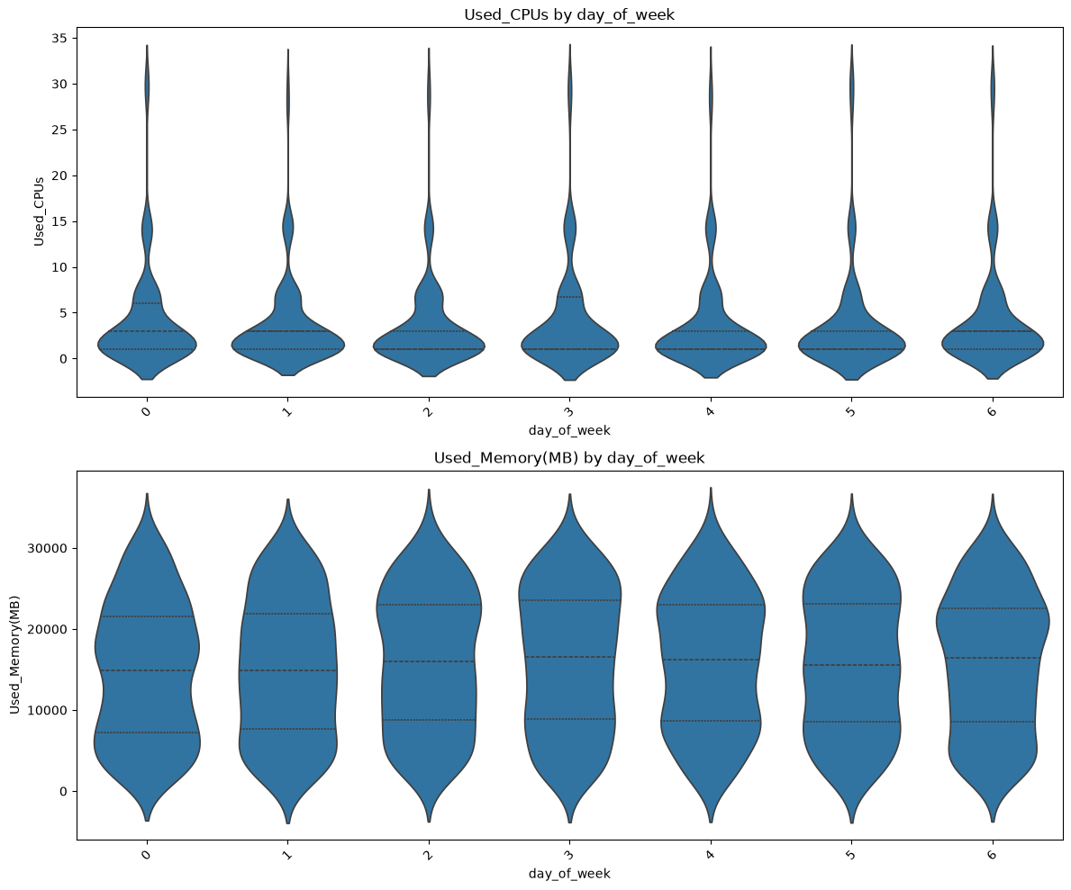
2.4 Train / Test Split
A random 80/20 split (random_state=42) produced 2,849 training and 713 test records. No stratification was applied, which is standard for regression on a continuous target.

2.5 Modelling Pipeline
ColumnTransformer
├── numeric: SimpleImputer(strategy='mean') → StandardScaler()
└── categorical: SimpleImputer(strategy='most_frequent') → OneHotEncoder(handle_unknown='ignore')
Pipeline
└── preprocessor → model
handle_unknown='ignore' guards against category levels appearing in test but not train. Standardisation is critical for SGDRegressor, whose convergence is highly sensitive to vide variances.

2.6 Algorithms and Hyperparameter Search
GridSearchCV with 5-fold KFold cross-validation (shuffle=True, random_state=42), optimising negative mean squared error:
Model | Rationale | Search space
SGDRegressor | Linear baseline. Establishes how much of the signal is simply linear. | loss ∈ {squared_error, huber}, penalty ∈ {l1, l2}
DecisionTreeRegressor | Non-linear single learner; can capture interaction effects a linear model cannot. | max_depth ∈ {None, 10, 20, 30}
RandomForestRegressor | Bagged ensemble; averages out the high variance of a single tree. | max_depth ∈ {None, 10, 20, 30}
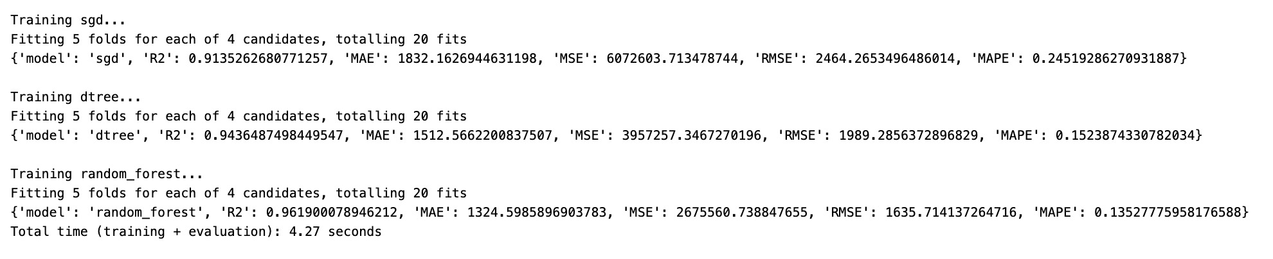
The huber loss was included specifically to test robustness, reducing the influence of outlying jobs. squared_error corresponds to ordinary least squares.

Evaluation metrics: R², MAE, MSE, RMSE and MAPE, supplemented by an actual-vs-predicted scatter plot and a residual plot.

3. Results

3.1 Cross-Validation (Negative MSE — higher is better)
Rank | Model | Mean Train Score | Mean Validation Score | Train–Validation Gap
1 | Random Forest | −4.163 × 10⁵ | −2.971 × 10⁶ | 7.1×
2 | Decision Tree | −1.075 × 10⁶ | −4.657 × 10⁶ | 4.3×
3 | SGD (linear) | −5.799 × 10⁶ | −5.895 × 10⁶ | 1.02×

3.2 Held-Out Test Set (713 records)
Rank | Model | R² | MAE | MSE | RMSE | MAPE
1 | Random Forest | 0.9619 | 1,324.6 | 2.676 × 10⁶ | 1,635.7 | 13.53 %
2 | Decision Tree | 0.9436 | 1,512.6 | 3.957 × 10⁶ | 1,989.3 | 15.24 %
3 | SGD (linear) | 0.9135 | 1,832.2 | 6.073 × 10⁶ | 2,464.3 | 24.52 %

Interpretation of scale
Higher R² is better. Lower MAE, MSE, RMSE and MAPE is better. The best model is Random Forest (max_depth=20) which scored highest R² and lowest RMSE.
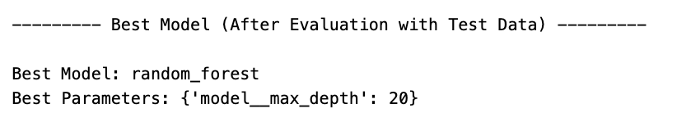

3.3 Residual Diagnostics
The actual-vs-predicted scatter clusters tightly along the 45° reference line across the whole range, with no systematic curvature.
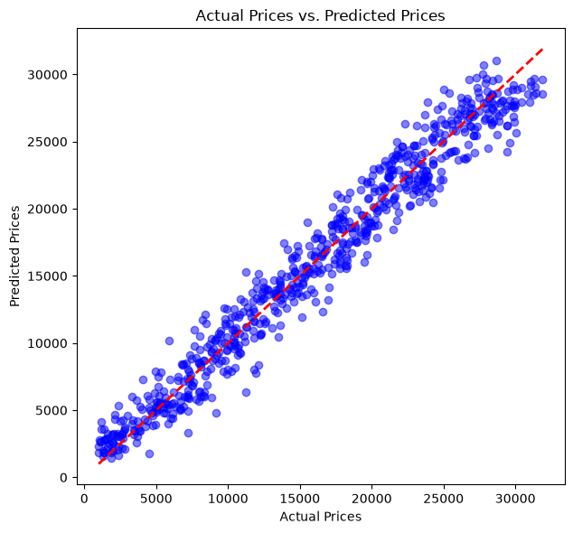

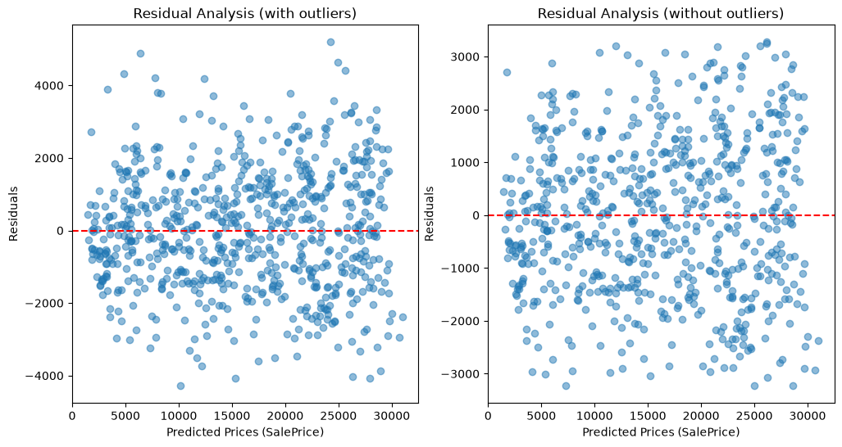
The residual plot shows residuals scattered symmetrically about zero with no visible funnel, trend, or clustering across the prediction range — approximately homoscedastic and unbiased. Removing outliers beyond 2 standard deviations leaves the same featureless cloud, confirming there is no structured signal the model has failed to capture.

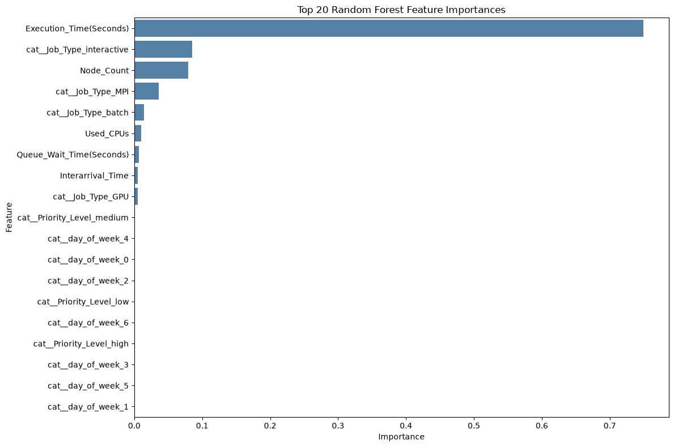
3.4 Feature Importances (Random Forest)
A single feature accounts for three-quarters of the model's decision-making. Job_Type (summed across its four one-hot columns) contributes slightly above 0.1, and Node_Count about 0.08. Everything else is effectively noise.

4. Discussion of Observations and Findings

4.1 The Model Is Almost Entirely a Function of Execution Time
Removing Execution_Time feature collapses R² from 0.96 to below zero — the model becomes worse than simply predicting the mean for every job. The seven remaining features contain essentially no independent information about memory usage, exactly as the near-zero marginal correlations and the flat violin plots predicted.

4.2 Execution Time Is a Look-Ahead Feature — a Deployment Concern
The dependence on Execution_Time(Seconds) raises a serious practical objection. Execution time is only known after a job has finished. If the business objective is to predict resource demand at submission time, so that the scheduler can place the job, this feature is unavailable at the moment the prediction is needed.
The notebook's own reasoning acknowledges the coupling — "when higher resources are requested it is expected that it will take longer execution time" — but this makes the causal direction run from memory to execution time, not the reverse. The model is effectively inverting the data generator rather than forecasting.

4.5 Engineered Features That Did Not Pay Off
day_of_week was extracted from Submit_Time, remapped to a Sunday-first convention, and cast to string so it would be one-hot encoded rather than treated as ordinal. It received an importance of ≈ 0.000 across all seven of its encoded columns. Priority_Level likewise contributed nothing.

5. Strengths and Weaknesses of the Models

Random Forest
Strengths
- Best on every test metric: R² = 0.962, MAE = 1,325 MB, RMSE = 1,636 MB, MAPE = 13.5 %.
- Bagging averages away the variance of individual trees, giving noticeably better generalisation than the single Decision Tree on identical inputs.
- Robust to the untransformed skew in Used_CPUs and Node_Count and indifferent to feature scaling.
- Provides feature importances.

Decision Tree
Strengths
- Fully interpretable: the learned splits could be presented to operations staff as a decision chart for sizing jobs.

SGDRegressor (Linear)
Strengths
- Fully interpretable coefficients.
- Can extrapolate beyond the training range — a genuine advantage over both tree models for forecasting unusually large jobs.
- The huber loss option provided built-in robustness to outlying jobs.
Weaknesses
- Worst absolute accuracy: MAPE of 24.5 % is nearly double the forest's 13.5 %, and MAE is 38 % higher.
- Dependent on the StandardScaler step; would fail to converge on raw features.
- Sensitive to learning-rate and regularisation settings that were not tuned in this grid.

6. Conclusion
- Random Forest (max_depth=20) was the best model, achieving R² = 0.962, MAE = 1,325 MB, RMSE = 1,636 MB and MAPE = 13.5 % on 713 held-out records.
- All three models performed respectably (R² between 0.914 and 0.962), and the ranking Random Forest > Decision Tree > SGD held consistently across cross-validation and every test metric.
- The model depends almost entirely on one feature - Execution_Time(Seconds).
- Execution_Time is a look-ahead feature, known only after a job completes. The model is therefore valid for retrospective analysis and anomaly detection.
- Residual diagnostics are clean — symmetric about zero, approximately homoscedastic, no visible trend or funnel, confirming no major structural signal was left unmodelled.
- Deliberately excluding Requested_Memory(MB) was the right call. Retaining it would have inflated R² while making the model a trivial restatement of the user's own request rather than a genuine demand predictor.

7. Personal Reflection
The most demanding part of this assignment was deciding which features to keep, and defending those decisions. The dataset made this unusually explicit: Requested_Memory(MB) correlates so tightly with Used_Memory(MB) that including it would have delivered an almost perfect R² with no effort. I chose to drop it, accepting a materially lower score, because a model that predicts used memory from requested memory answers a question nobody is asking — the whole point of demand forecasting is to work out what a job needs without relying on the user's own guess. Learning to recognise that a high score can indicate a badly-posed problem rather than a good model was the main lesson of Part B.
Having made that call, I then ran into the same problem with Execution_Time(Seconds). It is not as blatant as requested memory, and I initially treated it as a legitimate feature. Only when the feature importance chart came back at 0.75 for a single column did I stop to ask when that value actually becomes known — and realised that at job submission time, it does not exist. Discovering that the model's headline result rests on information unavailable at prediction time was uncomfortable.

