**Subnetting**

**Subnetting** is the practice of dividing a network into two or more smaller networks. It increases routing efficiency, enhances the security of the network and reduces the size of the broadcast domain.

1- You have been allocated a class A network address of **29.0.0.0**. You need to create at least 20 networks and each network will support a maximum of 160 hosts. Would the following two subnet masks Work?

**255.255.0.0** and or **255.255.255.0**

Yes both would work.

Mask **255.255.0.0** has 8 bits for the subnet and 16 bits for the host

8 bits would accommodate 28=256 subnets

16 bits would accommodate 216= over 64000 hosts

Mask 255.255.255.0 has 16 bits for the subnet and 8 bits of the host.

Have possible 28 -2 hosts =254 which is enough

2. – You have been allocated a class B network address of 135.1.0.0 and and need to create 4 subnets each with around 200 hosts what is the easiest mask to use to satisfy the criteria?

Easiest is to sub net on a byte boundary which would mean a subnet mask of **255.255.255.0**

This would allocate **8 bits** for the **subnet** and**8 bits** for the **host.**

We need to accommodate around 200 hosts which requires 8 bits which we have.

We need 4 subnets which require 4 bits and we have 8 bits. So we have more than enough.

3.  Write the IP address 222.1.1.20 mask 255.255.255.192 in CIDR notation

Decimal 192 =11000000 binary which means that 2 bits of this octet are used for the subnet. Now add the 24 bits 255.255.255 and we have 26 bits. So we write:

222.1.1.20/26

4. Write the IP address 135.1.1.25 mask 255.255. 248.0 in CIDR notation

Decimal 248 =11111000 binary which means that 5 bits of this octet are used for the subnet. Now add the 16 bits 255.255. and we have 21 bits. So we write:

135..1.1.25/21

5 – You have been allocated a class C network address of 211.1.1.0 and are using the default subnet mask of 255.255.255.0 how may hosts can you have?

A class C address has 8 bits of the host which will give 28 -2  =254 hosts

6 .Subnet the Class C IP Address 195.1.1.0 So that you have 10 subnets each with a maximum 12 hosts on each subnet. List the Address on host 1 on subnet 0,1,2,3,10

Current mask= 255.255.255.0

Bits needs for 10 subnets =4 =24 =16 possible subnets

Bits needs for 12 hosts = 4 = 24  = 16-2=14 possible hosts.

So our mask in binary =**11110000**= **240** decimal

Final Mask =**255.255.255.240**

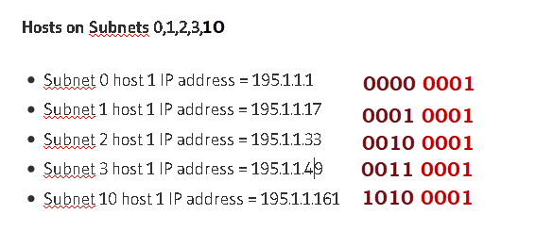

7. Subnet the Class C IP Address 205.11.2.0 so that you have 30 subnets.

What is the subnet mask for the maximum number of hosts?

How many hosts can each subnet have?

What is the IP address of host 3 on subnet 2 ?

Current mask= 255.255.255.0

Bits needs for 30 subnets =5 =25 =32 possible subnets

Bits left for hosts = 3 = 23  = 8-2=6 possible hosts.

So our mask in binary =**11111000**= **248** decimal

Final Mask =**255.255.255.248**

Address of host 3 on subnet 2 is

subnet 2 =00010000 host 3 =000000011

Add the two together =00010011=19

therefore IP address of host 3 on subnet  2 =205.11.2.19

8. Subnet the Class C IP Address 195.1.1.0 So that you have at least 2 subnets each subnet must have room for 48 hosts .

What are the two possible subnet masks?

Current mask= 255.255.255.0

Bits needs for 48 hosts = 6 = 26  = 64-2=62 possible hosts.

Bits needs for 2 subnets =1 =21 =2 possible subnets

Total of 7 bits needed so therefore we can use either 1 bit or 2 bits for the subnet. So we could have

1 bit subnet 7 bits hosts or 2 bits subnet 6 bit host

masks are 10000000 and 11000000 =128 decimal and 192 decimal.

Final possible masks are:

**255.255.255.128** and **255.255.255.192**

9 .Given the subnet Mask **255.255.255.192** What is the host address and subnet of the following IP address 197.1.2.67.

192 in binary =11000000 gives 4 possible subnets of (showing 2 most significant bits):

00,01,10,11

67 in binary =01000011

So Applying Mask:

