-- ============================================================
-- RETAILMART — SQL CAPSTONE PROJECT
-- Industry : Retail (3-store chain)
-- Duration : 3 Hours
-- Covers : DDL, DML, SELECT, JOINs, GROUP BY, Subqueries,
-- UNION/INTERSECT/EXCEPT, CTEs,
-- Window Functions, PIVOT, Views, Indexes,
-- Stored Procedures
-- ============================================================
-- STORY:
-- You are a data analyst at RetailMart — a retail chain with
-- 3 stores across Pakistan. Your job is to build their
-- database from scratch and answer key business questions.
-- ================ ASSIGNMENT_7 =======================
Name : NAHEED DEEDAR
ID : 801925
-- ============================================================
-- HOUR 1 — BUILD & LOAD
-- ============================================================

-- ============================================================
-- TASK 1: DDL — Create the schema
-- ============================================================

-- ============================================================
-- RETAILMART — CREATE TABLES PRACTICE
-- Task: Fill in the blanks to complete each CREATE TABLE.
-- Table names, column names, and hints are given.
-- You must choose the correct data type and constraints.
-- ============================================================
-- DATA TYPES TO CHOOSE FROM:
-- INT, VARCHAR(n), CHAR(n), DECIMAL(10,2), DATE
--
-- CONSTRAINTS TO CHOOSE FROM:
-- PRIMARY KEY, IDENTITY(1,1), NOT NULL, UNIQUE,
-- DEFAULT, CHECK, REFERENCES
-- ============================================================

create schema retailmart;
go

-- ============================================================
-- TABLE 1: categories
-- Stores product categories like Electronics, Clothing, etc.
-- ============================================================

CREATE TABLE retailmart.categories (
category_id INT PRIMARY KEY IDENTITY(1,1),
-- data type primary key auto-increment

category_name VARCHAR(200) NOT NULL
-- data type cannot be empty
);
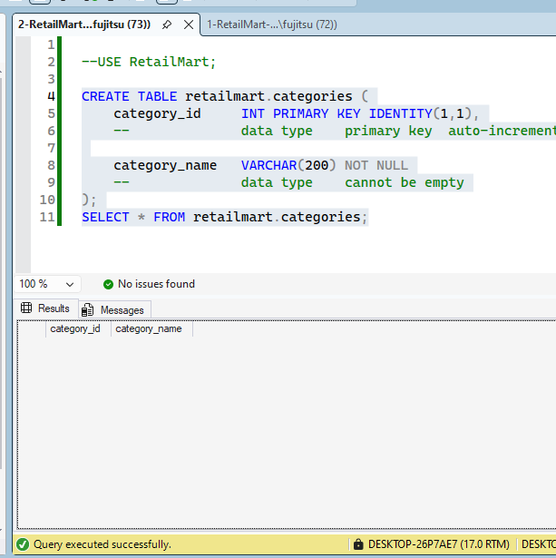

-- ============================================================
-- TABLE 2: products
-- Stores all products sold at RetailMart.
-- ============================================================

CREATE TABLE retailmart.products (

product_id INT PRIMARY KEY IDENTITY(1,1),
-- data type primary key auto-increment

product_name VARCHAR(300) NOT NULL,
-- data type cannot be empty

category_id INT NOT NULL REFERENCES retailmart.categories(category_id),
-- data type cannot be links to categories table
-- empty

price DECIMAL(10,2) NOT NULL CHECK(PRICE >0),
-- decimal type cannot be must be greater than 0
-- empty

stock_qty INT NOT NULL default 0
-- data type cannot be default value = 0
-- empty
);

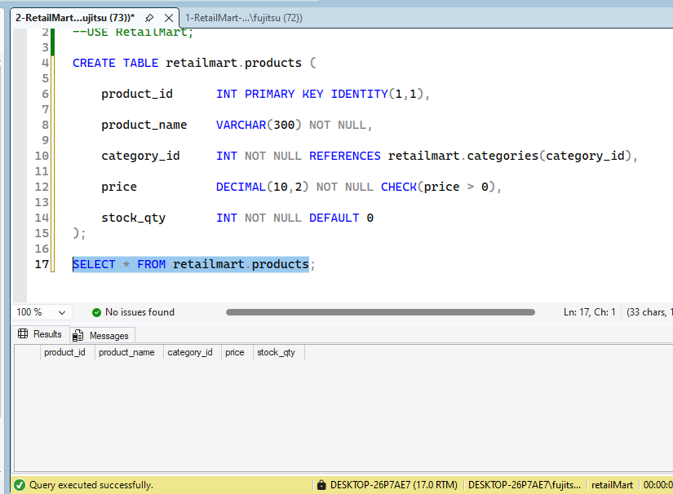
-- ============================================================
-- TABLE 3: stores
-- The 3 RetailMart store locations.
-- ============================================================

CREATE TABLE retailmart.stores (

store_id INT PRIMARY KEY IDENTITY(1,1),
-- data type primary key auto-increment

store_name VARCHAR(300) NOT NULL,
-- data type cannot be empty

city VARCHAR(300) NOT NULL,
-- data type cannot be empty
);

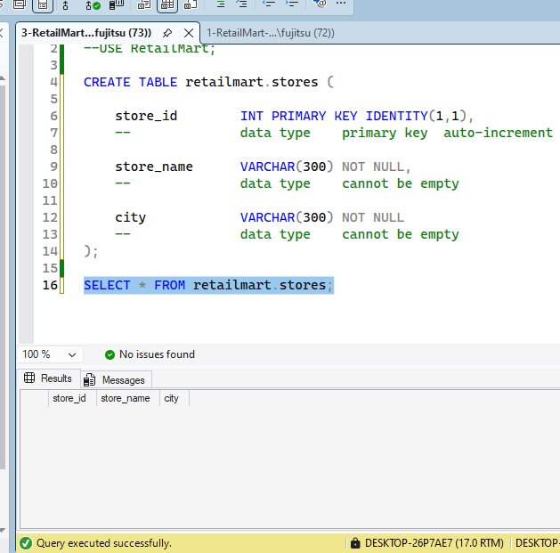
-- ============================================================
-- TABLE 4: customers
-- Registered customers of RetailMart.
-- ============================================================

CREATE TABLE retailmart.customers (

customer_id INT PRIMARY KEY IDENTITY(1,1),
-- data type primary key auto-increment

full_name VARCHAR(300) NOT NULL,
-- data type cannot be empty

email VARCHAR(300) NOT NULL UNIQUE,
-- data type cannot be no two customers
-- empty can share email

city VARCHAR(300),
-- data type (nullable - customer may not provide city)

gender CHAR(1) CHECK(gender IN ('M', 'F'))
-- single char only 'M' or 'F' allowed
);
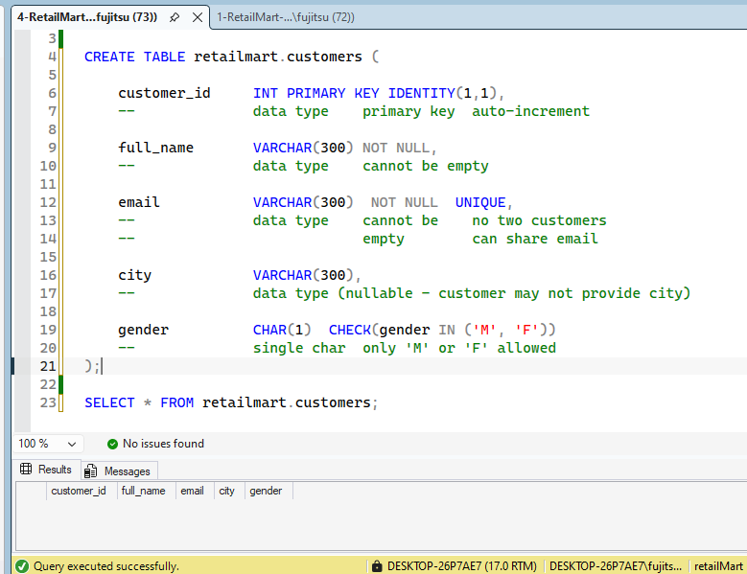

-- ============================================================
-- TABLE 5: orders
-- Each row = one order placed by a customer at a store.
-- ============================================================

CREATE TABLE retailmart.orders (

order_id INT PRIMARY KEY IDENTITY(1,1),
-- data type primary key auto-increment

store_id INT NOT NULL REFERENCES retailmart.stores(store_id),
-- data type cannot be links to stores table
-- empty

customer_id INT NOT NULL REFERENCES retailmart.customers(customer_id),
-- data type cannot be links to customers table
-- empty

order_date DATE NOT NULL DEFAULT GETDATE(),
-- date type cannot be default = today's date
-- empty (hint: use GETDATE())

status VARCHAR(200) NOT NULL DEFAULT 'Pending' CHECK(STATUS IN ('Pending' , 'Shipped' , 'Delivered' , 'Cancelled'))
-- data type cannot be default = only allow:
-- empty 'Pending' 'Pending'
-- 'Shipped'
-- 'Delivered'
-- 'Cancelled'
);
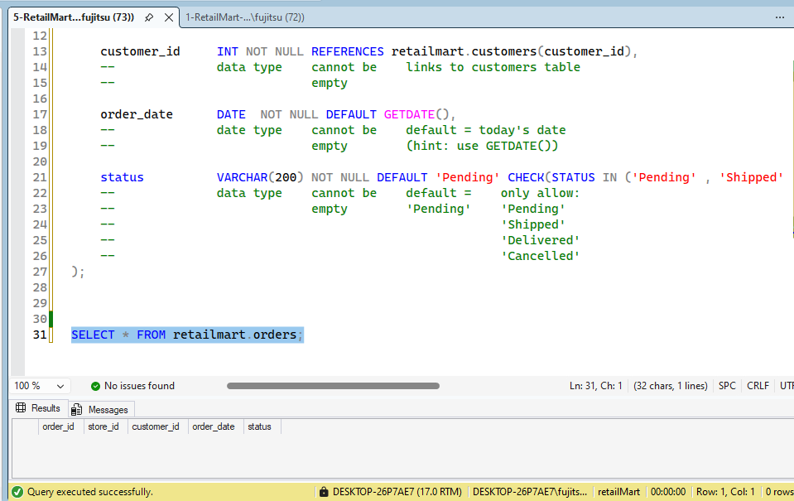

-- ============================================================
-- TABLE 6: order_items
-- Each row = one product line inside an order.
-- One order can have multiple items.
-- ============================================================

CREATE TABLE retailmart.order_items (

item_id INT PRIMARY KEY IDENTITY(1,1),
-- data type primary key auto-increment

order_id INT NOT NULL REFERENCES retailmart.orders(order_id),
-- data type cannot be links to orders table
-- empty

product_id INT NOT NULL REFERENCES retailmart.products(product_id),
-- data type cannot be links to products table
-- empty

quantity INT NOT NULL CHECK(quantity >0),
-- data type cannot be must be greater than 0
-- empty

unit_price DECIMAL(10,2) NOT NULL
-- decimal type cannot be empty
);
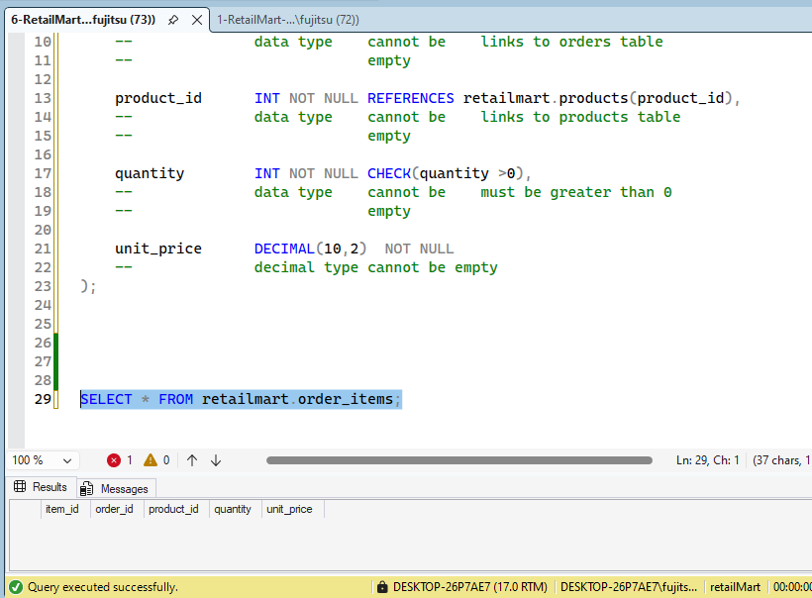

-- END OF EXERCISE
-- ============================================================

-- ============================================================
-- TASK 2: DML — INSERT, UPDATE, DELETE, MERGE
-- ============================================================

-- INSERT categories

INSERT INTO retailmart.categories (category_name) VALUES
('Electronics'), ('Clothing'), ('Groceries'), ('Accessories'), ('Home Appliances');
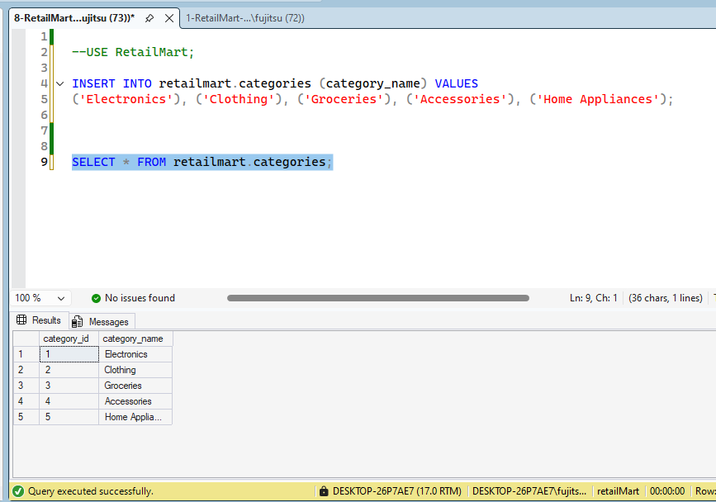

-- INSERT products
INSERT INTO retailmart.products (product_name, category_id, price, stock_qty) VALUES
('Samsung 4K TV', 1, 85000, 15),
('iPhone 15', 1, 295000, 10),
('Wireless Earbuds', 4, 4500, 80),
('Leather Jacket', 2, 8500, 40),
('Linen Shirt', 2, 2200, 60),
('Rice 5kg', 3, 950, 200),
('Cooking Oil 3L', 3, 750, 150),
('Sunglasses', 4, 1800, 55),
('Microwave Oven', 5, 18000, 20),
('Electric Kettle', 5, 3200, 35);
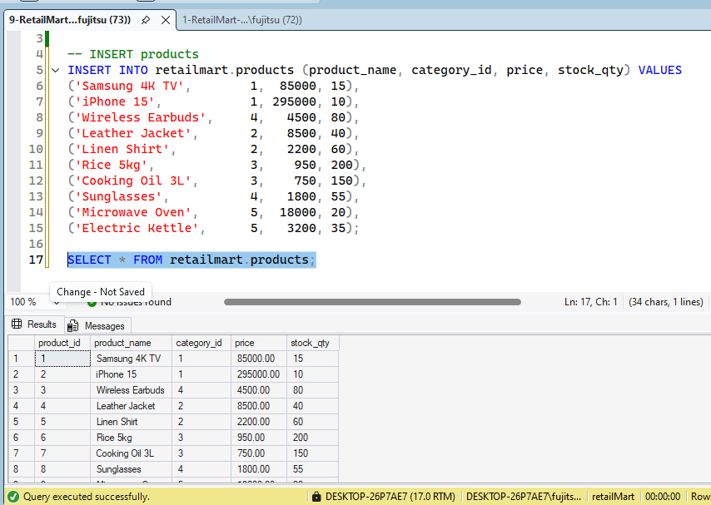
-- INSERT stores
INSERT INTO retailmart.stores (store_name, city) VALUES
('RetailMart Karachi', 'Karachi'),
('RetailMart Lahore', 'Lahore'),
('RetailMart Islamabad', 'Islamabad');
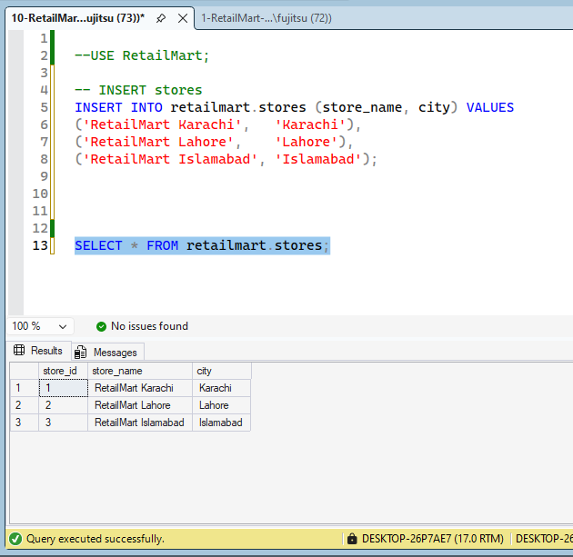
-- INSERT customers
INSERT INTO retailmart.customers (full_name, email, city, gender) VALUES
('Ahmed Khan', 'ahmed@gmail.com', 'Karachi', 'M'),
('Sara Malik', 'sara@gmail.com', 'Lahore', 'F'),
('Bilal Hussain', 'bilal@gmail.com', 'Islamabad', 'M'),
('Fatima Nawaz', 'fatima@gmail.com', 'Karachi', 'F'),
('Omar Sheikh', 'omar@gmail.com', 'Lahore', 'M'),
('Nadia Ali', 'nadia@gmail.com', 'Islamabad', 'F'),
('Hamza Raza', 'hamza@gmail.com', 'Karachi', 'M'),
('Zara Qureshi', 'zara@gmail.com', 'Lahore', 'F');
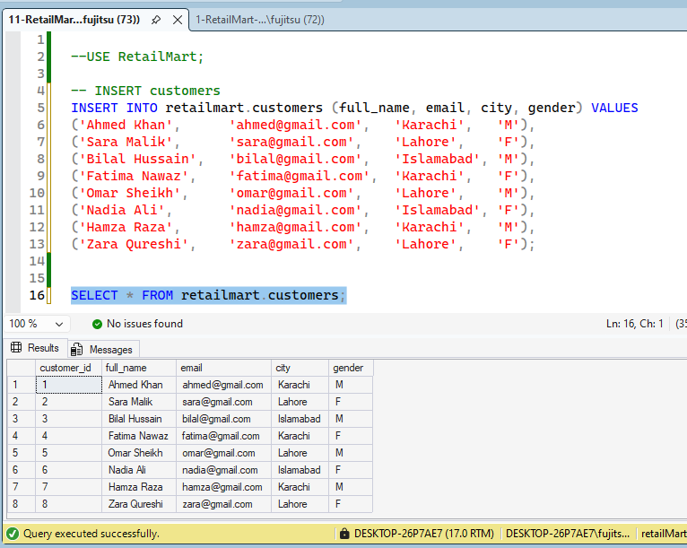
-- INSERT orders
INSERT INTO retailmart.orders (store_id, customer_id, order_date, status) VALUES
(1, 1, '2024-01-10', 'Delivered'),
(1, 4, '2024-01-15', 'Delivered'),
(2, 2, '2024-02-03', 'Delivered'),
(2, 5, '2024-02-20', 'Shipped'),
(3, 3, '2024-03-05', 'Delivered'),
(3, 6, '2024-03-18', 'Pending'),
(1, 7, '2024-04-01', 'Delivered'),
(2, 8, '2024-04-22', 'Cancelled'),
(1, 1, '2024-05-10', 'Delivered'),
(3, 3, '2024-06-01', 'Shipped');
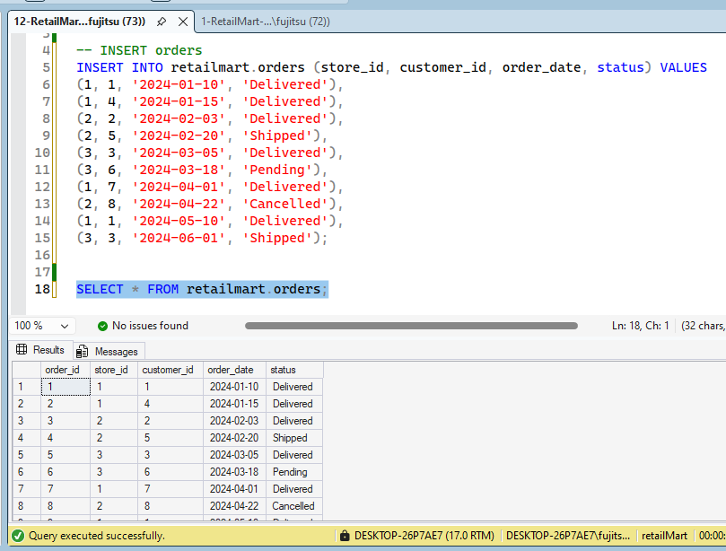
-- INSERT order items
INSERT INTO retailmart.order_items (order_id, product_id, quantity, unit_price) VALUES
(1, 2, 1, 295000),
(1, 3, 2, 4500),
(2, 4, 1, 8500),
(3, 5, 3, 2200),
(3, 8, 1, 1800),
(4, 1, 1, 85000),
(5, 9, 1, 18000),
(5, 10, 2, 3200),
(6, 6, 4, 950),
(7, 3, 1, 4500),
(8, 2, 1, 295000),
(9, 4, 2, 8500),
(10, 9, 1, 18000);
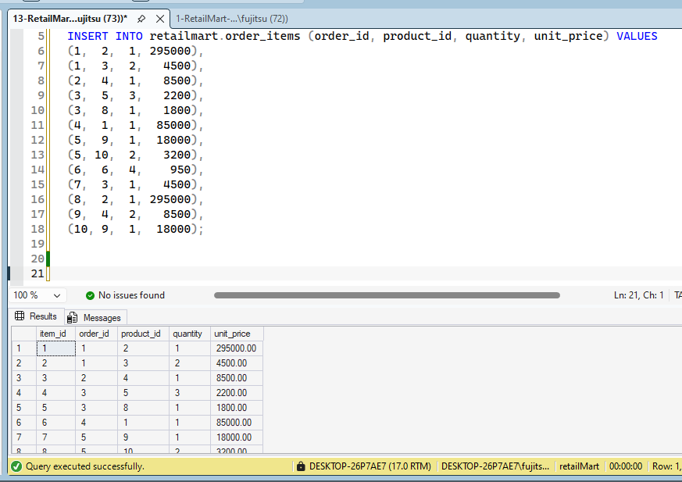
-- UPDATE: Reduce price of Electric Kettle by 10%
select * from retailmart.products where product_id = 10;
UPDATE retailmart.products
SET price = price * 0.90
WHERE product_id = 10;
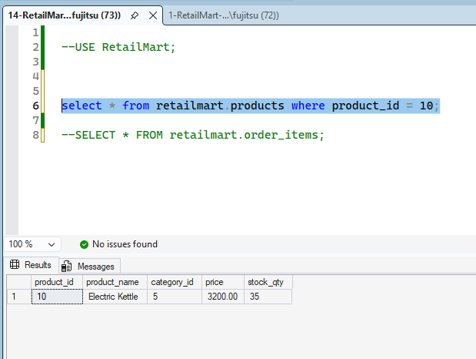
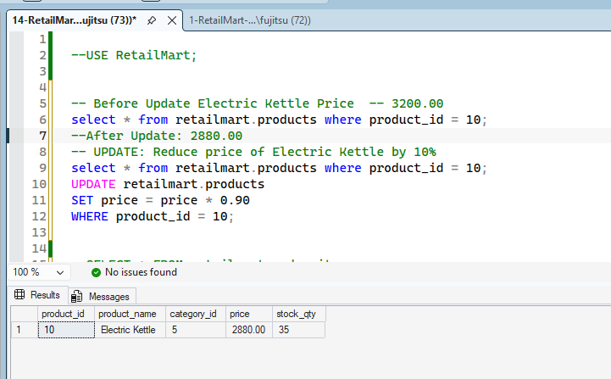
-- DELETE: Remove the cancelled order's items and the order itself
DELETE FROM retailmart.order_items WHERE order_id = 8;
DELETE FROM retailmart.orders WHERE order_id = 8;
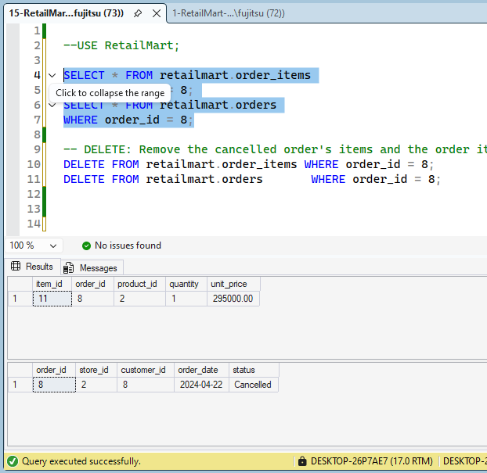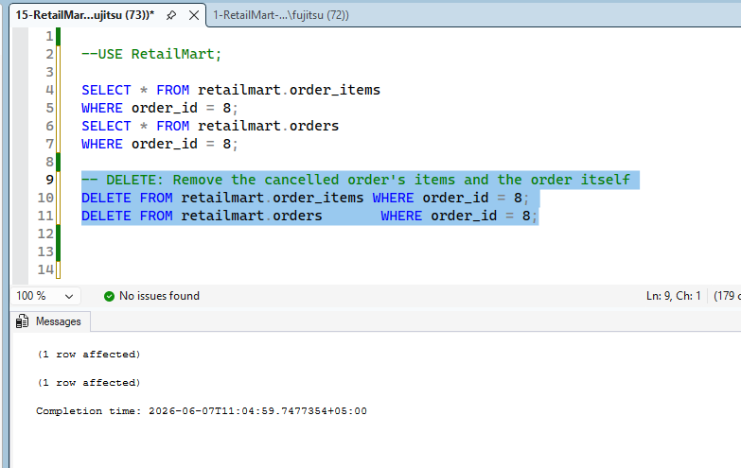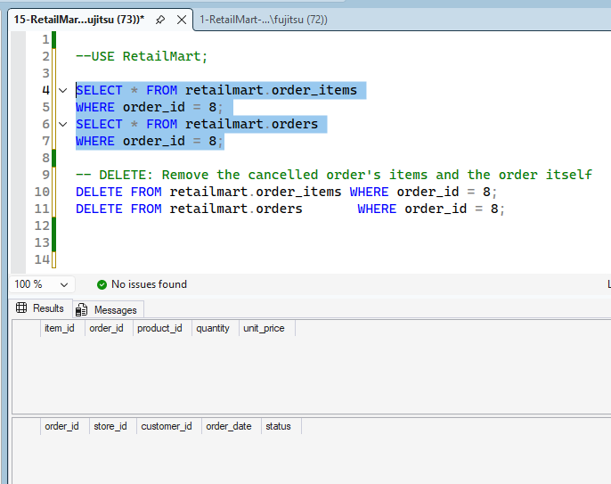

-- ============================================================
-- HOUR 2 — QUERY & ANALYZE
-- ============================================================

-- ============================================================
-- TASK 3: SELECT, filtering, sorting
-- ============================================================

-- All products under Rs. 5,000
select * from retailmart.products
where price < 5000;
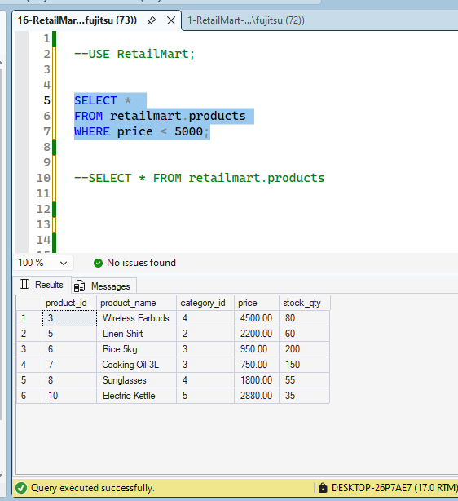
-- Customers from Karachi
select * from [retailmart].[customers]
where city = 'Karachi';
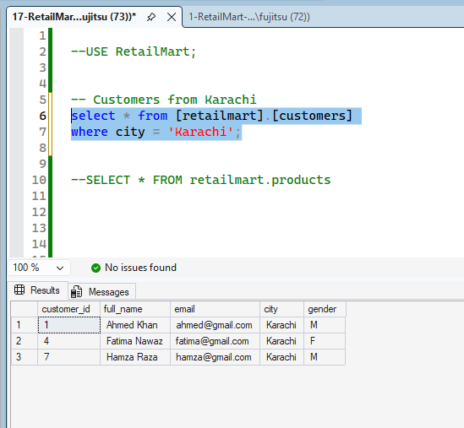
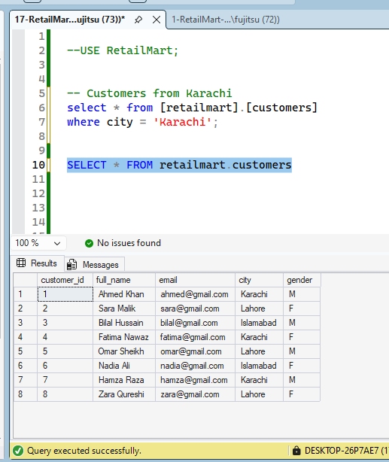
-- Orders placed in 2024 sorted by date descending
select * from [retailmart].[orders]
where year(order_date) = '2024';
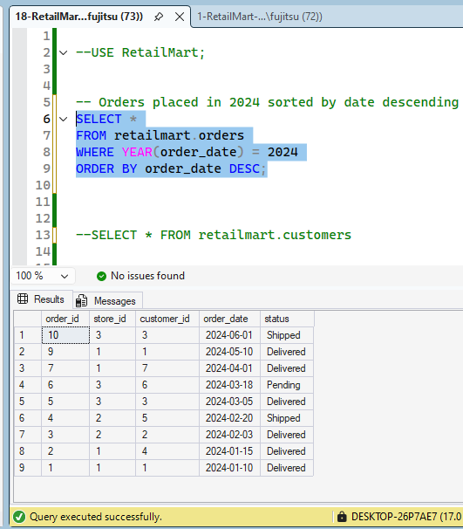
-- ============================================================
-- TASK 4: JOINs — INNER, LEFT, RIGHT
-- ============================================================

-- INNER JOIN: Orders with customer name and product details

select
c.customer_id,
c.full_name,
o.order_id,
o.order_date,
p.product_name
from [retailmart].[customers] c
inner join [retailmart].[orders]o
on c.customer_id=o.customer_id
inner join [retailmart].[order_items]oi
on oi.order_id=o.order_id
inner join [retailmart].[products]p
on p.product_id=oi.product_id;
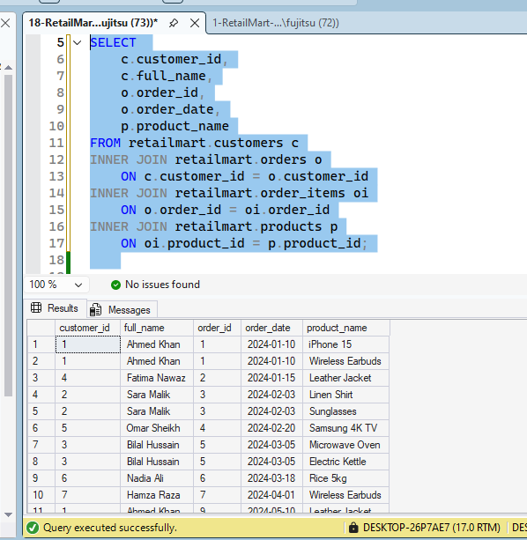

-- LEFT JOIN: All customers including those with no orders
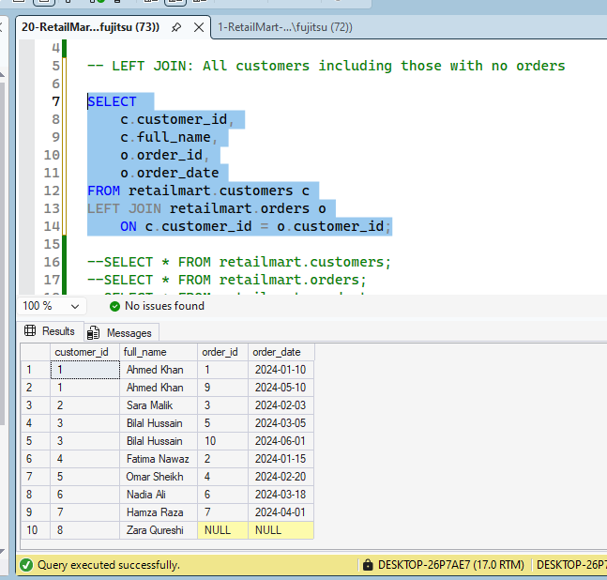
-- RIGHT JOIN: All products including those never ordered
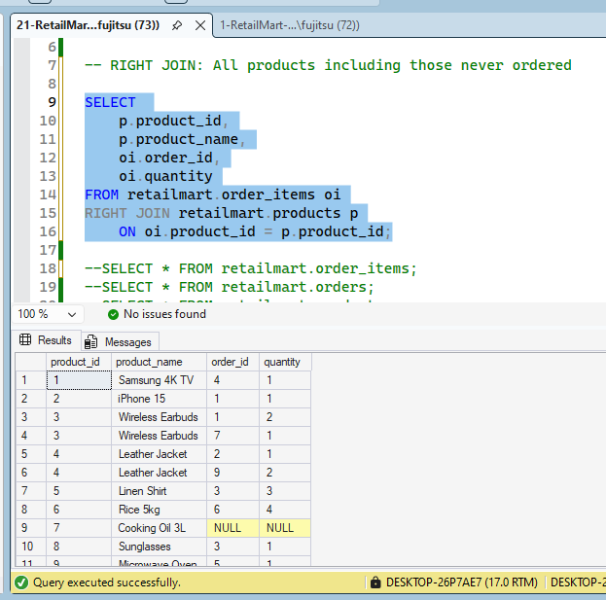

-- ===========================================================
-- TASK 5: GROUP BY + CASE
-- ============================================================

-- Total revenue by store and category
SELECT
s.store_name,
c.category_name,
SUM(oi.quantity* oi.unit_price) AS total_revenue
FROM [retailmart].[orders] o
JOIN [retailmart].[stores] s
ON s.store_id = o.store_id
JOIN [retailmart].[order_items] oi
ON o.order_id = oi.order_id
JOIN [retailmart].[products] p
ON p.product_id = oi.product_id
JOIN [retailmart].[categories] c
ON p.category_id = c.category_id
GROUP BY s.store_name,c.category_name;
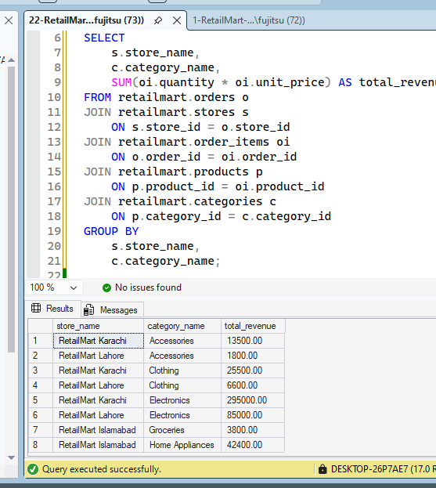
-- Label each product as Budget / Mid-range / Premium using CASE
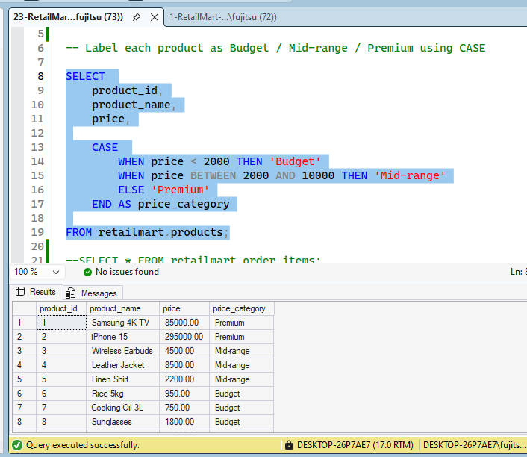
-- ============================================================
-- TASK 7: Subqueries
-- ============================================================

-- Orders where the total exceeds the average order value (subquery in WHERE)
select o.order_id, sum([quantity]*[unit_price]) as total
from [retailmart].[order_items] o
group by o.order_id
having sum([quantity]*[unit_price]) >
(select avg([quantity]*[unit_price]) from [retailmart].[order_items]) --59,123
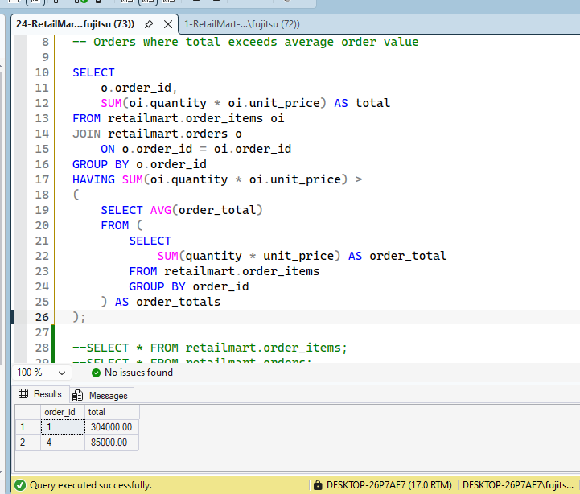

-- ============================================================
-- TASK 8: Set operators — UNION, INTERSECT, EXCEPT
-- ============================================================

-- UNION: All unique cities where we have customers OR stores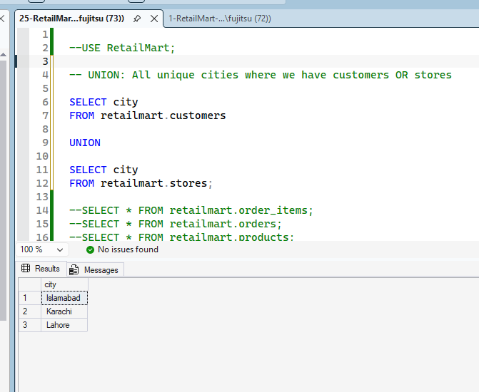

-- INTERSECT: Customers who ordered from BOTH store 1 AND store 2
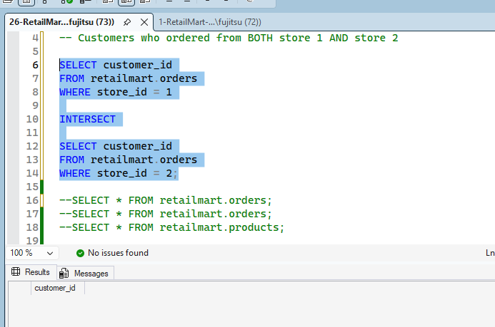
-- EXCEPT: Customers who have NEVER placed an order
-- A - B A = {1,2,3,4} , B= {2,4,6,7}===== A-B = {1,3}
select customer_id from [retailmart].[customers] --A
except
select customer_id from [retailmart].[orders] -- B

SELECT PRODUCT_ID FROM [retailmart].[products]
EXCEPT
SELECT PRODUCT_ID FROM [retailmart].[order_items]
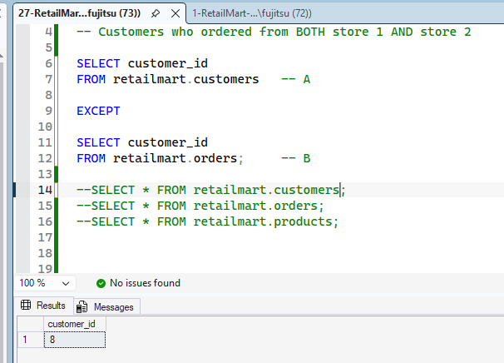
-- ============================================================
-- HOUR 3 — ADVANCED & AUTOMATE
-- ============================================================

-- ============================================================
-- TASK 9: CTEs + Recursive CTE
-- ============================================================

-- Regular CTE: Top 5 customers by total spend

JOIN CUSTOMERS --- JOIN -- ORDERS -- JOIN - ORDER ITEMS --- QUANTITY * UNIT_PRICE
GROUP CUSTOMER_ID -- TOTAL SPENDING
TOP 5
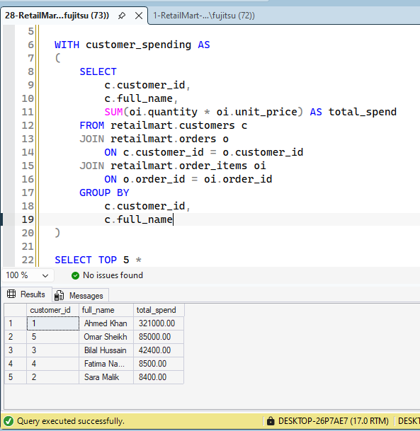
-- ============================================================
-- TASK 10: Window functions
-- ============================================================

-- ROW_NUMBER and RANK: Products ranked by revenue

CTE( PRODUCT -- JOIN -- ORDER ITEMS --
GROUP BY PRODUCT -- SUM(UNIT_PRICE* QUANTITY) -- REVENUE)

WITH CTE AS (
SELECT P.PRODUCT_ID, SUM(OI.UNIT_PRICE*OI.UNIT_PRICE) AS REVENUE
FROM [retailmart].[products] P INNER JOIN [retailmart].[order_items] OI
ON OI.product_id = P.product_id
GROUP BY P.PRODUCT_ID)

SELECT product_id, ROW_NUMBER() OVER(ORDER BY REVENUE DESC) AS RN FROM CTE

-- Running total of revenue by store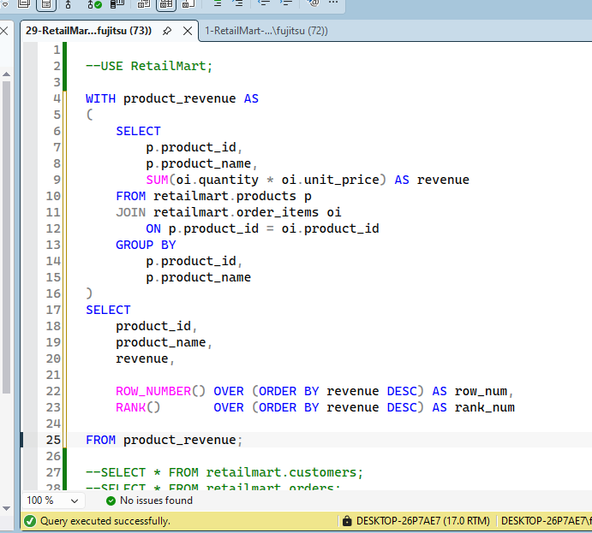
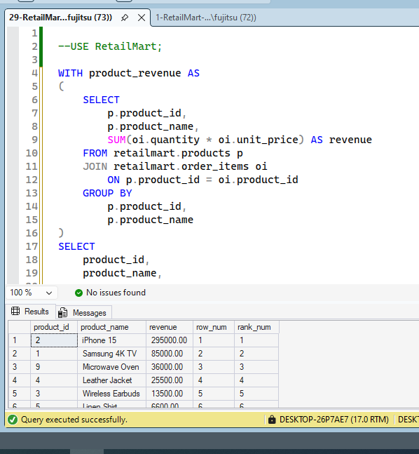
-- ============================================================
-- TASK 12: Views
-- ============================================================

-- Standard view: Order summary

-- Use the view

-- Indexed (materialized) view: Store revenue totals
-- Note: Requires SCHEMABINDING + unique clustered index
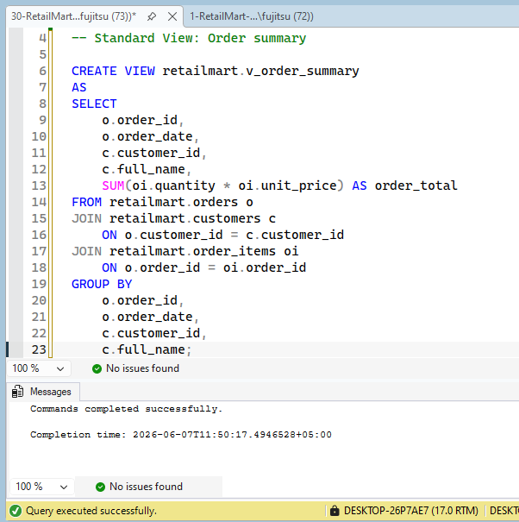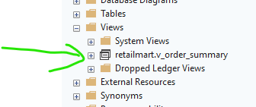
-- ============================================================
-- TASK 13: Indexes
-- ============================================================

-- Composite index: Speed up queries filtering by customer + date

-- Filtered index: Only index Pending orders (partial index)

-- Non-clustered index on customer email for fast lookups

-- Verify indexes
EXEC sp_helpindex 'retailmart.orders';
EXEC sp_helpindex 'retailmart.customers';

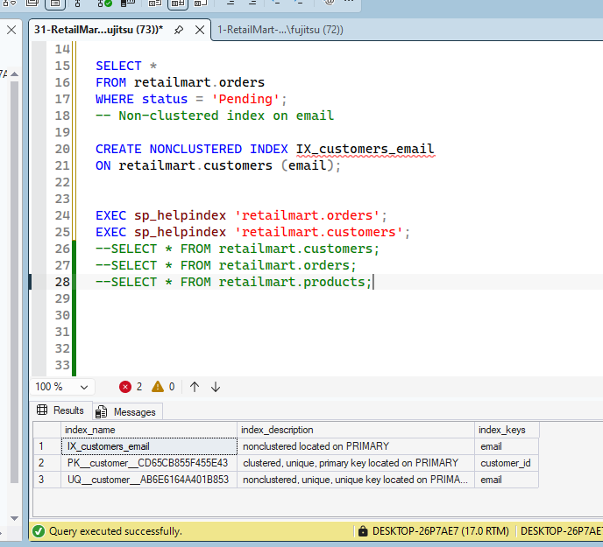
-- ============================================================
-- TASK 14: Stored Procedures + Error Handling
-- ============================================================

-- Procedure 1: Monthly sales report for a store

-- Test the report for Store 1 (Karachi)
EXEC retailmart.sp_MonthlySalesReport @StoreID = 1, @Year = 2024;

-- Test with default year
EXEC retailmart.sp_MonthlySalesReport @StoreID = 2;
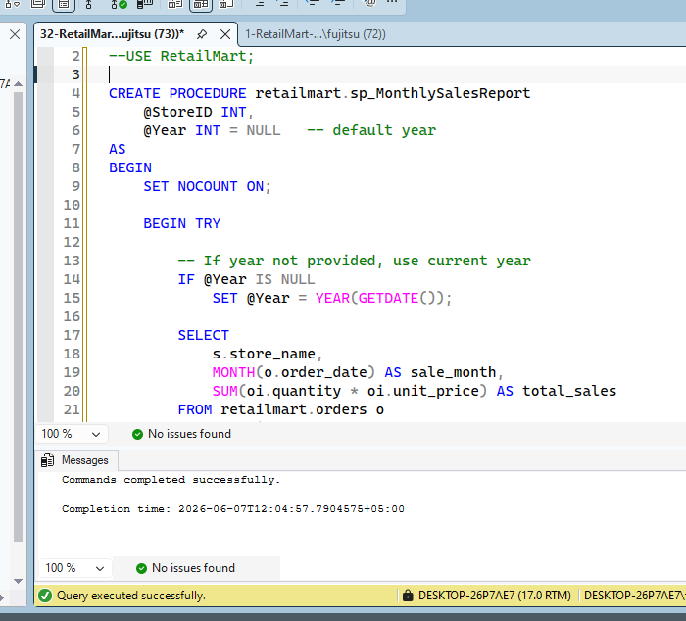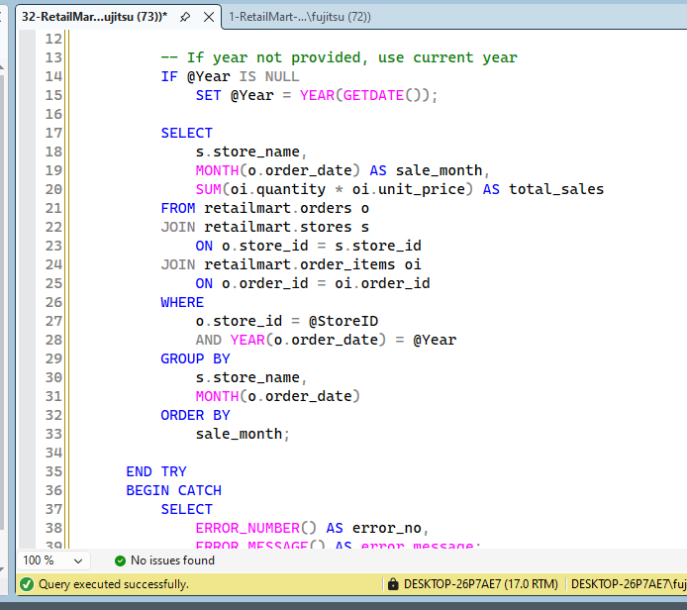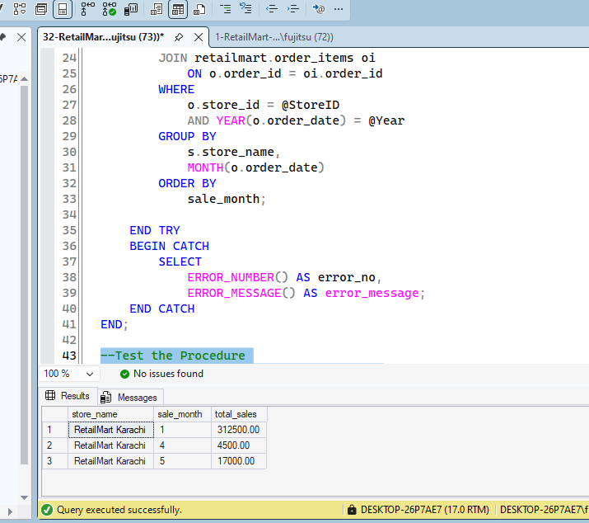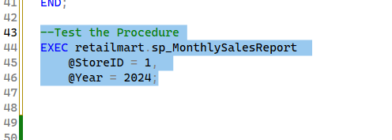

-- ============================================================
-- END OF CAPSTONE PROJECT
-- ============================================================
-- You have covered:
-- DDL CREATE TABLE, constraints, data types
-- DML INSERT, UPDATE, DELETE, MERGE
-- Querying SELECT, WHERE, ORDER BY
-- Joins INNER, LEFT, RIGHT
-- Aggregation GROUP BY, ROLLUP, CUBE, GROUPING SETS
-- CASE Price tier labelling
-- Subqueries Inline
-- Set ops UNION, INTERSECT, EXCEPT
-- CTEs Regular
-- Windows ROW_NUMBER, RANK
-- PIVOT Monthly revenue matrix
-- Views Standard + Indexed
-- Indexes Composite, Filtered, Non-clustered
-- Procedures Parameters, defaults
-- ============================================================

