SAYLANI IT TRAINING
SQL Server — Class 2 Homework
Joins & Views
BikeStores Sample Database

Instructions
Write a SQL Server query to answer each question below using the BikeStores sample database.
Tables: production.products | production.brands | production.categories | sales.customers | sales.orders | sales.order_items | sales.staffs | sales.stores | sales.stocks

Topic Legend:
INNER JOIN | LEFT JOIN | RIGHT JOIN | SELF JOIN | VIEWS | BONUS

Q1 | Show all product names along with their brand name. Sort by brand name, then by product name alphabetically. | INNER JOIN
Your answer:
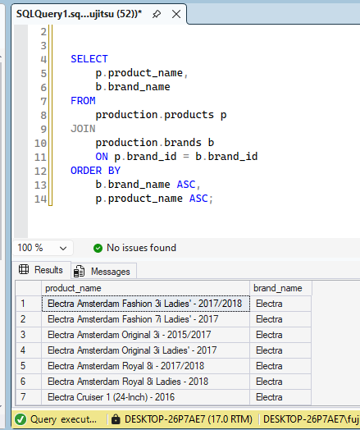

Q2 | List all products with their category name and list price. Sort by category name, then by price from cheapest to most expensive. | INNER JOIN
Your answer:

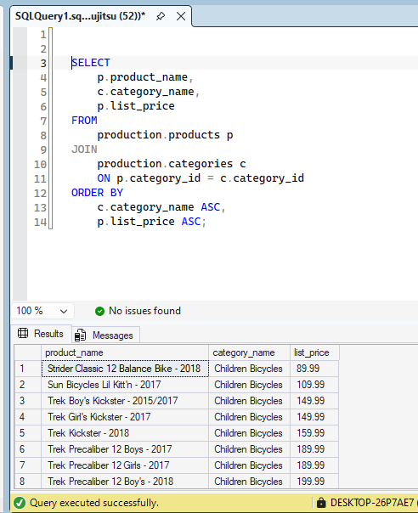

Q3 | Show all orders with the customer's full name and order date. Sort by order date from newest to oldest. | INNER JOIN
Your answer:
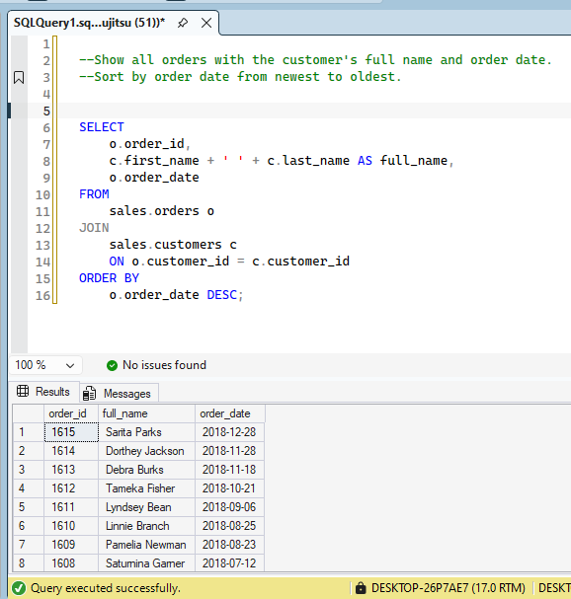

Q4 | Display each order item with the product name, quantity, unit price, and a computed column called "Line Total" (quantity × list_price). Sort by order ID. | INNER JOIN
Your answer: 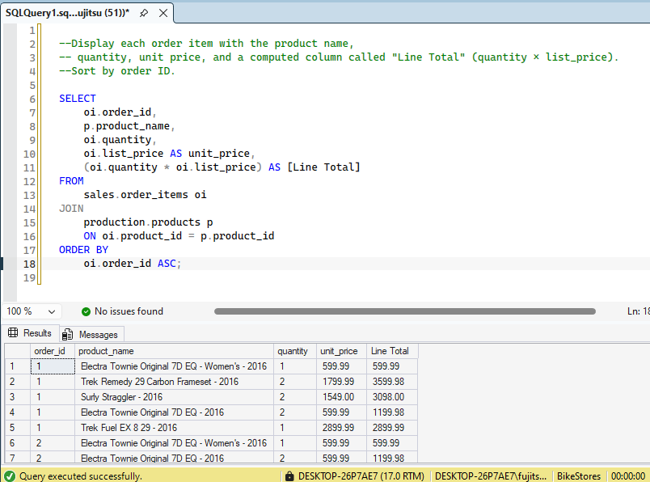

Q5 | Show each order along with the store name where it was placed and the order date. Sort by store name. | INNER JOIN
Your answer:
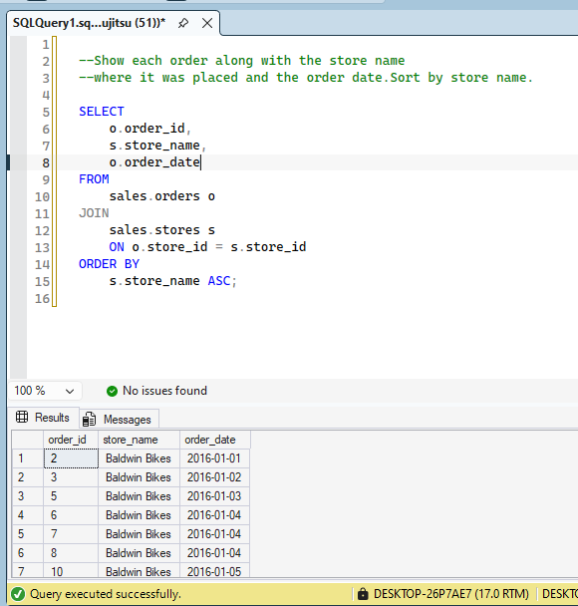

Q6 | Show each order with: order ID, customer full name, store name, and the staff member's full name who handled it. | INNER JOIN
Your answer: 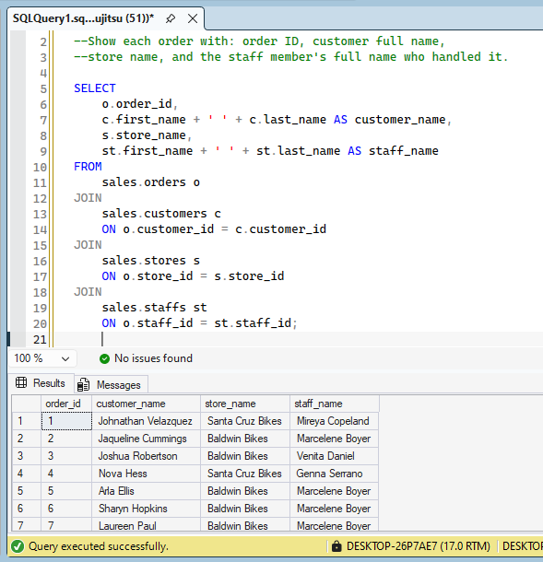

Q7 | List all products from the brand "Trek" along with their category name and price. Sort by price descending. (Use JOIN — do NOT filter by brand_id directly.) | INNER JOIN
Your answer:
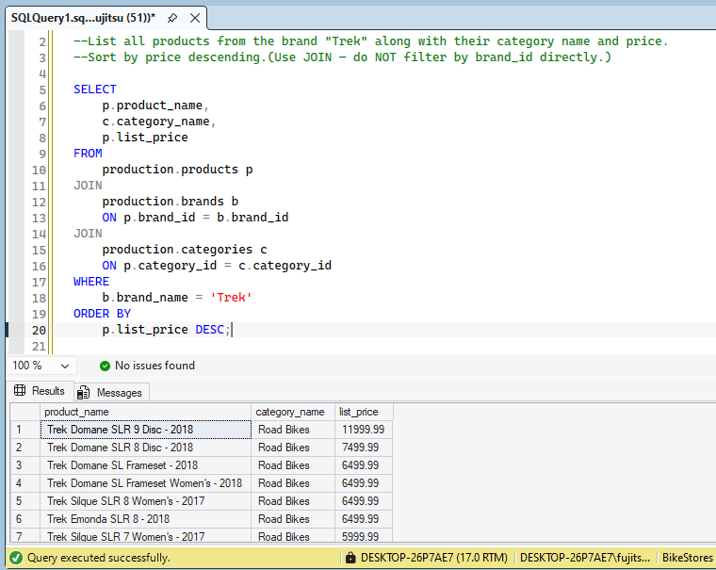

Q8 | Find all customers from the state of "NY" who have placed at least one order. Show customer full name, city, and order date. (Use JOIN — do not use a subquery.) | INNER JOIN
Your answer: 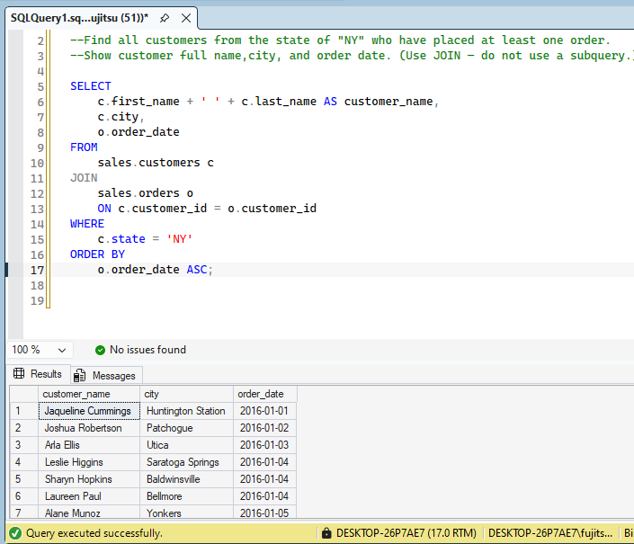

Q9 | Show all completed orders (order_status = 4) from the store "Rowlett Bikes". Display order ID, customer full name, and order date. | INNER JOIN
Your answer:
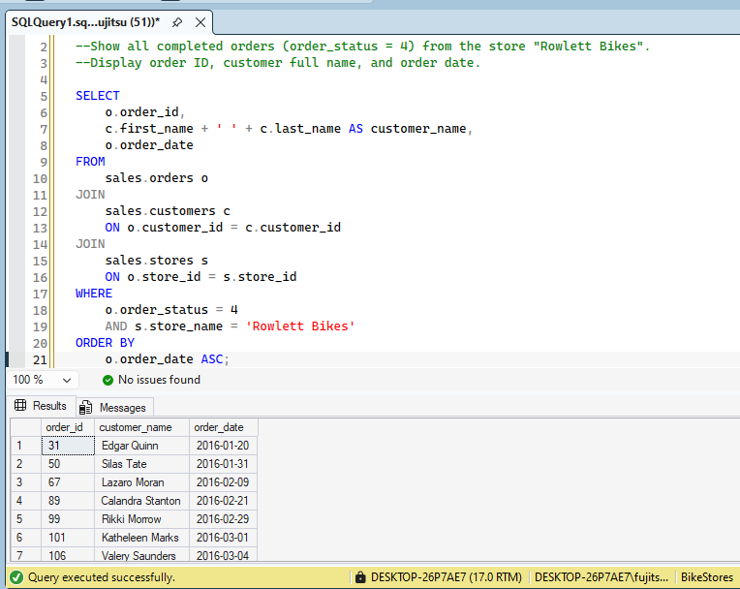

Q10 | List ALL customers and any orders they have placed. Include customers who have never placed an order (show NULL for order columns). Sort by customer ID. | LEFT JOIN
Your answer:

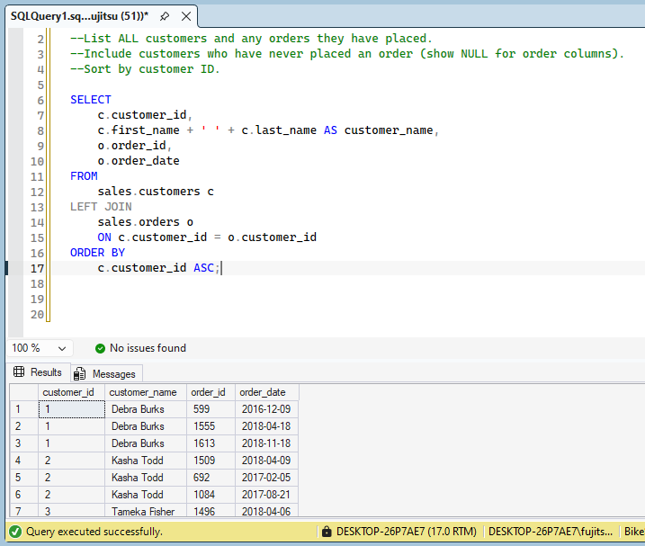

Q11 | Find all customers who have NEVER placed an order. Show their full name and email. | LEFT JOIN
Your answer:
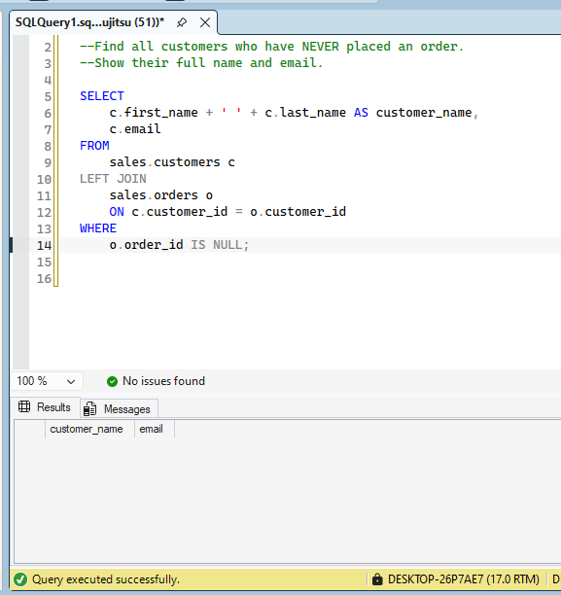

Q12 | List all products and their stock quantity at every store. Include products that have NO stock record at all. Show product name, store ID, and quantity. | LEFT JOIN
Your answer:
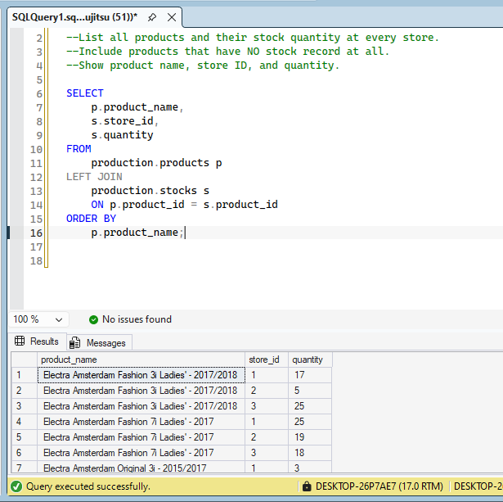

Q13 | Find all products that have NEVER been ordered (no record in order_items). Show product name and list price. | LEFT JOIN
Your answer: 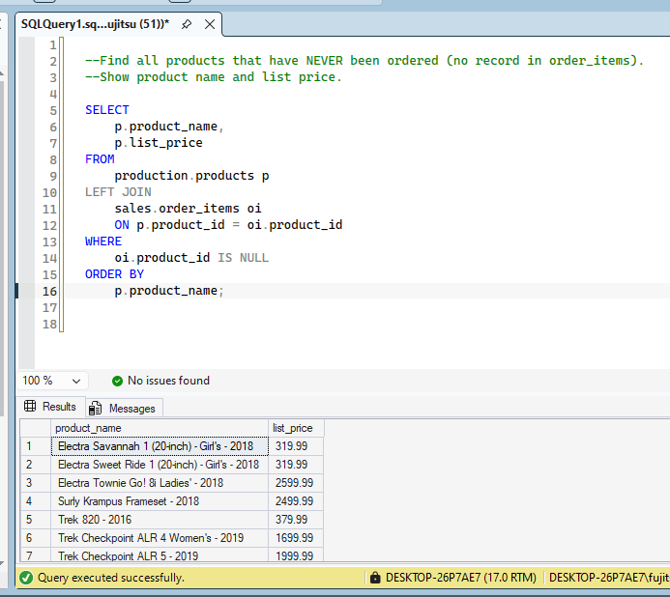

Q14 | List each staff member along with the full name of their manager. Staff with no manager (top-level) should still appear — show NULL for manager name. | SELF JOIN
Your answer:
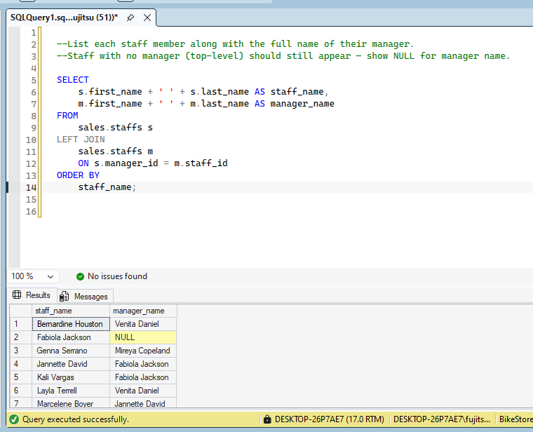

Q15 | Create a view called vw_bike_catalog that shows product_name, brand_name, category_name, model_year, and list_price. Then query it to show only products priced over $2,000, sorted by price descending. | VIEWS
Your answer: 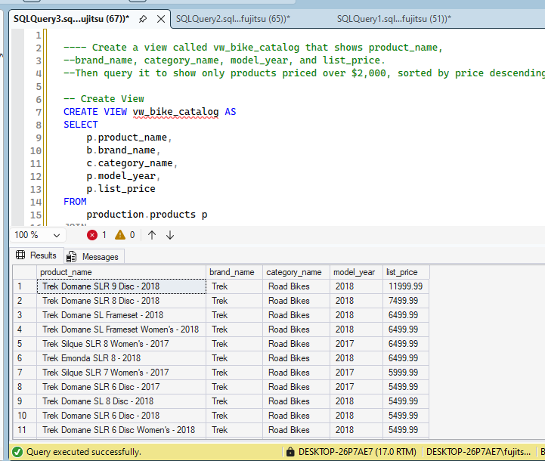

Q16 | BONUS: Create a view called vw_customer_orders showing: customer full name, order_id, order_date, store_name, and order_status. Then query it to show only orders where the customer city is "New York", sorted by order_date. | VIEWS
Your answer:
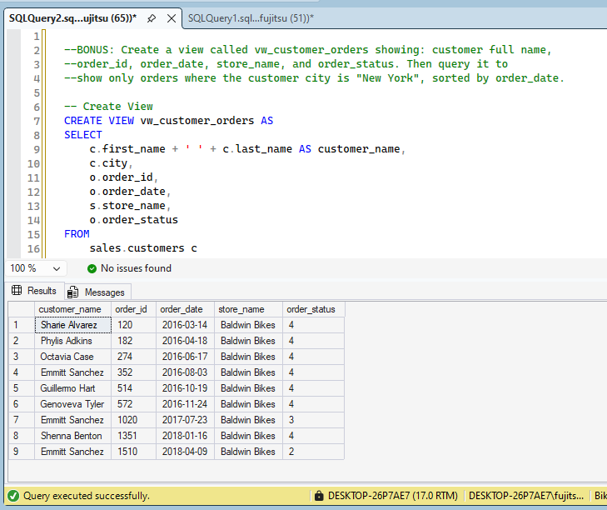

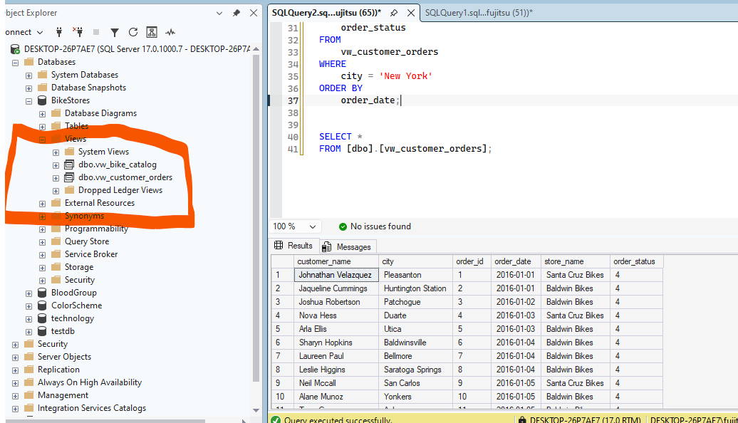

Saylani IT Training — SQL Server Class 2: Joins & Views

