**Project Proposal: Mood-Drawing Robot**

**I. Background Information**

My project is a mood-drawing robot. The project was inspired by the idea of mood rings, which are fun accessories that change color based on the temperature around them. My robot contains a temperature sensor that is able to use body heat to distinguish between times when the user is not covering the sensor and times when the user is covering the sensor. The robot then decides either that it is that it is happy (the user was covering the sensor) or sad (the user was not covering the sensor). Finally, using wheels connected to the chassis and a pen connected to a servo, the robot moves around and draws the user a corresponding smiley or frowny face on a standard sheet of letter paper.

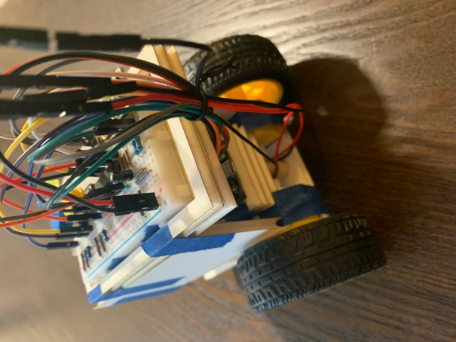

My project has already been prototyped using a solderless breadboard. Documentation of this prototype can be found on Hackster.IO at <https://www.hackster.io/summer-barrette/mood-drawing-robot-949c22>, and the code used in the prototype can be found on GitHub at <https://github.com/summer-barrette/ENGI301/tree/main/project_01>.

With an established proof of concept in the solderless breadboard prototype, the project is now moving into the next stage of prototyping: printed circuit-board design. The printed circuit board design should make the prototype more compact and remove the weight and volume added by the solderless breadboard and jumper wires.

In terms of parts used and electrical connections made between those parts, there should be no changes between the solderless breadboard prototype and the new printed circuit board design,

**II. System Block Diagram**

**III. Mechanical Block Diagram**

**IV. Components Required**

1 Pocket Beagle

1 USB to USBc Connector

1 Rechargeable Battery

1 Adafruit Si7021 Temperature & Humidity Sensor

1 SG90 Micro-Servo Motor

1 L293D Quadruple Half-H Drivers

2 DC Gear Motors with Smart Car Robot Plastic Tire Wheel

2 Buttons (Yellow and Blue)

2 LEDs (Yellow and Blue)

2 1KΩ Resistors

2 10KΩ Resistors

1 0.1μF Capacitor

1 Pen Ink Cartridge

1 Wooden Dowel