NovaAlloc: Systematic Multi-Asset Funds with News-Sentiment Analytics
FINS5545 Project B Report - Funds, Sentiment and App
Student folder: z5696767_projectB | Product name: NovaAlloc
Executive summary
NovaAlloc builds a menu of 12 investable out-of-sample funds across equity-only, crypto-only, and combined equity-plus-crypto universes. The evidence is now read through the redesigned figure sequence: Table 1 ranks the funds, Figures 1-5 connect growth, drawdown, asset allocation, Sharpe ranking, and risk-return positioning, and the later figures test whether news sentiment improves the base portfolio.
The sentiment extension produces a sector fear/greed index from 146,830 headlines and makes the signal tradable only after a one-day lag. The model uses NLTK VADER with a small finance lexicon extension, rather than treating every finance word as negative. The simple sentiment tilt does not improve the base equity minimum-variance fund: Sharpe falls from 0.550 to 0.482, while maximum drawdown improves slightly from -18.3% to -17.9%. This negative result is useful because it shows that sentiment is stronger as monitored context than as an automatic return-enhancing overlay in this first version.
The Streamlit app turns the analysis into a user journey: compare funds, read a fund fact sheet, set an allocation, inspect sentiment analytics, review the fusion test, and check the precomputed files loaded by the app. The deployment design follows the course requirement that the live app should stay light: it reads committed results/ CSV files and does not recompute VADER scores or portfolio backtests at runtime.

1. Product and data foundation
NovaAlloc is designed for a financially literate retail or adviser user who wants a transparent systematic fund menu rather than a black-box stock picker. The product offers investable funds built from three universes: 50 US large-cap equities, 10 major cryptocurrencies, and a combined equity-plus-crypto universe. Each universe is paired with four portfolio methods: equal weight, minimum variance, maximum Sharpe, and risk parity. This creates a menu of investable choices rather than one claimed winner, which is important because different users care about growth, drawdown, and stability in different ways.
The data foundation reuses my own Part A work. Equity returns cover 50 stocks from 2020-01-03 to 2023-12-29, aligned crypto returns cover 10 crypto assets from 2020-01-02 to 2023-12-29, and the combined return panel contains 60 assets and 60,310 asset-day rows. The headline panel covers 50 equity tickers, 37,962 ticker-days, and 146,830 cleaned headlines from 2020-01-02 to 2023-12-29. Crypto has no news field, so sentiment is only used for the equity part of the product.
The key data rule is to compute returns within each asset first and then align crypto returns to the equity trading calendar for the combined fund. This avoids creating artificial returns from mismatched calendars. News headlines are mapped to trading days before sentiment is scored, and crypto is kept price-only because the course data does not contain crypto headlines. These choices set up the report logic: first test the funds using clean returns, then add sentiment as an equity-only signal, and finally decide how the app should present the evidence to a user.

2. Funds and out-of-sample backtest design
The report evaluates funds with a walk-forward out-of-sample design. For equity-only and combined funds, the initial estimation window is 252 trading days and the live period starts in January 2021. For crypto-only funds, the initial window is 365 calendar days because crypto trades every day. All funds rebalance monthly. At each rebalance, portfolio weights are estimated using only returns available before the live month. The Sharpe ratio assumes a zero risk-free rate, and transaction costs are not deducted, although turnover is measured. The next exhibits follow the investment decision path: first the table ranks funds, then the figures show growth, losses, weights, and risk-adjusted performance.
The four methods create different economic products. Equal weight is the simple benchmark and is difficult to beat out of sample. Minimum variance seeks a defensive allocation by reducing portfolio volatility. Maximum Sharpe tries to use estimated expected returns, so it can look attractive in sample but unstable out of sample. Risk parity sits between these extremes by spreading risk contributions. This distinction matters because the app sells funds to users, not optimisation formulas.
Table 1. Out-of-sample performance metrics for all NovaAlloc funds, 2021-2023. Annualised return, annualised volatility, Sharpe ratio, maximum drawdown, final growth of USD 1, and average monthly turnover are computed from live fund returns.
Fund | Ann. return | Ann. vol. | Sharpe | Max drawdown | Growth | Turnover
Combined - Equal Weight | 15.0% | 21.3% | 0.70 | -28.7% | 1.52 | 0.0%
Combined - Maximum Sharpe | 8.3% | 34.8% | 0.24 | -52.7% | 1.27 | 18.0%
Combined - Minimum Variance | 7.0% | 12.8% | 0.55 | -18.3% | 1.23 | 2.2%
Combined - Risk Parity | 12.8% | 17.2% | 0.74 | -22.9% | 1.43 | 0.3%
Crypto - Equal Weight | 34.2% | 80.4% | 0.43 | -81.6% | 2.42 | 0.0%
Crypto - Maximum Sharpe | 5.4% | 79.0% | 0.07 | -85.5% | 1.17 | 11.0%
Crypto - Minimum Variance | 25.1% | 64.3% | 0.39 | -75.6% | 1.96 | 1.3%
Crypto - Risk Parity | 35.8% | 78.8% | 0.45 | -80.4% | 2.50 | 0.3%
Equity - Equal Weight | 12.6% | 16.2% | 0.78 | -20.3% | 1.43 | 0.0%
Equity - Maximum Sharpe | 13.4% | 23.7% | 0.56 | -38.3% | 1.46 | 16.1%
Equity - Minimum Variance | 7.0% | 12.8% | 0.55 | -18.3% | 1.23 | 2.2%
Equity - Risk Parity | 10.1% | 15.0% | 0.67 | -19.6% | 1.33 | 0.2%

Table 1 establishes the first ranking. NovaAlloc beats the required minimum because it does not stop at one combined fund with two methods; it creates 12 funds across three universes and four methods. The best risk-adjusted result is Equity Equal Weight, while Combined Risk Parity is the most defensible balanced product. Figures 1-5 then explain why this ranking is not just a return ranking.
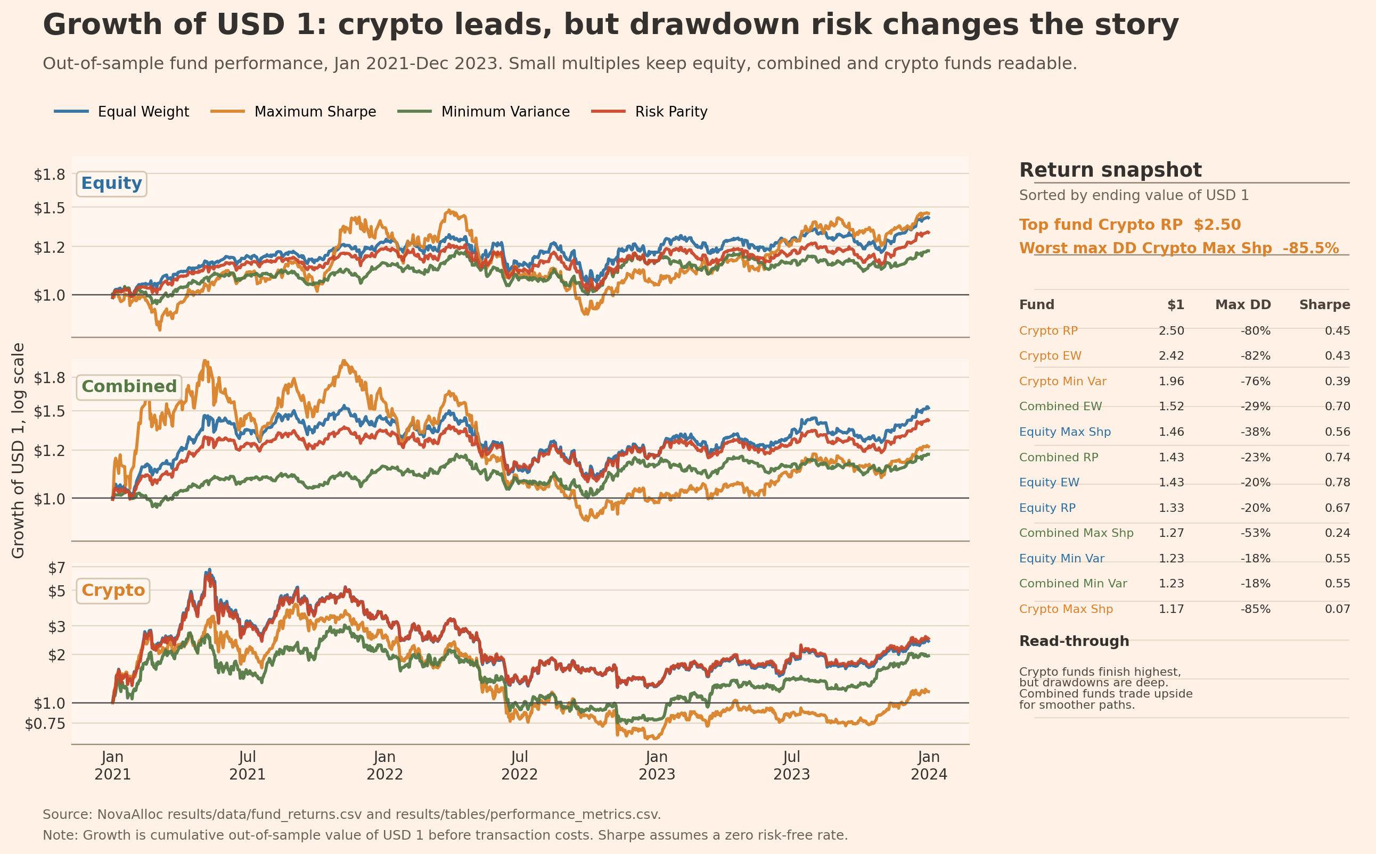
Figure 1. Growth of USD 1 for NovaAlloc funds, out-of-sample period 2021-2023. The redesigned figure uses Equity, Combined, and Crypto small multiples plus a return snapshot sorted by ending value of USD 1.
Figure 1 turns Table 1 into a path that an investor can understand. Crypto Risk Parity and Crypto Equal Weight finish highest, but their path is much more volatile. The small-multiple layout makes the lower-volatility equity and combined funds visible instead of letting crypto dominate the scale.
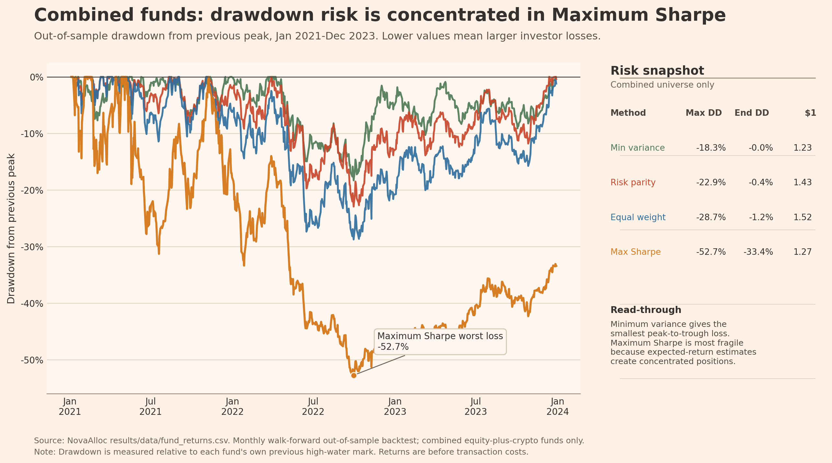
Figure 2. Drawdowns for combined equity-plus-crypto funds, out-of-sample period 2021-2023. The redesigned figure highlights maximum drawdown and reports a right-side risk snapshot for each combined method.
Figure 2 shows that the combined universe is not automatically safe. Combined Equal Weight has strong final growth, but its drawdown reaches about 29 percent. Minimum Variance limits the drawdown to about 18 percent, while Maximum Sharpe suffers the deepest loss because expected-return estimation creates a fragile allocation.
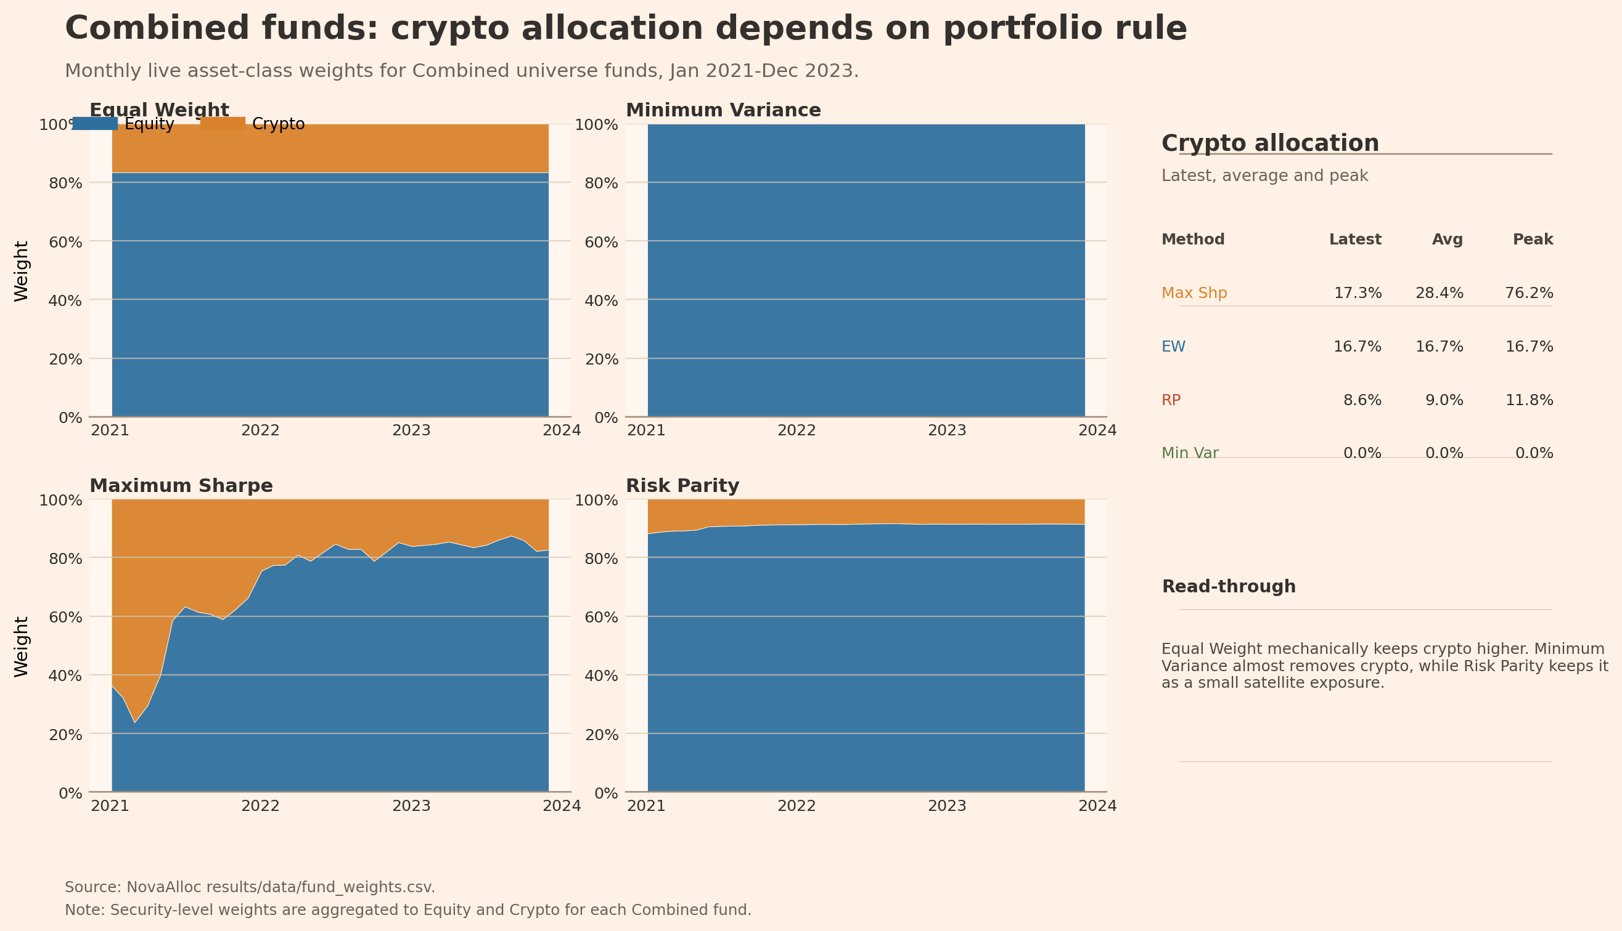
Figure 3. Combined funds' asset-class weights over time by method, 2021-2023. The redesigned figure compares Equity and Crypto buckets across all four combined-fund methods and reports a crypto-allocation snapshot.
Figure 3 links the risk result back to portfolio construction. Equal Weight mechanically keeps crypto higher. Minimum Variance almost removes crypto because crypto volatility dominates the covariance matrix. Risk Parity keeps crypto as a small satellite exposure, which explains why it is a credible balanced default rather than a pure return-chasing strategy.
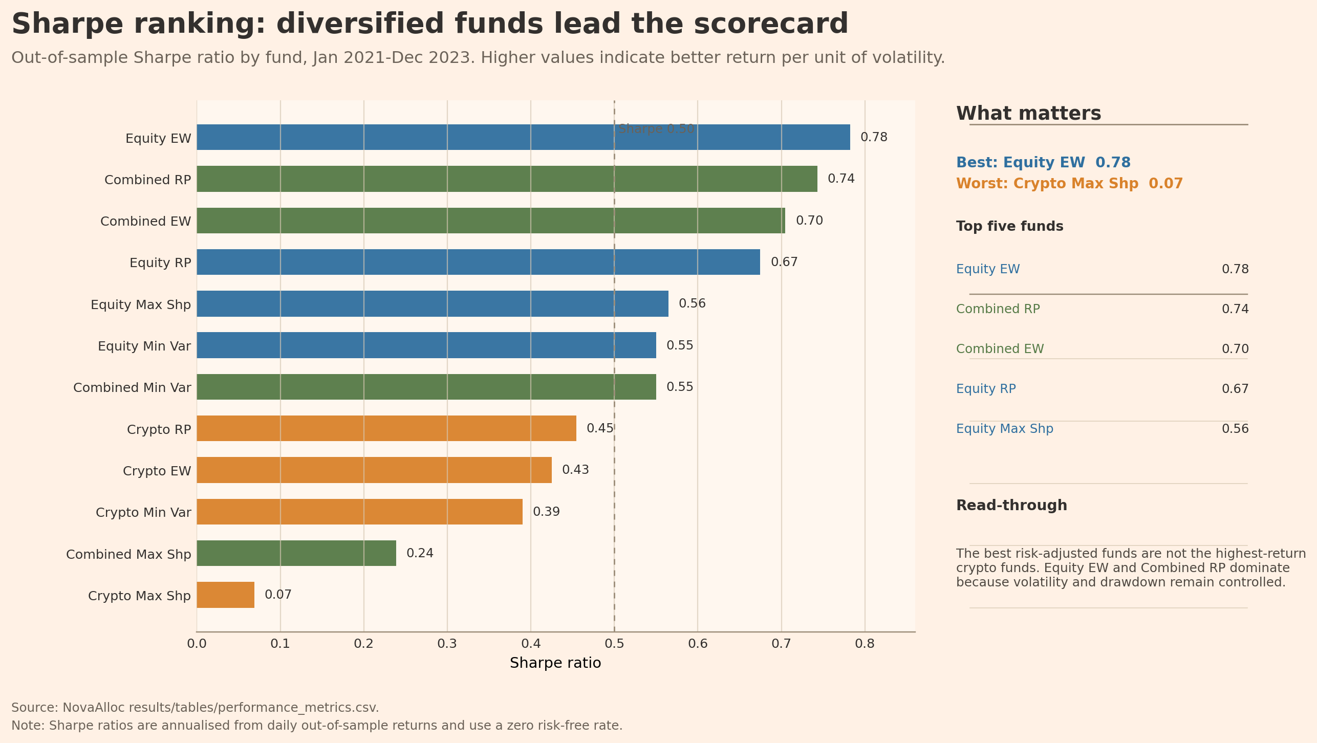
Figure 4. Sharpe ratios across funds and methods, out-of-sample period 2021-2023. The redesigned ranking highlights the best and worst funds and reports the top-five Sharpe results in a side panel.
Figures 4 and 5 close the fund comparison. Figure 4 shows that Equal Weight and Risk Parity are stronger out-of-sample baselines than the estimated Maximum Sharpe optimiser in this sample. This result is economically plausible because Maximum Sharpe relies heavily on noisy expected returns, while Equal Weight and Risk Parity depend more on robust diversification rules.
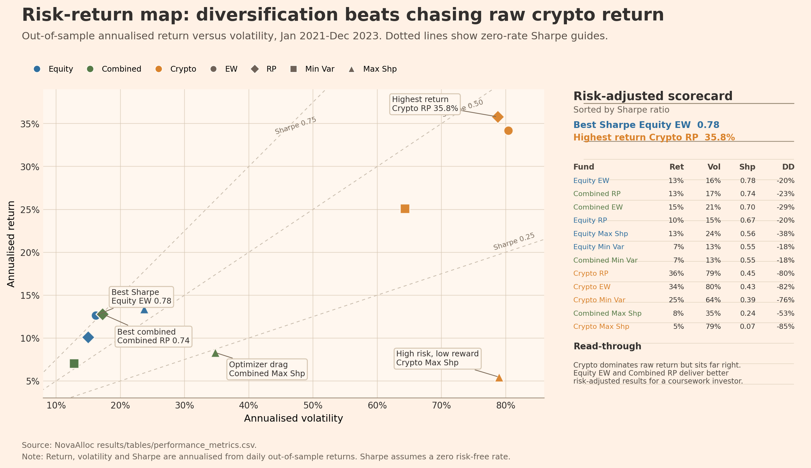
Figure 5. Risk-return map for all NovaAlloc funds, 2021-2023. Annualised return is plotted against annualised volatility, with dotted zero-rate Sharpe guide lines.
Figure 5 explains why the Sharpe result is not simply a ranking of returns. Crypto Risk Parity has the highest raw annualised return, but it sits far to the right of the chart and carries very deep drawdown risk. Equity Equal Weight and Combined Risk Parity are more useful product candidates because they convert risk into return more consistently.

3. Fund fact-sheet interpretation
A fund fact sheet converts the model evidence into a user decision. The app therefore reports growth of USD 1, drawdown, annualised return, annualised volatility, Sharpe ratio, and current holdings for each fund. Table 2 selects representative funds using the evidence from Table 1 and Figures 1-4: the best overall Sharpe fund, the best combined Sharpe fund, and the defensive combined minimum-variance fund.
Table 2. Representative fund fact-sheet metrics. These rows summarise the investor-facing facts shown in the Streamlit fund pages.
Fund | Universe | Method | Ann. return | Ann. vol. | Sharpe | Max drawdown | Growth
Equity - Equal Weight | Equity | Equal Weight | 12.6% | 16.2% | 0.78 | -20.3% | 1.43
Combined - Risk Parity | Combined | Risk Parity | 12.8% | 17.2% | 0.74 | -22.9% | 1.43
Combined - Minimum Variance | Combined | Minimum Variance | 7.0% | 12.8% | 0.55 | -18.3% | 1.23

The fact-sheet evidence supports a product menu rather than a single winner. Equity equal weight is the best risk-adjusted historical fund, combined risk parity is the most defensible default for a multi-asset product, and combined minimum variance is useful for a more defensive user. This prepares the next part of the report. Once the user can choose between funds, the app needs a market-context layer that explains whether recent equity news is unusually fearful or greedy.

4. Sentiment index
The sentiment model scores the assembled headlines with NLTK VADER plus a small finance lexicon extension. This is not the full finVADER package; it is a controlled extension inspired by the course material. Positive finance words such as upgrade, buyback, beat, and tailwind receive positive valence, while terms such as downgrade, impairment, insolvency, and headwind receive negative valence. I do not add accounting category words such as debt, tax, cost, or liability as automatically negative, because the Week 8 material warns that general dictionaries can misread ordinary financial vocabulary as sentiment. The VADER compound score is mapped from [-1, 1] to a 0-100 fear/greed scale. The sector index then equal-weights ticker-days within each sector. Ticker-days with no headlines are dropped rather than treated as neutral, because no news is missing information, not neutral information. For trading use, the report relies on lagged live z-scores, so the signal uses only prior sector sentiment.
Table 3. Sector sentiment summary, 2020-2023. Score is the 0-100 fear/greed index; coverage is the average share of sector tickers with at least one headline on a sector-day.
Sector | Obs. | Mean score | Min | Max | Mean coverage | Headlines
Utilities | 962 | 59.9 | 30.9 | 90.4 | 62.0% | 6,319
RealEstate | 940 | 57.3 | 18.8 | 88.9 | 59.5% | 5,339
Tech | 1,006 | 56.5 | 28.6 | 79.1 | 86.5% | 26,632
Healthcare | 997 | 56.2 | 31.0 | 83.0 | 84.3% | 14,697
Energy | 996 | 56.2 | 33.0 | 79.3 | 85.3% | 19,365
Industrials | 998 | 55.9 | 36.9 | 77.5 | 75.8% | 13,156

Table 3 checks the sentiment data before the time-series figures are interpreted. Average sector scores are above 50 in every high-coverage sector reported here, which means the news stream is mildly positive on average. Figures 6 and 7 separate two questions: whether sentiment moves through time, and which sectors have the highest average tone.
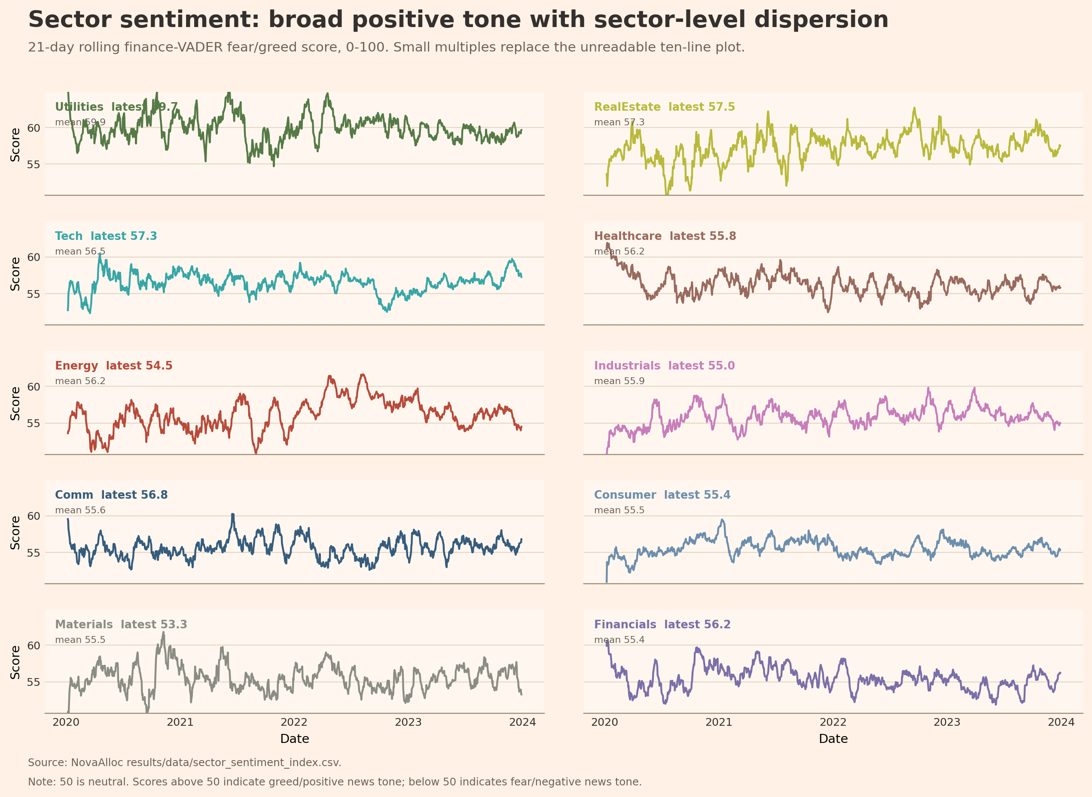
Figure 6. Sector fear/greed sentiment index over time, 2020-2023. The redesigned figure uses sector small multiples to show 21-day rolling 0-100 scores without a crowded ten-line legend.
Figure 6 shows why the sector index belongs in the app even before it is used for trading. Sentiment changes over time and sectors do not move identically. The index should not be sold as a clean return predictor because headlines are short and noisy, but it is useful context for interpreting investor mood and sector-specific news pressure.
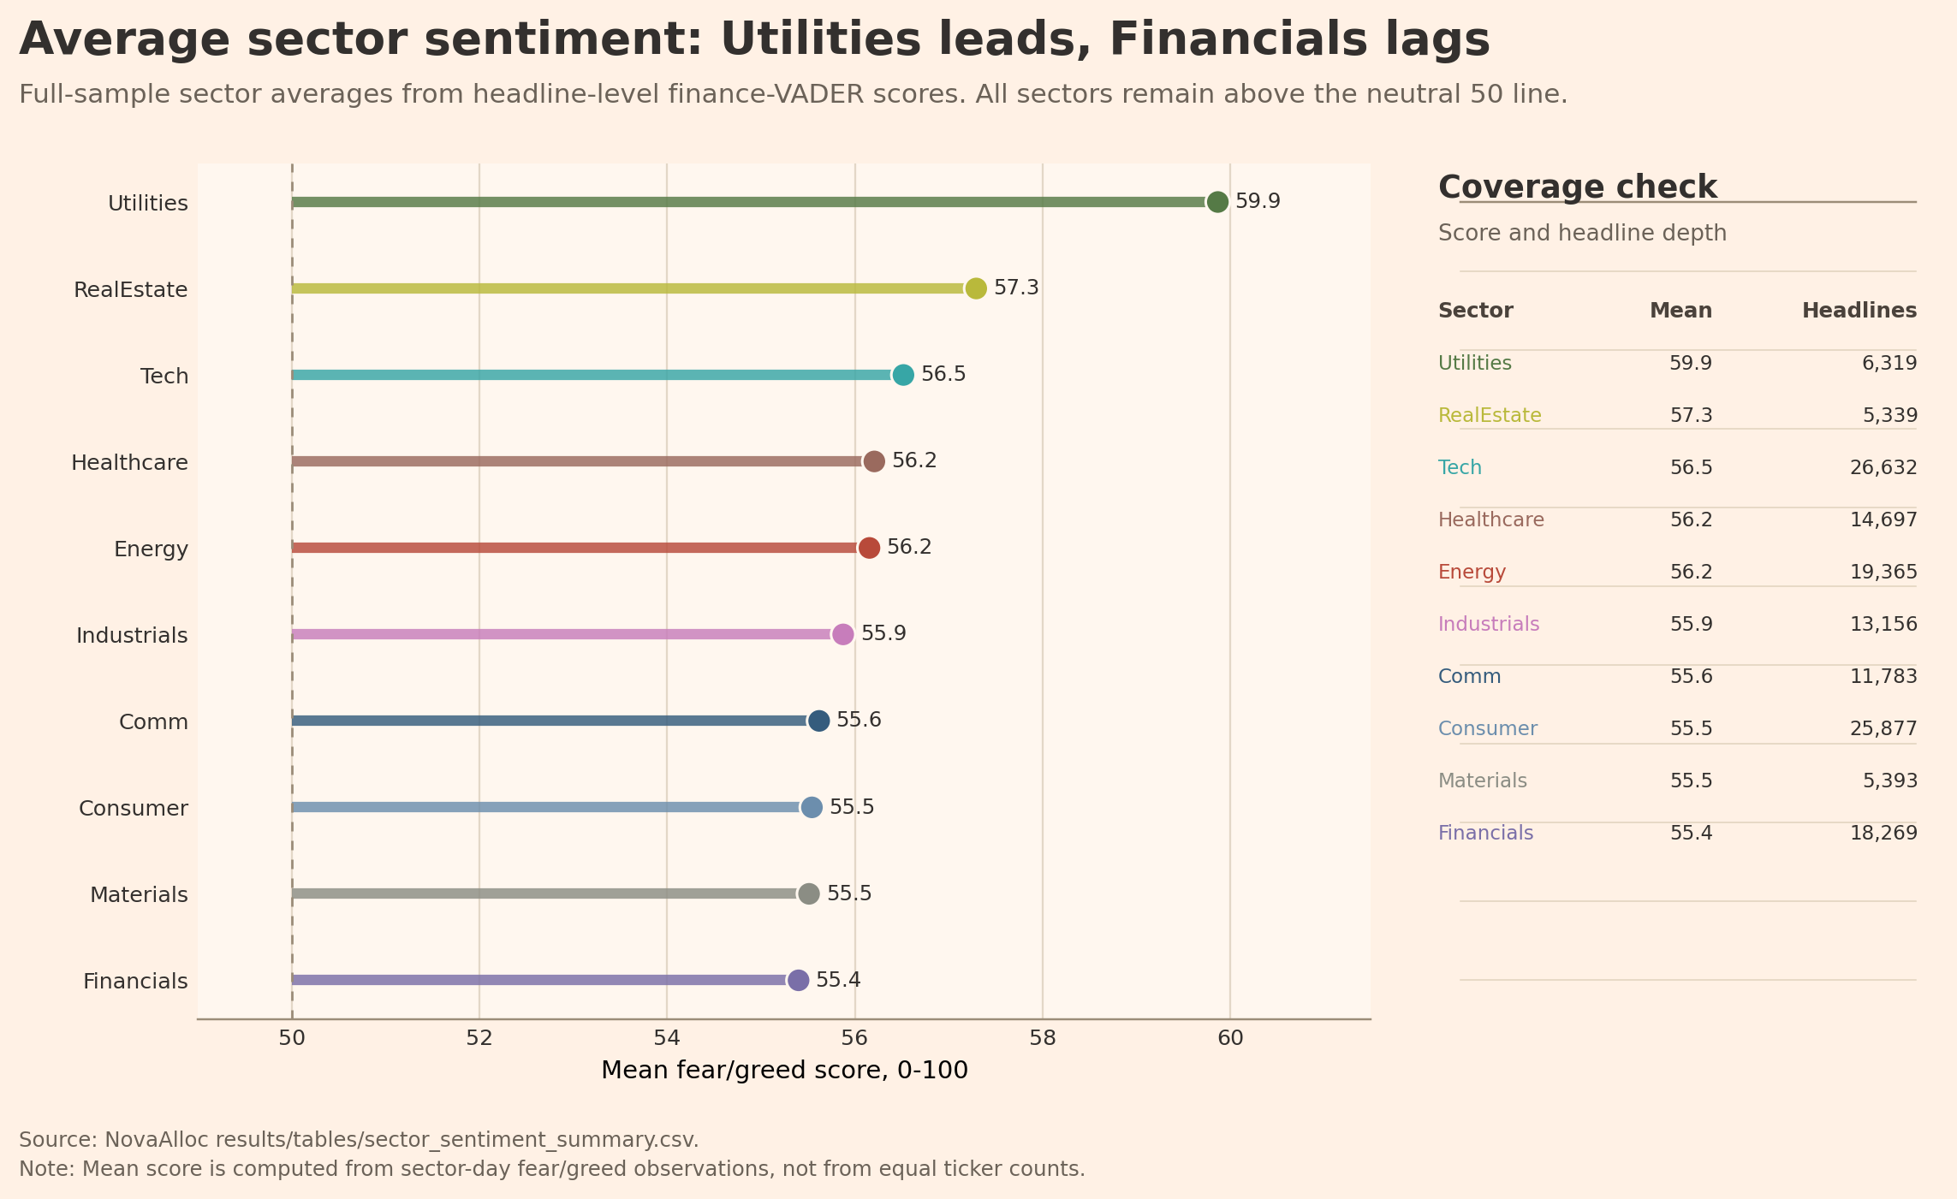
Figure 7. Average sector fear/greed ranking, 2020-2023. The redesigned ranking compares full-sample sector sentiment averages and headline coverage.
Figure 7 makes the cross-sectional sentiment result easier to read. Utilities, Real Estate and Technology have the highest average fear/greed scores, while Financials is the lowest among the reported sectors. This ranking is descriptive evidence, not a trading signal by itself, because the portfolio overlay must use lagged sector signals.
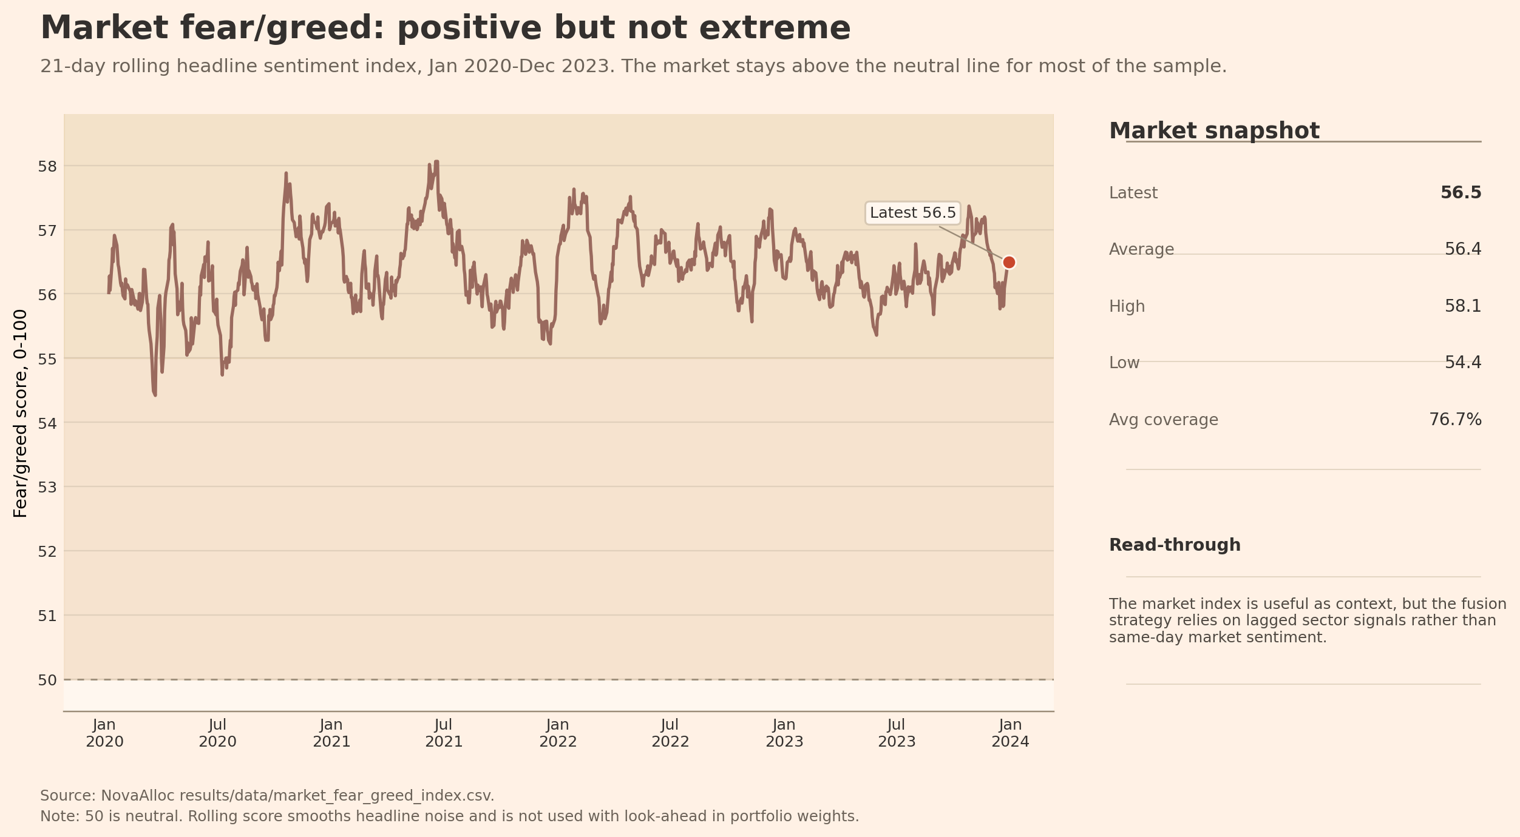
Figure 8. Market-level news fear/greed index, 2020-2023. The redesigned figure shows the 21-day rolling market index, the neutral 50 line, and a right-side market snapshot.
Figure 8 gives the user a simpler market fear/greed reading across 1,006 trading days from 2020-01-02 to 2023-12-29. The market index is useful because the app user can compare fund performance with the tone of recent equity news. At the same time, the market index is deliberately not used as a same-day trading signal, because that would create look-ahead risk.

5. Fusion extension
The fusion extension connects the sentiment evidence to the portfolio evidence. The test starts from the Equity Minimum Variance fund because it is a defensive, transparent base. Each month, the fund weights are nudged toward sectors with better-than-usual lagged sentiment z-scores and away from sectors with weaker lagged sentiment. The tilt strength is fixed at 0.15, the z-score is clipped, the portfolio remains long-only, and weights are renormalised to sum to one. This keeps the test disciplined rather than tuned after seeing the result.
Table 4. Fusion before-vs-after comparison for the equity minimum-variance base fund and the sentiment-tilted fund, 2021-2023.
Model | Fund | Ann. return | Ann. vol. | Sharpe | Max drawdown | Growth | Delta Sharpe
Base | Equity - Minimum Variance | 7.0% | 12.8% | 0.55 | -18.3% | 1.23 | 0.000
Sentiment Tilt | Equity - Minimum Variance Sentiment Tilt | 6.2% | 12.8% | 0.48 | -17.9% | 1.20 | -0.068

Table 4 gives the main result: the sentiment tilt reduces annualised return from 7.0% to 6.2% and reduces Sharpe from 0.550 to 0.482. Maximum drawdown improves slightly from -18.3% to -17.9%, but the smaller drawdown is not enough to offset the lower return. The diagnostic check reports zero lag violations, a mean absolute weight change of about 0.17 percentage points, and a maximum absolute weight change of about 4.9 percentage points. This means the test is not look-ahead biased and the tilt is economically modest. Figures 9 and 10 then show whether these table differences are visible in the return path.
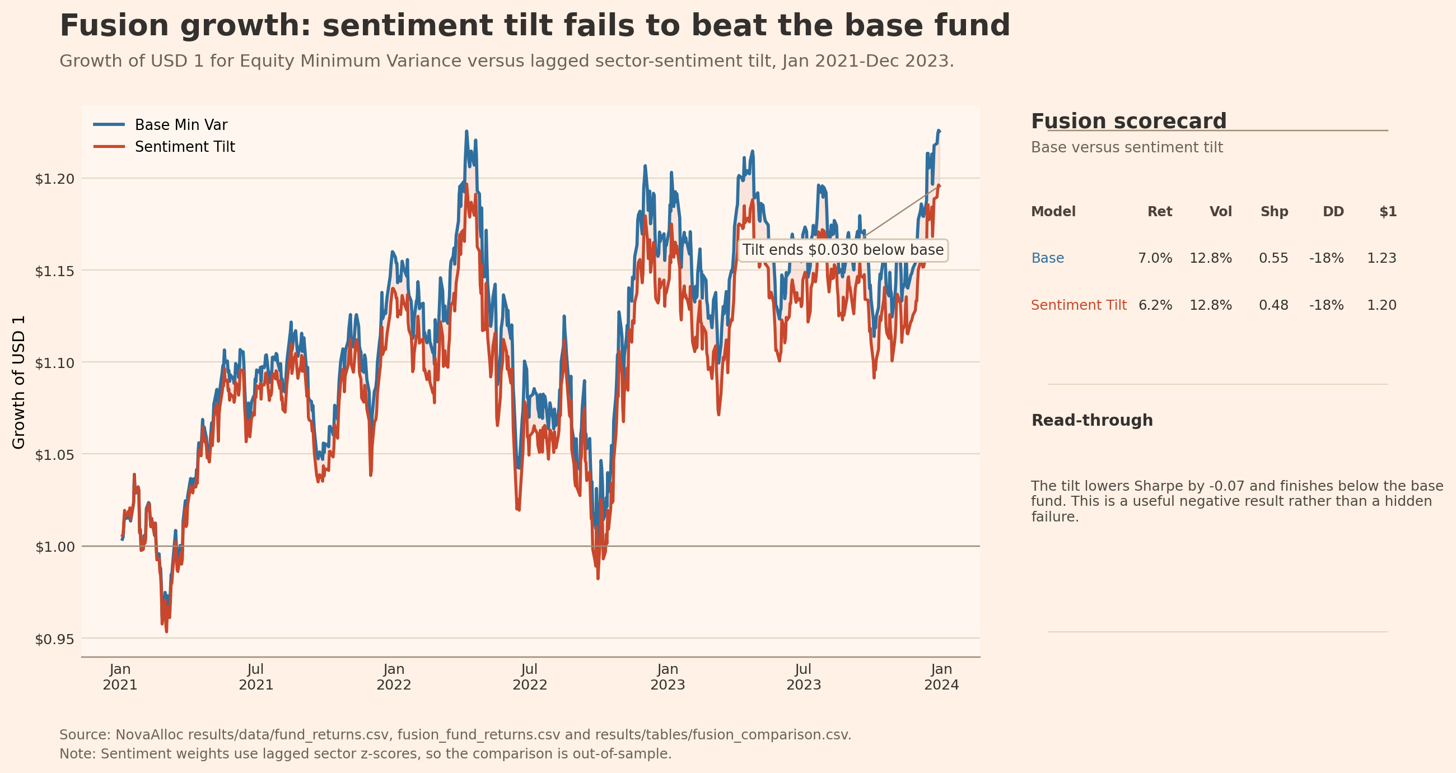
Figure 9. Fusion growth comparison: base equity minimum-variance fund versus sentiment tilt, 2021-2023. The redesigned figure highlights that the sentiment tilt finishes below the base fund.
Figure 9 shows that the sentiment tilt does not create a better growth path in this sample. The correct interpretation is not that sentiment has no value. The result says that this simple linear momentum tilt is not strong enough to market as alpha after it is made lagged and investable.
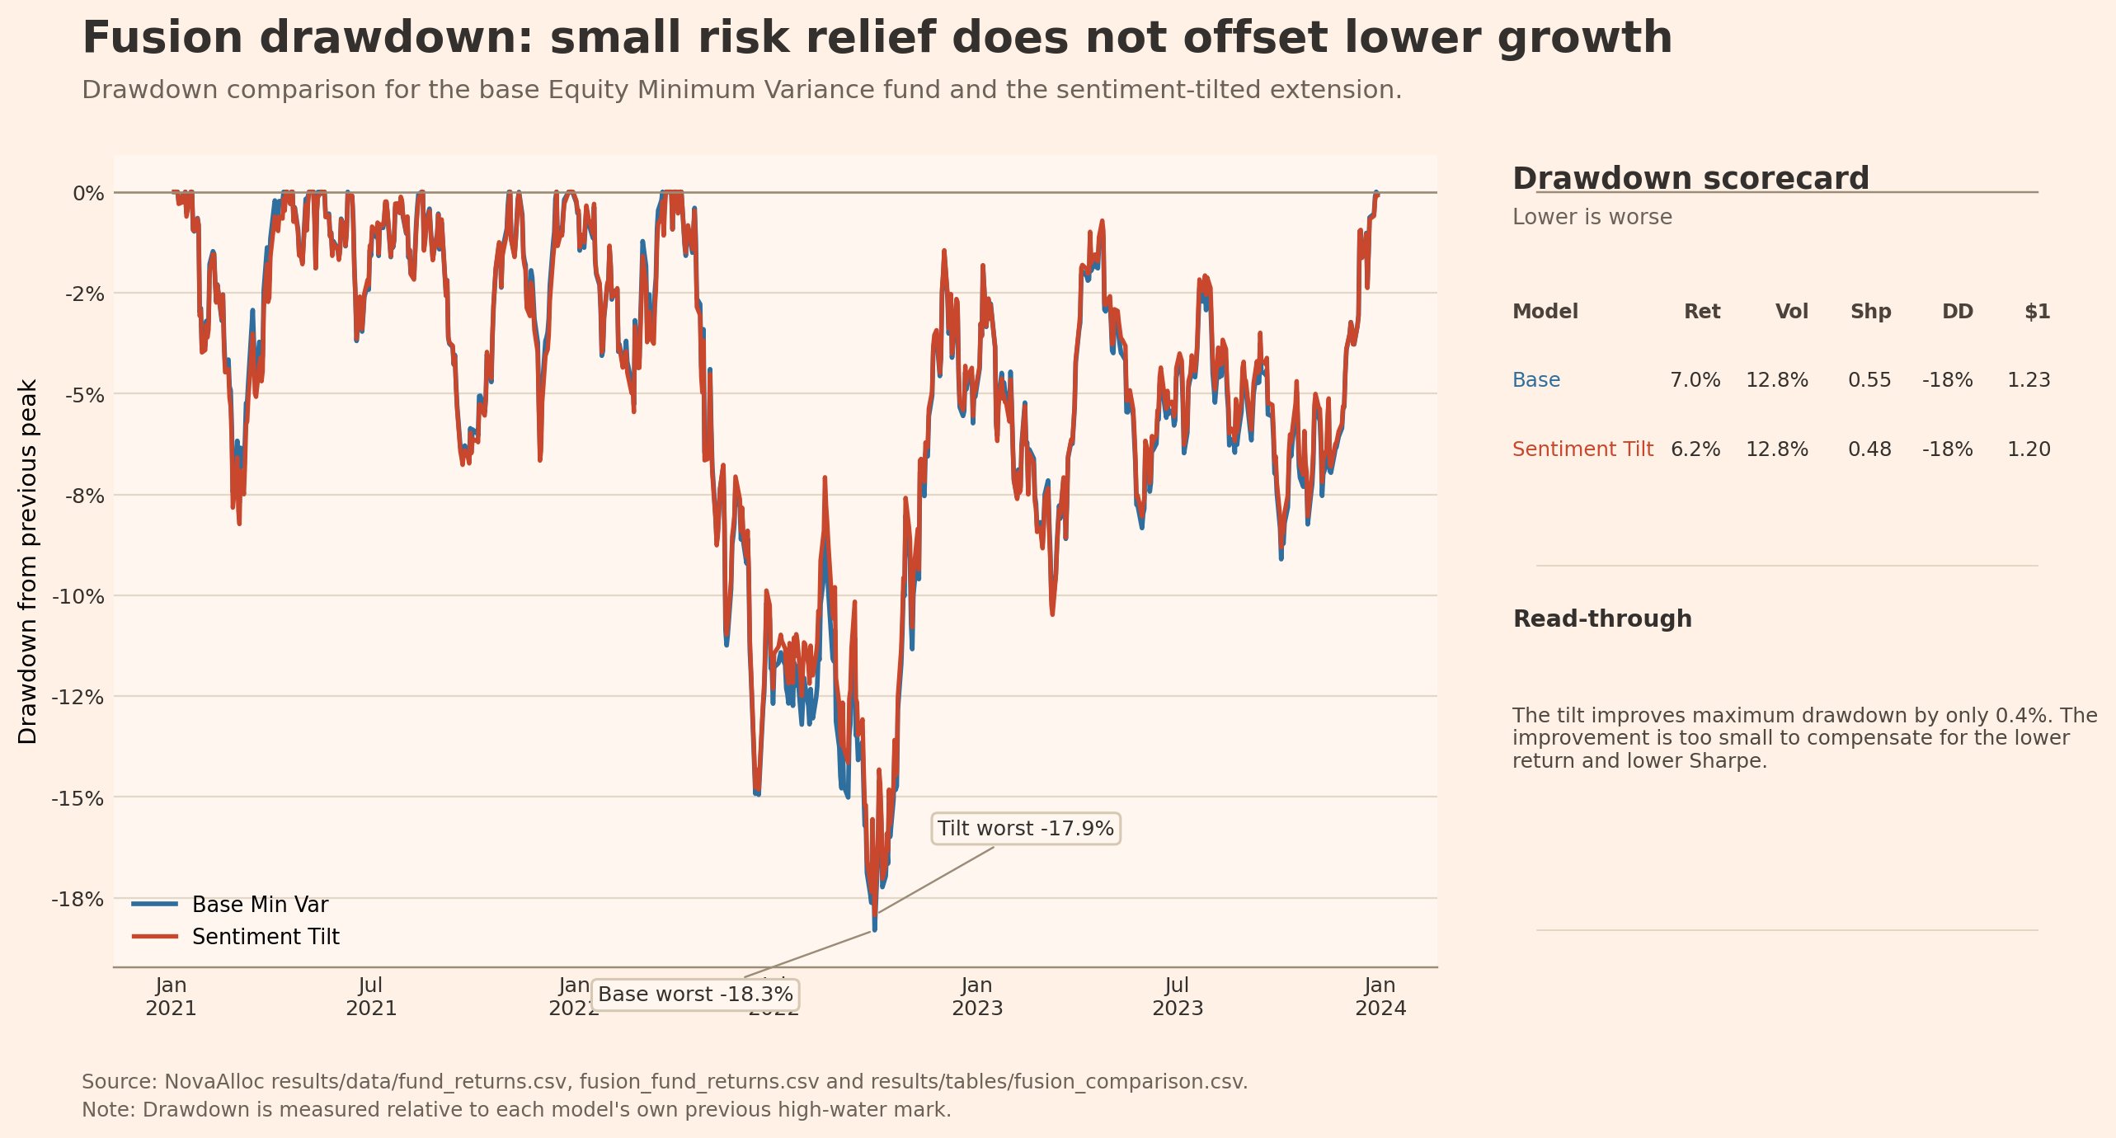
Figure 10. Fusion drawdown comparison: base equity minimum-variance fund versus sentiment tilt, 2021-2023. The redesigned figure shows the small drawdown improvement next to the lower-growth result.
Figure 10 shows a small drawdown benefit from the sentiment tilt. A risk-focused investor may value this direction, but the improvement is too small to justify the overlay without transaction costs, more validation, and tests over different market regimes. This is why the report treats sentiment as useful analytics first and as a trading overlay second.

6. App and investor journey
The Streamlit app is the implementation layer of the product. It runs from streamlit_app.py and reads precomputed artifacts from results/data and results/tables. This design follows the course requirement that the deployed app should stay light and should not recompute VADER sentiment or portfolio backtests at runtime. The app therefore turns the report evidence into an interface, rather than running the research pipeline again on each click.
Table 5. Required app-readable artifacts and their role in the NovaAlloc product.
Artifact | Size | App/report role
fund_returns.csv | 10,404 rows | Daily out-of-sample fund returns, growth of USD 1, and drawdown.
fund_weights.csv | 17,280 rows | Monthly live weights and turnover for each fund.
sector_sentiment_index.csv | 9,832 rows | Sector-level fear/greed scores, ticker coverage, and lagged signal columns.
performance_metrics.csv | 12 rows | Fund fact-sheet metrics across universes and methods.

The app journey follows the same order as the redesigned report. Overview starts with the product and the best fund evidence. Funds lets the user filter by universe and method, compare metrics, read a fund fact sheet, and inspect current holdings. Allocation explains portfolio weights. Sentiment shows the sector and market fear/greed views. Fusion reports the before-vs-after result. Data Health shows which precomputed files were loaded.
The design choice to move navigation into the sidebar is practical. Top tabs were harder to read on narrower screens, while the sidebar keeps the full investor journey visible. The app also includes a data health page and manifest files so that a marker can verify the required artifacts without searching through raw CSV files.
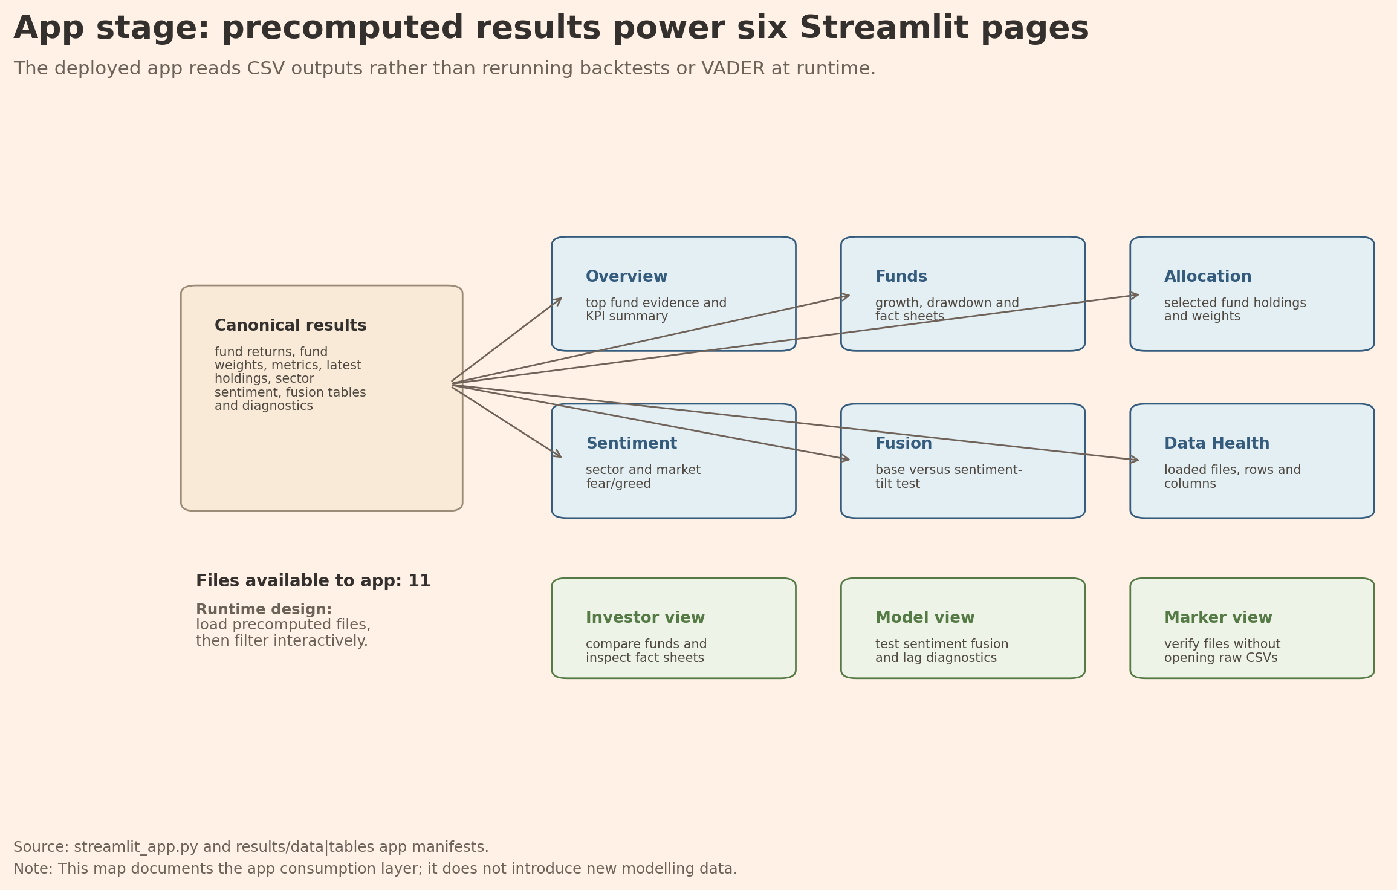
Figure 11. Streamlit app page-data map. The redesigned diagram shows how precomputed results feed the six app pages without rerunning backtests or VADER at runtime.
Figure 11 turns the app requirement into a clear product journey. It also documents the deployment logic: the app consumes precomputed results, which keeps the interface light and reduces the risk that a public deployment fails because of a long backtest or sentiment rebuild.
For final submission, the local app command is only a development check. The graded app artifact must be a live Streamlit Community Cloud URL deployed from the project root with streamlit_app.py as the entrypoint, and the GitHub repository must be public at hand-in. This report therefore treats deployment as part of the investor journey: the marker should be able to open the public app, compare funds, read fact sheets, set allocations, and inspect sentiment analytics without rerunning the research pipeline.

7. Innovation and limitations
NovaAlloc's contribution is not that it finds one perfect fund. Its contribution is a tested product design that goes beyond the minimum combined-fund requirement. The brief asks for a combined equity-plus-crypto fund with at least two methods; NovaAlloc instead builds 12 investable funds across equity-only, crypto-only, and combined universes using equal weight, minimum variance, maximum Sharpe, and risk parity. This wider fund menu matters because it separates product choice from model choice. A user can see that crypto funds have the highest final growth but extreme drawdowns, that maximum Sharpe is fragile when expected returns are noisy, and that Combined Risk Parity is a more balanced default. The contribution is therefore the choice architecture supported by Table 1 and Figures 1-5, not a claim that one optimiser is always best.
The second contribution is the treatment of news as a standalone sector analytics layer before it is used for trading. The sentiment model scores 146,830 equity headlines and turns them into sector fear/greed indices from 2020 to 2023. I use VADER with a small finance lexicon extension, but I do not treat general accounting words such as debt, cost, tax, or liability as automatically negative. This design choice responds to the finance-dictionary problem: a word can be financially relevant without being sentiment-bearing. The report also keeps crypto price-only because the data do not contain crypto headlines. This makes the sentiment index more credible as equity news context and avoids pretending that unobserved crypto sentiment exists.
The third contribution is the measured fusion test. The project does not stop at plotting sentiment; it converts lagged sector sentiment z-scores into a monthly long-only tilt on the equity minimum-variance fund. The tilt strength is fixed at 0.15 before evaluation, sector scores are lagged by at least one trading day, and the diagnostic table reports zero lag violations. The result is negative: Sharpe falls from 0.550 to 0.482 and final growth falls from 1.225 to 1.196, while maximum drawdown improves only slightly from -18.3% to -17.9%. This result is still useful because it rejects an easy marketing claim. In this sample, sentiment is more defensible as monitored context than as an automatic alpha overlay.
The fourth contribution is communication and implementation. The redesigned figure set is not only cosmetic: small multiples, side panels, and consistent source notes help the reader compare growth, drawdown, asset weights, sentiment, and fusion without searching across raw CSVs. The Streamlit app then uses the same evidence path as the report. It reads precomputed results, opens fund fact sheets, lets the user set a hypothetical allocation, displays sector sentiment, and exposes data-health checks. This design keeps the public app light and reproducible. It also turns the analysis from a notebook-style backtest into a product prototype that a marker can inspect through a user journey.
These contributions have clear limits. The out-of-sample window, 2021-2023, includes unusual crypto cycles, inflation shocks, and rising rates, so the ranking may not hold in calmer markets. Transaction costs and taxes are not deducted, which matters for high-turnover maximum-Sharpe funds. The finance lexicon is deliberately small and should be benchmarked against finVADER or another finance-specific model before production use. The fusion test uses one base fund and one tilt strength, so it is a first controlled experiment rather than a final signal. These limits lower the commercial readiness of NovaAlloc, but they also make the evidence honest: the project shows what the current data support and what they do not support.

8. Critical reflection and recommendations
The strongest result is a product lesson rather than a pure return lesson. Crypto Risk Parity and Crypto Equal Weight finish with the highest growth, but their drawdowns are above 80%, which makes them difficult to present as core funds for a normal retail investor. Maximum Sharpe also looks less reliable than its name suggests because it depends on expected-return estimates that are unstable in a short and volatile sample. The more defensible message is that simple diversification rules survive the out-of-sample test better than estimation-heavy rules. For that reason, Combined Risk Parity is the best default product even though it is not the highest-return fund.
The weak sentiment-fusion result is also economically informative. The problem is not just that VADER is noisy. The deeper issue is a timing mismatch between daily headline tone and monthly portfolio allocation. A sector may have positive news coverage without earning stronger next-month returns, and sector-level averaging can dilute firm-specific news. The base minimum-variance fund is already defensive, so a small sentiment tilt has limited room to improve drawdown. Coverage also varies across sectors, which means the same sentiment score may not carry the same information everywhere. The negative result therefore does not make the sentiment index useless. It means the current signal should support interpretation and monitoring before it is sold as a return-enhancing rule.
Recommendation 1: launch Combined Risk Parity as the default balanced fund and frame crypto-only funds as satellite exposures, not core products. Combined Risk Parity earns a 12.8% annualised return with 17.2% volatility and a 0.74 Sharpe ratio, while avoiding the extreme drawdowns of pure crypto funds. The app should present this fund first for balanced users, then allow investors to choose Combined Equal Weight for higher growth or crypto-only funds for high-risk exposure. The fact sheet should show maximum drawdown and turnover beside return, because those measures prevent the user from choosing funds only by final growth.
Recommendation 2: keep sentiment analytics in the product, but require a stricter validation rule before using sentiment for live allocation. The next version should predefine the base fund, rebalance timing, tilt strength, z-score window, transaction-cost assumption, and success criteria before running the test. A trading overlay should only be promoted if it improves Sharpe or drawdown in rolling out-of-sample tests and remains useful after costs. The next model should also compare the small lexicon extension with a full finance lexicon and test whether the signal works better for specific sectors, regimes, or shorter holding periods.
Recommendation 3: build a governance process around every monthly rebuild and every public deployment. Before the app is refreshed, the owner should check that raw data still load only through data_access, required results files exist, portfolio weights sum to one, sentiment variables are lagged, and no look-ahead violations are reported. Before submission or release, the owner should confirm that the GitHub repository is public, the Streamlit URL opens in a logged-out browser, the app reads precomputed artifacts, and report/report.pdf has been exported from Word. This governance process is not administrative only. It controls the main model risks in the project: stale data, accidental look-ahead, missing artifacts, and a local app being mistaken for a deployed product.
The commercial boundary should also be clear. NovaAlloc is a coursework prototype, not personalised financial advice. A real version would need transaction-cost modelling, investor suitability controls, clearer risk labels, and a compliance review before accepting client money. This boundary does not weaken the report; it prevents overclaiming. The project is most credible when it presents the funds, sentiment index, and fusion result as tested evidence, then states what still has to be proven before the product becomes investable.

9. Conclusion
NovaAlloc meets the Part B task by turning the Part A data foundation into out-of-sample funds, standalone news-sentiment analytics, a tested sentiment fusion extension, and a Streamlit product. The report's main result is practical: diversified simple methods are more reliable than the estimation-heavy maximum-Sharpe optimiser in this sample, while sentiment is useful as market context but not yet strong enough as an automatic allocation overlay. The product should therefore lead with transparent fund comparison, keep sentiment visible, and treat the first fusion result as a disciplined test that guides future improvement.

Appendix A. Required exhibit checklist
Appendix Table A1. Mapping between Project B required exhibits and this report.
Course required exhibit | Where included
Performance metrics table across funds and methods | Table 1
Growth of USD 1 figure comparing methods | Figure 1
Drawdown figure for at least one fund | Figure 2 and Figure 10
Portfolio weights over time figure | Figure 3
Sharpe or return-vs-risk barplot | Figure 4 and Figure 5
Sentiment-index time series for equity sectors | Figure 6
Fusion before-vs-after table and figure | Table 4, Figure 9, and Figure 10
Sector sentiment ranking and coverage | Table 3 and Figure 7
App journey and precomputed-data map | Table 5 and Figure 11
Workflow and reproducibility diagram | Appendix Figure A1

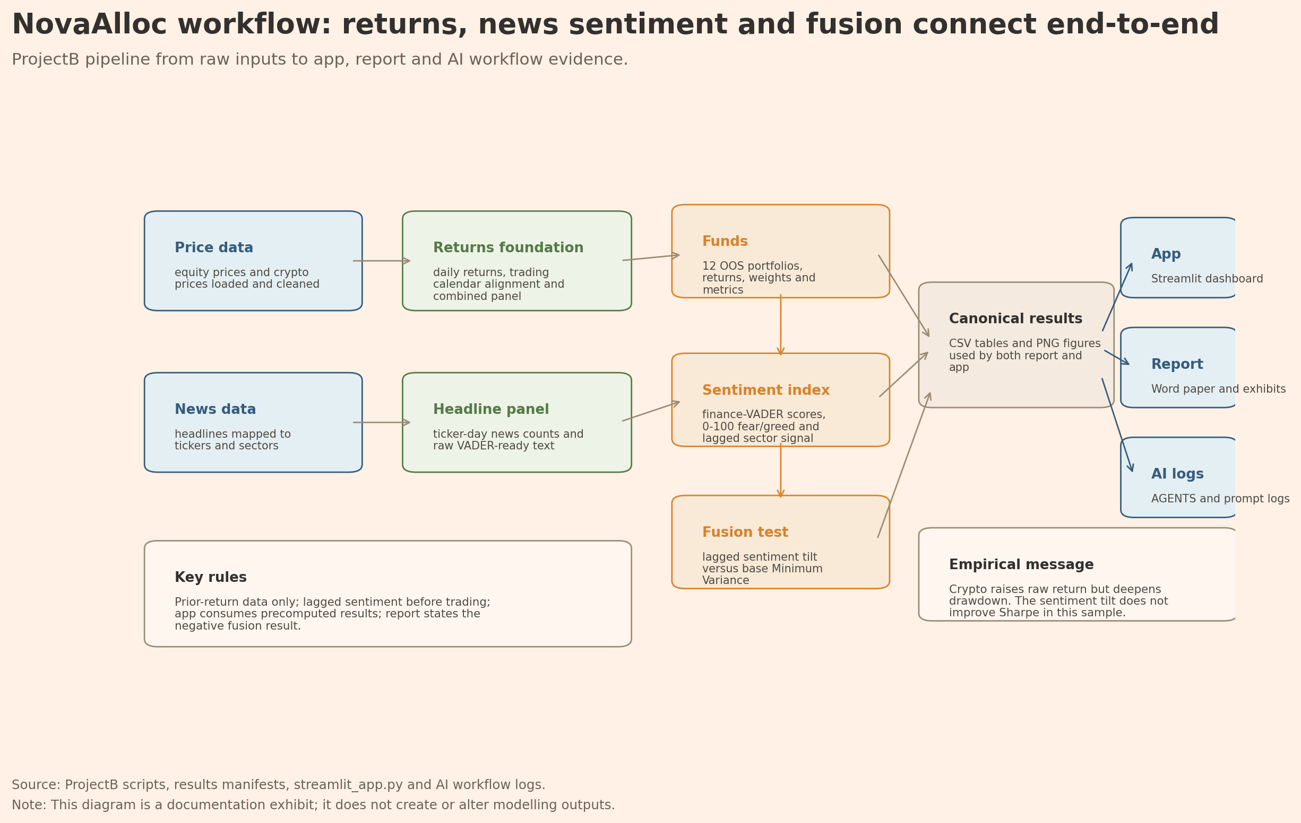
Appendix Figure A1. NovaAlloc ProjectB workflow and data-flow map. The diagram summarises how raw price/news inputs flow into returns, funds, sentiment, fusion, app, report, and AI workflow evidence.
Appendix Figure A1 is included as reproducibility support rather than as a new modelling result. It helps explain how the report, Streamlit app, and AI logs all use the same canonical results files.

Appendix B. Reproducibility notes
The main reproduction command is run from the project root:
..\..\.venv\Scripts\python.exe scripts\run_part_b.py
The local app command is:
..\..\.venv\Scripts\python.exe -m streamlit run streamlit_app.py
The mechanical hand-in check is:
..\..\.venv\Scripts\python.exe scripts\check_handin.py
AI workflow evidence is stored in AGENTS.md and the numbered ai/ prompt logs, including ai/06_prompt_log_self_correction.md. The new 06 log is used for self-correction rather than generation: it records where AI-assisted work created risks or mismatches, such as Word encoding problems, image-count regression during report editing, the misleading Report Figures navigation page, and earlier ambiguity about localhost versus the public Streamlit deployment. The report and app are based on the precomputed results files listed in Table 5, while Appendix Figure A1 documents how the data foundation, portfolios, sentiment, fusion, app, report, and AI workflow checks connect.
Final hand-in still requires a manual Word export to report/report.pdf and a public deployment check in a logged-out browser. These steps cannot be proven by the local Word source alone, so they are listed explicitly in the AI logs and submission checklist rather than hidden as completed work.

References
FINS5545 Project Brief. Systematic Multi-Asset Funds with News-Sentiment Analytics. Provided in course_requirements/project_brief_FINS5545.pdf and PROJECT_BRIEF.md. Project data bundle described in the course brief: equity prices, crypto prices, and news headlines, 2020-2023. Accessed through src/data_access.py.
FINS5545 Week 7 Financial News, Week 8 VADER, Week 9 Fear and Greed, and Week 10 Revision materials. Provided in course_requirements/. Sentiment method background: Hutto and Gilbert (2014) on VADER; Loughran and McDonald (2011) on finance dictionary bias; Baker and Wurgler (2007) and Tetlock (2007) on investor sentiment and media tone.
Portfolio method background: Markowitz (1952) on mean-variance portfolio selection; Sharpe (1966) on risk-adjusted performance; Maillard, Roncalli and Teiletche (2010) on risk parity; DeMiguel, Garlappi and Uppal (2009) on the strength of simple diversification benchmarks.

