Basics of database systems

**Project – Database design**

Lappeenranta-Lahti University of Technology LUT

Software Engineering

Basics of database systems

Spring 2023

Jongeun Park

Table of contents

Table of contents 1

1 Definition 2

2 modeling 4

2.1 Concept model 4

2.2 Relational model 5

3 database implementation 6

4 discussion 7

# Definition

**Book World database**

In project ‘Book World database,’ database is developed for a platform/game manager who manages a book share platform/game that users can make their own books, and take notes into them. Users can read other user’s books by making friendship. They should have each of their own house and can buy books from shop, even borrow books from library.

Within the database, the key points are User and Book information. the User information is stored in User table. It stores user ID, password and nickname. Users can make their own ID and password when they sign up to this platform. And they should set their own nickname, and house name when starting this game/platform. This information as well as friendship of each other is also stored in database. When they make books for taking notes, the book information is stored. The database stores book name that user should sets, book type that decides what type of this book is, and book ID. The database also stores the information of possession status between user and book.

The book information is related with many other information. For example, store sells books, so they have to have book’s information. In addition to that, library that manages books and lend them to users and review board that has a books list which show ranks, review also are related with book. Thus, the database should keep above information according to the relationship.

The following database queries have to be implemented: (1) List the information of a specific book ID, book name and book type. (2) List all books, their review and rank up to 10th place. (3) List all bookID, bookName, bookType and price that sold in store less than 10 price. (4) Show the nickname, bookname and book type according to the possession relation between user and book and order the information by user. (5) List the all users that have friendship with other users and order those by user

# modeling

## Concept model

In Figure 1 is the ER model of the designed database. There are six entities in the model and six relationships. There are two N:M relationships. First one is in between User and User which is recursive relationship. It represents friendship of each user. Second one is in between User and Book that shows possession relation between users and books. Books must have at least one user because only user can make books. There is also a one-to-one relationship in between User and House. User can have only one house and the same is true of the opposite. There are also three one-to-many relationships. First one is in between Book and Library. Library manages books according to their topics. It can have relationships with many books but books are only managed with one library. Second one is in between Book and Review board. Books can be on the Review board with review and ranking. The last one is in between Book and Store. The store sells books according to the price. The Manages relationship has a multivalued attribute ‘Topic’ that may be reduced to a single value, an additional relation to accommodate multiple values. The OnBoard relationship may be a new additional relation although it is a one-to-many relationship. Because, not all books are on the review board. The review board only shows top 100 ranking of books. So if it isn’t made to additional relation, there can be many null values in book information.

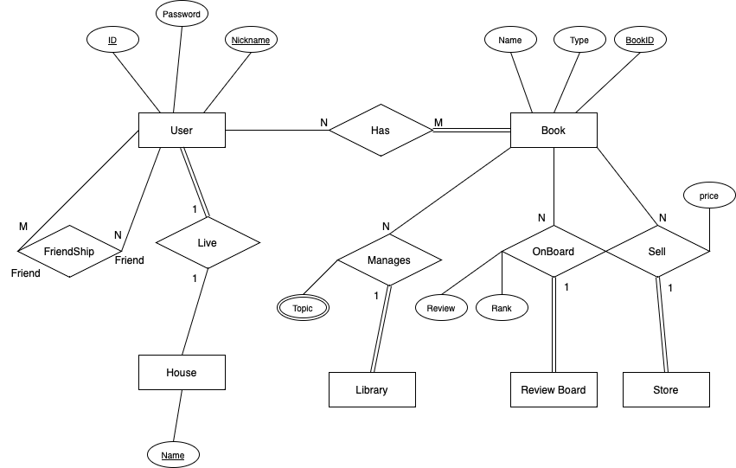

­­­­

**Figure 1:** ER model

## Relational model

Figure 2 shows the relational model that has been created based on the ER model. Due to the N:M relationship, two linking relations were created. First thing is ‘Has’ relation that was created between User and Book entities. Second one is ‘Friendship’ relation that shows recursive relationship of each user. Additionally, the multivalued attribute ‘BookTopic’was separated into an additional entity, which shows the possession relationship between books and library. Finally, there is a new linking relation called ‘OnBoard’. Though it is a one-to-many relationship, not all books are on the review board because the review board only shows top 100 ranking of books. Thus, it has to be made to prevent to make many null values in book information.

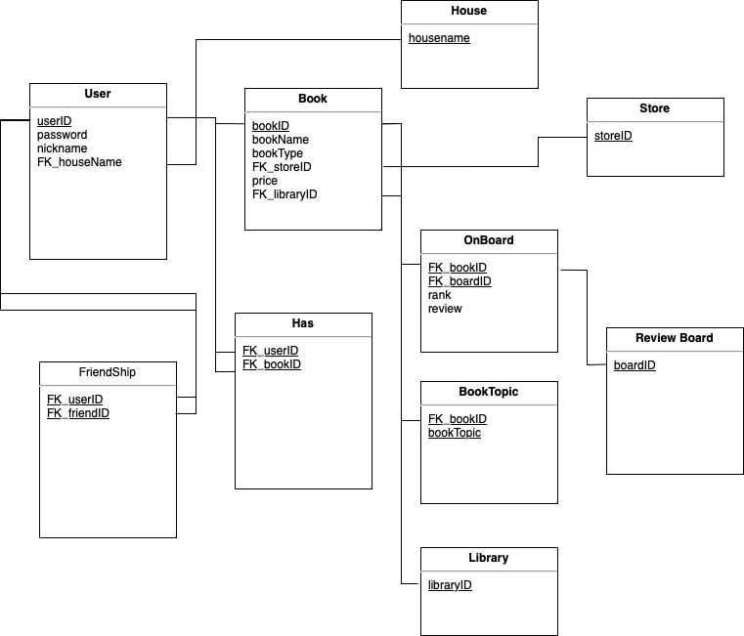

**Figure 2:** Relational modelfrom the ER model

# Database implementation

During implementation, the following constraints are created for the relations:

* **Book**:
  + Book type and Book name cannot be null (NOT NULL)
  + Unique key of bookname so that user doesn’t make same book name
  + FK_storeID and FK_library defaults to 1(DEFAULT)
  + Foreign key reference to store and library.
  + ON UPDATE CASCADE
  + ON DELETE SET DEFAULT
* **BookTopic**:
  + Foreign key reference to book.
  + ON UPDATE CASCADE
* **FriendShip**:
  + Foreign key reference to user
  + ON UPDATE CASCADE
* **Has**:
  + Foreign key reference to user and book
  + ON UPDATE CASCADE
* **OnBoard**:
  + Foreign key reference to book and review board.
  + Unique key of rank to prevent duplicate rank
  + FK_boardID defaults to 1(DEFAULT)
  + ON UPDATE CASCADE
  + ON DELETE SET DEFAULT
* **User**:
  + Unique key of nickname to prevent duplicate name
  + Foreign key reference to house.
  + ON UPDATE CASCADE
* **Store**:
  + Primary key to storeID
* **ReviewBoard**:
  + Primary key to boardID
* **Library**:
  + Primary key to libraryID
* **House**:
  + Primary key to housename

In addition to the integrity constraints listed above, the database will also implement two indices; One based on the Book name, another based on the house name. These indices are to allow quickly search book that has specific name for library as well as to search for user that want to find their friend’s house .

# discussion

Nothing to discuss.