3.11

/*评：其实可以直接takes与course natural join而不是与section，毕竟都有course_id*/

a.

**select** distinct student.name

**from** ~~student natural join takes natural join section,course~~

**where** section.course_id = course.course_id and course.dept_name='Comp. Sci.'

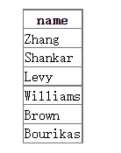

b.

select ID,name

from student ~~natural join takes~~  /*评：此处不需要natural join takes，只需要选所有学生，毕竟后面才是限制*/

except

select ID,name

from student natural join takes

where year<2009

c.

select dept_name,max(salary)

from instructor

group by dept_name

d.

with max_salary_dept(dept_name,max_sal) as 【别忘记with创表时标明名字】

(select dept_name,max(salary) as max_sal 【此时下面就不用重命名】

from instructor

group by dept_name)

select min(max_sal)

~~from max_salary_dept natural join department 【复杂了】~~

3.12

1.Insert into course

Values(“CS-001”,’Weekly Seminar’, ‘Comp. Sci.’, 0)

b.

insert into section

values(‘CS-001’, 1, ‘Autumn’, 2009, null, null, null)

c.

insert into takes

(select ID, ‘CS-001’, 1, ‘Autumn’, 2009, null

From student

Where dept_name = ‘Comp. Sci.’)

c. 【这里很严重，where必须出来】

delete from takes

select student.ID, course_id, sec_id, semester, year, grade

from student natural join takes

where name = ‘Chavez’

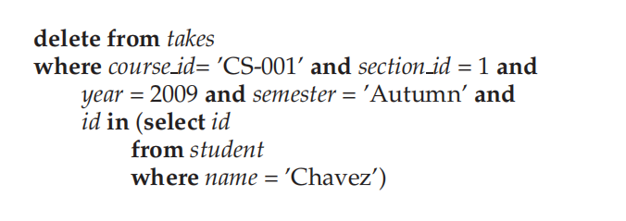

e.【删这门课，就要删掉所有与之相关的地方，还得注意顺序！！！】

Delete from course

Where course_id = ‘CS-001’

f.【此处lower必须写上】

delete from takes

where course_id in (

select course_id

from course

where lower(title) like ‘%database%’)

3.13

Create table person(

Driver_id char(7),

Name varchar(20),

Address varchar(20),

Primary key(driver_id))

Create table car(

license varchar(7),

model varchar(7),

year numeric(4,0),

Primary key(license))

3.14

a.

Select count(*)

From person natural join participated

Where name = ‘John Smith’

b.

update participated

set damage_count=3000

where license =’AABB2000’ and report_number=’AR2197’

3.15

//思路基本正确，但还需要打磨

Select *

From customer as T

Where not exists(

(Select account_number

From account

Where branch_name=’Brooklyn’)

Except

(select account_number

From account natural join depositor natural join (customer as S)

where T.customer_name = S.customer_name))

b.

select branch_name, sum(amounts)

from loan

group by branch_name

3.16

A【多余了】

select employee_name

from employee natural join works

where works.company_name = ‘First Bank Corporation’

b

select employee_name

from employee natural join works, company

where employee.city = company.city and works.company_name=company.company_name

c.

select T.employee_name【少加T可不行】

from employee as T natural join managers, employee as S

where managers.manager_name = S.employee_name

and T.city = S.city

and T.street = S.street

d:

with com_avg_salary(company_name, value) as

(select company_name, avg(salary)

From works

Group by company_name)

Select employee_name

From works natural join com_avg_salary

Where works.salary > com_avg_salary.value

E:

With tot_salary(company_name, value) as

(select company_name, sum(salary)

From works

Group by company_name)

Select company_name

From tot_salary

Where tot_salary.value <= all(

Select value

From tot_salary)

b.

update works as T

set salary = salary * 1.1

where company_name = ‘First xxx’ and

exists (

select *

from managers

where managers.manager_name = T.employee_name)

2.13