**Law of large numbers in Excel: Demo notes**

**Demo file: large-numbers.xlsx**

1. Simulate a roulette toss 500 times in Column B: RANDBETWEEN(0,36)
2. Take a running total in Column C: SUM($B$2:B2)
3. Take a running total in Column D: C2/A2
4. Plot Column D as a line chart. Press F9 to recalculate.
   1. The line converges to the expected mean due to the law of large numbers.

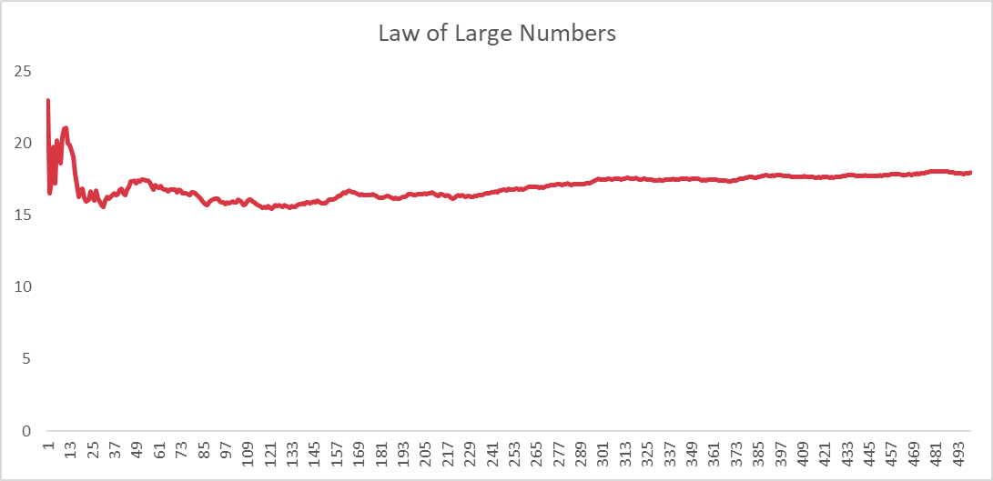

**Explanation:**

This is a visual depiction of the law of large numbers: the average of results obtained from trials become closer to the expected value as more trials are performed.

1. We can often see empirically that the sample gets more reflective of the expected value at a sample size of 30, 60 and 100.