MARGIN OF ERROR IN EXCEL – DEMO NOTES

Pollsters tend to report results with a “margin of error” that is assumed to be within 2-3%. What does this number mean, and why is it assumed to be 2-3%?

The margin of error is the range within which we expect to find our true population. Here is a good visualization [from Wikipedia](https://en.wikipedia.org/wiki/Margin_of_error). Notice the relationship between sample size and margin of error:

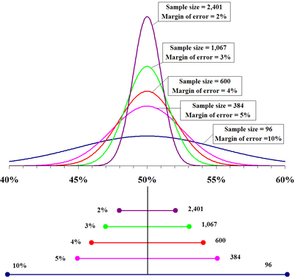

Our equation for the margin of error is

$$Margin of error=Z * \frac{σ}{\sqrt{n}}$$

Where

$$Z=critical value \\ σ=standard deviation \\ n=sample size \\ \frac{σ}{\sqrt{n}}=standard error$$

For the demonstration, fill out the below columns of the start worksheet using these formulas.

We will take a running mean and standard deviation of our samples, then compute the margin of error given using the above formula. This is for a two-tailed test at the 95% confidence interval.

**Demo file:** [**margin-of-error.xlsx**](https://github.com/summerofgeorge/blog-files/blob/master/margin-of-error.xlsx)

|  |  |  |
| --- | --- | --- |
| **Column position** | **Column label** | **Formula** |
| C | Sample mean | =AVERAGE($B$7:B8) |
| D | Standard deviation | =STDEV.S($B$7:C8) |
| E | Standard Error | =D8/SQRT(A8) |
| F | Critical value | =VLOOKUP(A8,critical_values,2,TRUE) |
| G | Margin of error | =F8*E8 |
| H | Margin of error as % of mean | =G8/C8/2 |

By default, Column H will be plotted as a line chart expressing the margin of error as a percent of the mean:

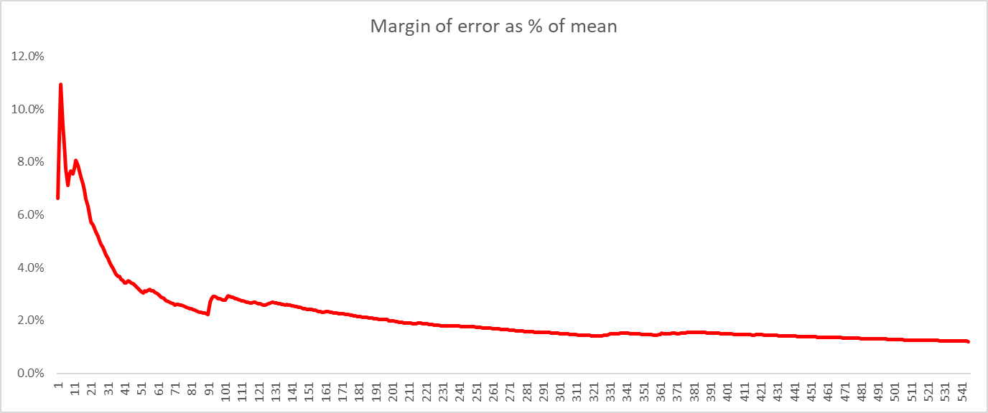

This expresses the amount of sampling error there is in the sample mean being reflective of the population. The margin of error dips significantly around n=30, n=60 and n=100. These are empirical results but are generally good rules of thumb as “good, better, best” sample sizes for conducting inferential statistics.