The Monty Hall problem in Excel: demo notes

Download the exercise file: monty-hall.xlsx

This thought experiment comes from the television show *Let’s Make a Deal!*

* Behind three doors randomly lie two goats and a car, respectively.
* You pick a door.
* Monty opens another door: it has a goat.
* Do you stick to your door, or switch doors? *Does it matter?*

Let’s simulate 1,000 rounds of the Monty Hall problem and see whether one strategy works better.

We will use emojis inside conditional formatting to make our simulations come to life. 🎉

You can insert emojis on Windows with the keyboard shortcut Ctrl + ; . For Mac, it’s Ctrl + Cmd + Space.

1. Enter the following formulas into the table:

|  |  |  |  |
| --- | --- | --- | --- |
| **Column reference** | **Column label** | **Formula used** | **Description** |
| B | Random shuffle | =RANDBETWEEN(1,3) | This is used to randomly shuffle our prizes behind the doors. |
| C | Door #1 | =IF($B3=1,"🚗","🐐") | Assign a car or goat to this door. |
| D | Door #2 | =IF($B3=2,"🚗","🐐") | Assign a car or goat to this door. |
| E | Door #3 | =IF($B3=3,"🚗","🐐") | Assign a car or goat to this door. |
| F | Random selection | ="Door #"&RANDBETWEEN(1,3) | Let's pick a door at random. |
| G | Prize if you stick | =IF(F3="Door #1",C3, IF(F3="Door #2",D3,E3)) | Here's what we win if we stick with that door. |
| H | Result if you stick | =IF(G3="🚗","Win","Lose") | Did we win or lose by sticking? |
| I | Prize if you switch | =IF(G3="🐐","🚗","🐐") | Here's what we win if we switch doors. |
| J | Result if you switch | =IF(G3="🐐","Win","Lose") | Did we win or lose by switching? |

1. Set conditional formatting to turn the cells with a car emoji green in cells C, D, E, G and I.

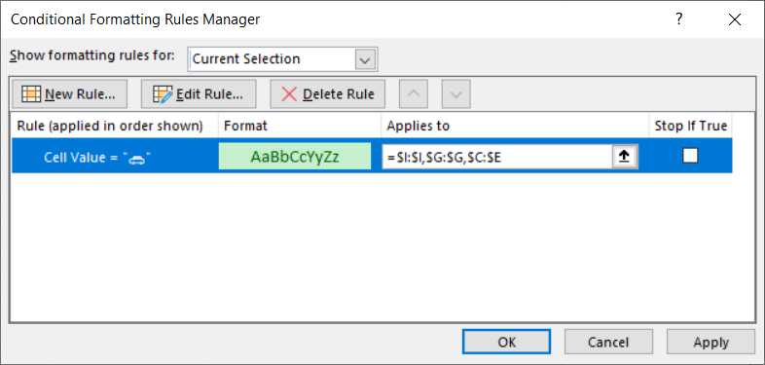

Our simulation now looks like this:

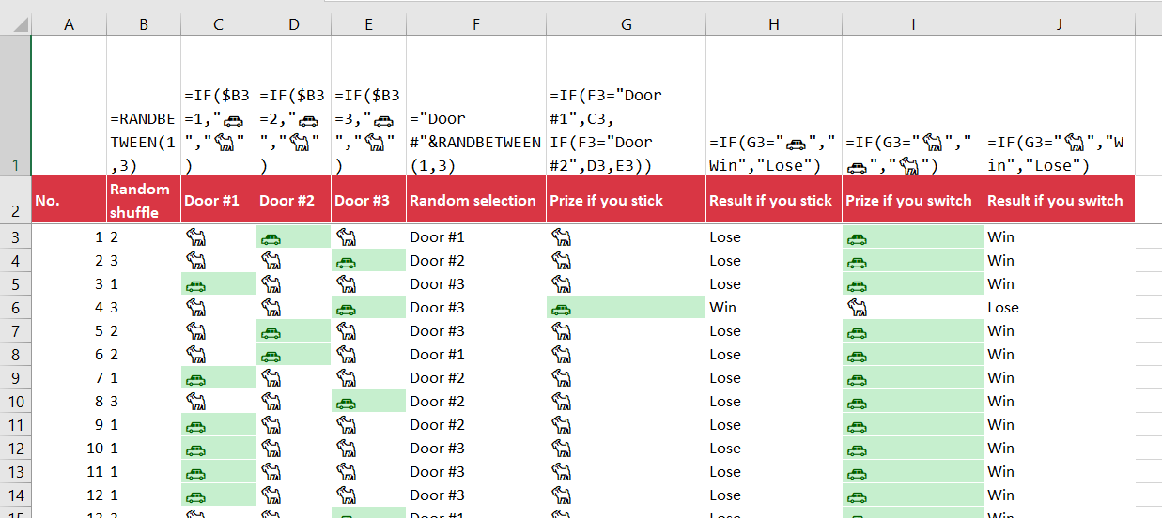

1. We can now count the number of times we win by sticking versus switching:
   1. =COUNTIF($H$3:$H$1002,"Win")
   2. =COUNTIF($J$3:$J$1002,"Win")

It turns out that we win about two-thirds of the time when we switch. Why?

**Interpretation**

A contestant gains to benefit from switching in the Monty Hall problem because Monty reveals more information about the placement of the car after opening a door to one of the goats:

* When you pick the first door, you have a 33% chance of picking the car.
* That leaves 66% of the doors “unanswered.”
* Monty opens another door: it has a goat. You *know* this door doesn’t have a car.
  + You are now twice as likely to find the car in that second door than the first door, because the 66% likelihood has been “pushed into” one door.

**Credits**

My workbook demonstration is heavily borrowed from the post “[Monty Hall Problem Simulation in Excel](https://blog.genglinxiao.com/monty-hall-problem-simulation-in-excel/).”

Special thank-you to Numberphile’s [Monty Hall Problem video](https://www.youtube.com/watch?v=4Lb-6rxZxx0) and Statistics by Jim’s [Monty Hall Problem blog post](https://statisticsbyjim.com/fun/monty-hall-problem/) for further understanding of the problem.