结果

1. 绘制时序图

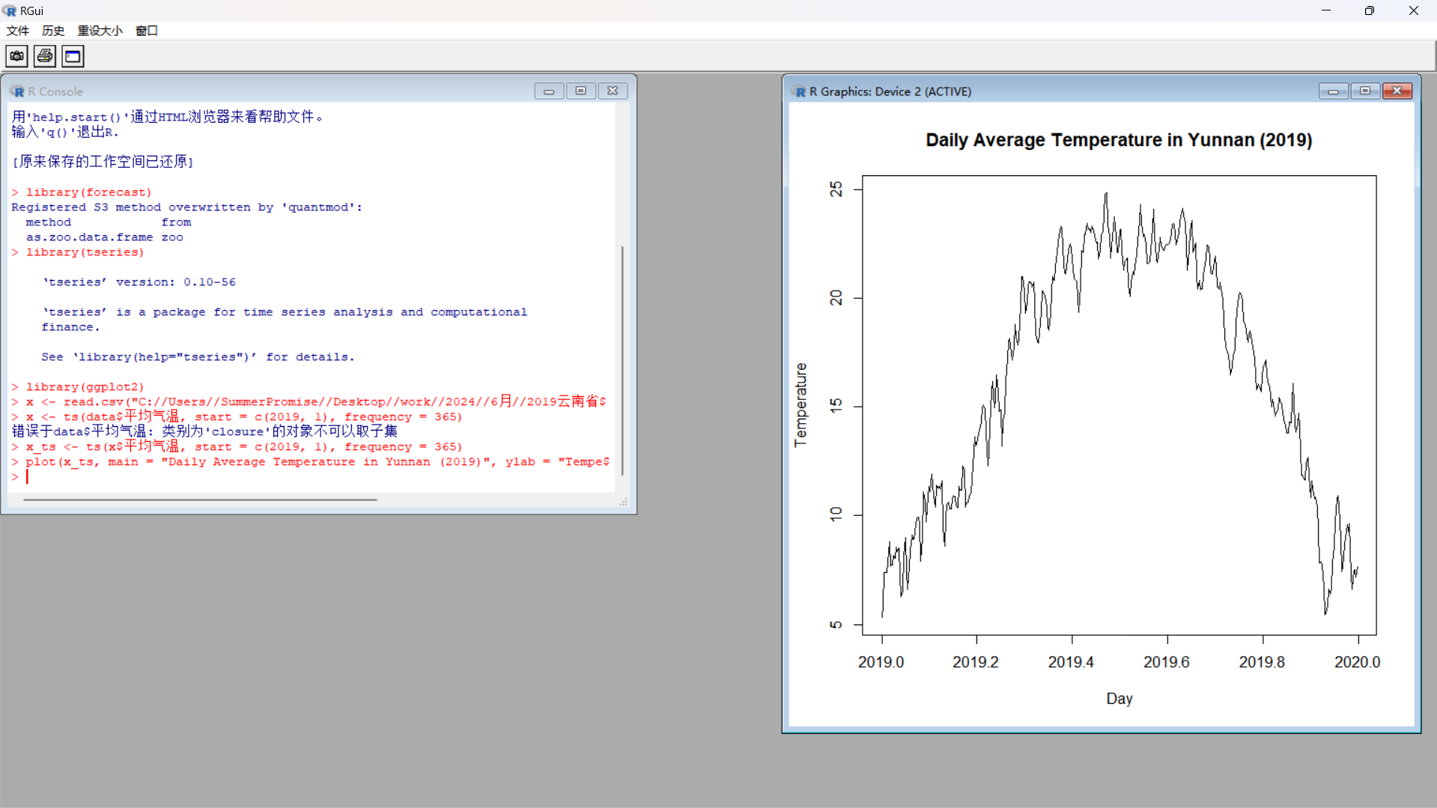



1. 计算并绘制ACF和PACF

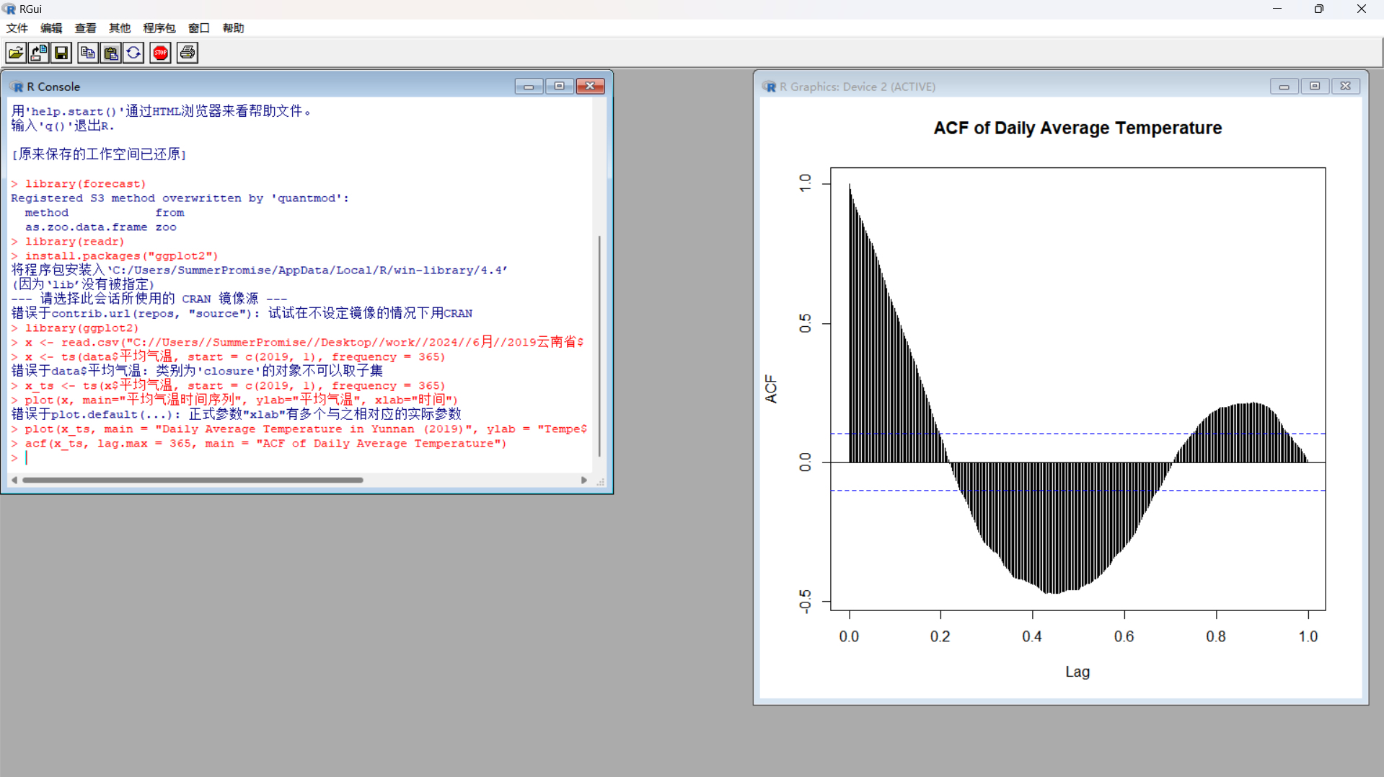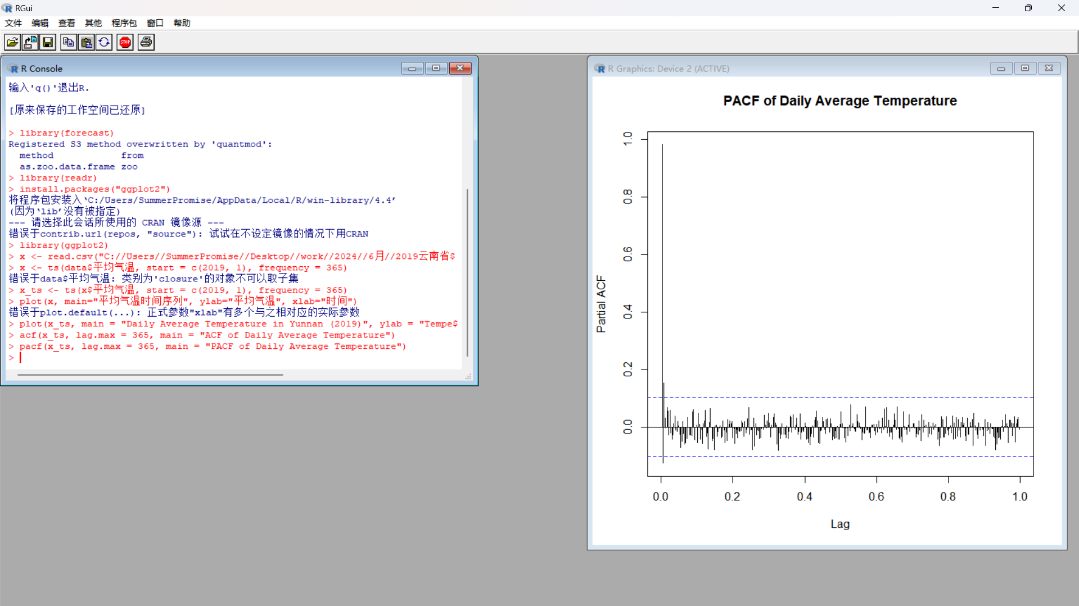

1. 使用SRIMA模型和指数平滑模型进行建模

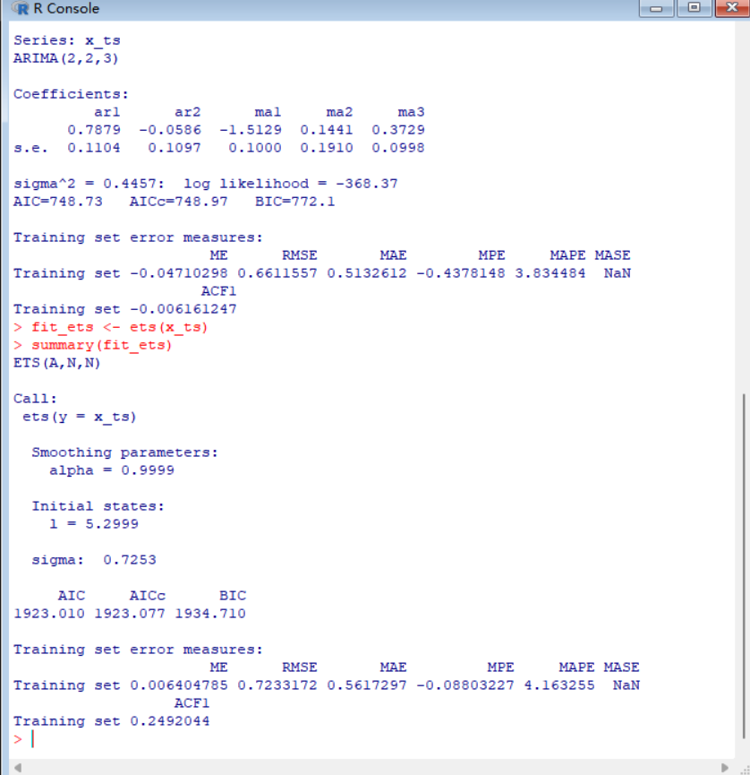

1. 绘制预测结果

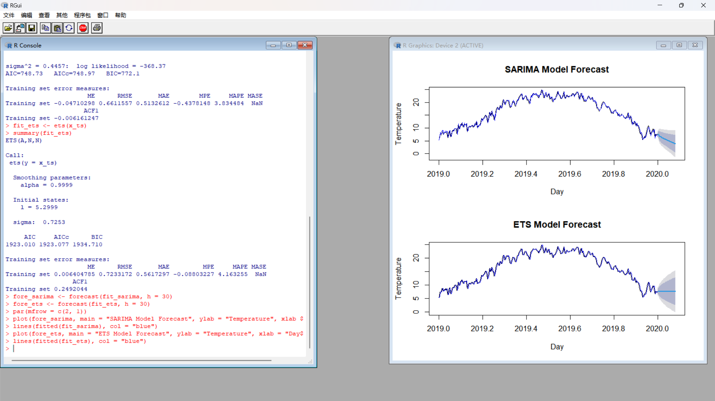

1. 打印预测结果

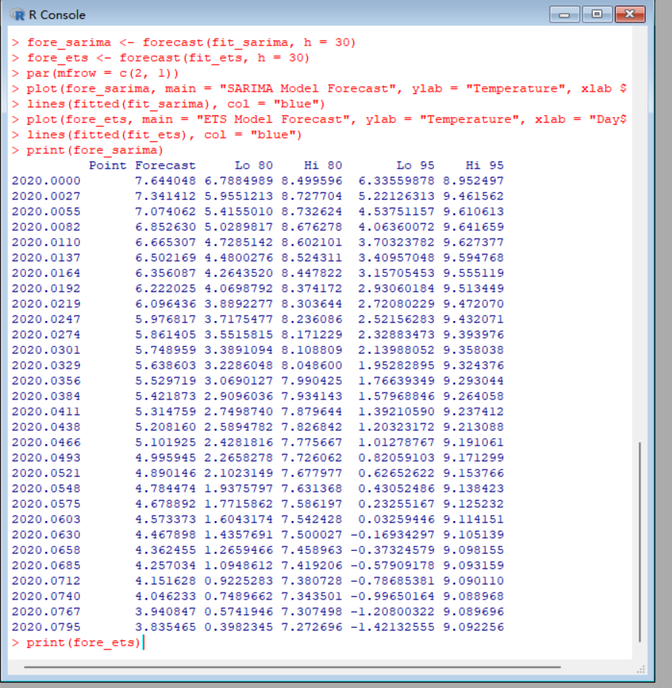

Point Forecast Lo 80 Hi 80 Lo 95 Hi 95

2020.0000 7.644048 6.7884989 8.499596 6.33559878 8.952497

2020.0027 7.341412 5.9551213 8.727704 5.22126313 9.461562

2020.0055 7.074062 5.4155010 8.732624 4.53751157 9.610613

2020.0082 6.852630 5.0289817 8.676278 4.06360072 9.641659

2020.0110 6.665307 4.7285142 8.602101 3.70323782 9.627377

2020.0137 6.502169 4.4800276 8.524311 3.40957048 9.594768

2020.0164 6.356087 4.2643520 8.447822 3.15705453 9.555119

2020.0192 6.222025 4.0698792 8.374172 2.93060184 9.513449

2020.0219 6.096436 3.8892277 8.303644 2.72080229 9.472070

2020.0247 5.976817 3.7175477 8.236086 2.52156283 9.432071

2020.0274 5.861405 3.5515815 8.171229 2.32883473 9.393976

2020.0301 5.748959 3.3891094 8.108809 2.13988052 9.358038

2020.0329 5.638603 3.2286048 8.048600 1.95282895 9.324376

2020.0356 5.529719 3.0690127 7.990425 1.76639349 9.293044

2020.0384 5.421873 2.9096036 7.934143 1.57968846 9.264058

2020.0411 5.314759 2.7498740 7.879644 1.39210590 9.237412

2020.0438 5.208160 2.5894782 7.826842 1.20323172 9.213088

2020.0466 5.101925 2.4281816 7.775667 1.01278767 9.191061

2020.0493 4.995945 2.2658278 7.726062 0.82059103 9.171299

2020.0521 4.890146 2.1023149 7.677977 0.62652622 9.153766

2020.0548 4.784474 1.9375797 7.631368 0.43052486 9.138423

2020.0575 4.678892 1.7715862 7.586197 0.23255167 9.125232

2020.0603 4.573373 1.6043174 7.542428 0.03259446 9.114151

2020.0630 4.467898 1.4357691 7.500027 -0.16934297 9.105139

2020.0658 4.362455 1.2659466 7.458963 -0.37324579 9.098155

2020.0685 4.257034 1.0948612 7.419206 -0.57909178 9.093159

2020.0712 4.151628 0.9225283 7.380728 -0.78685381 9.090110

2020.0740 4.046233 0.7489662 7.343501 -0.99650164 9.088968

2020.0767 3.940847 0.5741946 7.307498 -1.20800322 9.089696

2020.0795 3.835465 0.3982345 7.272696 -1.42132555 9.092256

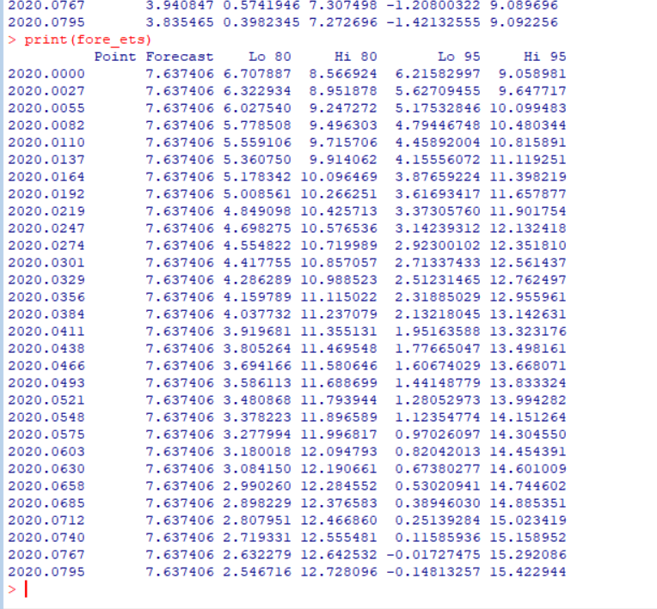

Point Forecast Lo 80 Hi 80 Lo 95 Hi 95

2020.0000 7.637406 6.707887 8.566924 6.21582997 9.058981

2020.0027 7.637406 6.322934 8.951878 5.62709455 9.647717

2020.0055 7.637406 6.027540 9.247272 5.17532846 10.099483

2020.0082 7.637406 5.778508 9.496303 4.79446748 10.480344

2020.0110 7.637406 5.559106 9.715706 4.45892004 10.815891

2020.0137 7.637406 5.360750 9.914062 4.15556072 11.119251

2020.0164 7.637406 5.178342 10.096469 3.87659224 11.398219

2020.0192 7.637406 5.008561 10.266251 3.61693417 11.657877

2020.0219 7.637406 4.849098 10.425713 3.37305760 11.901754

2020.0247 7.637406 4.698275 10.576536 3.14239312 12.132418

2020.0274 7.637406 4.554822 10.719989 2.92300102 12.351810

2020.0301 7.637406 4.417755 10.857057 2.71337433 12.561437

2020.0329 7.637406 4.286289 10.988523 2.51231465 12.762497

2020.0356 7.637406 4.159789 11.115022 2.31885029 12.955961

2020.0384 7.637406 4.037732 11.237079 2.13218045 13.142631

2020.0411 7.637406 3.919681 11.355131 1.95163588 13.323176

2020.0438 7.637406 3.805264 11.469548 1.77665047 13.498161

2020.0466 7.637406 3.694166 11.580646 1.60674029 13.668071

2020.0493 7.637406 3.586113 11.688699 1.44148779 13.833324

2020.0521 7.637406 3.480868 11.793944 1.28052973 13.994282

2020.0548 7.637406 3.378223 11.896589 1.12354774 14.151264

2020.0575 7.637406 3.277994 11.996817 0.97026097 14.304550

2020.0603 7.637406 3.180018 12.094793 0.82042013 14.454391

2020.0630 7.637406 3.084150 12.190661 0.67380277 14.601009

2020.0658 7.637406 2.990260 12.284552 0.53020941 14.744602

2020.0685 7.637406 2.898229 12.376583 0.38946030 14.885351

2020.0712 7.637406 2.807951 12.466860 0.25139284 15.023419

2020.0740 7.637406 2.719331 12.555481 0.11585936 15.158952

2020.0767 7.637406 2.632279 12.642532 -0.01727475 15.292086

2020.0795 7.637406 2.546716 12.728096 -0.14813257 15.422944

>